Monoalphabetic Substitution Cipher
Program Output Screenshot
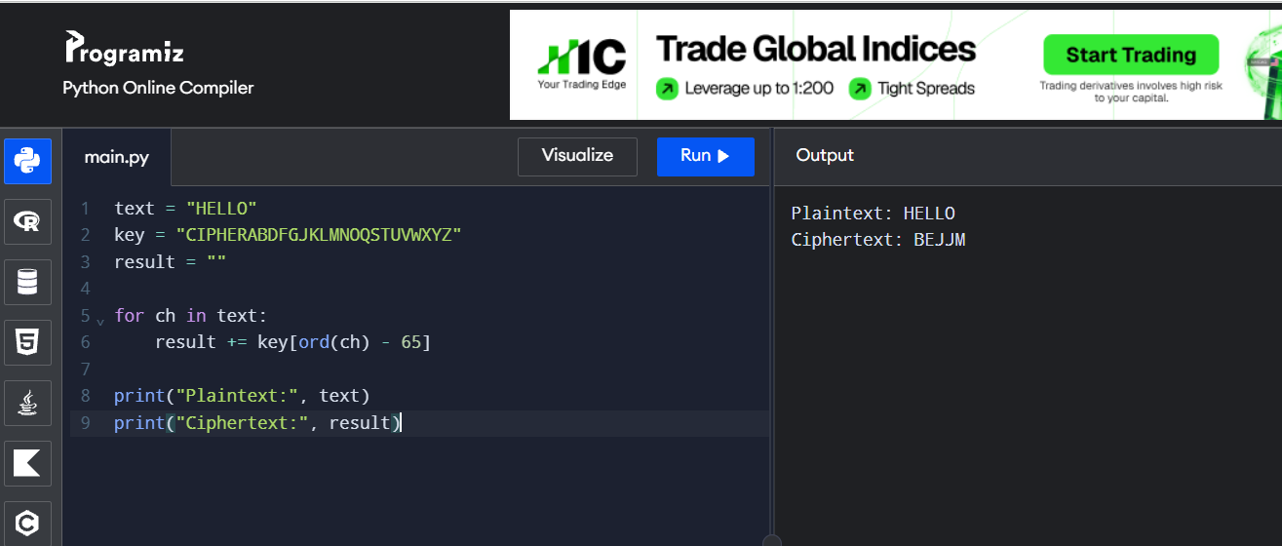
Output:
Plaintext: HELLO
Ciphertext: BEJJM

