Playfair Cipher Matrix – Message Example
Program Output Screenshot
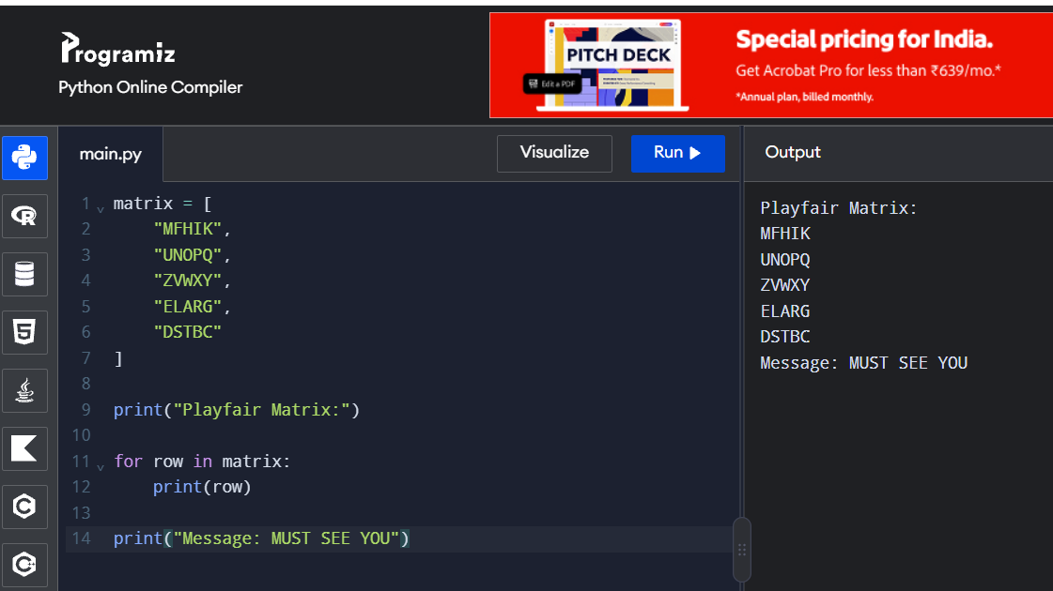
Output:
Playfair Matrix:
MFHIK
UNOPQ
ZVWXY
ELARG
DSTBC
Message: MUST SEE YOU

