ITA1447 - ETHICAL HACKING FOR ENUMERATING WINDOWS
LAB MANUAL

Experiment No: 11
Packet Analyser Tool
Aim:
To capture, filter and inspect TCP/UDP/HTTP packets on a network using Wireshark as a packet analyser.
Procedure:
- Install and open Wireshark on the system.
- Go to the Capture tab, select the appropriate network interface, and begin capturing live traffic.
- Allow the tool to capture a mix of TCP, UDP and HTTP packets by browsing the internet or performing network activity.
- In the display filter bar, type tcp and press Enter to filter and view only TCP packets; observe the three-way handshake (SYN, SYN-ACK, ACK) and subsequent data segments.
- Change the filter to udp and press Enter to filter and view only UDP packets; observe connectionless communication without a handshake.
- Change the filter to http and press Enter to filter and view only HTTP packets; observe GET and POST requests along with server responses.
- Select an individual packet from the list and expand the packet details pane to inspect the Frame, Ethernet, Internet Protocol and Transport Protocol layers.
- Examine the hex dump pane to view the raw byte-level content of the selected packet.
- Record observations about the source, destination, protocol, length and content of representative packets from each filtered category.
- Stop the capture once sufficient data has been gathered and save the capture file if required for later analysis.
Filter used
tcp
udp
http
Output:
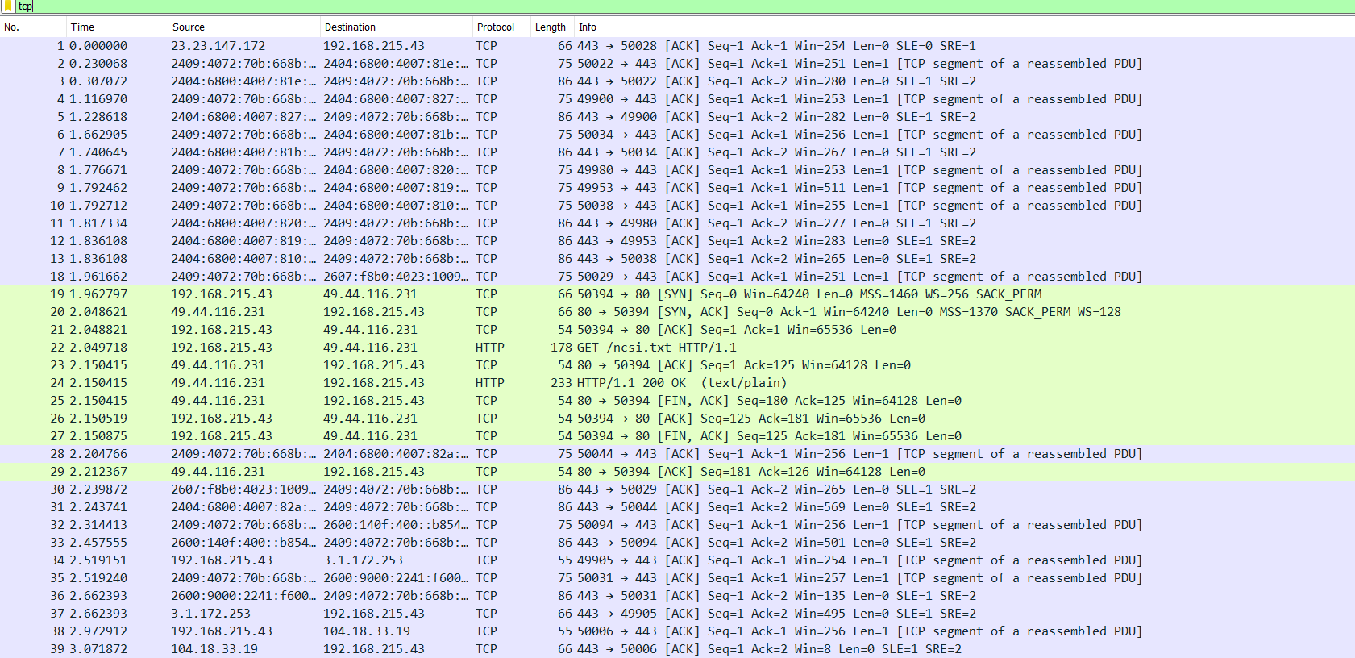
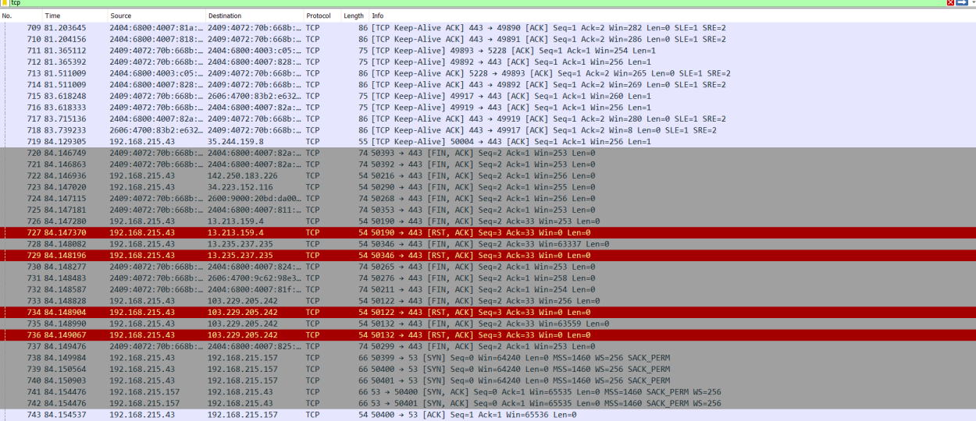
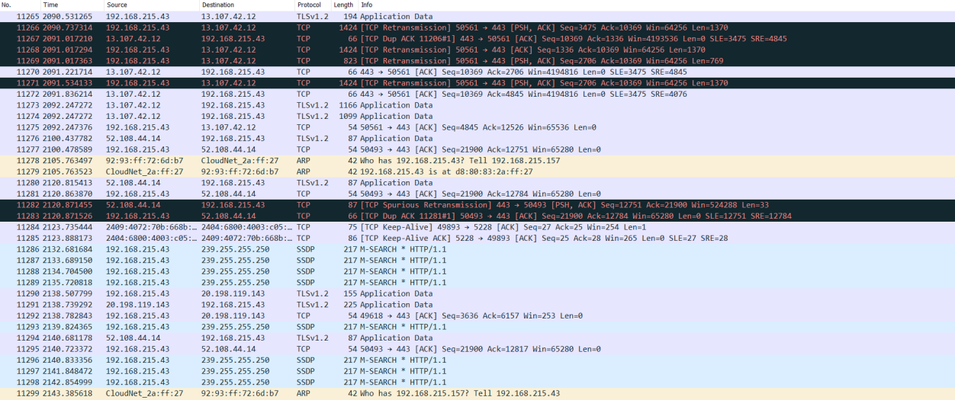
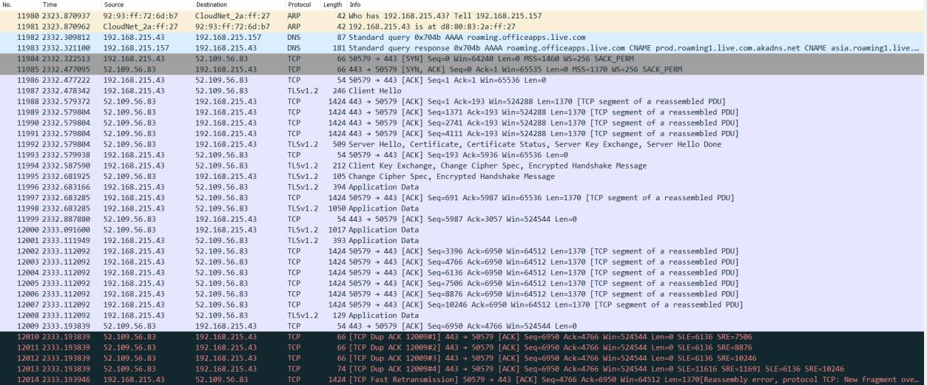
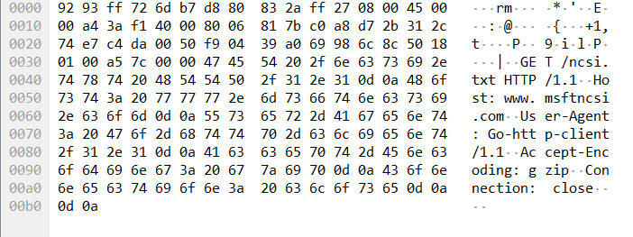
Result:
Wireshark was used to capture, filter and inspect TCP, UDP and HTTP packets, and the source, destination, protocol and packet details were successfully analysed.

