ITA1447 - ETHICAL HACKING FOR ENUMERATING WINDOWS
LAB MANUAL

Experiment No: 12
Port Scanning Tools (Port Specification)
Aim:
To perform port scanning with specific port ranges and fast scan options using Nmap.
Procedure:
- Open Nmap from Kali Linux: Applications -> Information Gathering -> Nmap, or open a terminal window directly.
- Identify the target host to scan (for example, 192.168.1.1).
- Perform the standard scan types as needed: TCP SYN scan (-sS), TCP Connect scan (-sT), UDP scan (-sU) and TCP ACK scan (-sA).
- To scan a specific port or range of ports, use the -p flag followed by the port range, for example: nmap -p 1-30 192.168.1.1.
- To scan all 65535 ports on the target, use the -p- flag, for example: nmap -p- 192.168.1.1, noting that this scan takes considerably longer than a default scan.
- To perform a fast scan of the 100 most common ports, use the -F flag, for example: nmap -F 192.168.1.1.
- Compare the time taken and the number of ports scanned/open for each port specification method.
- Record the results, noting which ports were found open, closed or filtered in each case.
Port Specification
nmap -sS 192.168.1.1 (TCP SYN port scan)
nmap -sT 192.168.1.1 (TCP connect port scan)
nmap -sU 192.168.1.1 (UDP port scan)
nmap -sA 192.168.1.1 (TCP ACK port scan)
nmap -p 1-30 192.168.1.1 (specify a port or port range)
nmap -p- 192.168.1.1 (scan all ports)
nmap -F 192.168.1.1 (fast port scan)
Output:
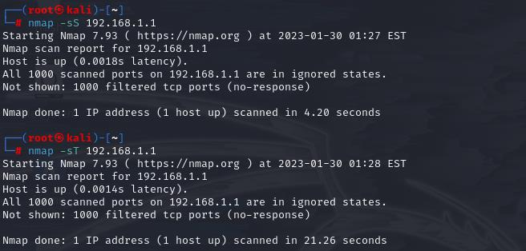
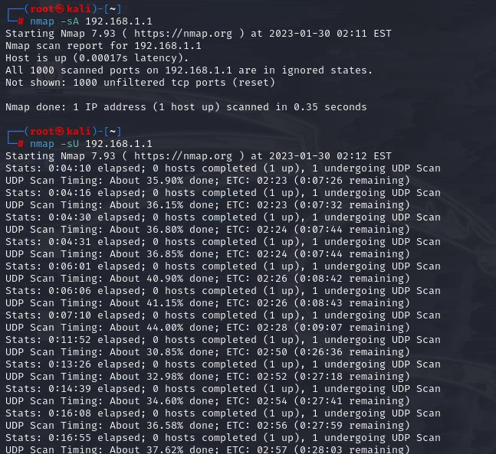
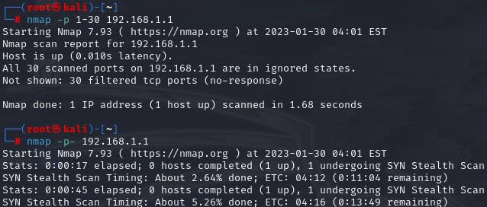
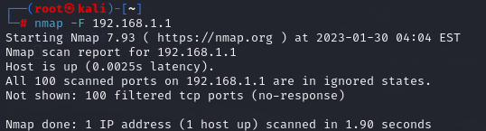
Result:
Port scanning with custom port ranges, full port scan and fast scan options was successfully performed using Nmap on the target host.

