ITA1447 - ETHICAL HACKING FOR ENUMERATING WINDOWS
LAB MANUAL

Experiment No: 13
Nmap Timing & Performance
Aim:
To study and apply Nmap's timing templates to control the speed and performance of a scan.
Procedure:
- Open Nmap from Kali Linux: Applications -> Information Gathering -> Nmap, or open a terminal window directly.
- Identify the target host to scan (for example, 192.168.1.1).
- Review the six Nmap timing templates, ranging from T0 (Paranoid, slowest) to T5 (Insane, fastest).
- Run a scan using the -T0 flag to perform a Paranoid scan, which is extremely slow and intended to avoid intrusion detection systems.
- Run a scan using the -T1 flag to perform a Sneaky scan, which is also slow but slightly faster than T0.
- Run a scan using the -T2 flag to perform a Polite scan, which slows down to consume less bandwidth and target machine resources.
- Run a scan using the -T3 flag, the Normal/default timing template, which balances speed and reliability.
- Run a scan using the -T4 flag to perform an Aggressive scan, which speeds up the scan assuming a fast and reliable network.
- Run a scan using the -T5 flag to perform an Insane scan, which is the fastest but may sacrifice accuracy on slower networks.
- Compare the time taken to complete the scan under each timing template and observe how the Ping Scan and SYN Stealth Scan progress percentages differ.
- Record the results and timing differences for analysis in the report.
Timing Templates
nmap -T0 192.168.1.1 (Paranoid)
nmap -T1 192.168.1.1 (Sneaky)
nmap -T2 192.168.1.1 (Polite)
nmap -T3 192.168.1.1 (Normal - default)
nmap -T4 192.164.1.1 (Aggressive)
nmap -T5 192.164.1.1 (Insane)
Output:
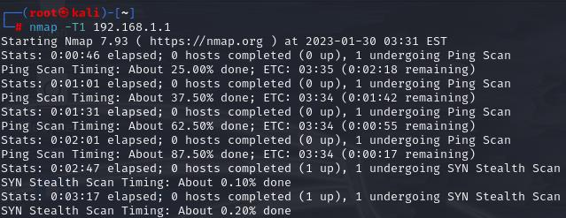
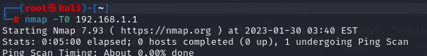
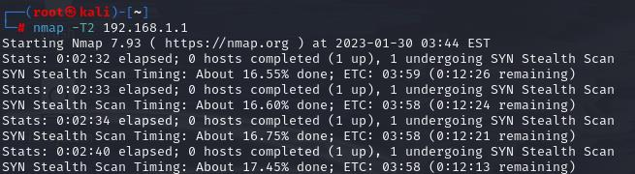
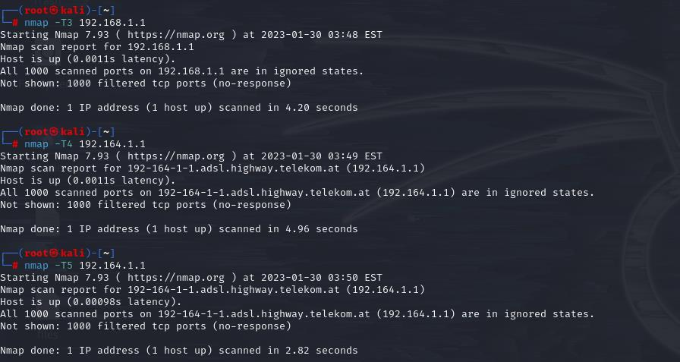
Result:
Nmap scans were performed using different timing templates (T0-T5), and the effect of each template on scan speed and performance was observed.

