ITA1447 - ETHICAL HACKING FOR ENUMERATING WINDOWS
LAB MANUAL

Experiment No: 1
Port Scanning Tools
Aim:
To perform different types of port scanning on a target host using the Nmap tool in Kali Linux.
Procedure:
- Open the Kali Linux virtual machine and log in as root.
- Navigate to Applications -> Information Gathering -> Nmap to launch the Nmap tool, or open a terminal window directly.
- Identify the target host/IP address to be scanned (for example, 192.168.1.1).
- Perform a TCP SYN scan using the -sS flag to quickly identify open ports without completing the full TCP handshake.
- Perform a TCP Connect scan using the -sT flag, which completes the full TCP three-way handshake with each port.
- Perform a UDP scan using the -sU flag to identify open UDP ports and services.
- Perform a TCP ACK scan using the -sA flag to determine whether a firewall is stateful and which ports are filtered.
- Additional scan types such as FIN (-sF), NULL (-sN), XMAS (-sX), RPC (-sR) and Idle (-sI) scans may also be performed to evade detection or identify open ports in different ways.
- Observe and record the output for each scan type, noting the open, closed and filtered ports.
- Compare the results of the different scan types to understand their behaviour and typical use cases.
Scanning Techniques
nmap -sS 192.168.1.1 (TCP SYN port scan)
nmap -sT 192.168.1.1 (TCP connect port scan)
nmap -sU 192.168.1.1 (UDP port scan)
nmap -sA 192.168.1.1 (TCP ACK port scan)
Output:
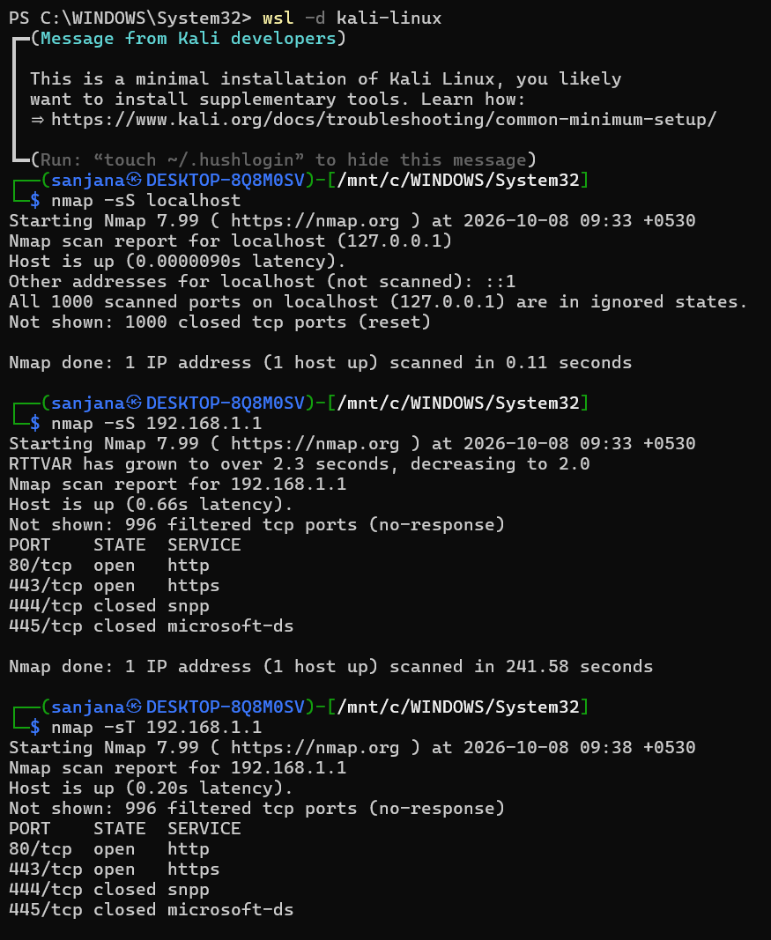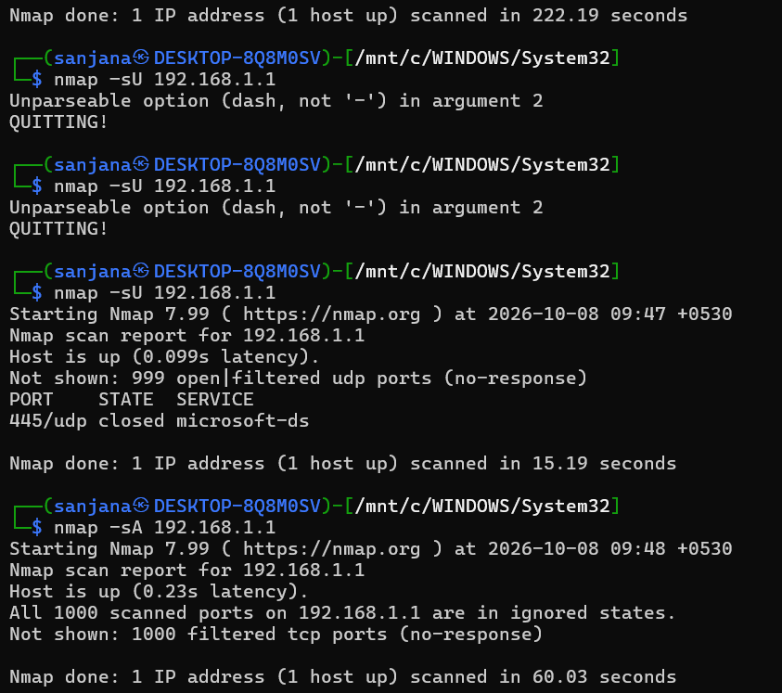
Result:
The different Nmap port scanning techniques (SYN, Connect, UDP, ACK) were performed successfully and the open/filtered/closed ports on the target host were identified.

