ITA1447 - ETHICAL HACKING FOR ENUMERATING WINDOWS
LAB MANUAL

Experiment No: 3
Cracking the Password using Hydra
Aim:
To crack FTP service credentials of a target machine using the Hydra password-cracking tool.
Procedure:
- Open Kali Linux and navigate to Applications -> Password Attacks -> Online Attacks -> hydra, or open a terminal and type hydra.
- Identify the target service to attack; in this case, the FTP service running on the Metasploitable machine with IP address 192.168.1.101.
- Prepare a wordlist containing possible usernames and passwords. Create (or use an existing) wordlist file with the extension .lst, stored at the path usr/share/wordlist/Metasploit.
- Open a terminal window on Kali Linux.
- Construct the Hydra command specifying the login wordlist file (-l) and the password wordlist file (-P), along with the target service and IP address.
- Add the -V flag to display each username and password combination being attempted in real time.
- Execute the Hydra command and allow it to attempt each combination against the FTP service.
- Observe the output as Hydra reports each attempt, including successful and failed logins.
- Record the valid username and password combination once found (msfadmin:msfadmin in this case).
- Verify the discovered credentials by manually logging into the FTP service using an FTP client.
Command
hydra -l /usr/share/wordlists/metasploit/user -P \
/usr/share/wordlists/metasploit/password ftp://192.168.1.101 -V
Output: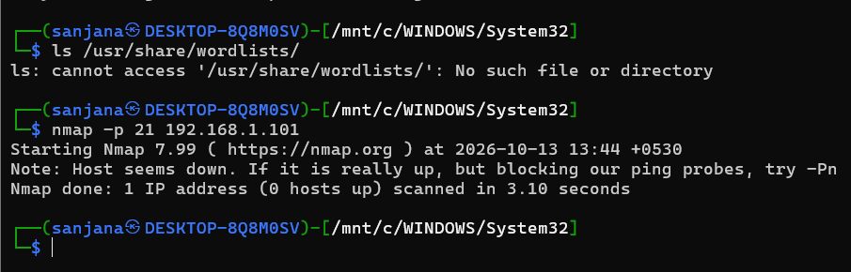

Result:
Hydra was used to successfully brute force the FTP login credentials of the target machine, and the valid credentials (msfadmin:msfadmin) were obtained.

