ITA1447 - ETHICAL HACKING FOR ENUMERATING WINDOWS
LAB MANUAL

Experiment No: 4
Information Gathering using theHarvester
Aim:
To gather information such as subdomains, IPs, ASNs and URLs about a target domain using theHarvester tool.
Procedure:
- Open a terminal window in Kali Linux.
- Review the theHarvester options: -d specifies the target domain/URL to gather information from, -l limits the number of results returned, and -b specifies which search engine or data source to use (or 'all' to query every available source).
- Choose a target domain to investigate, for example www.zoho.com.
- Construct the theHarvester command using the -d, -l and -b options as required.
- Execute the command in the terminal.
- Observe the tool as it queries multiple sources (search engines, certificate transparency logs, DNS databases, etc.) for information about the domain.
- Note any 'missing API key' warnings, which indicate that some sources could not be queried without additional configuration.
- Review the final output summary, including the number of ASNs found, interesting URLs discovered, IP addresses found, and any email addresses or subdomains identified.
- Record the gathered information for further analysis or reporting.
Command
theHarvester -d www.zoho.com -l 300 -b all
Output:
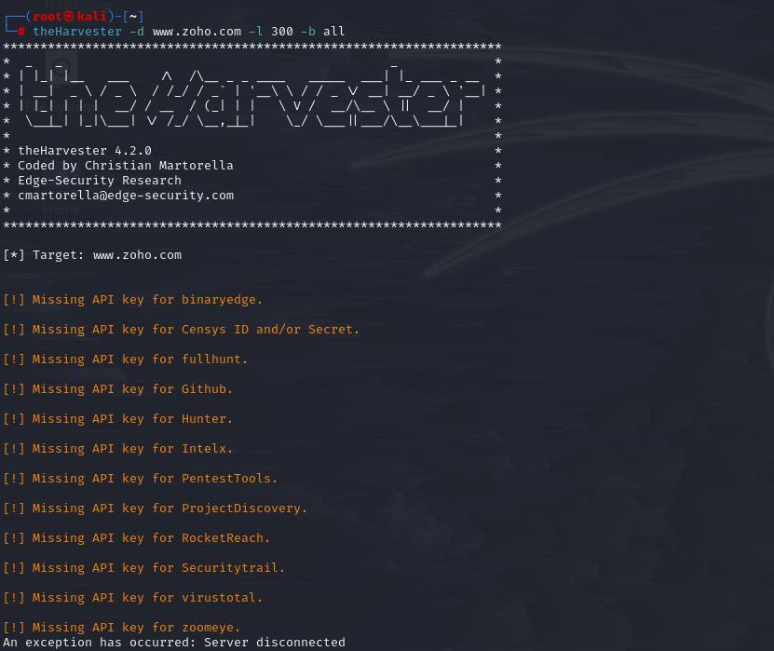
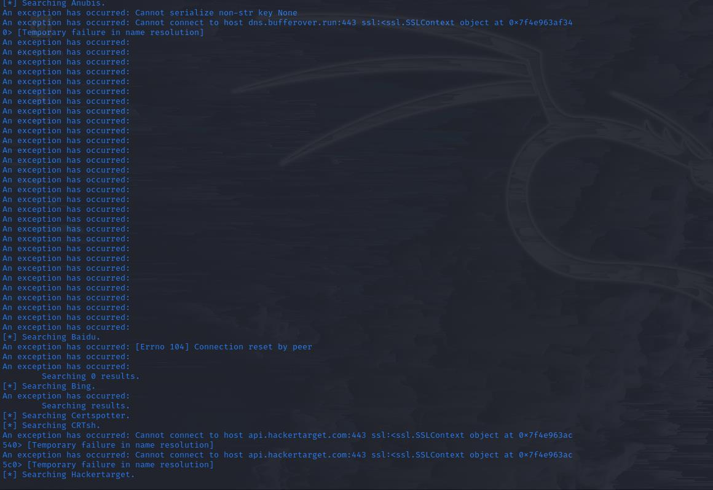
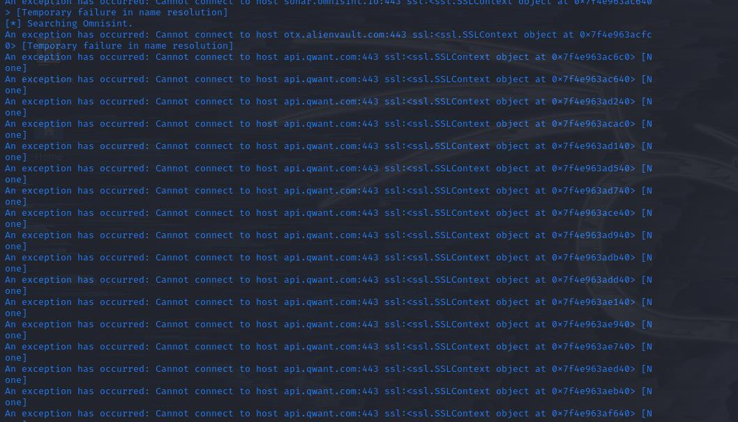
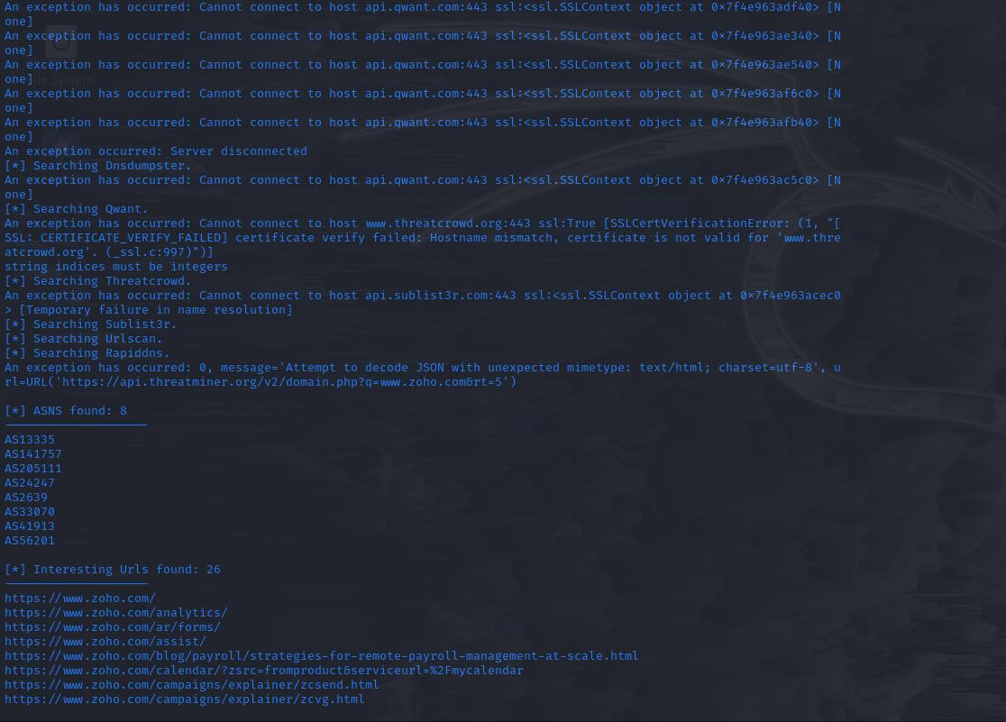
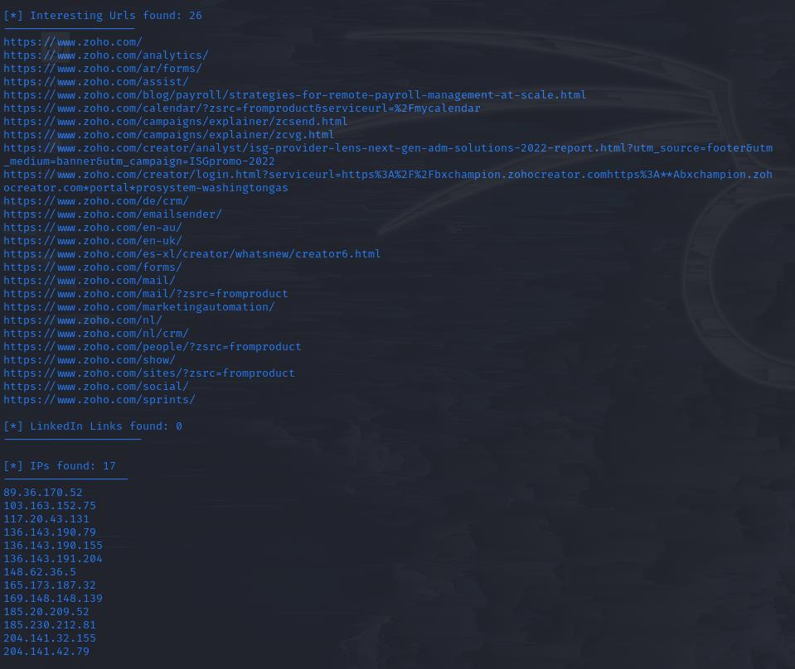
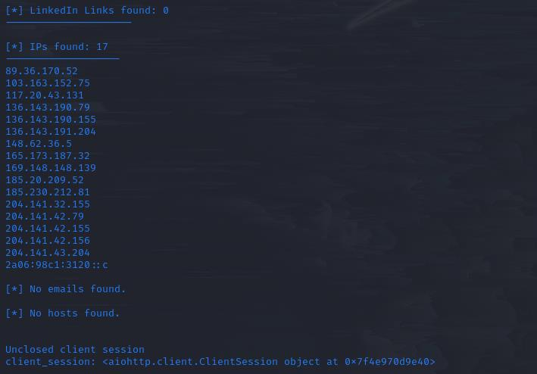
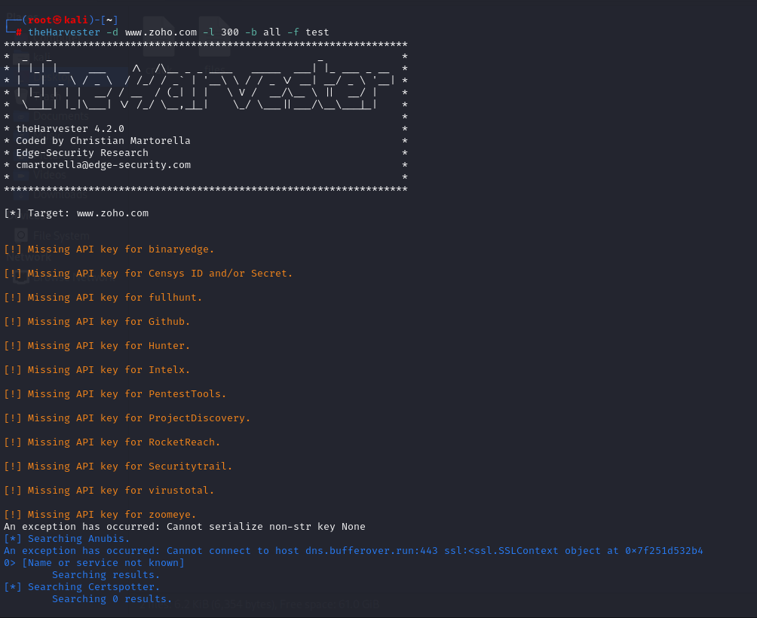
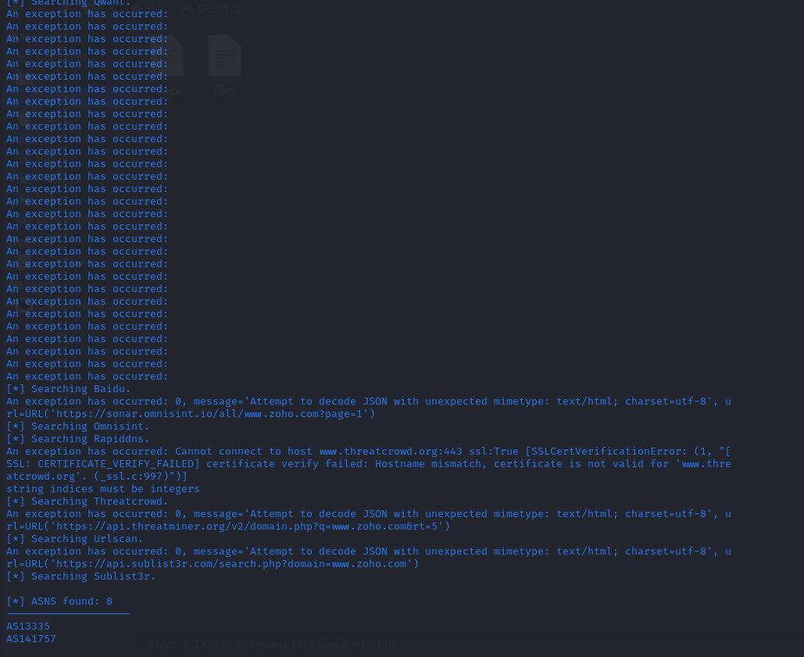
Result:
theHarvester tool was used to gather OSINT information (ASNs, interesting URLs and IP addresses) about the target domain www.zoho.com.

