ITA1447 - ETHICAL HACKING FOR ENUMERATING WINDOWS
LAB MANUAL

Experiment No: 5
Use Google & Whois for Reconnaissance
Aim:
To perform reconnaissance on a target domain using Google Chrome and the Whois lookup service.
Procedure:
- Open Google Chrome (or any web browser) on a Windows operating system.
- In the address bar or search bar, search for the 'who.is' website and navigate to it.
- On the who.is website, locate the search box used to look up domain information.
- Enter the target domain name to investigate, for example www.saveetha.com, and submit the search.
- Review the Whois Information tab, which displays registrar details, important dates (registration, expiry, last updated) and name server information.
- Click on the DNS Records tab to view the domain's DNS records, including SOA, NS, A and MX records along with their TTL and priority values.
- Click on the Diagnostics tab to view ping and traceroute results for the domain, showing network latency and the path taken to reach the server.
- Record and screenshot the relevant information obtained from each tab for the report.
Output:
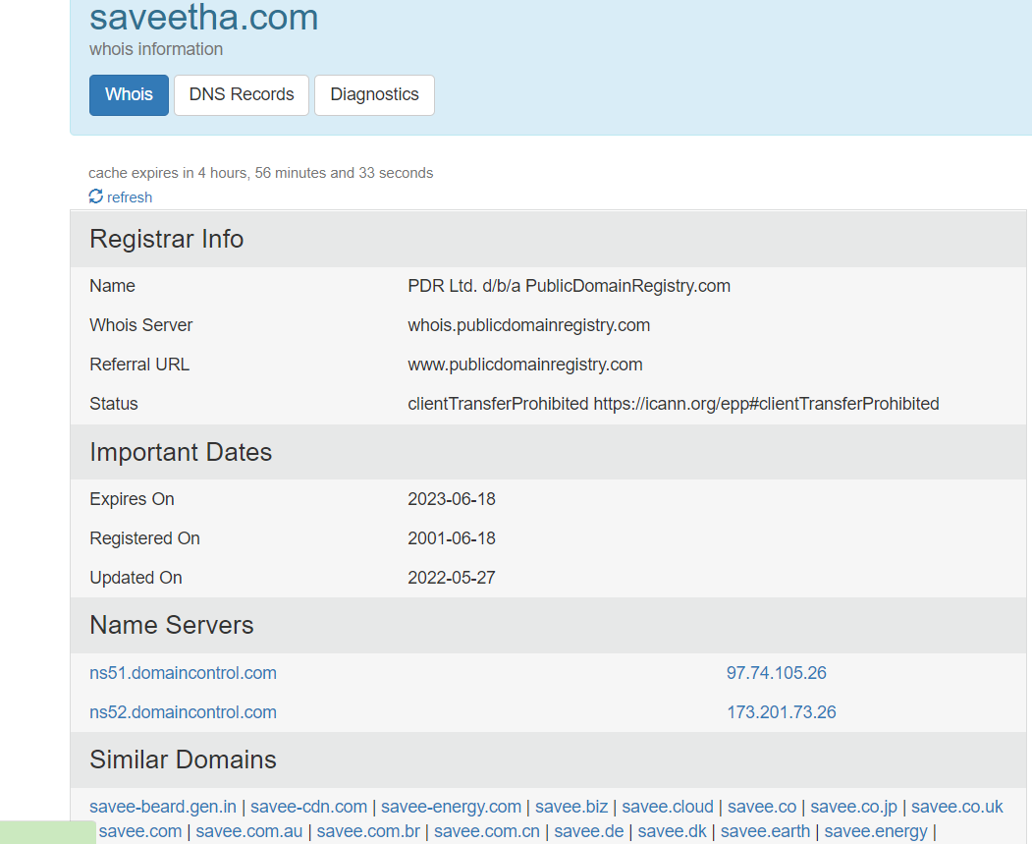
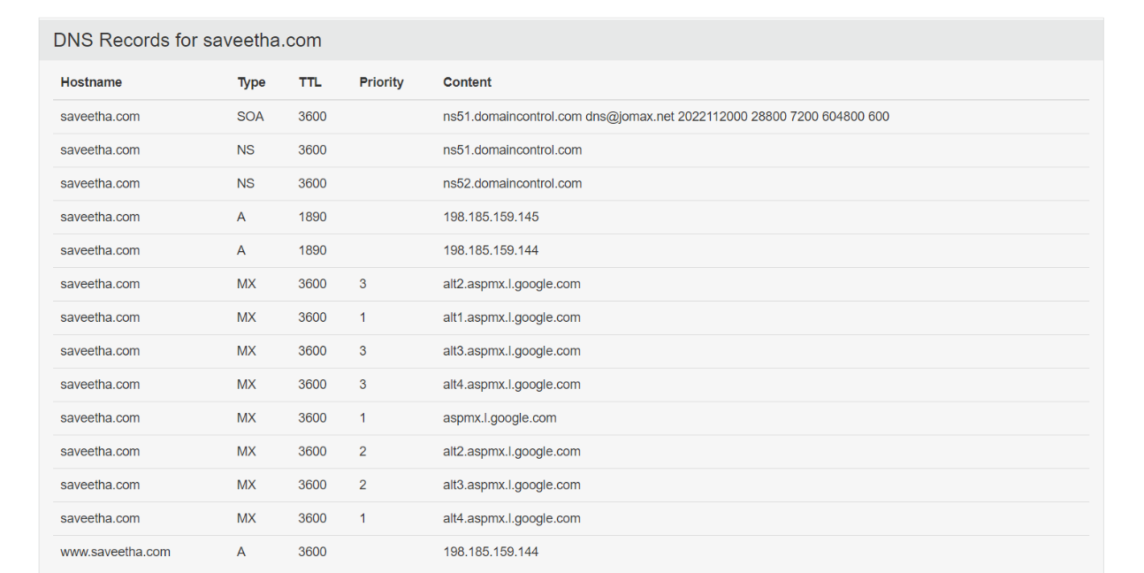
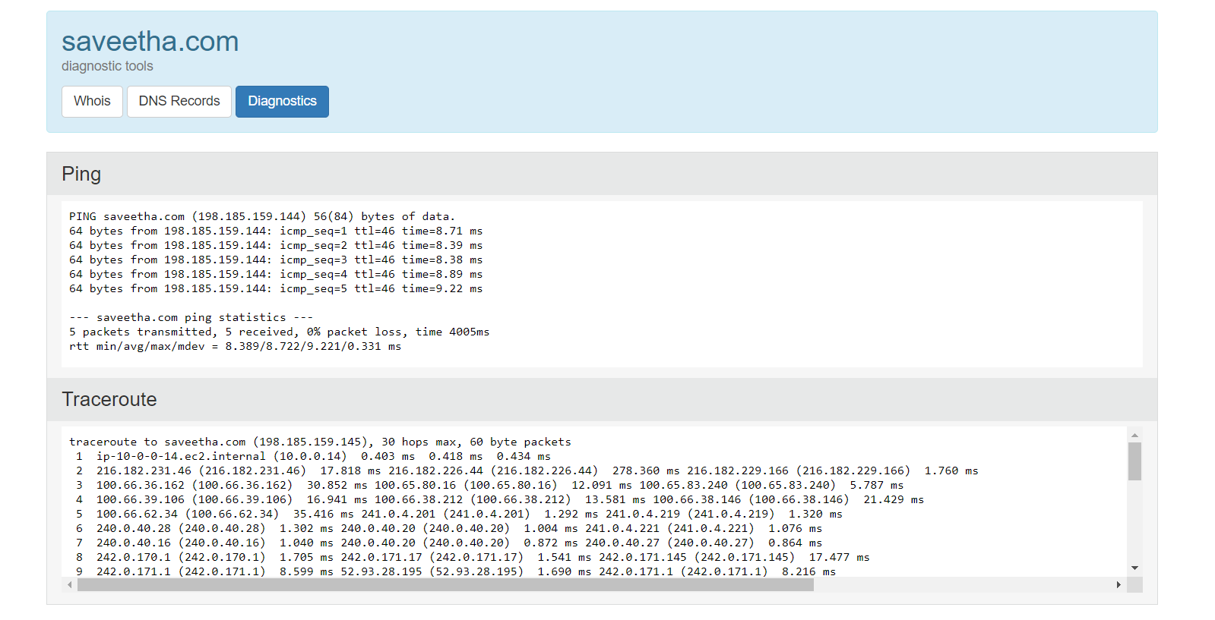
Result:
Whois reconnaissance was performed on www.saveetha.com and registrar information, DNS records, important dates and similar domains were successfully retrieved.

