ITA1447 - ETHICAL HACKING FOR ENUMERATING WINDOWS
LAB MANUAL

Experiment No: 6
Windows OS Commands Execution - Traceroute, Ping, Ifconfig & Netstat
Aim:
To execute and analyse basic Windows and Linux networking commands: tracert, ping, ifconfig and netstat.
Procedure:
- Open the Windows Command Prompt by searching for 'cmd' in the Start menu or pressing Win+R and typing cmd.
- To trace the network path to a destination, type the tracert command followed by the target hostname, for example: tracert www.saveetha.com, and press Enter.
- Observe the list of hops (intermediate routers) along with the round-trip time for each hop until the destination is reached.
- To test connectivity to a specific host, type the ping command followed by the target IP address, for example: ping 172.18.64.1, and press Enter.
- Observe the number of packets sent, received and lost, along with the minimum, maximum and average round-trip times.
- To view network interface configuration details (on a Linux system), open a terminal and type the ifconfig command, then press Enter.
- Observe the interface details including IP address, netmask, broadcast address, MAC address and packet statistics (RX/TX packets, bytes, errors).
- To view active network connections on Windows, open the command prompt and type the netstat command, then press Enter.
- Observe the list of active TCP connections, including local address, foreign address, protocol and connection state.
- Record the outputs of each command for comparison and analysis in the report.
Commands
tracert www.saveetha.com
ping 172.18.64.1
ifconfig
netstat
Output:
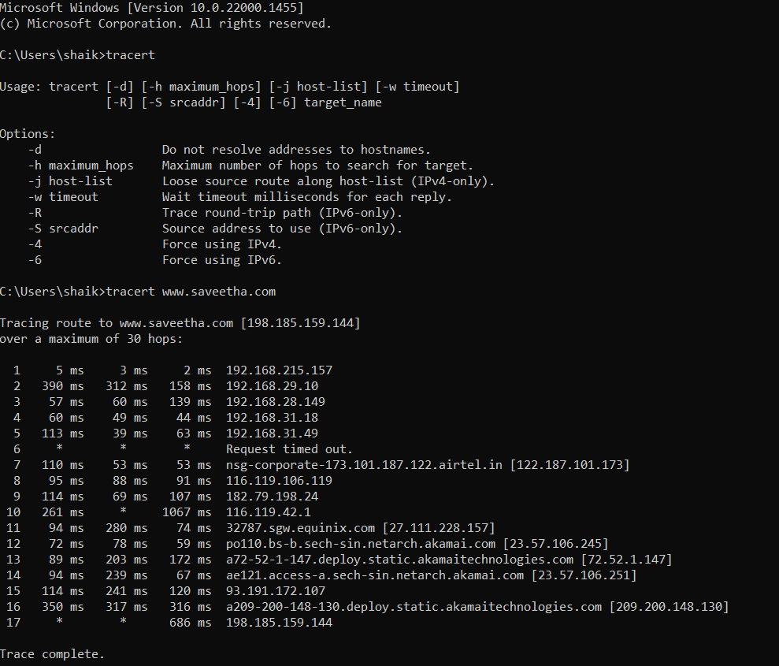
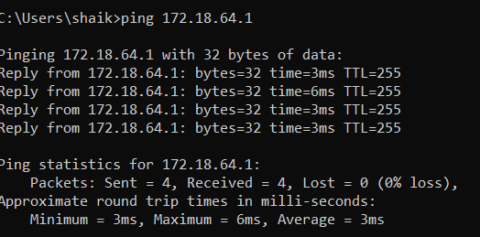
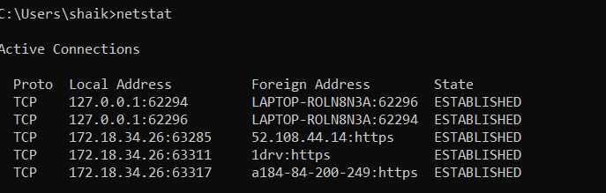
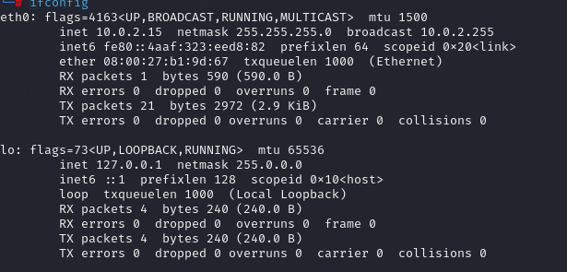
Result:
The traceroute, ping, ifconfig and netstat commands were executed successfully, displaying the route, round-trip times, interface configuration and active network connections respectively.

