ITA1447 - ETHICAL HACKING FOR ENUMERATING WINDOWS
LAB MANUAL

Experiment No: 8
Wireshark Sniffer for Network Traffic & Analyse
Aim:
To capture and analyse live network traffic using Wireshark, including identifying HTTP POST credentials.
Procedure:
- Install Wireshark on the system if not already installed, then open the application.
- Go to the Capture tab and select the network interface to monitor (for example, the WIFI interface), then start the capture.
- Observe the live stream of packets being captured, showing source address, destination address, protocol and packet length.
- Open a web browser in a new window and navigate to a website that requires login (register for an account if needed).
- Enter a username/email and password into the login form and submit it to sign in.
- Allow Wireshark to continue recording packets in the background while the login request is sent.
- In the Wireshark display filter bar, type http and press Enter (or click Apply) to filter the capture and show only HTTP traffic.
- Stop the packet capture once the login attempt has been completed.
- Locate the HTTP POST request packet corresponding to the login form submission by examining the Info column.
- Right-click the POST packet and select Follow -> HTTP Stream (or expand the packet details) to view the submitted form data.
- Identify the plaintext username/email and password fields within the captured POST data.
- Record the findings to demonstrate the risk of transmitting credentials over unencrypted HTTP.
Filter used
http
Output:
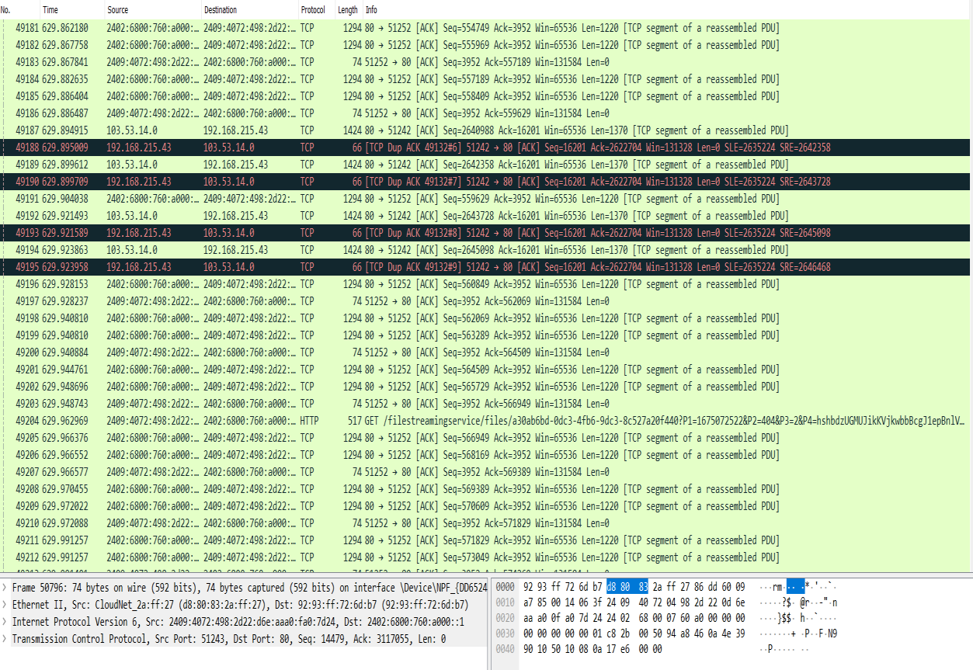
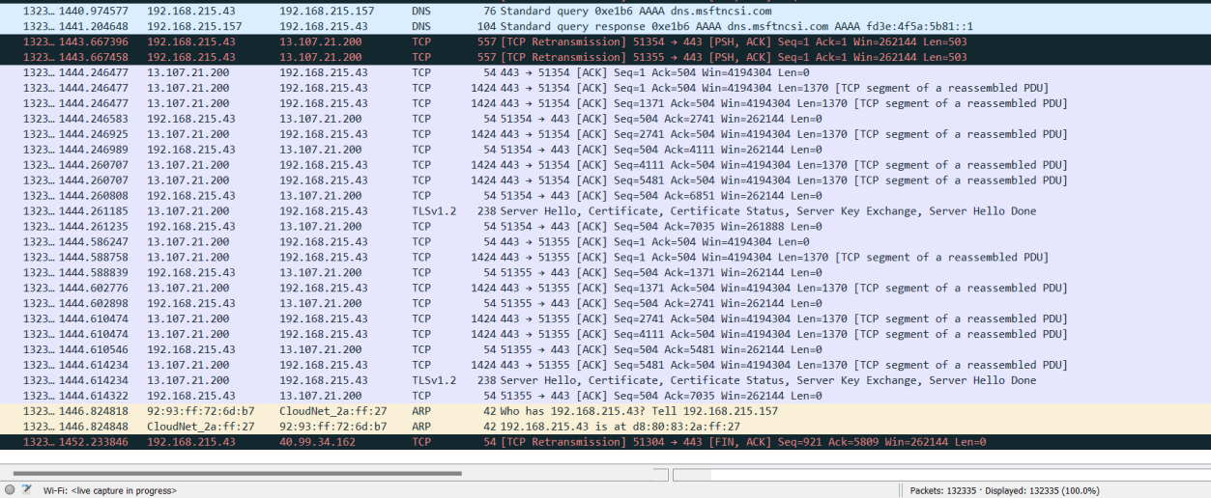
Result:
Wireshark successfully captured live network traffic, and by applying the HTTP filter the POST request containing the login credentials was identified and analysed.

