LinkShield
To explain the code clearly, I’ve broken it down into its logical layers. Think of it as a security checkpoint: first, it checks if you're a "known guest" (Whitelist), then it "scans your bags" (Feature Extraction), and finally, an "AI Officer" (Random Forest) decides if you're a threat.
1. The Global Whitelist
This is your first line of defense. It bypasses the AI for trusted domains like Google or Amazon to avoid "False Positives" (marking a good site as bad).
How it works: It strips the https:// and www. from the URL and checks if the remaining domain exists in your WHITELIST list.
Benefit: Improves speed and accuracy for common websites.
2. Feature Extraction (The "Bag Scanner")
Machine Learning models can't "read" text; they only understand numbers. This function transforms a URL string into a numerical profile.
Key Features:
Length: Phishing URLs are often unusually long.
Special Characters: It counts dots (.), hyphens (-), and @ symbols, which are common in "masked" links.
Protocol: Checks if it uses https (secure) or http (less secure).
IP Check: Scans for raw IP addresses (like 192.168.1.1), which legitimate companies rarely use for public logins.
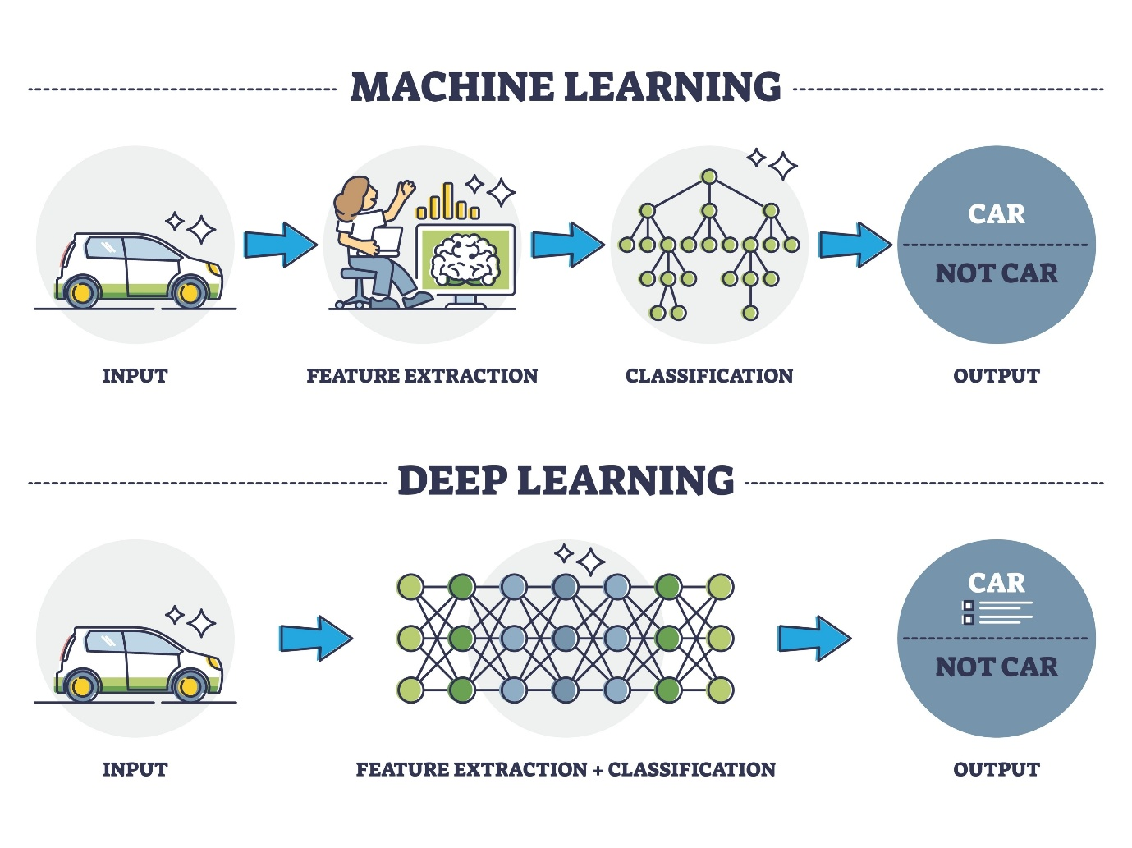
Shutterstock
3. Model Training (The "AI Brain")
We use the Random Forest Classifier. It’s like a committee of decision trees that vote on whether a link is malicious.
@st.cache_resource: This is a Streamlit trick. It ensures the AI only trains once when you start the app, so it doesn't slow down every time you scan a link.
Training Data: We provide a small "Seed List" of safe (0) and malicious (1) examples to teach the AI what patterns to look for.
4. The 1% Sensitivity Logic
This is the core of your "Zero Trust" requirement.
Standard AI: Usually needs 50% certainty to flag a risk.
Your Code: If the AI is even 1% sure that a link looks like phishing, it triggers the "🚨 RISK DETECTED" alert.
Code line: is_risk = prob >= 1.0
5. Streamlit UI & Visualization
The interface is built using Streamlit for the web layout and Plotly for the interactive gauge.
Gauge Chart: It uses go.Indicator to create a visual speedometer.
Color Logic: The risk_color variable dynamically switches the gauge bar to Red if the risk is $\geq 1\%$, providing instant visual feedback to the user.

📂 File Structure Summary
Component | Purpose
st.text_input | Captures the URL from the user.
model.predict_proba | Calculates the mathematical probability of a threat.
st.plotly_chart | Renders the visual Gauge.
st.error/success | Displays the final text verdict.
Would you like me to explain how the Random Forest algorithm specifically makes its decision using those features?

