SIMATS ENGINEERING
SAVEETHA INSTITUTE OF MEDICAL AND TECHNICAL SCIENCES
COMPUTER SCIENCE AND ENGINEERING PROGRAMME
CSA1302 - THEORY OF COMPUTATION
LAB Experiment - 3

Name: Sanjana. G
Reg No: 192511020

QUESTION
1. Write a C program to find ε-closure for all the states in a Non-Deterministic
Finite Automata (NFA) with ε-moves.

1. AIM
To write and execute a C program to find the ε-closure of every state in an NFA with ε-transitions.

2. ALGORITHM
- Start the program.
- Read the number of states and the number of ε-transitions.
- Read each ε-transition as a source state and a destination state.
- Initialize each state's ε-closure to include itself.
- Use transitive reachability to find all states reachable through one or more ε-transitions.
- Display the ε-closure of every state.
- Stop the program.

3. PROGRAM
#include <stdio.h>
int main() {
int n, e, i, j, k, a, b;
int closure[20][20] = {0};
printf("Enter number of states: ");
scanf("%d", &n);
printf("Enter number of epsilon transitions: ");
scanf("%d", &e);
printf("Enter epsilon transitions (from to):\\n");
for (i = 0; i < e; i++) {
scanf("%d %d", &a, &b);
closure[a][b] = 1;
}
for (i = 0; i < n; i++)
closure[i][i] = 1;
for (k = 0; k < n; k++)
for (i = 0; i < n; i++)
for (j = 0; j < n; j++)
closure[i][j] = closure[i][j] ||
(closure[i][k] && closure[k][j]);
printf("\\nEpsilon Closure of each state:\\n");
for (i = 0; i < n; i++) {
printf("E-closure(q%d) = { ", i);
for (j = 0; j < n; j++)
if (closure[i][j])
printf("q%d ", j);
printf("}\\n");
}
return 0;
}

4. OUTPUT
The program was executed with 4 states and 3 ε-transitions: 0 → 1, 1 → 2, and 2 → 3.
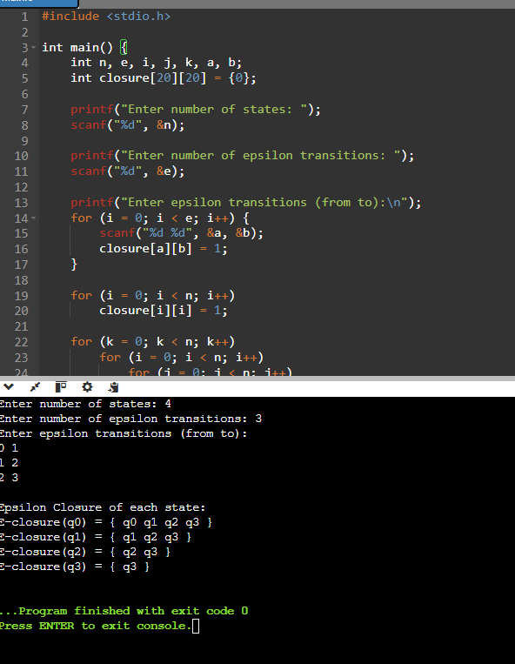

5. RESULT
Thus, the C program to find the ε-closure of all states in an NFA with ε-moves was written and executed successfully.

