Docker Full-Stack Assignment Documentation
Name: Sanjana
Platform: Tutedude - DevOps Assignment

1. Project Links
GitHub Repository: sanjana236g-droid/Docker-Assignment
Docker Hub Frontend Image: 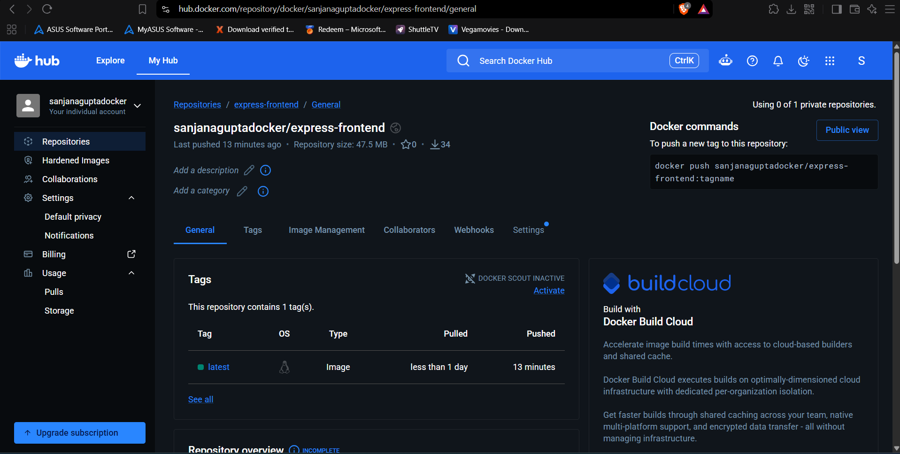

2. Architecture & Explanation

Frontend (Node.js/Express)
The frontend is built using Node.js and Express. It serves HTML templates using EJS. When the user submits the form on the UI, the frontend sends an HTTP POST request to the Flask backend using the Axios library. It is containerized using the 'node:18-alpine' base Docker image to ensure a lightweight and efficient container.
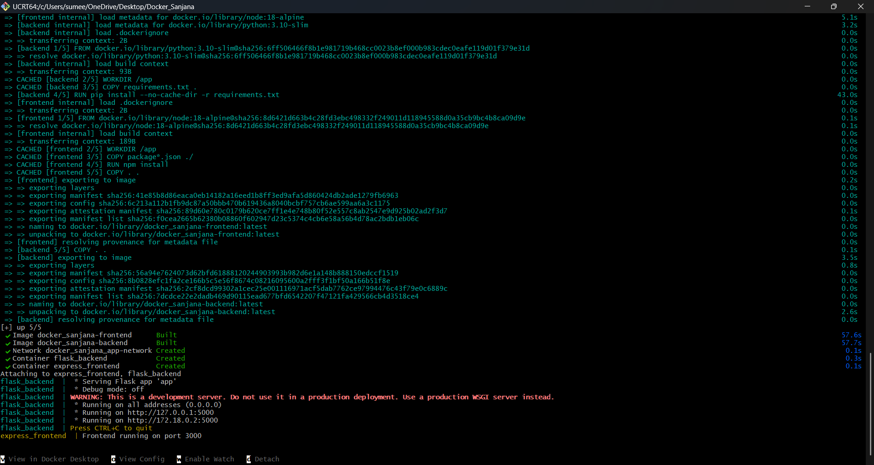

Backend (Flask)
The backend is built using Python and the Flask framework. It provides a RESTful API listening on the '/submit' endpoint. It processes the incoming JSON data from the frontend and returns a formatted success message along with the received data. It is containerized using the 'python:3.10-slim' image.

Docker Compose & Networking
The 'docker-compose.yml' file defines two separate services: 'frontend' and 'backend'. Both containers run securely within a custom bridge network called 'app-network'. The frontend communicates with the backend via the internal Docker DNS using the service name (http://backend:5000). Port 3000 is exposed to the host for the frontend web interface, and port 5000 is exposed for backend API access if needed.

3. Evidence and Screenshots

A. Docker Build and Compose Up

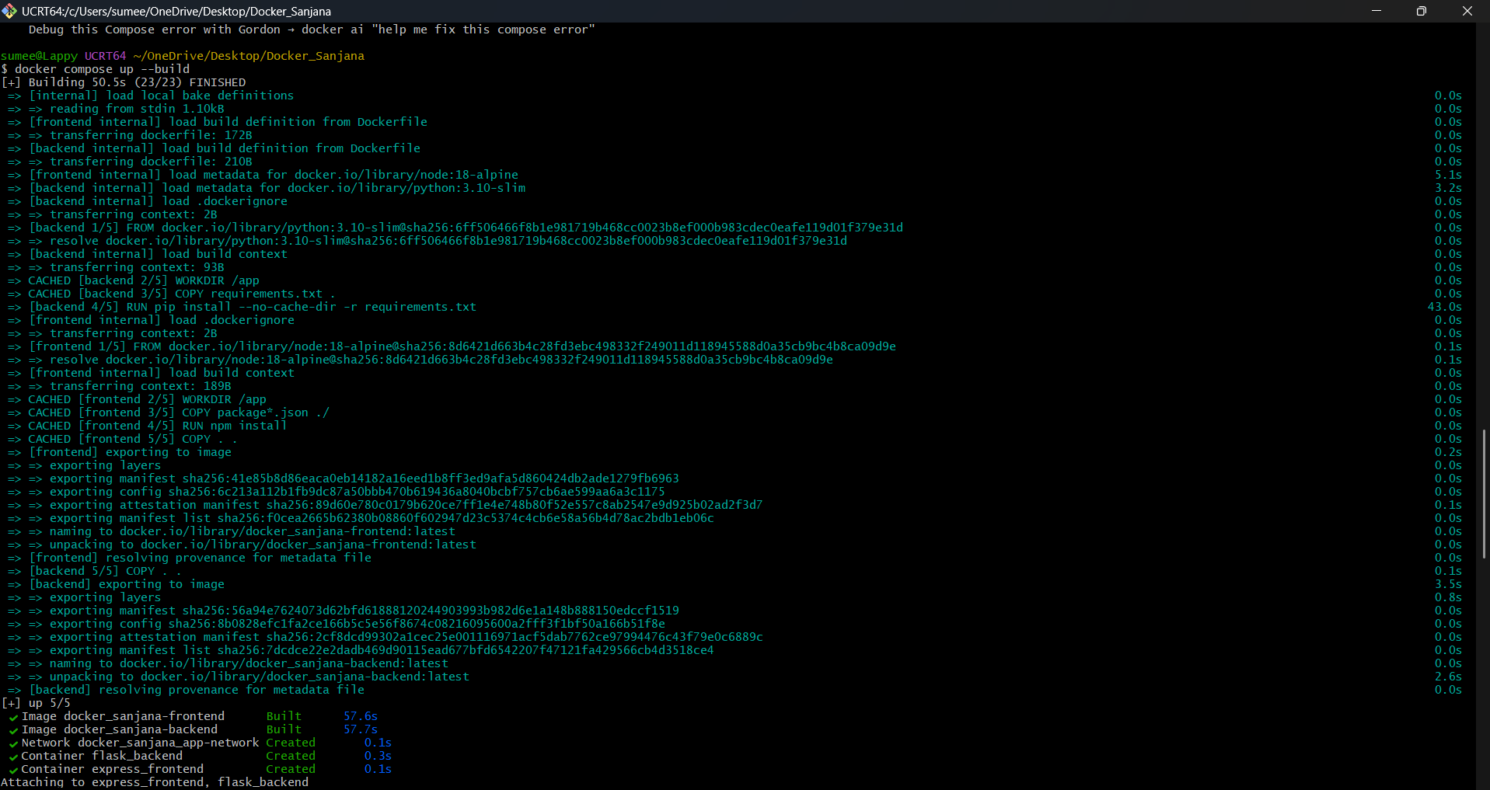B. Application Frontend Running

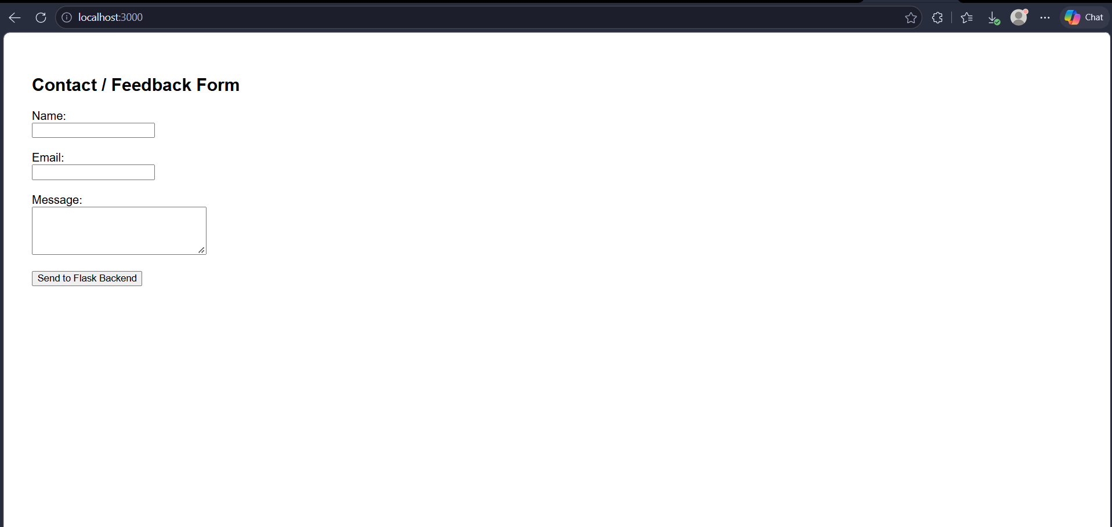

C. Backend Processing Result

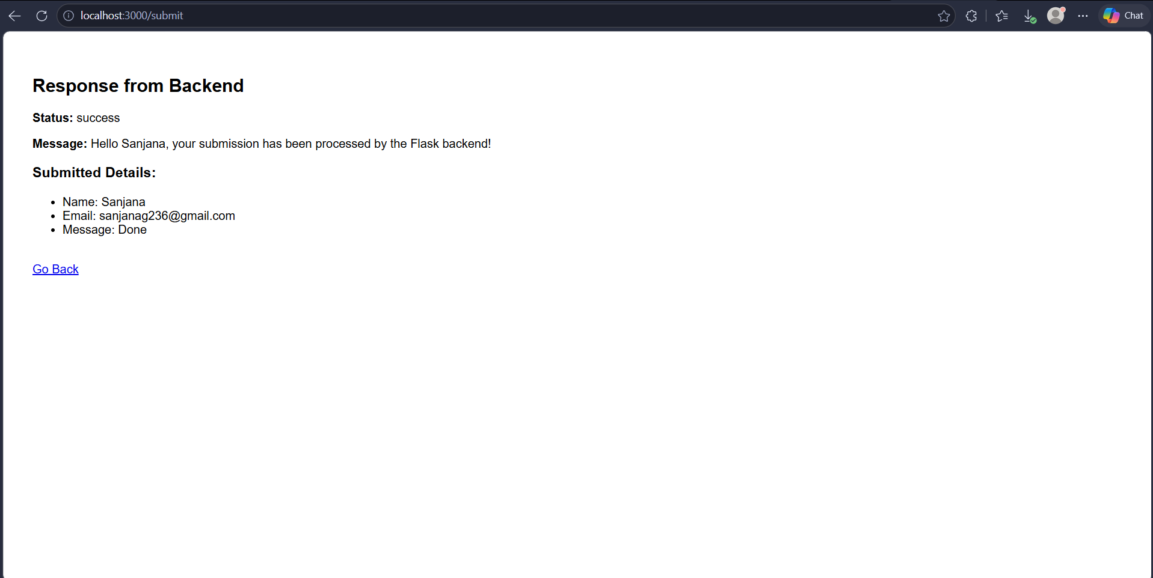

D. Pushed Images to Docker Hub

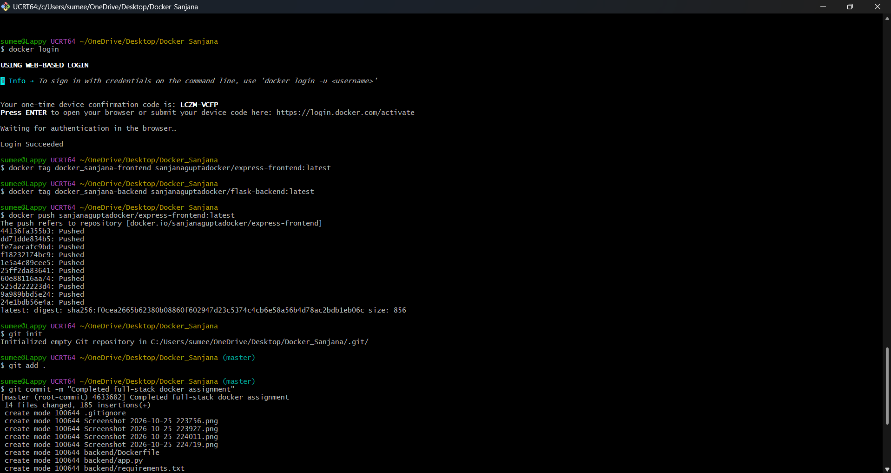

E. Pushed Code to GitHub

