Git & GitHub Assignment Explanation

Submitted by: Sanjana Gupta

Github Repository link:

Task 1: Repository Setup & First Branch
Objective: Initialize the project, use SSH for cloning, and merge a base branch.
Explanation: A new GitHub repository was created and successfully cloned to the local machine using an SSH key. A new branch named after my username was created. The Flask project files (such as app.py and requirements.txt) were staged, committed, and finally merged into the main branch.
Commands Executed:
git clone git@github.com:[username]/Git_and_GitHub_Sanjana.git
cd Git_and_GitHub_Sanjana
git checkout -b sanjana236g-droid
# (Add project files to directory)
git add .
git commit -m "Initial commit with Flask files"
git checkout main
git merge sanjana236g-droid
git push origin main
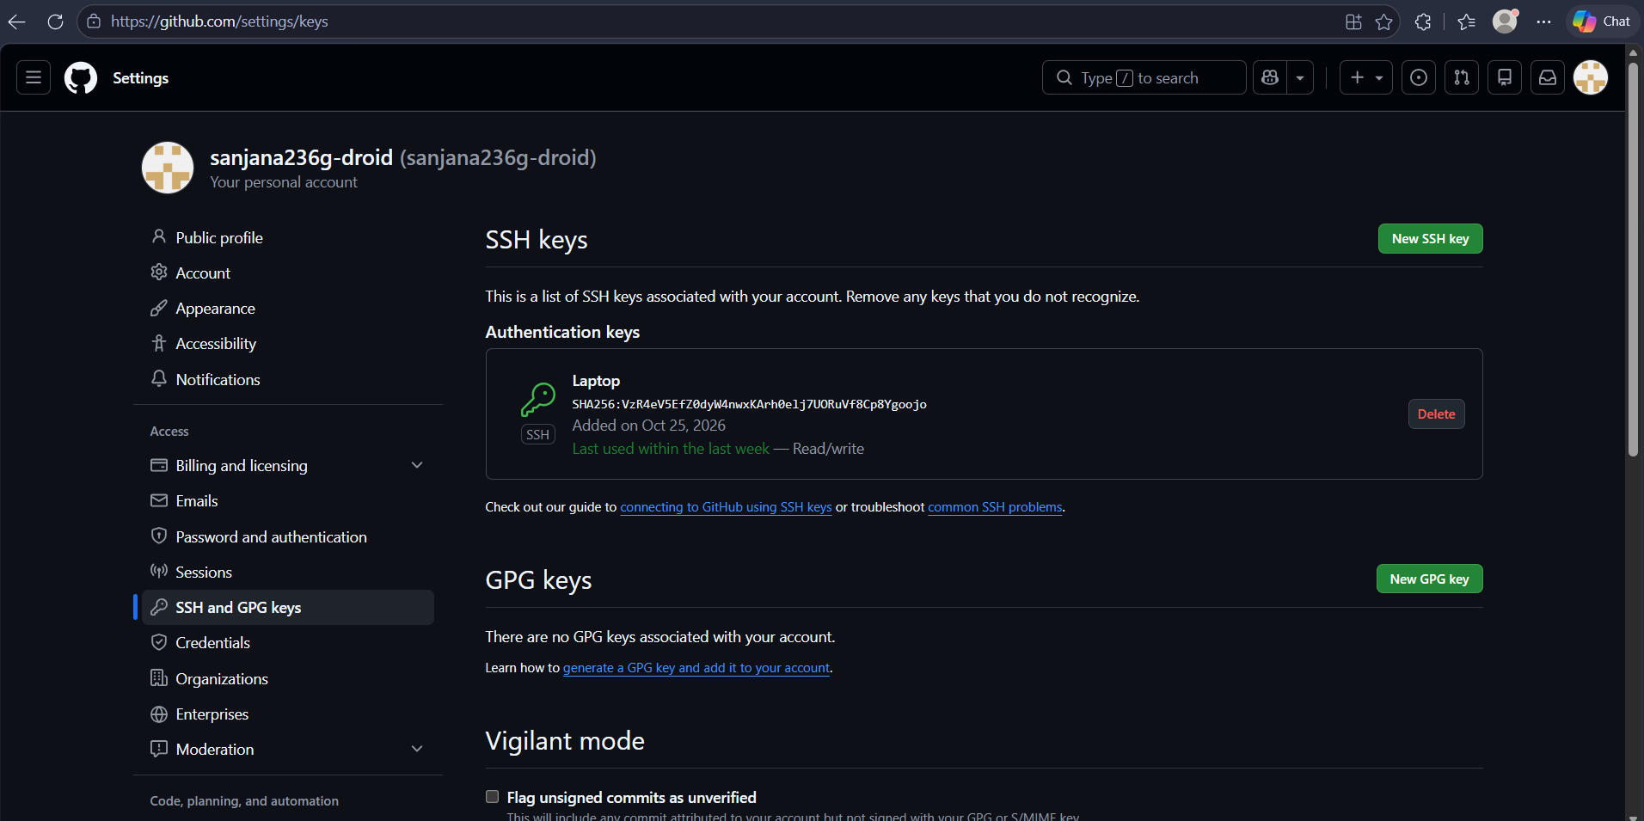

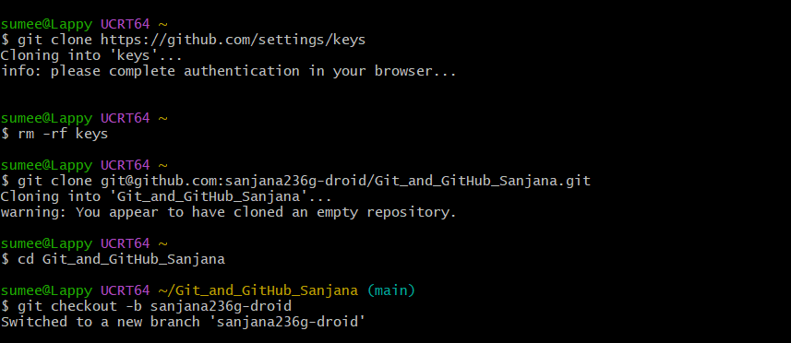

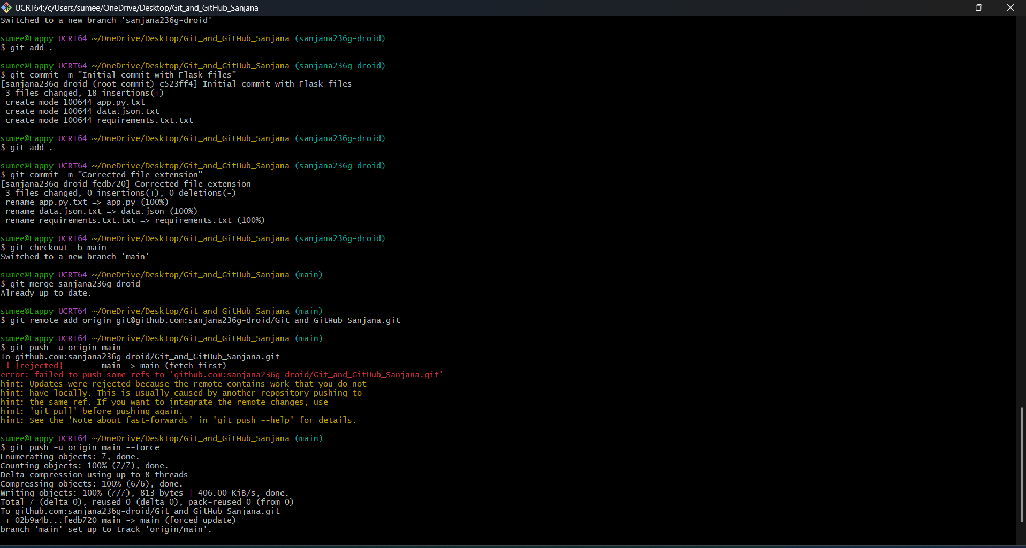
--------------------------------------------------

Task 2: Update JSON & Resolve Conflicts
Objective: Create a new branch, update JSON data, and resolve conflicts during merge.
Explanation: A new branch named _new was created. The JSON data file associated with the /api route was updated. During the merge back into the main branch, Git flagged conflicts. These were manually resolved by accepting the changes from the _new branch. The resolved files were then staged, committed, and pushed to GitHub.
Commands Executed:
git checkout -b sanjana236g-droid_new
# (Update JSON file for /api route)
git add data.json
git commit -m "Updated JSON content for Task 2"
git checkout main
git merge sanjana236g-droid_new
# (If conflicts occur, resolve them manually in the editor)
git add data.json
git commit -m "Resolved merge conflicts for JSON update"
git push origin main
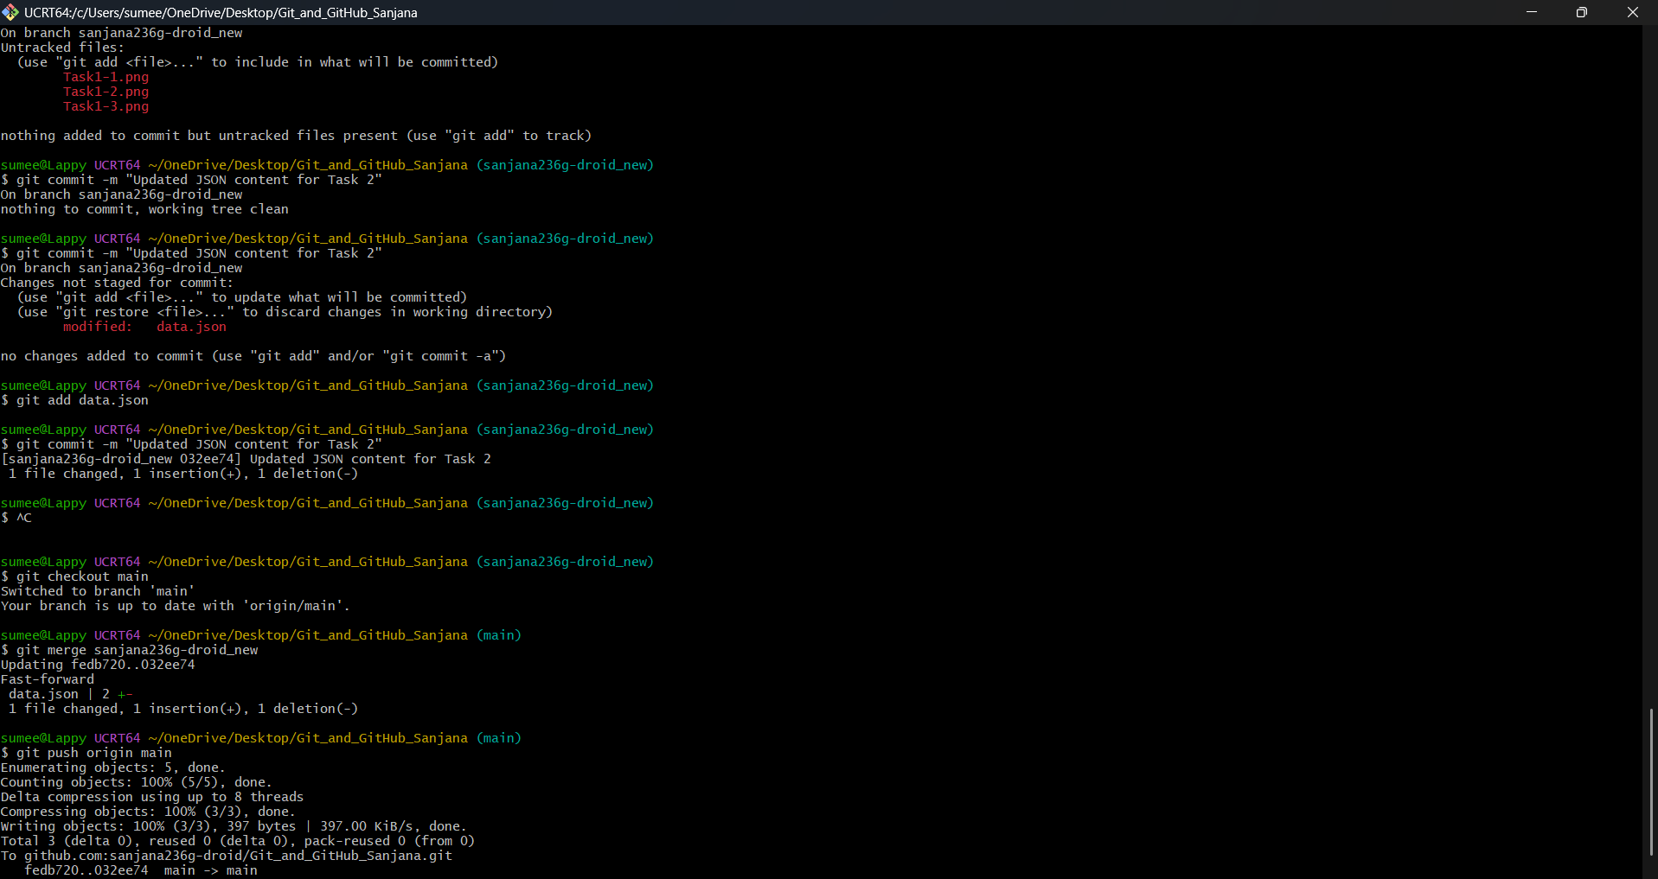

--------------------------------------------------

Task 3: Parallel Feature Development
Objective: Develop a frontend and backend concurrently in separate branches and merge both.
Explanation: Two feature branches, master_1 and master_2, were created from main. On master_1, the To-Do frontend (todo.html) was built with "Item Name" and "Item Description" fields. On master_2, the Flask backend route (/submittodoitem) was added to app.py to connect and insert data into MongoDB via a POST request. Both branches were successfully merged into main one after the other.
Commands Executed:
# Frontend Development
git checkout -b master_1
# (Develop todo.html)
git add templates/todo.html
git commit -m "Added To-Do frontend form"
# Backend Development
git checkout main
git checkout -b master_2
# (Develop /submittodoitem route in app.py)
git add app.py
git commit -m "Added backend route and MongoDB connection"
# Merging both
git checkout main
git merge master_2
git merge master_1
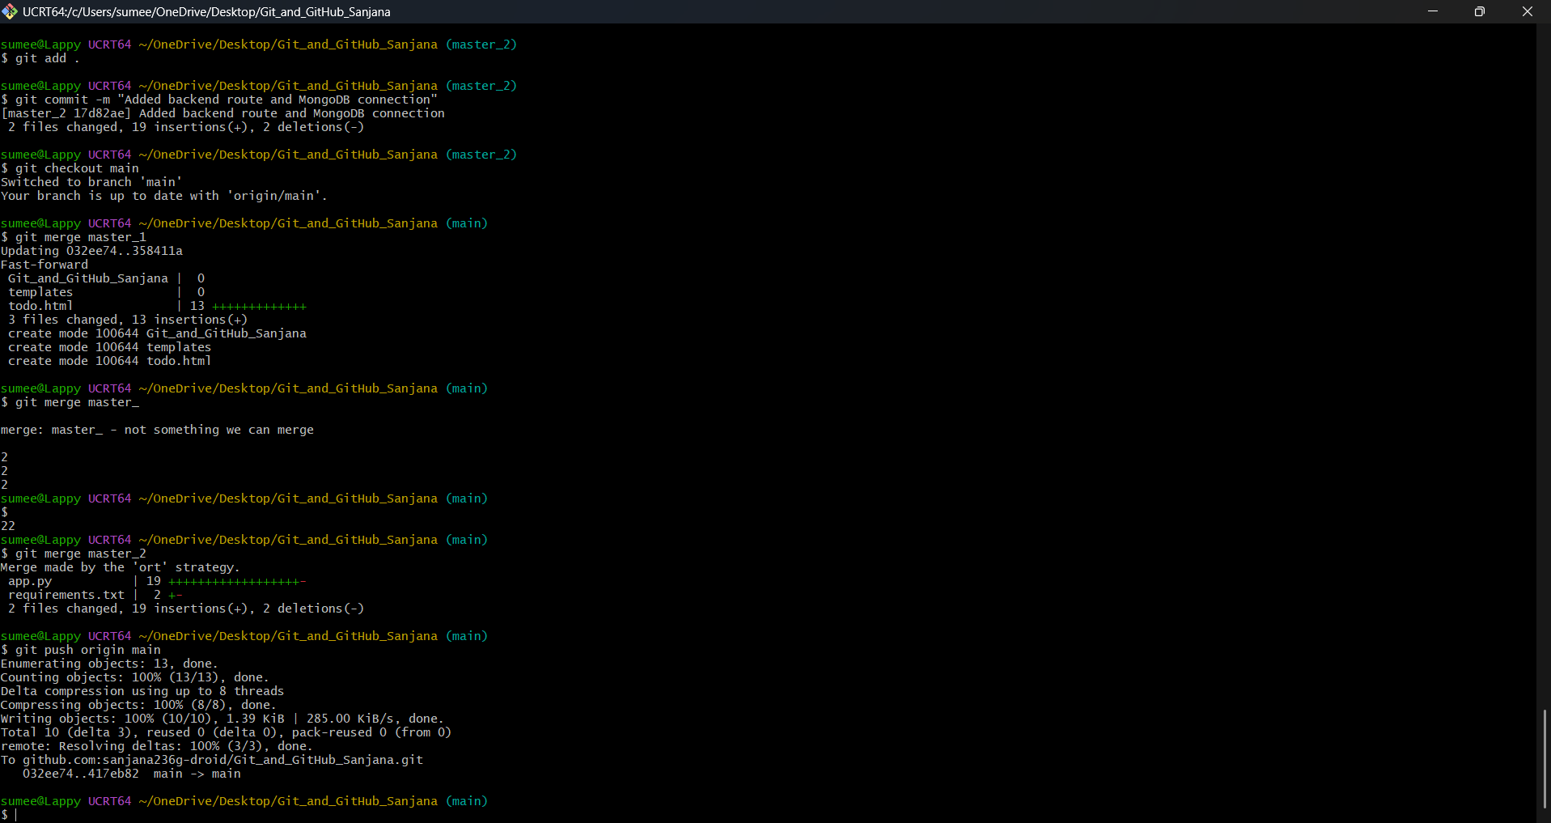
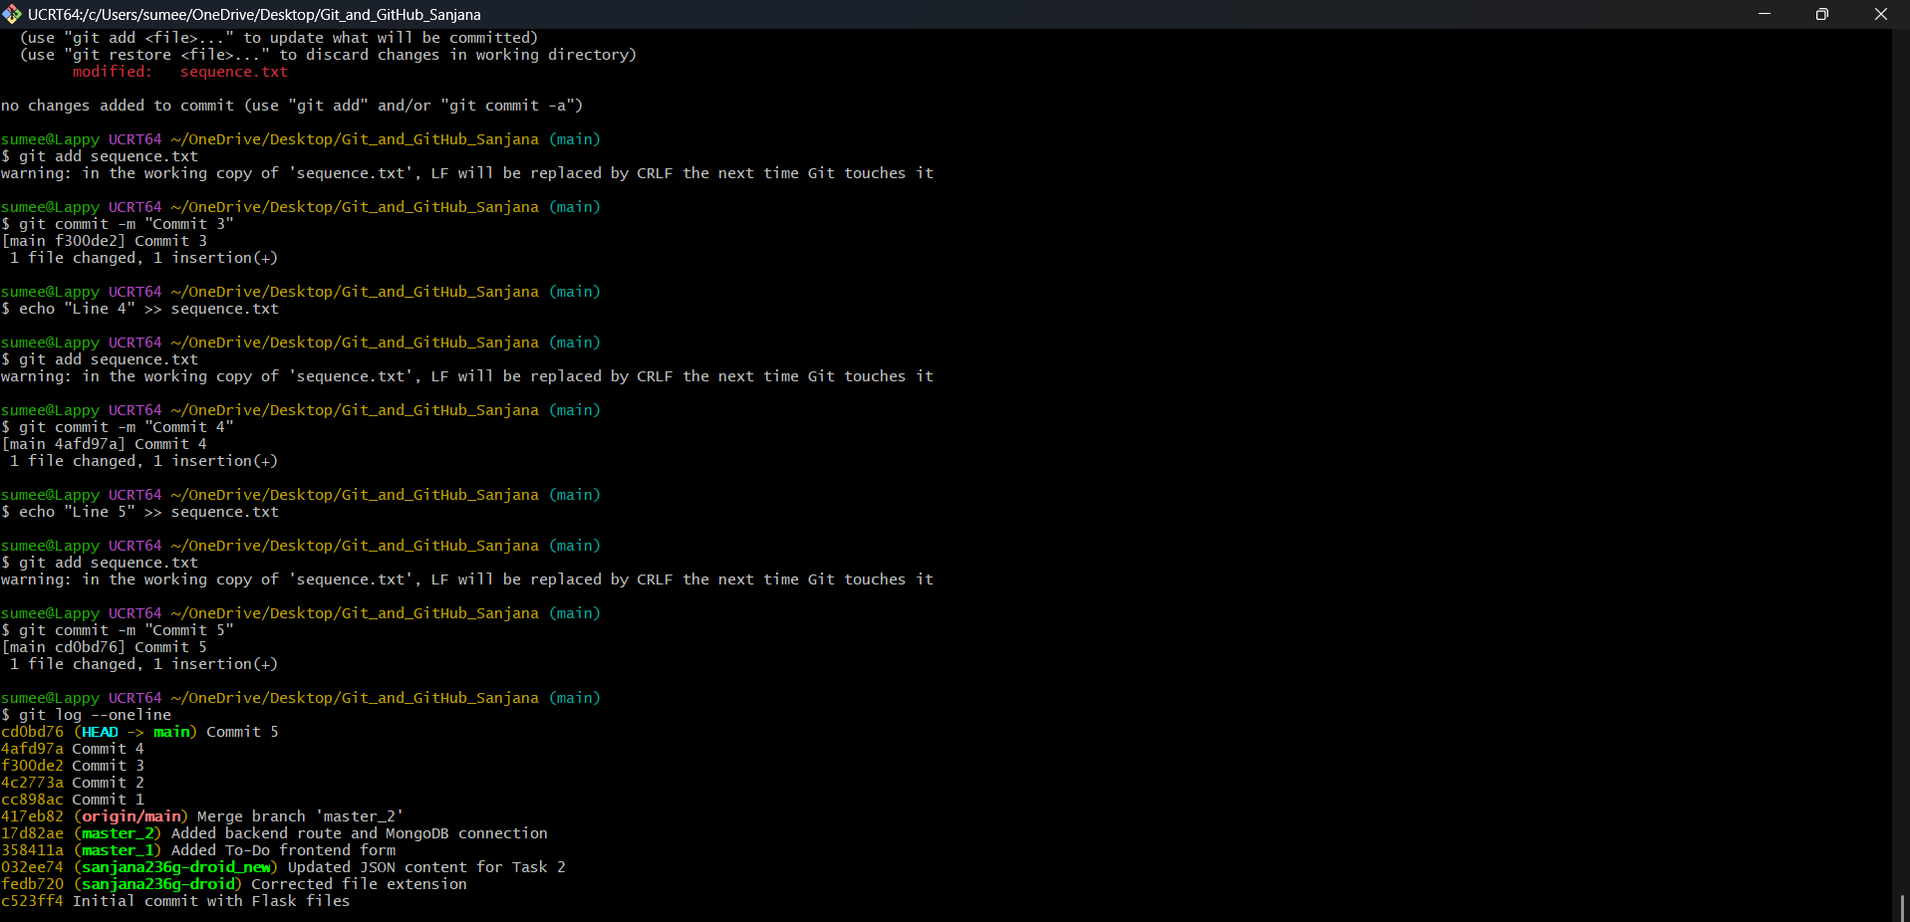
--------------------------------------------------

Task 4: Sequential Commits, Reset & Rebase
Objective: Demonstrate granular commits, soft resets, and interactive rebasing to manipulate history.
Explanation: On the master_1 branch, three new form fields (Item ID, Item UUID, Item Hash) were added. Each field was committed individually to create a sequence. After merging master_1 into main, a `git reset --soft` command was used to roll the main branch back to the commit containing only the Item ID field. The remaining staged changes were bundled into a new unified commit. Finally, the main branch was rebased onto master_1 (`git rebase main master_1`) to synchronize the timelines. This required manual resolution of HTML structure conflicts at each rebase step to strictly preserve the individual commit history of the master_1 branch.
Commands Executed:
git checkout master_1
# (Add Item ID field in VS Code)
git add .
git commit -m "Added Item ID field"
# (Add Item UUID field in VS Code)
git add .
git commit -m "Added Item UUID field"
# (Add Item Hash field in VS Code)
git add .
git commit -m "Added Item Hash Field"
git checkout main
git merge master_1
# Soft Reset & Unified Re-commit
git reset --soft 72d109d # Commit hash of Item ID
git commit -m "Added UUID and Hash fields"
# Rebasing
git rebase main master_1
# (Conflict 1: Resolved manually in todo.html, saved)
git add .
git rebase --continue
# (Conflict 2: Resolved manually in todo.html, saved)
git add .
git rebase --continue
git push -f origin master_1



