Linux Basics - Assignment Documentation
Name: Sanjana Jitendra Gupta
GitHub Repository Link:

Task 1: Creating and Renaming Files/Directories
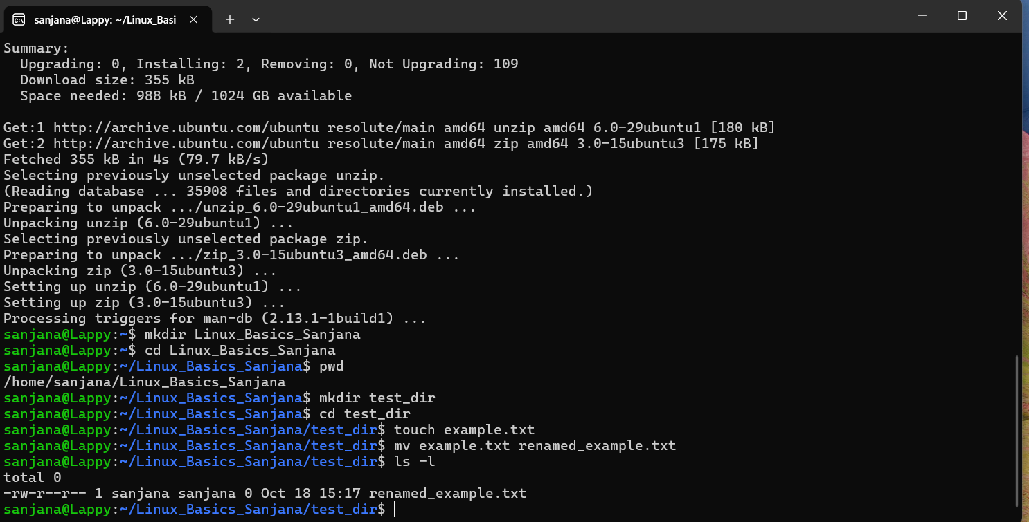
Explanation: In this task, I created a new directory named test_dir using the mkdir command. I navigated into it, created an empty file named example.txt using the touch command, and then successfully renamed that file to renamed_example.txt using the mv command.

Task 2: Viewing File Contents
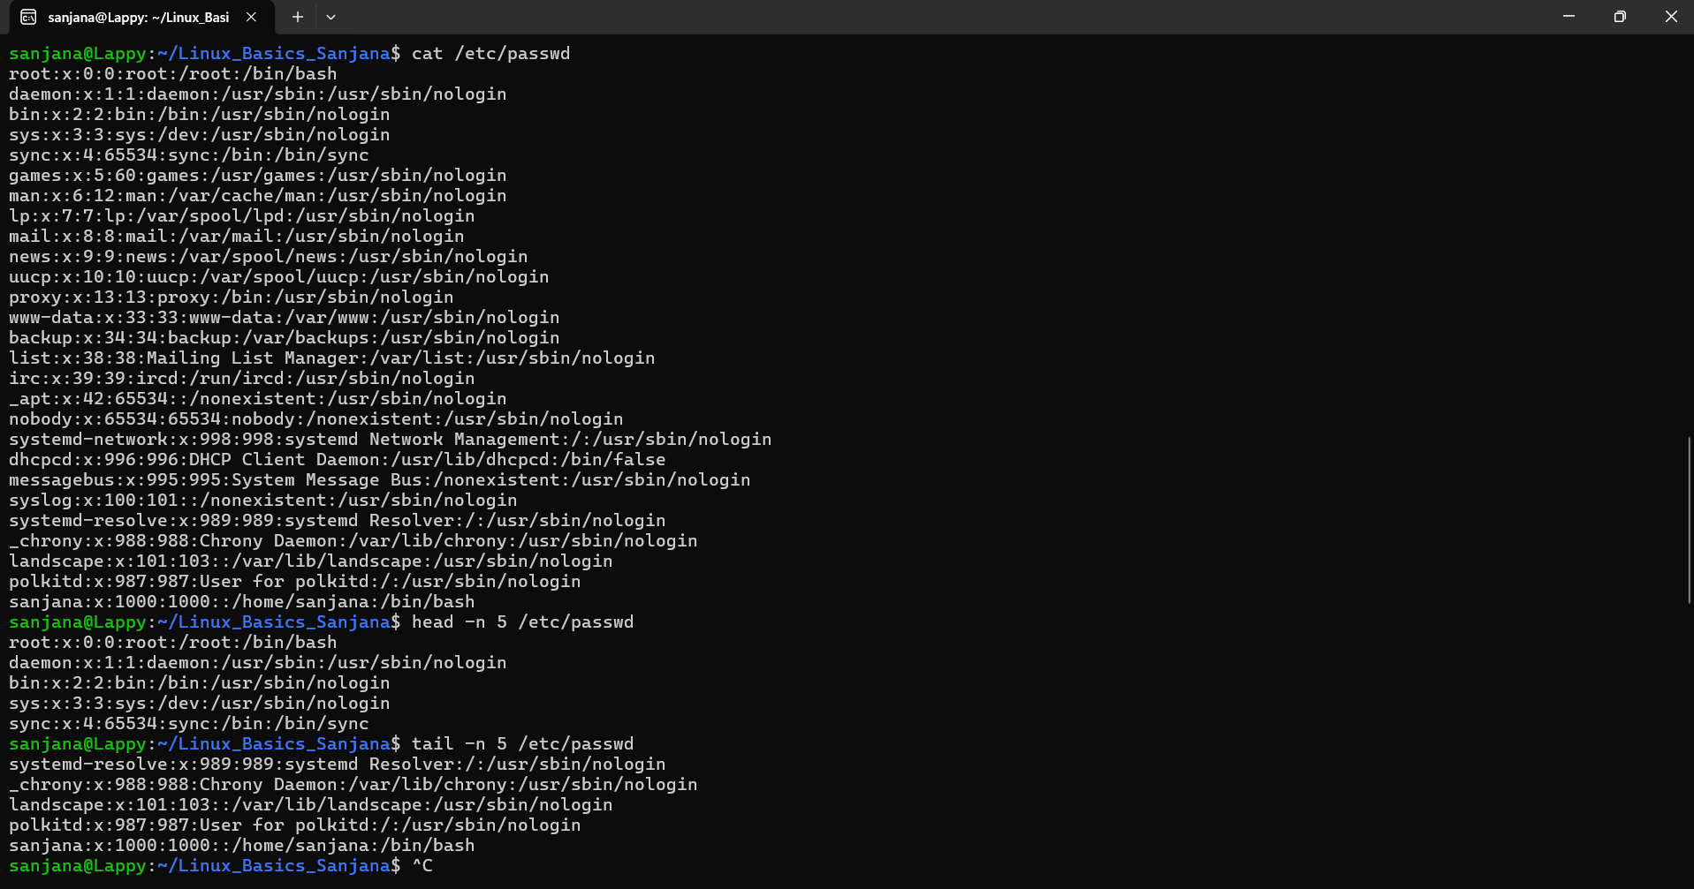
Explanation: I used the cat command to output the entire contents of the /etc/passwd file to the terminal. Following that, I used the head -n 5 command to display only the first 5 lines of the file, and the tail -n 5 command to display only the last 5 lines.

Task 3: Searching for Patterns
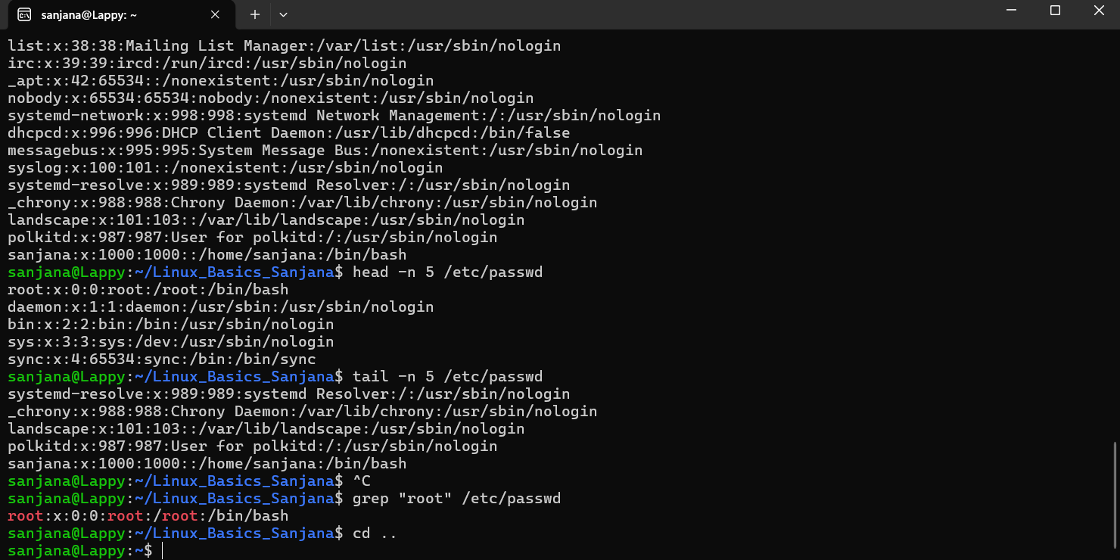

Explanation: I used the grep command to search for the specific word "root" inside the /etc/passwd file. The terminal successfully filtered the document and printed only the lines containing that exact pattern.

Task 4: Zipping and Unzipping
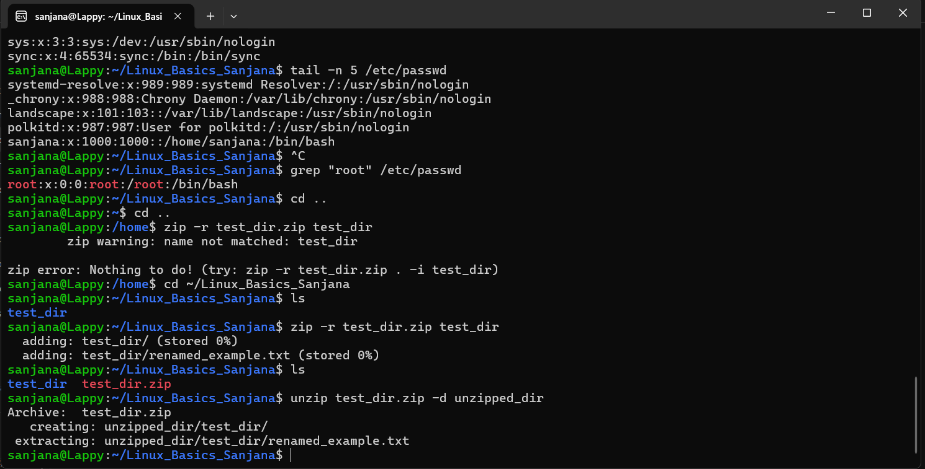
Explanation: First, I compressed the test_dir directory into a zip archive named test_dir.zip using the zip -r command. Next, I extracted the contents of that zip file into a completely new directory called unzipped_dir using the unzip command.

Task 5: Downloading Files
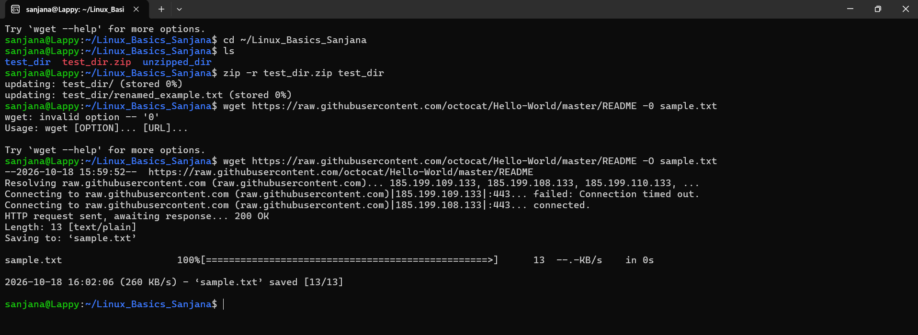

Explanation: I used the wget command to download a sample text file directly from a web URL to my local directory via the command line.

Task 6: Changing Permissions
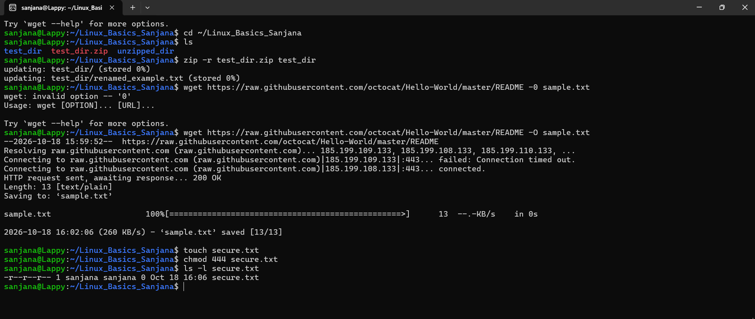

Explanation: After creating a new file named secure.txt, I used the chmod 444 command to modify its permissions, making it read-only for everyone (owner, group, and others).

Task 7: Working with Environment Variables
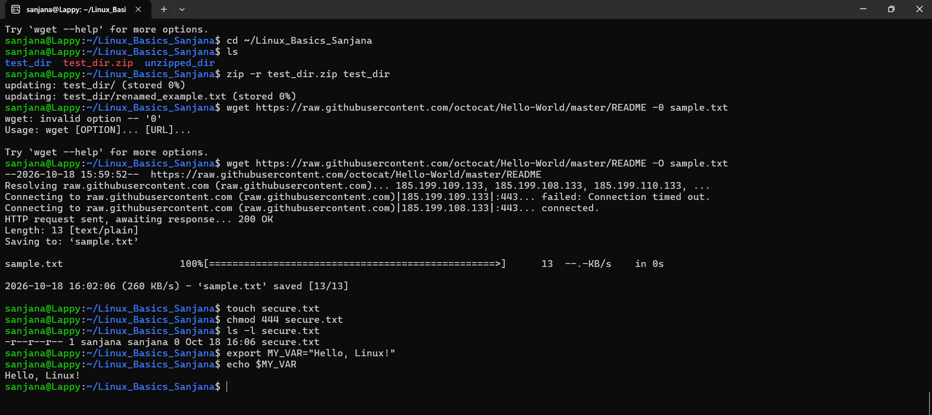
Explanation: I used the export command to create a new system environment variable named MY_VAR and assigned it the text value "Hello, Linux!". I then used the echo command to call the variable and verify that the text was stored correctly.

