# **GCP – VM Setup with Jupyter**

**Step 1. Create or log in to a GCP account**

* You must have an account in [google cloud platform](https://console.cloud.google.com/home/dashboard?project=wise-scene-227111) with which all the billing will be carried with it.
* You can also create a free tier account [here](https://cloud.google.com/free/) and receive $300 GCP credits to spend on Google Cloud Platform over the next 12 months.

**Step 2. Create or select a GCP project**

* In order to setup an instance, you need to select or create a project in GCP. Creating a project is simple, here’s how:



**Step 3. Setup a VM instance**

* In a new project, you must enable billing to use Compute Engine Service. Go to Compute Engine > VM instance and click “Enable billing”.



* Click “Create” to create a new VM instance with the configurations below:
* Instance Name: <Name your instance>
* Select your nearest region and zone.
* Region: asia-south1 (Mumbai)
* Zone: asia-south1-c
* Machine Type: select “8 vCPUs 30 GB memory, n1-standard-8 (You can increase the memory as per your need)
* Boot Disk: Ubuntu 16.04 LTS
* Boot disk type: Standard Persistent disk
* Size (GB): 10
* Keep “Identity and API access” as default.
* Firewall: Click the checkbox to allow both HTTP and HTTPS traffic.
* Click “Management, security, disks, networking, sole tenancy” to expand and go to Disks section.
* Uncheck “Delete boot disk when the instance is deleted” deletion rule.
* Click on the “Create” button.
* Now your instance is ready!

***Note****: When you are not using your instance, you can stop your instance to save money. You can stop your instance by clicking Stop present under three dots menu.*

**Step 4. Make External IP as Static**

* In order to access the Jupyter notebook, we need to make External Ip as static.
* Go to Networking > VPC Network > External IP addresses.
* You will see an external IP address of your instance, change the type from Ephemeral to Static.
* You will see a popup window where you need to provide a name for the new static IP address and click Reserve.

**Note:** Make a note of your external IP address, you will require it later.

**Step 5. Create Firewall Rules**

* On the same path, click Firewall rules (Networking > VPC Network > Firewall rules) and Click “CREATE FIREWALL RULE” with below configuration:
* Name: <Enter a firewall name>
* Targets: All instances in the network
* Source IP ranges: 0.0.0.0/0
* Protocols and ports: Select “Specified protocols and ports” option.
* tcp: 8888 <You can change any other port number>
* Keep other configuration as default.
* Click on the Create button.



**Step 6. Install Anaconda in your VM instance**

* Go to your VM instance (Compute > Compute Engine > VM instance) and click on SSH button of your instance.

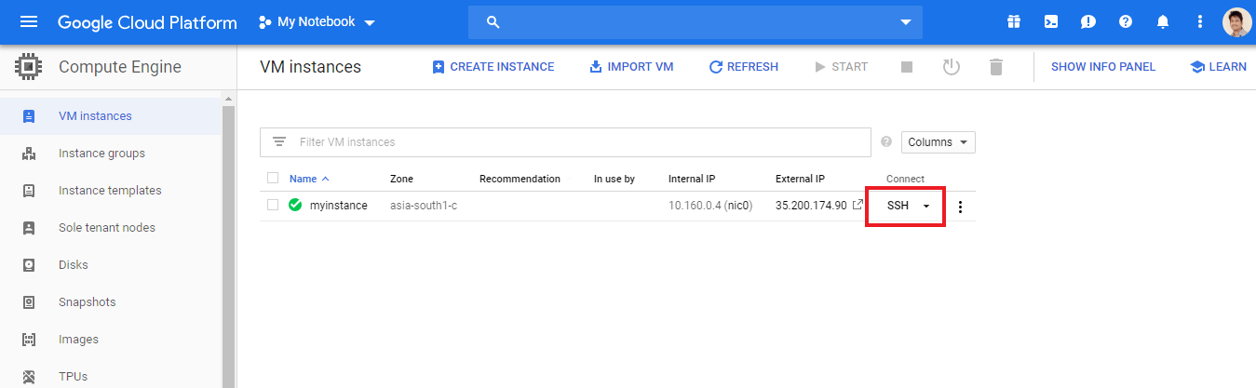

* In your SSH terminal, enter the commands below one by one:

wget https://repo.continuum.io/archive/Anaconda3-4.2.0-Linux-x86_64.sh

bash Anaconda3-4.2.0-Linux-x86_64.sh

* Now follow the on-screen instructions and choose yes for question – Do you wish the installer to prepend the Anaconda3 install location to PATH in your /home/haroldsoh/.bashrc ?[yes|no][no]
* Enter the commands below and install the other software:

source ~/.bashrc

pip install tensorflow

pip install keras

**Step 7. Setup the VM server**

* Enter the commands below to create and configure the Jupyter configurations files:

jupyter notebook --generate-config

vi ~/.jupyter/jupyter_notebook_config.py

* Press “i” to insert and add the following lines in the configuration file:

c = get_config()

c.NotebookApp.ip = '*'

c.NotebookApp.open_browser = False

c.NotebookApp.port = 8888

**Note:** You can change the port number. I have chosen the 8888 port here.

* Once you are done with making changes, press Esc and type “:wq” to save and exit from the file.

**Step 8. Launch Jupyter Notebook**

* Run the command below:

jupyter notebook

* Now, you can launch the notebook in your browser

http://<external-ip-address>:enter< your port number without angular brackets>