# Weekly Project Meeting Minutes

*The main purpose of the document is to capture all the work that has been done by the group over the course of one week and* ***not*** *to write down what was discussed in a single meeting. You should be meeting and/or working throughout the week*.

Time group spent on project: 5-6 Hours

Group Number: 02

Group members present (Name, ID):

* Sanjana Reddy Patlolla (0736615)
* Sai Prudvi Adusumalli (0734178)
* Pradeep Kumar Kolisetty (0734185)

Specific Activities from prior week:

* List brief description of activities carried out **by group member**
* Sanjana and Prudvi cleaned the data removed unwanted columns in our dataset.
* Prudvi and Pradeep has gone through different articles to learn different models to apply on our dataset.

Specific Output from prior week:

* Include brief summary of any written work, experiments, or code developed
* We now have the data ready to work on jupyter notebook. We have applied SVR model on our data and got output from SVR model. We have results of both train and test accuracies.
* Attach actual output as a separate file when submitting minutes; for example, export your Jupiter notebook as an html file and upload that with your minutes
* We have now data ready to work on Jupiter notebook.

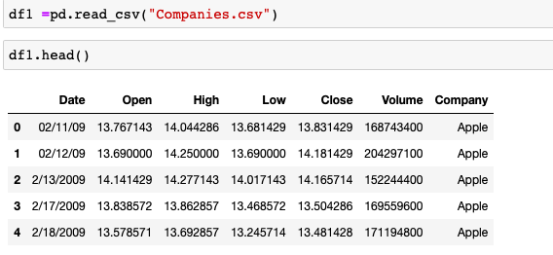

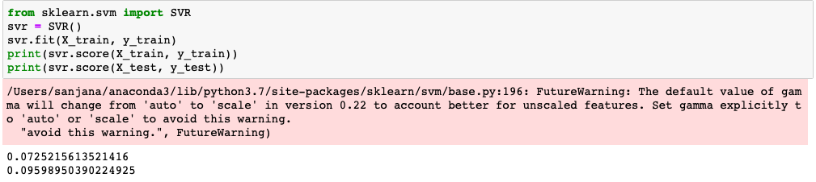

On Target:

* Indicate the current status of your project
  + _____ green: everything on track for completion by due date

Challenges/Disagreements:

* List any particular challenges identified/discussed and possible solutions
  + While working on jupyter notebook we have faced some challenges. When we try to read our data, it was in another format, using a letter r in read.csv command which helps to convert the format in required form.
* List any notable disagreements and subsequent discussion and resolution
* After loading our dataset, when we were using Support vector machine algorithm, we had to convert string to float and there are values in our data which are continuous which we have to sort out.

Planned Activities for coming week:

* List brief description of activities **by group member**
* The next tasks for upcoming week after loading our data into jupyter notebook and applying different machine learning models we have to look at the outputs for best accuracies.
* Sanjana and Prudvi will work on learning NLP package to work on our data from websites.
* Pradeep will be working on the Jupiter notebook.
* **LITERATURE REVIEW**
* [1] Darmadi Komo, Chein-I Chang, Hanseok KO, “Neural Network Technology for Stock Market Index Prediction”, International Symposium on Speech, Image Processing and Neural Networks, 13-16 April 1994
* [2] Hu, Zhen & Zhu, Jie & Tse, Ken. (2013). Stocks market prediction using Support Vector Machine. 115-118. 10.1109/ICIII.2013.6703096.
* [3] Dase R.K. and Pawar D.D., “Application of Artificial Neural Network for stock market predictions: A review of literature”, International Journal of Machine Intelligence, ISSN: 0975–2927, Volume 2, Issue 2, pp-14-17, 2010
* [4] Cao, L.J., Tay, F.E.H.: Financial Forecasting Using Support Vector Machines. J. Neural Compute. Appl. 10, 184–192 (2001)
* [5] D. Ashok Kumar and S. Murugan, “Performance Analysis of Indian Stock Market Index using Neural Network Time Series Model”, International Conference on Pattern Recognition, Informatics and Mobile Engineering (PRIME), IEEE, 978-1-4673-5845-3, 2013