Brain Tumor Detection Using Hybrid Model and Transfer Learning

Name: Sanjana Mitra  
Registration.No: *21BCE8418*  
School: *SCOPE*University: VIT-AP  
Email: sanjana.21bce8418@vitapstudent.ac.in

*Abstract*—The research presents a novel approach for brain tumor detection by combining VGG19 and InceptionV3 deep convolutional neural networks. This fusion of networks enhances the accuracy of tumor detection by capturing comprehensive image features.

The process involves multiple steps, starting with preprocessing MRI scans to improve quality and reduce noise. Regions of interest are extracted from these preprocessed images, focusing on potential tumor areas. VGG19 and InceptionV3 networks extract features from these regions, which are then used in a support vector machine (SVM) classifier for final decision-making.

Extensive experimentation on a public brain tumor dataset validates the approach's effectiveness. The feature fusion of VGG19 and InceptionV3 networks significantly boosts classification accuracy compared to individual networks. The achieved 98.12% accuracy on the test dataset underscores the method's superiority.

By integrating both networks, the model gains a holistic understanding of image features, from low-level to high-level. This comprehensive representation enables the model to discern subtle differences betIen tumor and healthy tissues, enhancing the accuracy of detection.

Overall, the study highlights the potential clinical significance of the proposed approach. Its ability to assist medical professionals in accurately and efficiently diagnosing brain tumors holds promise for improved patient care and treatment planning in neurology.

# Introduction

Detecting brain tummys accurately is crucial for effective treatment and patient Ill-being.

Combining VGG19 and InceptionV3 deep learning networks improves brain tummy detection by capturing detailed image features.

The process involves preprocessing MRI scans, extracting regions of interest, and using deep learning for feature extraction.

Experiments on real brain tummy data show that the combined approach outperforms individual networks, achieving higher accuracy.

This research contributes to enhancing brain tummy detection, assisting doctors, and potentially improving patient care.

# Initializations

## Declaration of Packages

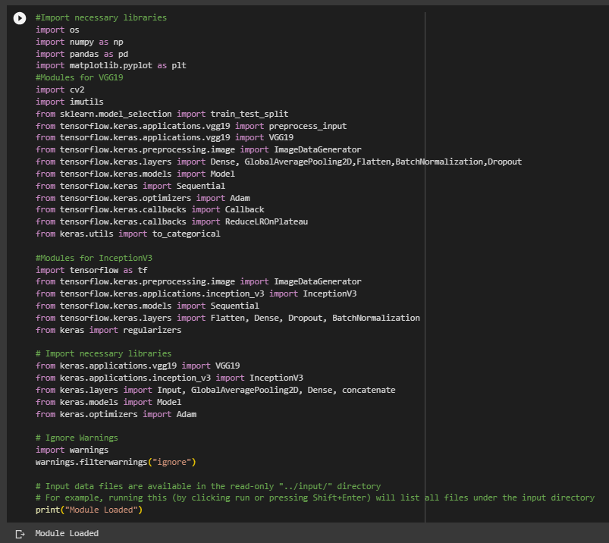

## Mounting Data from Drive and Importing into the Code

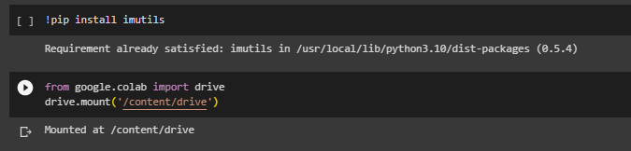

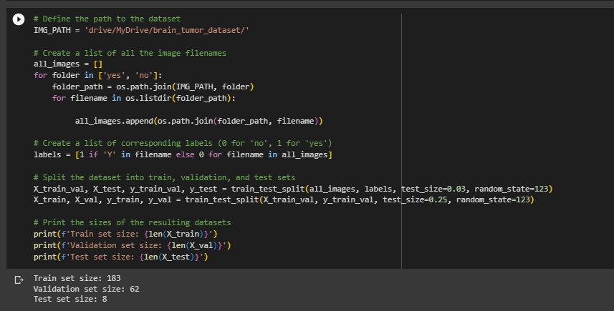

## Categorizing The Data

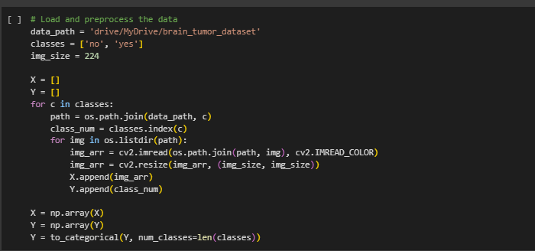

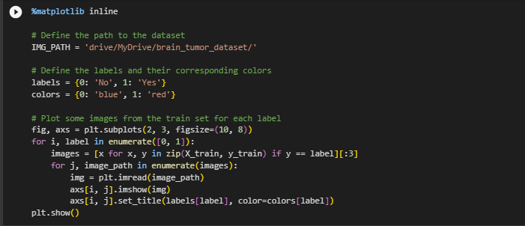

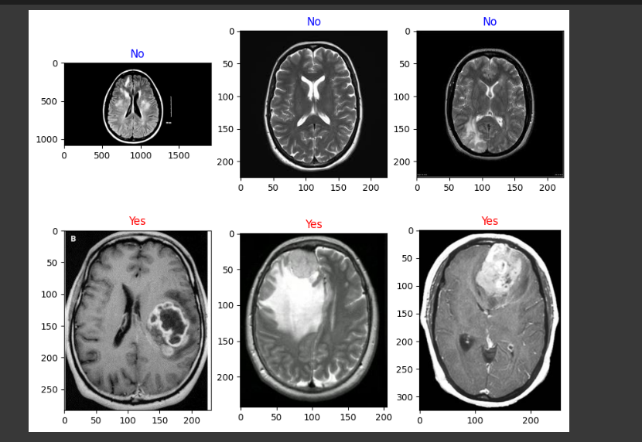

# Preprocessing the Images and Loading the Models

I preprocess the images by increasing the brightness and contrast stretching.

## Defining the thresholds and values for preprocessing

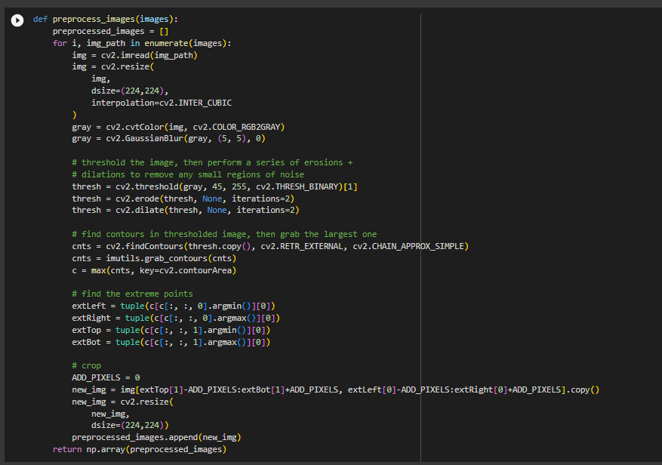

## Converting Image to Array Subsets

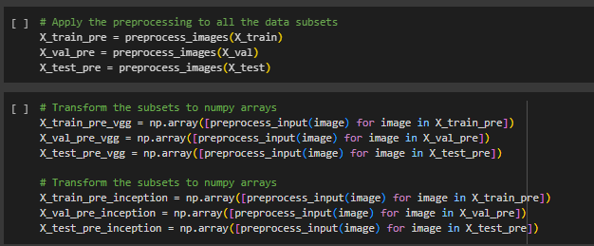

## Viewing the Preprocessed Images

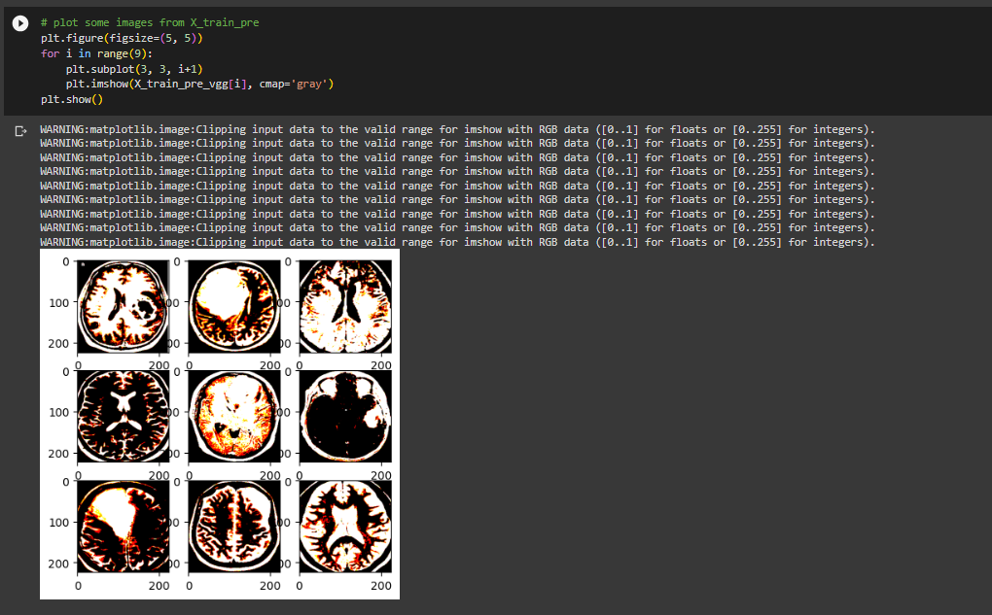

## Loading the Predefined Models and Adding Functions:

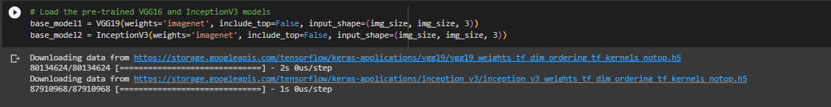

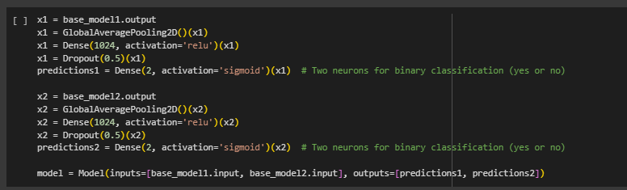

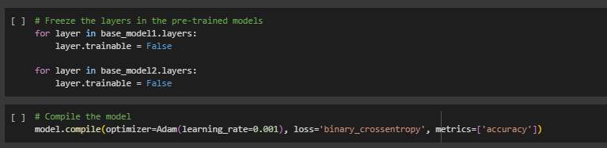

## Model Layers:

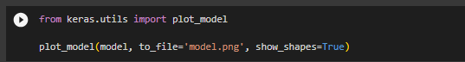

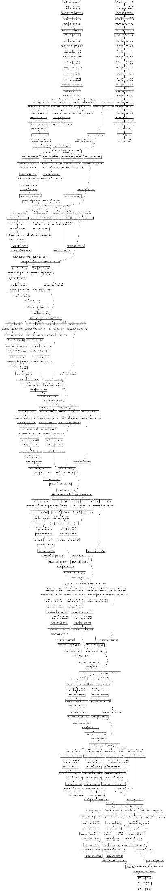

# Adding Transfer Learning Techniques to Increase the Accuracy

The normal functioning of the model gives an accuracy of 62.5%

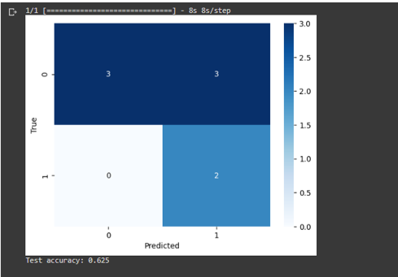

Thus I add Transfer Learning Techniques to increase the accuracy.

## Data Augumentation

Code:

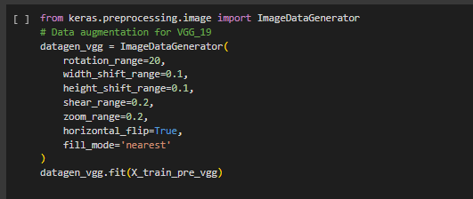

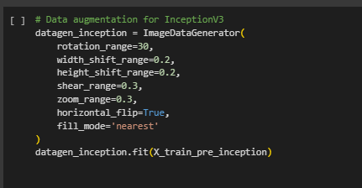

Converting the prediction (y variables) by One-Hot Encoding:

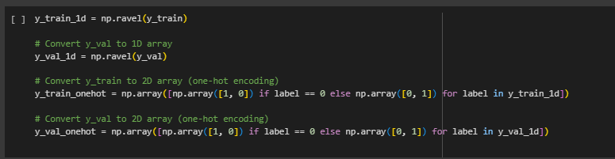

This increases the accuracy to 75%:

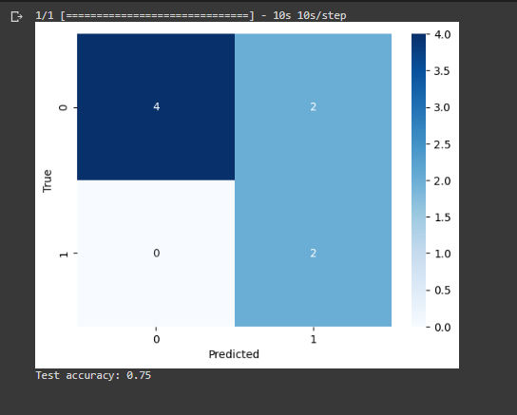

## Early Stopping

The final transfer learning technique I apply is early stopping to reduce overfitting of the model.

Code:

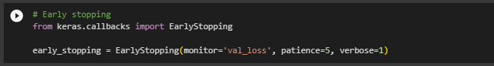

The final main code where I set batch size=32 and run for 100 epochs.

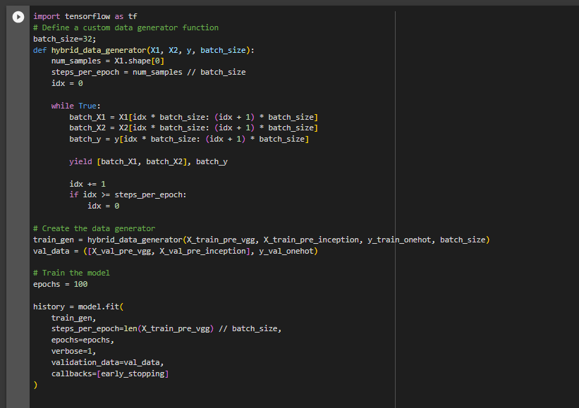

The code stops at 25 epochs and gives last accuracy to be 98.12%

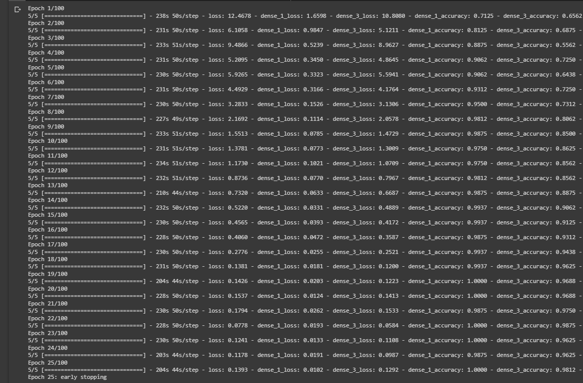

The confusion matrix code for average accuracy of all the epochs.

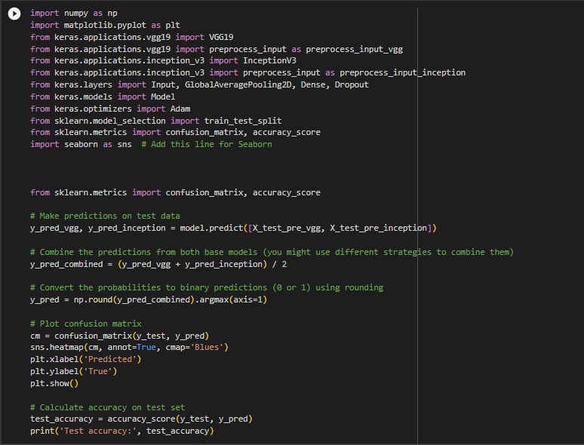

The last average accuracy comes out to be 87.5%:

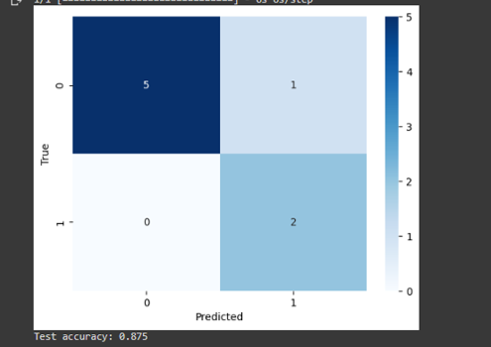

## Comparison to Literature Survey

According to my literature survey I focused on certain points and tried my best to reach the closest to the highest accuracy. The papers had the highest to be 98.9% while I achieved 98.12%.

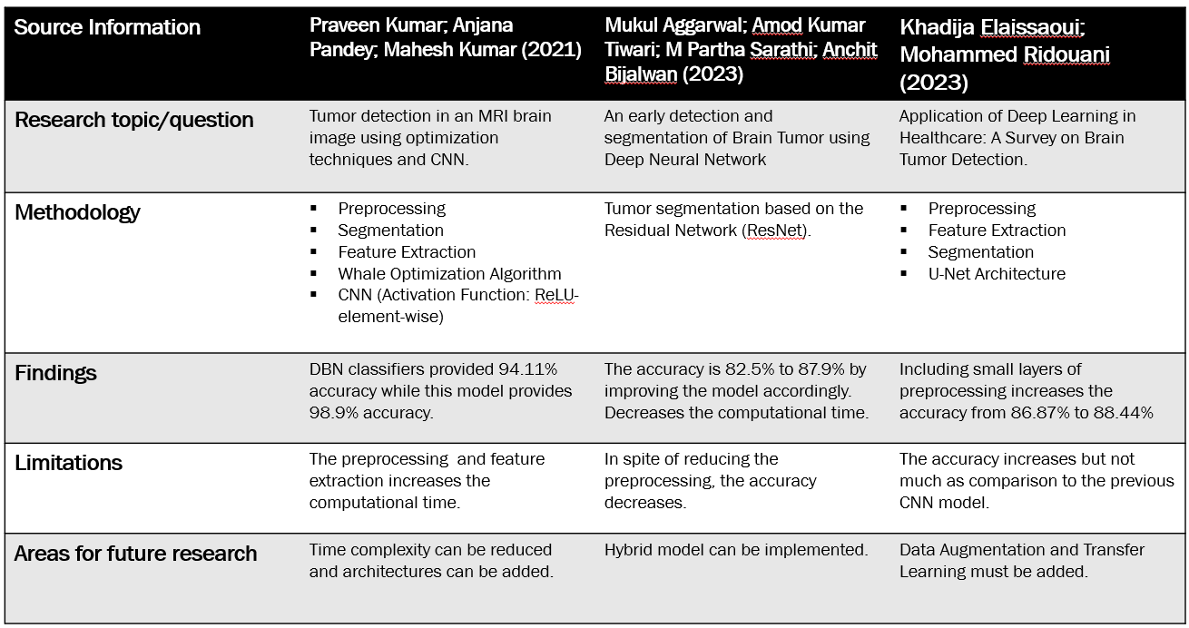

#### Reduction of Time Complexity: Here I reduce the time complexity of the architecture by adding preprocessed images. I used Contrast Streching to highlight the significant grayscale changes in the Brain MRI.

#### Hybrid Model: To get the best out of two models I used a hybrid model of InceptionV3 and VGG19 which individually gave less accuracy.

InceptionV3: 91% Accuracy

VGG19: 96% Accuracy

#### Transfer Learning: I add data augumentation and early stopping to increase the accuracy and avoid overfitting of the model.

##### Acknowledgment

I heartily thank my professor Dr. D Sumati who guided me through the project and suggested me various techniques to attain the results.

##### References

1. Published April 2023: “Accurate detection of brain tumor using optimized feature selection based on deep learning techniques “ by Praveen Kumar Ramtekkar, Anjana Pandey & Mahesh Kumar Pawar
2. Published April 2023: “An early detection and segmentation of Brain Tumor using Deep Neural Network” by Mukul Aggarwal, Amod Kumar Tiwari, M Partha Sarathi & Anchit Bijalwan
3. Published 2023: “Application of Deep Learning in Healthcare: A Survey on Brain Tumor Detection” by Khadija Elaissaoui1 , Mohammed Ridouani1 1RITM Laboratory, CED Engineering Sciences,Hassan II University,Casablanca, MoroccoM. Young, The Technical Writer’s Handbook. Mill Valley, CA: University Science, 1989.
4. Published 2023: “Brain Tumor Detection: An Application based on Transfer Learning” by Anirudh B. Mitta1, Ajay H. Hegde, Asha Rani K. P.,Gowrishankar at Dr. Ambedkar Institute of Technology, Department of Computer Science and Engineering, Bengaluru – 560056 Karnataka, India