Collabdocs
Users:
- Create user : http://127.0.0.1:8000/api/users/
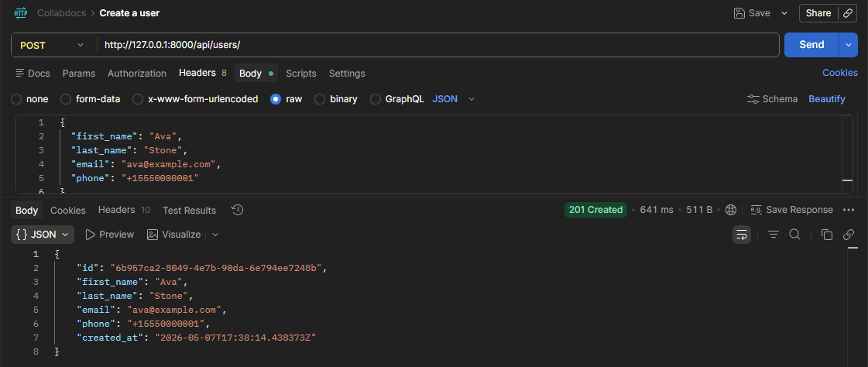
- Get user : http://127.0.0.1:8000/api/users/{{user_id}}/
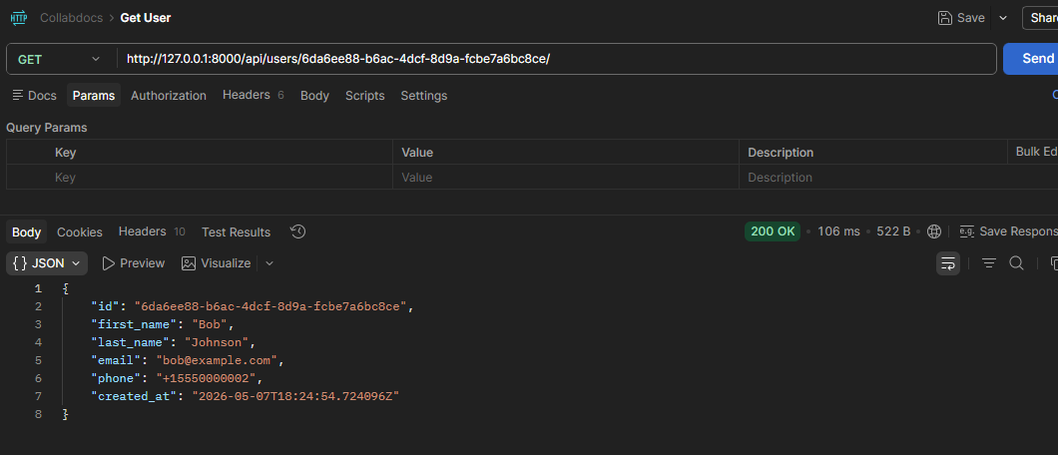

Workspaces:
- Create workspace +auto-add owner as admin member
POST http://127.0.0.1:8000/api/workspaces/ and add header details with user id
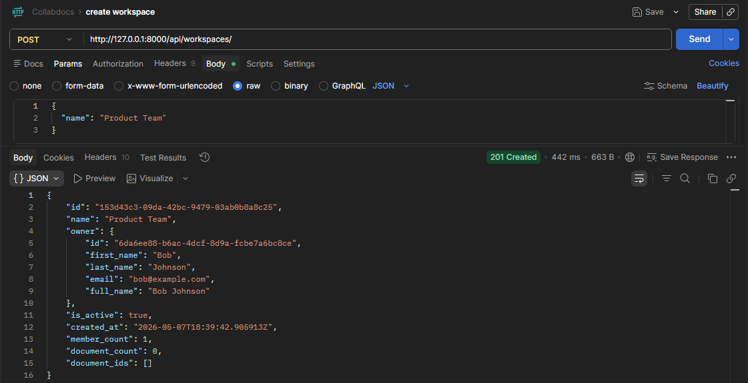
- Get workspace with member count:
http://127.0.0.1:8000/api/workspaces/{{workspaceid}}/
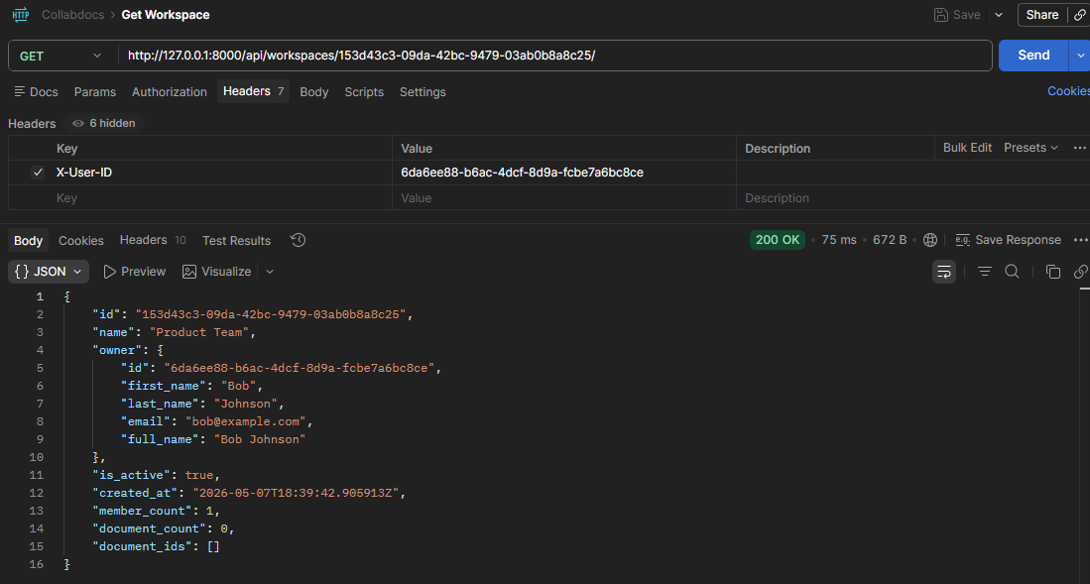

- To add a member to a workspace with a role, use:
POST http://127.0.0.1:8000/api/workspaces/{{workspace_id}}/members/
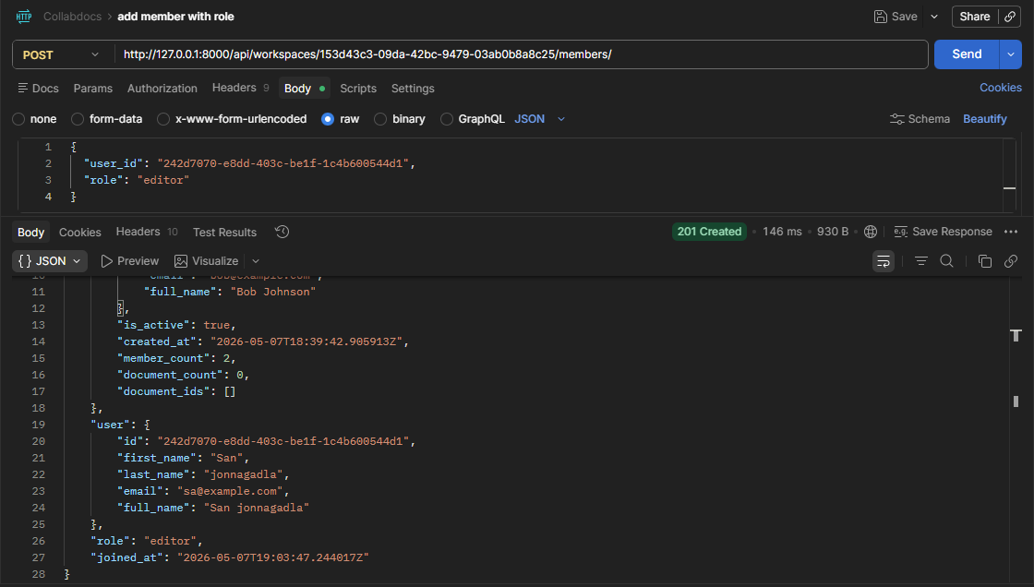
- List all members with their roles
GET http://127.0.0.1:8000/api/workspaces/{{workspace_id}}/members/
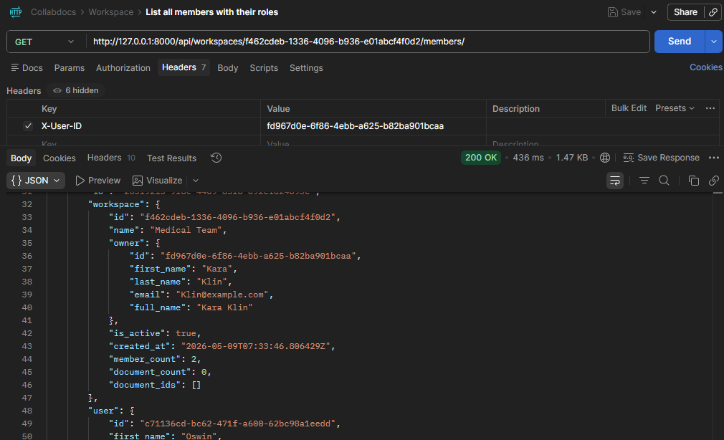

- Doc Count, Member Count, Total Comments
GET http://127.0.0.1:8000/api/workspaces/f462cdeb-1336-4096-b936-e01abcf4f0d2/summary/
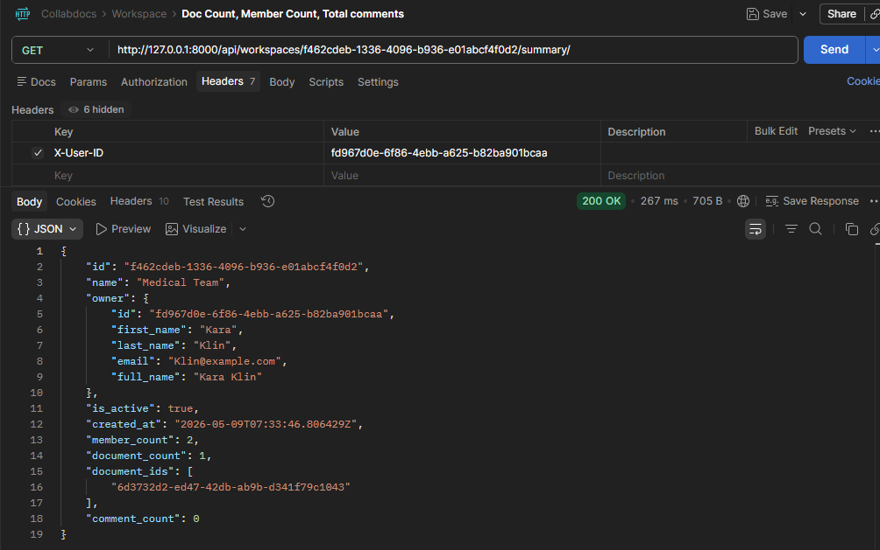

Documents:
- Create a document + first version (atomic)
POST http://127.0.0.1:8000/api/documents/
Header : User id
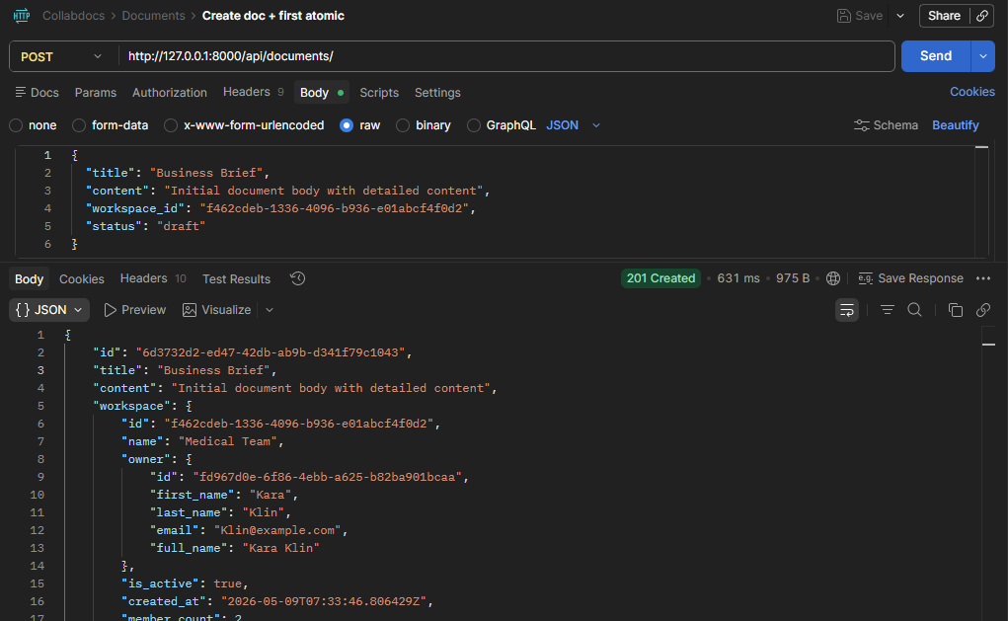
- Update document content - saves a new version
PUT http://127.0.0.1:8000/api/documents/6d3732d2-ed47-42db-ab9b-d341f79c1043/
Header: User id
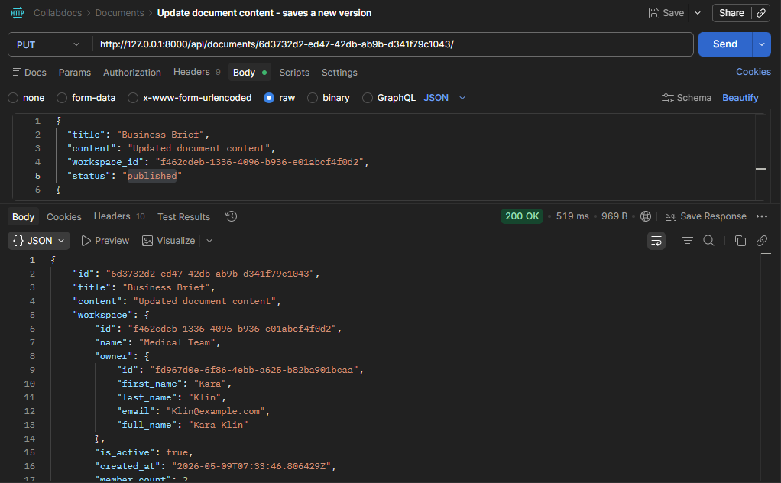

- List Docs - filter by workspace, status, tag name, search title
GET http://127.0.0.1:8000/api/documents/
You can filter with these query params:
?workspace_ids={{workspace_id}}
?status_in=draft,published
?search=brief
?title_icontains=project

List all docs:
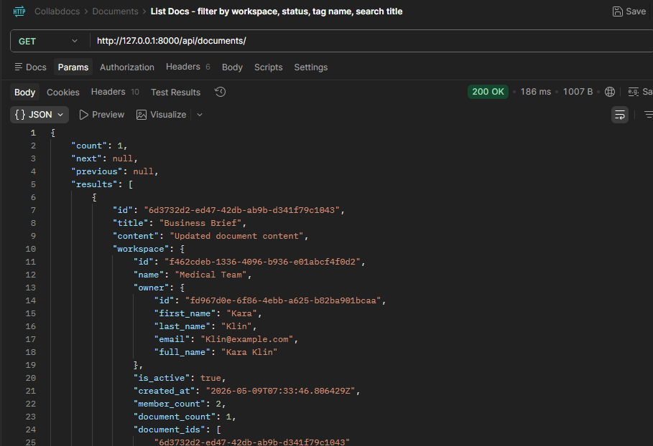

Filter by workspace:
GET http://127.0.0.1:8000/api/documents/?workspace_ids=f462cdeb-1336-4096-b936-e01abcf4f0d2
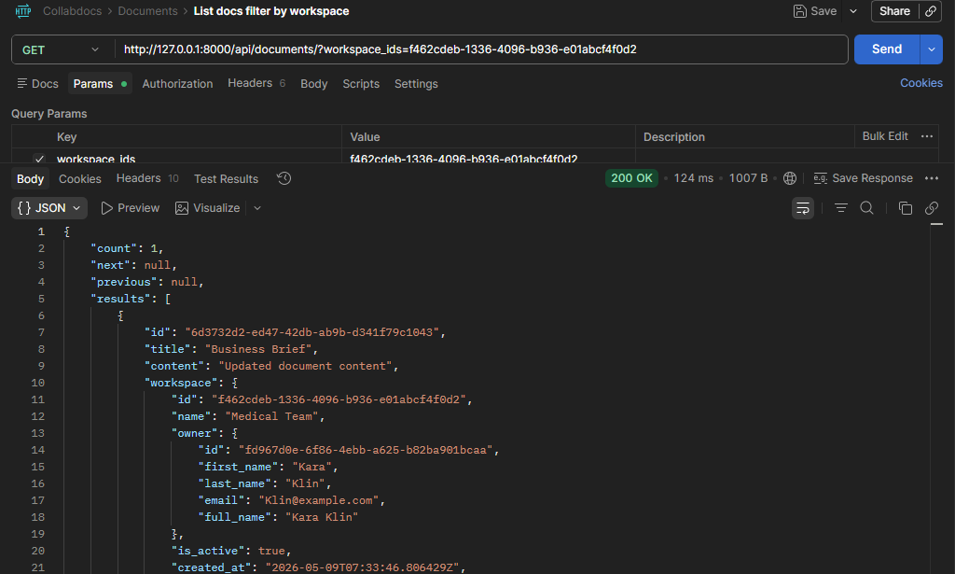
Filter by status:
GET http://127.0.0.1:8000/api/documents/?status_in=draft
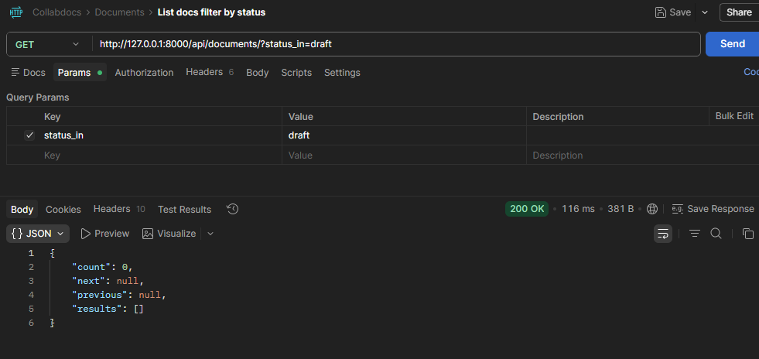
Search title/Content
GET http://127.0.0.1:8000/api/documents/?search=brief
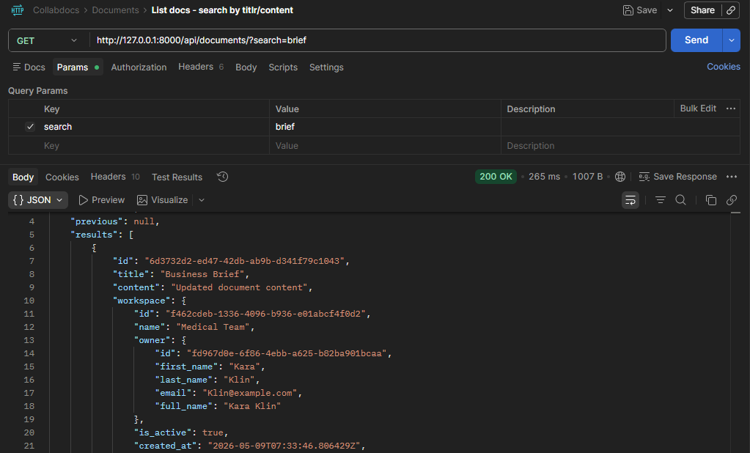

Search only titles:
GET http://127.0.0.1:8000/api/documents/?title_icontains=project
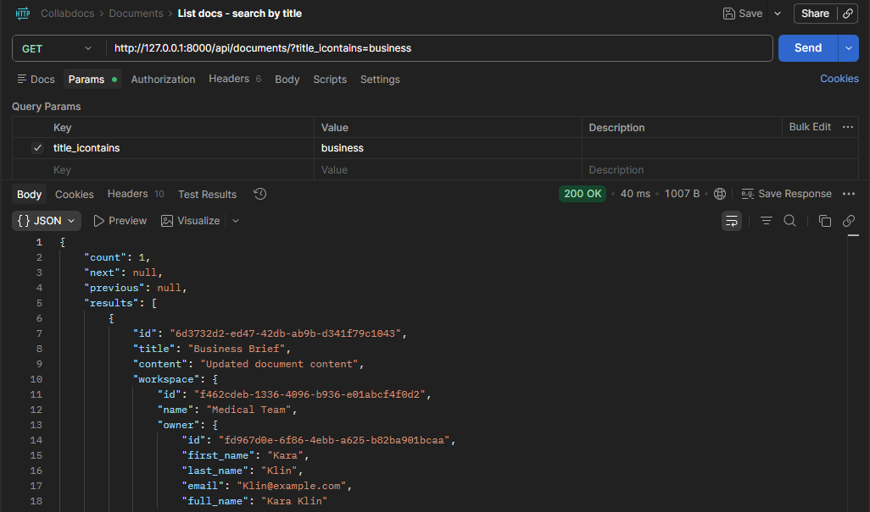

- All versions of document in order
GET http://127.0.0.1:8000/api/documents/{{document_id}}/versions/
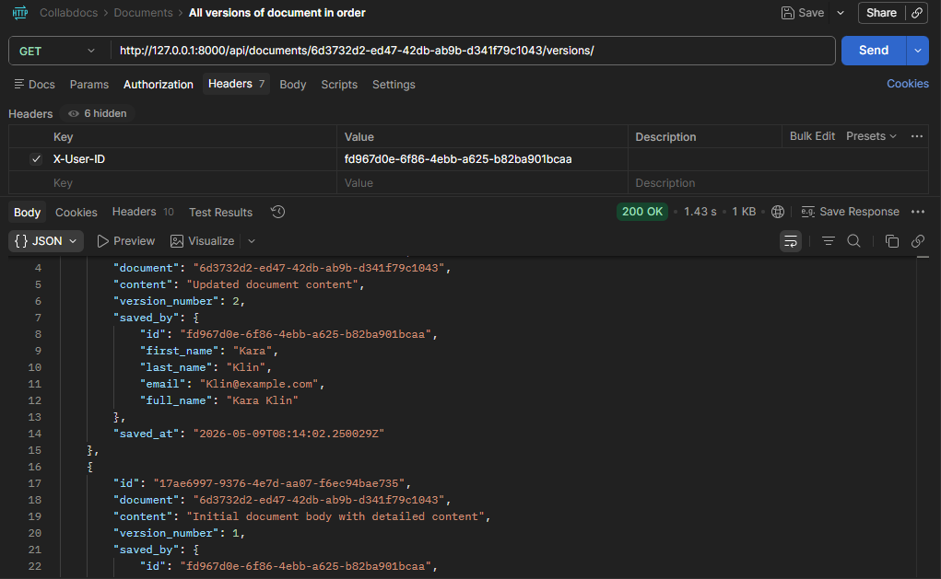
- Version count, comment count contributor count
http://127.0.0.1:8000/api/documents/{{document_id}}/stats/
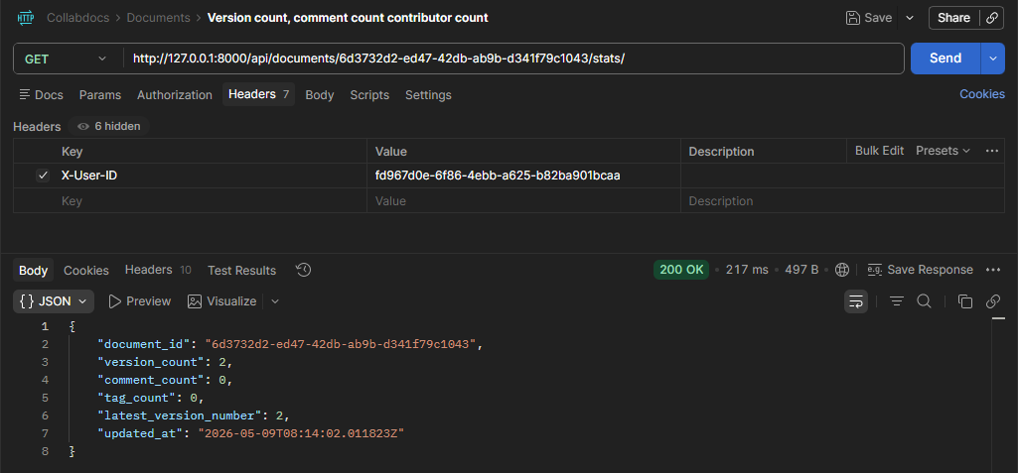
- Add one or more tags to a document
POST http://127.0.0.1:8000/api/documents/6d3732d2-ed47-42db-ab9b-d341f79c1043/tags/
Header : UserID and tag id in body
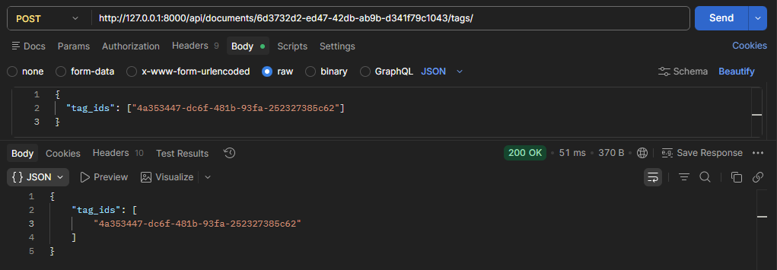

Comments:
- Add a top level comment to a reply
To add a top-level comment to a document:
POST http://127.0.0.1:8000/api/comments/
Headers:X-User-ID
Body:
{
"document": "6d3732d2-ed47-42db-ab9b-d341f79c1043",
"content": "This is the first comment"
}
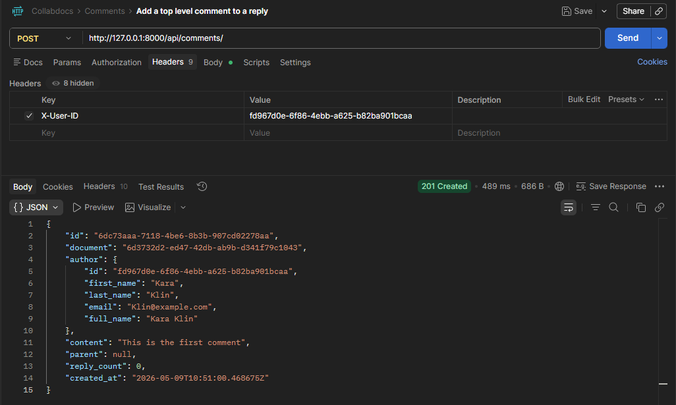

Reply to the comment: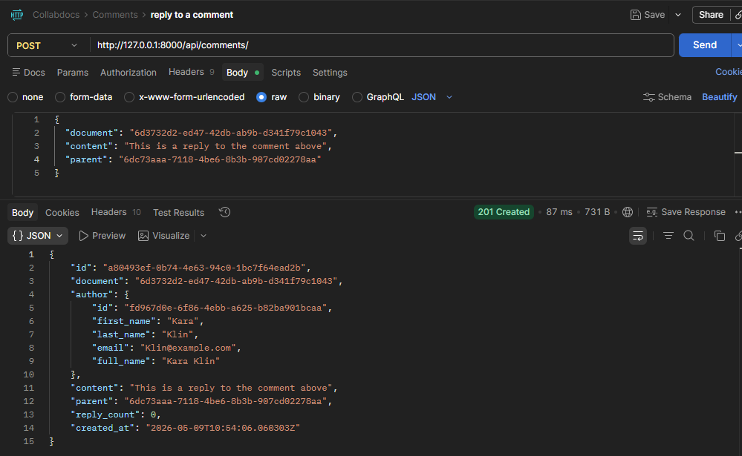
- List all comments for a document GET /api/comments/?document={id}
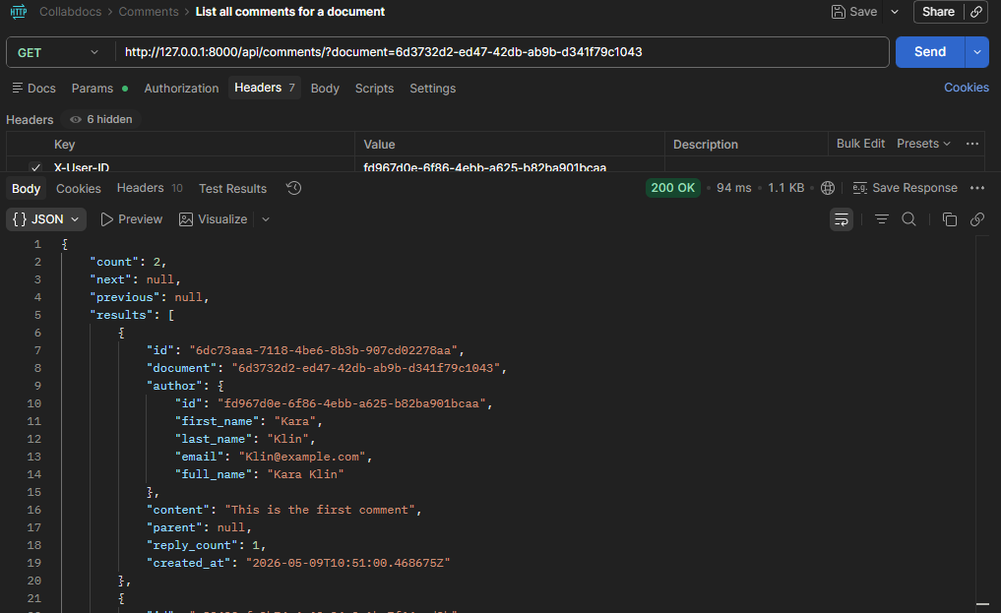
Tags & Audit Logs
1. Create a tag
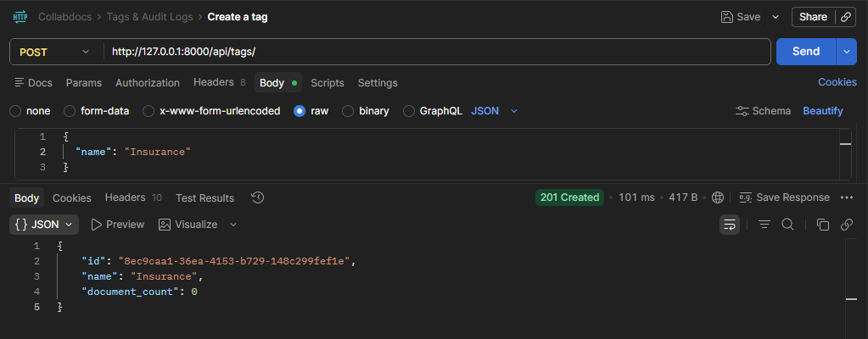
2. Audit logs filtered by actor id and date range
Add tags to existing doc
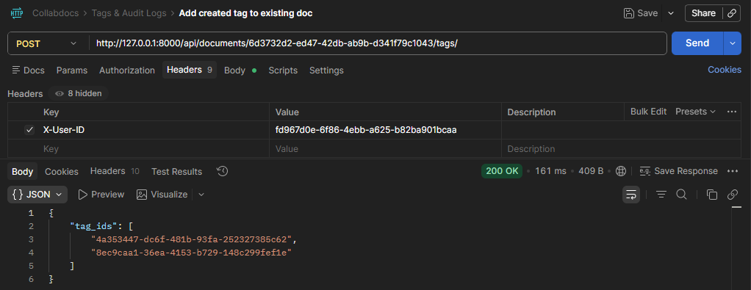

List audit-logs