**WEEK_3 JAVA**

**Exercise 1: Configuring a Basic Spring Application**

**applicationContext.xml**

<?xml version="1.0" encoding="UTF-8"?>

<beans xmlns="http://www.springframework.org/schema/beans"

xmlns:xsi="http://www.w3.org/2001/XMLSchema-instance"

xsi:schemaLocation="

http://www.springframework.org/schema/beans

http://www.springframework.org/schema/beans/spring-beans.xsd">

<!-- BookRepository Bean -->

<bean id="bookRepository" class="com.library.LibraryManagement.BookRepository" />

<!-- BookService Bean -->

<bean id="bookService" class="com.library.LibraryManagement.BookService">

<property name="bookRepository" ref="bookRepository"/>

</bean>

</beans>

**BookRepository:**

package com.library.LibraryManagement;

public class BookRepository {

public String getBookTitle() {

return "The Lord Of Ten Rings ";

}

}

**BookService :**

package com.library.LibraryManagement;

public class BookService {

private BookRepository bookRepository;

public void setBookRepository(BookRepository bookRepository) {

this.bookRepository = bookRepository;

}

public void printBookTitle() {

String title = bookRepository.getBookTitle();

System.***out***.println("Book Title: " + title);

}

}

**Output:**

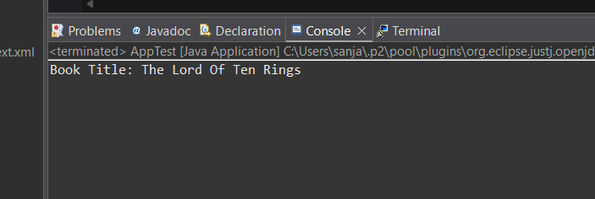

**Exercise 2: Implementing Dependency Injection**

**Applicationcontext.xml**

<?xml version="1.0" encoding="UTF-8"?>

<beans xmlns="http://www.springframework.org/schema/beans"

xmlns:xsi="http://www.w3.org/2001/XMLSchema-instance"

xsi:schemaLocation="http://www.springframework.org/schema/beans

http://www.springframework.org/schema/beans/spring-beans.xsd">

<!-- BookRepository Bean -->

<bean id="bookRepository" class="com.library.repository.BookRepository" />

<!-- BookService Bean with dependency injected -->

<bean id="bookService" class="com.library.service.BookService">

<property name="bookRepository" ref="bookRepository" />

</bean>

</beans>

**BookService.java**

package com.library.service;

import com.library.repository.BookRepository;

public class BookService {

private BookRepository bookRepository;

public void setBookRepository(BookRepository bookRepository) {

this.bookRepository = bookRepository;

}

public void printBookTitle() {

System.out.println("Book Title: " + bookRepository.getBookTitle());

}

}

**BookRepository.java**

package com.library;

import com.library.service.BookService;

import org.springframework.context.ApplicationContext;

import org.springframework.context.support.ClassPathXmlApplicationContext;

public class LibraryManagementApplication {

public static void main(String[] args) {

ApplicationContext context = new ClassPathXmlApplicationContext("applicationContext.xml");

BookService bookService = (BookService) context.getBean("bookService");

bookService.printBookTitle();

((ClassPathXmlApplicationContext) context).close();

}

}

**OUTPUT**:

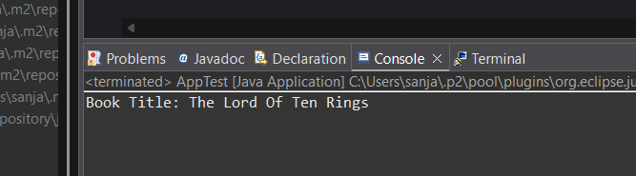

**Exercise 4: Creating and Configuring a Maven Project**

LibraryManagement :

POM.xml:

<project xmlns="http://maven.apache.org/POM/4.0.0"

xmlns:xsi="http://www.w3.org/2001/XMLSchema-instance"

xsi:schemaLocation="http://maven.apache.org/POM/4.0.0

http://maven.apache.org/xsd/maven-4.0.0.xsd">

<modelVersion>4.0.0</modelVersion>

<groupId>com.library</groupId>

<artifactId>LibraryManagementApp</artifactId>

<version>1.0-SNAPSHOT</version>

<properties>

<maven.compiler.source>1.8</maven.compiler.source>

<maven.compiler.target>1.8</maven.compiler.target>

</properties>

<dependencies>

<!-- Spring Core -->

<dependency>

<groupId>org.springframework</groupId>

<artifactId>spring-context</artifactId>

<version>5.3.33</version>

</dependency>

<!-- Spring AOP -->

<dependency>

<groupId>org.springframework</groupId>

<artifactId>spring-aop</artifactId>

<version>5.3.33</version>

</dependency>

<!-- Spring Web MVC -->

<dependency>

<groupId>org.springframework</groupId>

<artifactId>spring-webmvc</artifactId>

<version>5.3.33</version>

</dependency>

<!-- JUnit (optional for testing) -->

<dependency>

<groupId>junit</groupId>

<artifactId>junit</artifactId>

<version>4.13.2</version>

<scope>test</scope>

</dependency>

</dependencies>

<build>

<plugins>

<plugin>

<artifactId>maven-compiler-plugin</artifactId>

<version>3.8.1</version>

<configuration>

<source>1.8</source>

<target>1.8</target>

</configuration>

</plugin>

</plugins>

</build>

</project>

**Spring Data JPA - Quick Example**

Country.java

package com.cognizant.ormlearn.model;

import javax.persistence.Column;

import javax.persistence.Entity;

import javax.persistence.Id;

import javax.persistence.Table;

@Entity

@Table(name = "country")

public class Country {

@Id

@Column(name = "code")

private String code;

@Column(name = "name")

private String name;

public String getCode() {

return code;

}

public void setCode(String code) {

this.code = code;

}

public String getName() {

return name;

}

public void setName(String name) {

this.name = name;

}

@Override

public String toString() {

return "Country [code=" + code + ", name=" + name + "]";

}

}

**CountryRepository.java**

package com.cognizant.ormlearn.repository;

import org.springframework.data.jpa.repository.JpaRepository;

import org.springframework.stereotype.Repository;

import com.cognizant.ormlearn.model.Country;

@Repository

public interface CountryRepository extends JpaRepository<Country, String> {

}

**3. File: CountryService.java**

package com.cognizant.ormlearn.service;

import java.util.List;

import org.springframework.beans.factory.annotation.Autowired;

import org.springframework.stereotype.Service;

import org.springframework.transaction.annotation.Transactional;

import com.cognizant.ormlearn.model.Country;

import com.cognizant.ormlearn.repository.CountryRepository;

@Service

public class CountryService {

@Autowired

private CountryRepository countryRepository;

@Transactional

public List<Country> getAllCountries() {

return countryRepository.findAll();

}

}

**OrmLearnApplication.java**

package com.cognizant.ormlearn;

import java.util.List;

import org.slf4j.Logger;

import org.slf4j.LoggerFactory;

import org.springframework.boot.SpringApplication;

import org.springframework.boot.autoconfigure.SpringBootApplication;

import org.springframework.context.ApplicationContext;

import com.cognizant.ormlearn.model.Country;

import com.cognizant.ormlearn.service.CountryService;

@SpringBootApplication

public class OrmLearnApplication {

private static final Logger LOGGER = LoggerFactory.getLogger(OrmLearnApplication.class);

private static CountryService countryService;

public static void main(String[] args) {

ApplicationContext context = SpringApplication.run(OrmLearnApplication.class, args);

countryService = context.getBean(CountryService.class);

testGetAllCountries();

}

private static void testGetAllCountries() {

LOGGER.info("Start");

List<Country> countries = countryService.getAllCountries();

LOGGER.debug("countries={}", countries);

LOGGER.info("End");

}

}

**application.properties**

logging.level.org.springframework=info

logging.level.com.cognizant=debug

logging.level.org.hibernate.SQL=trace

logging.level.org.hibernate.type.descriptor.sql=trace

logging.pattern.console=%d{dd-MM-yy} %d{HH:mm:ss.SSS} %-20.20thread %5p %-25.25logger{25} %25M %4L %m%n

spring.datasource.driver-class-name=com.mysql.cj.jdbc.Driver

spring.datasource.url=jdbc:mysql://localhost:3306/ormlearn

spring.datasource.username=root

spring.datasource.password=root

spring.jpa.hibernate.ddl-auto=validate

spring.jpa.properties.hibernate.dialect=org.hibernate.dialect.MySQL5Dialect

**schema.sql**

CREATE DATABASE ormlearn;

USE ormlearn;

CREATE TABLE country (

code VARCHAR(2) PRIMARY KEY,

name VARCHAR(50)

);

INSERT INTO country VALUES ('IN', 'India');

INSERT INTO country VALUES ('US', 'United States of America');

Output :

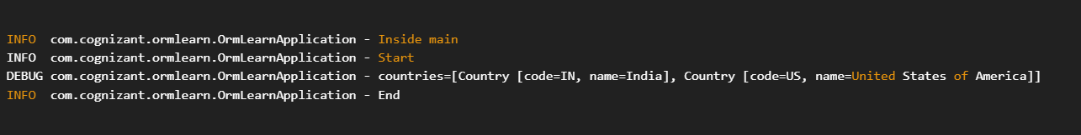

**Difference between Spring Data JPA and Hibernate :**

| **Feature** | **Spring Data JPA** | **Hibernate (JPA Implementation)** |
| --- | --- | --- |
| **Type** | Abstraction over JPA | JPA Implementation Framework |
| **Goal** | Simplify database access with minimal boilerplate | Provide a complete ORM framework |
| **Ease of Use** | Very high – fewer lines of code | More configuration and code required |
| **Built on** | Top of JPA and ORM providers like Hibernate | Direct implementation of JPA |
| **Repository Support** | CrudRepository, JpaRepository etc. with no SQL | Manual creation of DAO and queries |
| **Query Creation** | Derived queries using method names (e.g., findBy...) | Requires JPQL or Criteria API |
| **Transactions** | Spring manages transactions declaratively | Requires manual handling or integration with Spring |
| **Usage in Spring Boot** | Seamless auto-configuration | Needs manual setup if used standalone |
| **Custom Queries** | Supports JPQL, Native SQL, and @Query annotation | Supports JPQL, Native SQL via @NamedQuery, etc. |