**Week4_java_handson**

**Create a Spring Web Project using Maven**

**CODE:**

**SpringLearnApplication.java**

package com.cognizant.spring_learn;

import org.springframework.boot.SpringApplication;

import org.springframework.boot.autoconfigure.SpringBootApplication;

@SpringBootApplication

public class SpringLearnApplication {

public static void main(String[] args) {

SpringApplication.run(SpringLearnApplication.class, args);

System.out.println("SpringLearnApplication started");

}

}

Output:

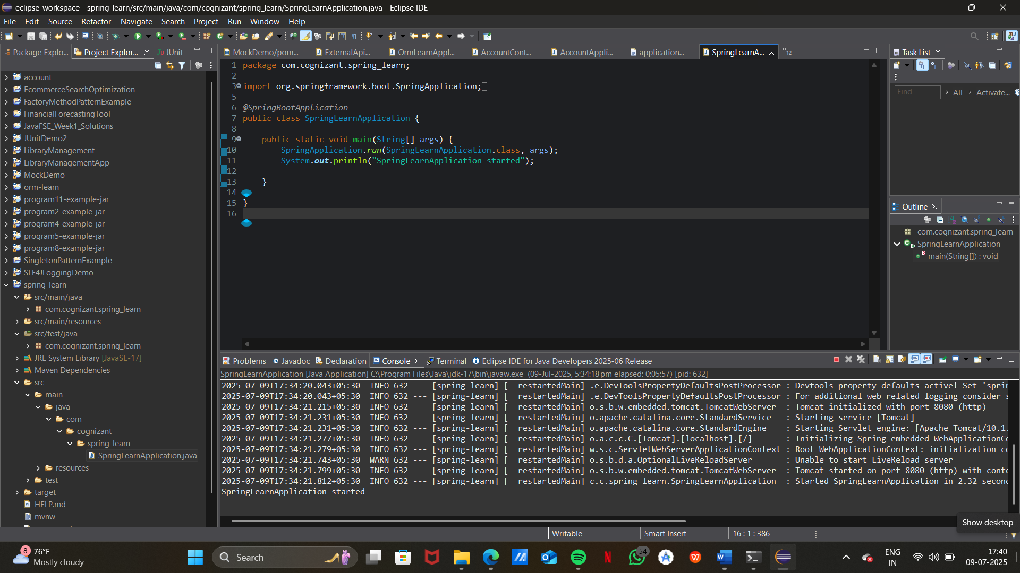

**Spring Core – Load Country from Spring Configuration XML**

**Code:**

**country.xml**

<?xml version="1.0" encoding="UTF-8"?>

<beans xmlns="http://www.springframework.org/schema/beans"

xmlns:xsi="http://www.w3.org/2001/XMLSchema-instance"

xsi:schemaLocation="http://www.springframework.org/schema/beans

http://www.springframework.org/schema/beans/spring-beans.xsd">

<bean id="country" class="com.cognizant.springlearn.Country">

<property name="code" value="IN"/>

<property name="name" value="India"/>

</bean>

</beans>

**Country:**

package com.cognizant.springlearn;

import org.slf4j.Logger;

import org.slf4j.LoggerFactory;

public class Country {

private static final Logger LOGGER = LoggerFactory.getLogger(Country.class);

private String code;

private String name;

public Country() {

LOGGER.debug("Inside Country Constructor.");

}

public String getCode() {

LOGGER.debug("Inside getCode()");

return code;

}

public void setCode(String code) {

LOGGER.debug("Inside setCode()");

this.code = code;

}

public String getName() {

LOGGER.debug("Inside getName()");

return name;

}

public void setName(String name) {

LOGGER.debug("Inside setName()");

this.name = name;

}

@Override

public String toString() {

return "Country [code=" + code + ", name=" + name + "]";

}

}

**SpringLearnApplication.java:**

public static void displayCountry() {

ApplicationContext context = new ClassPathXmlApplicationContext("country.xml");

Country country = context.getBean("country", Country.class);

LOGGER.debug("Country : {}", country.toString());

}

OutPut:

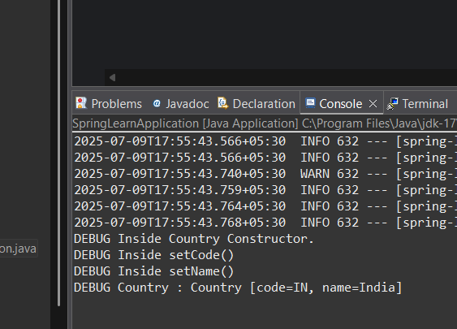

**Hello World RESTful Web Service**

**Code:**

HelloController.java

package com.cognizant.springlearn.controller;

import org.slf4j.Logger;

import org.slf4j.LoggerFactory;

import org.springframework.web.bind.annotation.GetMapping;

import org.springframework.web.bind.annotation.RestController;

@RestController

public class HelloController {

private static final Logger LOGGER = LoggerFactory.getLogger(HelloController.class);

@GetMapping("/hello")

public String sayHello() {

LOGGER.debug("Start - sayHello()");

String message = "Hello World!!";

LOGGER.debug("End - sayHello()");

return message;

}

}

Output:

Hello World!!

**REST - Country Web Service**

Code:

**country.xml**

<bean id="country" class="com.cognizant.springlearn.Country">

<property name="code" value="IN" />

<property name="name" value="India" />

</bean>

**CountryController.java**

package com.cognizant.springlearn.controller;

import com.cognizant.springlearn.Country;

import org.springframework.context.ApplicationContext;

import org.springframework.context.support.ClassPathXmlApplicationContext;

import org.springframework.web.bind.annotation.RequestMapping;

import org.springframework.web.bind.annotation.RestController;

@RestController

public class CountryController {

@RequestMapping("/country")

public Country getCountryIndia() {

ApplicationContext context = new ClassPathXmlApplicationContext("country.xml");

Country country = context.getBean("country", Country.class);

return country;

}

}

Output:

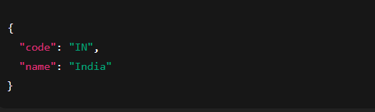

**REST - Get country based on country code**   
  
**country.xml**

<beans xmlns="http://www.springframework.org/schema/beans"

xmlns:xsi="http://www.w3.org/2001/XMLSchema-instance"

xmlns:util="http://www.springframework.org/schema/util"

xsi:schemaLocation="http://www.springframework.org/schema/beans

http://www.springframework.org/schema/beans/spring-beans.xsd

http://www.springframework.org/schema/util

http://www.springframework.org/schema/util/spring-util.xsd">

<bean id="country" class="com.cognizant.springlearn.Country">

<property name="code" value="IN" />

<property name="name" value="India" />

</bean>

<util:list id="countryList">

<bean class="com.cognizant.springlearn.Country">

<property name="code" value="IN" />

<property name="name" value="India" />

</bean>

<bean class="com.cognizant.springlearn.Country">

<property name="code" value="US" />

<property name="name" value="United States" />

</bean>

<bean class="com.cognizant.springlearn.Country">

<property name="code" value="DE" />

<property name="name" value="Germany" />

</bean>

<bean class="com.cognizant.springlearn.Country">

<property name="code" value="JP" />

<property name="name" value="Japan" />

</bean>

</util:list>

</beans>

**CountryService.java**

package com.cognizant.springlearn.service;

import com.cognizant.springlearn.Country;

import org.springframework.context.ApplicationContext;

import org.springframework.context.support.ClassPathXmlApplicationContext;

import org.springframework.stereotype.Service;

import java.util.List;

@Service

public class CountryService {

public Country getCountry(String code) {

ApplicationContext context = new ClassPathXmlApplicationContext("country.xml");

List<Country> countryList = context.getBean("countryList", List.class);

return countryList.stream()

.filter(c -> c.getCode().equalsIgnoreCase(code))

.findFirst()

.orElse(null); // You can throw custom exception instead

}

}

**CountryController.java**

package com.cognizant.springlearn.controller;

import com.cognizant.springlearn.Country;

import com.cognizant.springlearn.service.CountryService;

import org.slf4j.Logger;

import org.slf4j.LoggerFactory;

import org.springframework.beans.factory.annotation.Autowired;

import org.springframework.web.bind.annotation.*;

@RestController

public class CountryController {

private static final Logger LOGGER = LoggerFactory.getLogger(CountryController.class);

@Autowired

private CountryService countryService;

@GetMapping("/countries/{code}")

public Country getCountry(@PathVariable String code) {

LOGGER.debug("Start - getCountry()");

Country country = countryService.getCountry(code);

LOGGER.debug("End - getCountry()");

return country;

}

}

**Output:**

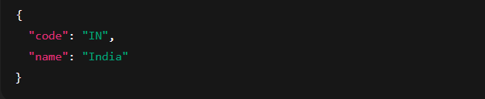

**Create authentication service that returns JWT**

Code:

**pom.xml**

<dependency>

<groupId>io.jsonwebtoken</groupId>

<artifactId>jjwt</artifactId>

<version>0.9.1</version>

</dependency>

<dependency>

<groupId>org.springframework.boot</groupId>

<artifactId>spring-boot-starter-security</artifactId>

</dependency>

<dependency>

<groupId>org.springframework.boot</groupId>

<artifactId>spring-boot-starter-web</artifactId>

</dependency>

**AuthenticationController.java**

package com.cognizant.auth.controller;

import com.cognizant.auth.util.JwtUtil;

import jakarta.servlet.http.HttpServletRequest;

import org.springframework.beans.factory.annotation.Autowired;

import org.springframework.web.bind.annotation.*;

@RestController

public class AuthenticationController {

@Autowired

private JwtUtil jwtUtil;

@RequestMapping(value = "/authenticate", method = RequestMethod.GET)

public String authenticate(HttpServletRequest request) {

return null;

}

}

**com.cognizant.auth.config**

package com.cognizant.auth.config;

import org.springframework.context.annotation.Configuration;

import org.springframework.security.config.annotation.web.builders.HttpSecurity;

import org.springframework.security.config.annotation.web.configuration.WebSecurityCustomizer;

import org.springframework.security.web.SecurityFilterChain;

import org.springframework.context.annotation.Bean;

@Configuration

public class SecurityConfig {

@Bean

public SecurityFilterChain filterChain(HttpSecurity http) throws Exception {

http

.csrf().disable()

.authorizeHttpRequests()

.requestMatchers("/authenticate").permitAll()

.anyRequest().authenticated()

.and()

.httpBasic(); // Enables -u user:pwd support

return http.build();

}

}

**application.properties**

spring.security.user.name=user

spring.security.user.password=pwd

server.port=8090

**Output:**

