**WEEK7_JAVA_Handson**

**9. ReactJS-HOL**

**ListofPlayers.js**

Code:

import React from "react";

function ListofPlayers() {

const players = [

{ name: "Virat", score: 85 },

{ name: "Rohit", score: 68 },

{ name: "Rahul", score: 72 },

{ name: "Pant", score: 50 },

{ name: "Jadeja", score: 78 },

{ name: "Bumrah", score: 40 },

{ name: "Shami", score: 65 },

{ name: "Siraj", score: 30 },

{ name: "Gill", score: 90 },

{ name: "Iyer", score: 55 },

{ name: "Kuldeep", score: 45 },

];

// Filter players using arrow function

const lowScorePlayers = players.filter(player => player.score < 70);

return (

<div>

<h2>All Players</h2>

{players.map((p, i) => (

<p key={i}>{p.name} - {p.score}</p>

))}

<h3>Players with Score Below 70</h3>

{lowScorePlayers.map((p, i) => (

<p key={i}>{p.name}</p>

))}

</div>

);

}

export default ListofPlayers;

**IndianPlayers.js**  
CODE:

import React from "react";

function IndianPlayers() {

const OddPlayers = ["Virat", "Rahul", "Jadeja", "Shami", "Gill"];

const EvenPlayers = ["Rohit", "Pant", "Bumrah", "Siraj", "Iyer", "Kuldeep"];

// Destructuring example

const [first, second, ...rest] = OddPlayers;

// Merge arrays using spread operator

const T20players = ["Virat", "Rohit", "Rahul"];

const RanjiTrophy = ["Pujara", "Rahane", "Saha"];

const merged = [...T20players, ...RanjiTrophy];

return (

<div>

<h2>Odd Players:</h2>

{OddPlayers.map((p,i) => <p key={i}>{p}</p>)}

<h2>Even Players:</h2>

{EvenPlayers.map((p,i) => <p key={i}>{p}</p>)}

<h3>Destructured First: {first}</h3>

<h3>Destructured Second: {second}</h3>

<h3>Remaining Players: {rest.join(", ")}</h3>

<h3>Merged Array of Players: {merged.join(", ")}</h3>

</div>

);

}

export default IndianPlayers;

**App.js:**

CODE:

import React from "react";

import ListofPlayers from "./ListofPlayers";

import IndianPlayers from "./IndianPlayers";

function App() {

const flag = true; // Change to false to display IndianPlayers

return (

<div>

{flag ? <ListofPlayers /> : <IndianPlayers />}

</div>

);

}

export default App;

**Output:**

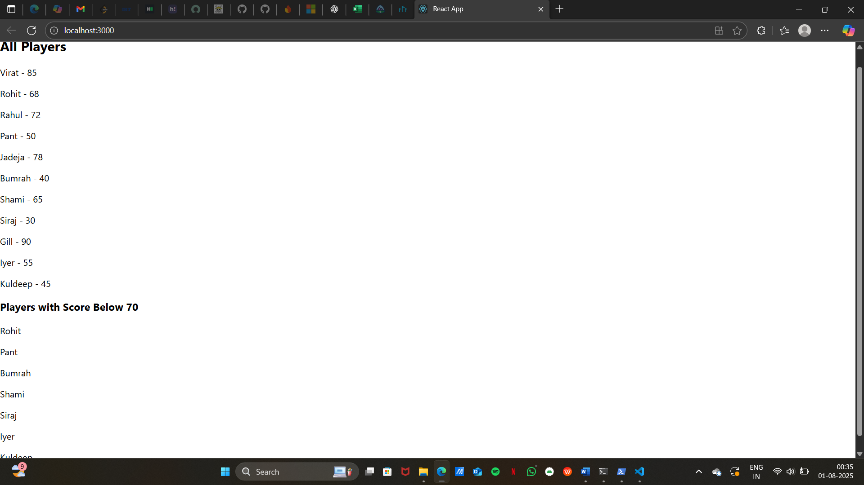

**10. ReactJS-HOL**

**App.js:**

CODE:

import React from "react";

function App() {

// Office details

const office = { name: "Skyline Tower", rent: 55000, address: "MG Road, Bangalore" };

// List of office spaces

const officeList = [

{ name: "Skyline Tower", rent: 55000, address: "MG Road, Bangalore" },

{ name: "Tech Park", rent: 75000, address: "Whitefield, Bangalore" },

{ name: "Startup Hub", rent: 45000, address: "HSR Layout, Bangalore" }

];

// Function to get color based on rent

const getRentColor = (rent) => {

return { color: rent < 60000 ? "red" : "green" };

};

return (

<div style={{ textAlign: "center", fontFamily: "Arial" }}>

<h1>🏢 Office Space Rental</h1>

<img

src="https://cdn.pixabay.com/photo/2017/02/12/21/29/office-2061188_1280.jpg"

alt="Office Space"

style={{ width: "500px", borderRadius: "10px" }}

/>

<h2>Office Details:</h2>

<p>Name: {office.name}</p>

<p style={getRentColor(office.rent)}>Rent: ₹{office.rent}</p>

<p>Address: {office.address}</p>

<h2>All Available Offices:</h2>

<ul style={{ listStyleType: "none", padding: 0 }}>

{officeList.map((o, index) => (

<li key={index} style={getRentColor(o.rent)}>

{o.name} - ₹{o.rent} - {o.address}

</li>

))}

</ul>

</div>

);

}

export default App;  
  
  
  
  
  
  
  
  
 **OUTPUT:**

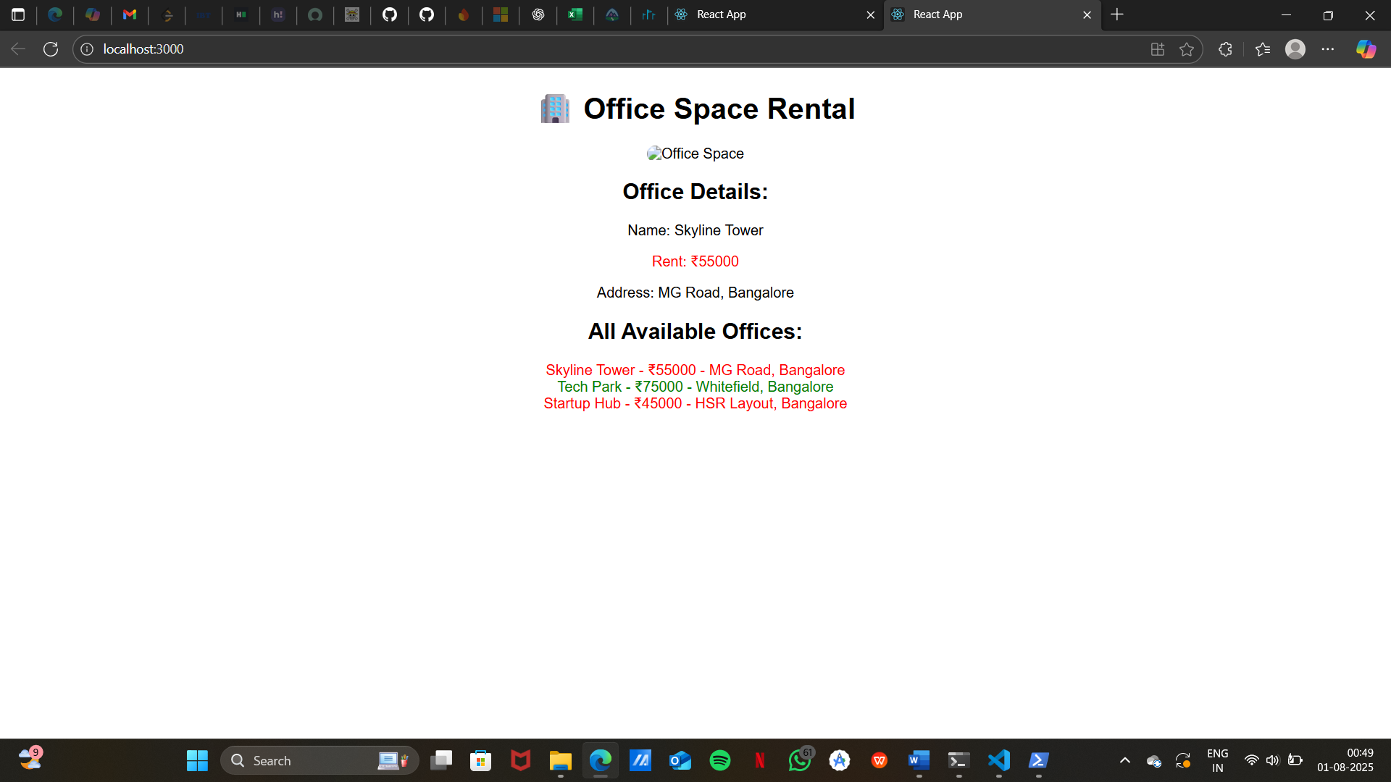

**11. ReactJS-HOL**

**App.js:**

CODE:

import React, { Component } from "react";

class App extends Component {

constructor(props) {

super(props);

this.state = {

counter: 0

};

// Binding methods

this.increment = this.increment.bind(this);

this.sayHello = this.sayHello.bind(this);

}

// Method to increment counter

increment() {

this.setState({ counter: this.state.counter + 1 });

}

// Method to log message

sayHello() {

console.log("Hello! Counter button clicked!");

}

// Method to decrement counter

decrement = () => {

this.setState({ counter: this.state.counter - 1 });

};

render() {

return (

<div style={{ textAlign: "center", marginTop: "50px" }}>

<h1>React Event Handling Example</h1>

<h2>Counter: {this.state.counter}</h2>

<button

onClick={() => {

this.increment();

this.sayHello();

}}

style={{ marginRight: "10px" }}

>

Increment

</button>

<button onClick={this.decrement}>Decrement</button>

</div>

);

}

}

export default App;

**OUTPUT:**

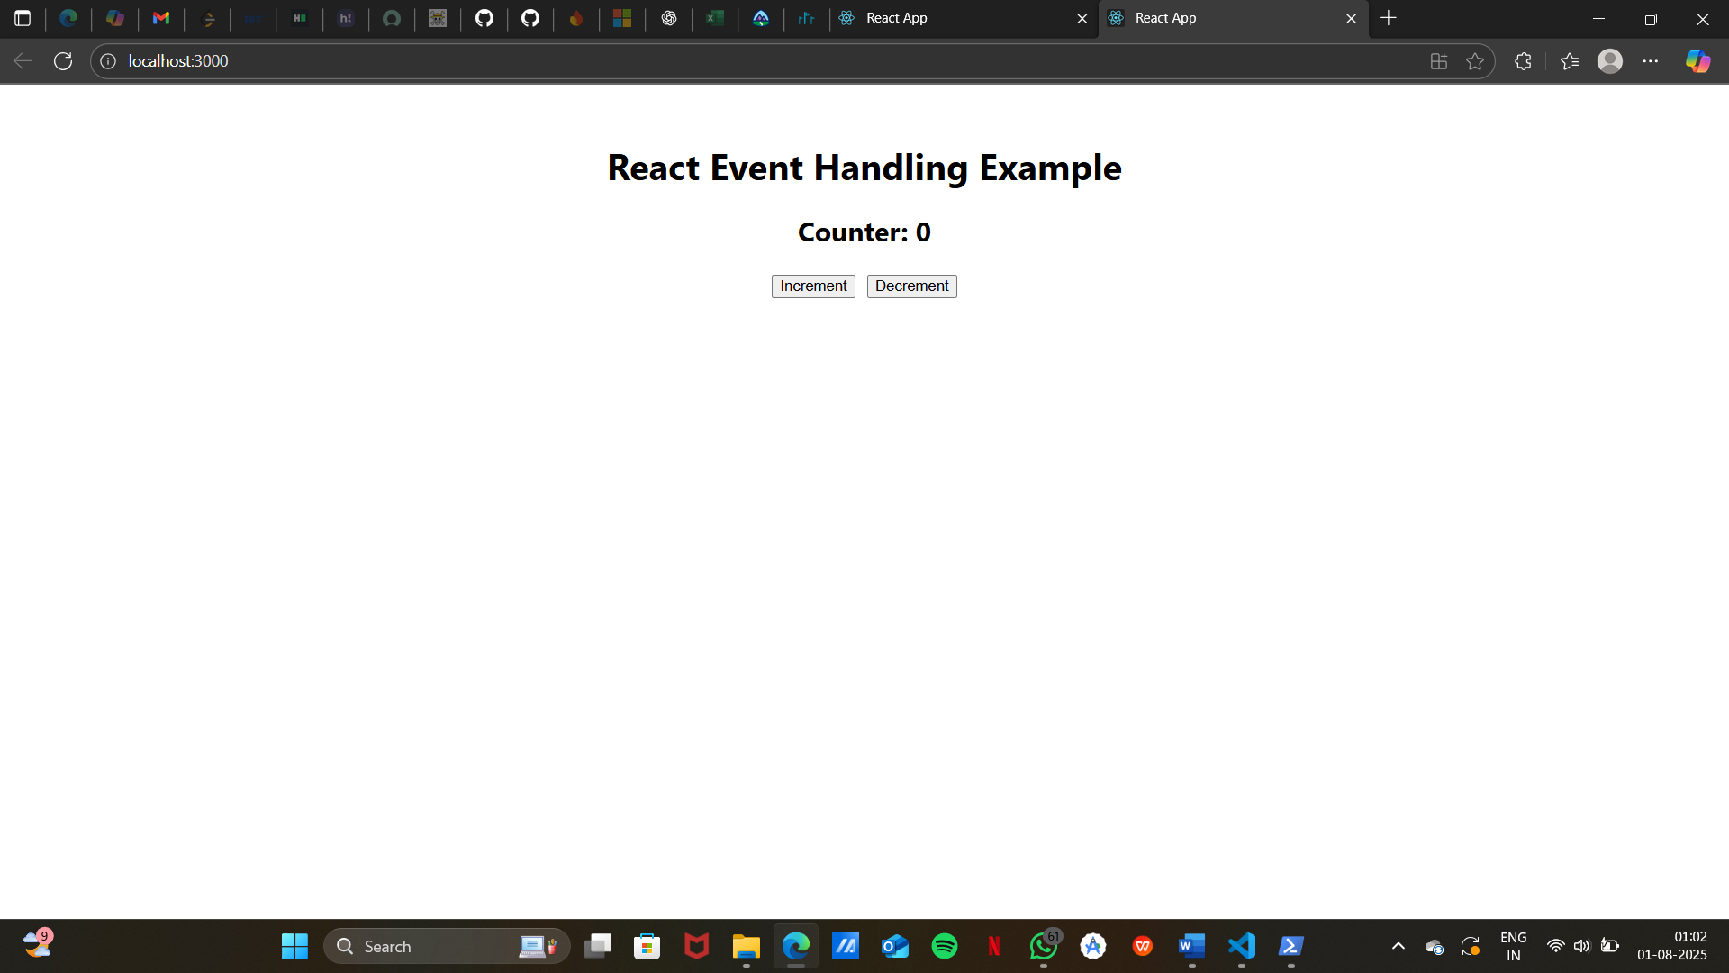

**12. ReactJS-HOL:**

**App.js:**

CODE:

import React, { useState } from "react";

function GuestPage() {

return (

<div style={{ textAlign: "center" }}>

<h2>Welcome Guest!</h2>

<p>You can browse flight details but need to log in to book tickets.</p>

</div>

);

}

function UserPage() {

return (

<div style={{ textAlign: "center" }}>

<h2>Welcome User!</h2>

<p>You can now book tickets for your favorite flights.</p>

</div>

);

}

function App() {

const [isLoggedIn, setIsLoggedIn] = useState(false);

// Toggle login/logout

const handleLogin = () => setIsLoggedIn(true);

const handleLogout = () => setIsLoggedIn(false);

return (

<div style={{ textAlign: "center", marginTop: "50px" }}>

<h1>✈ Ticket Booking App</h1>

{isLoggedIn ? <UserPage /> : <GuestPage />}

<div style={{ marginTop: "20px" }}>

{isLoggedIn ? (

<button onClick={handleLogout}>Logout</button>

) : (

<button onClick={handleLogin}>Login</button>

)}

</div>

</div>

);

}

export default App;

**OUTPUT:**

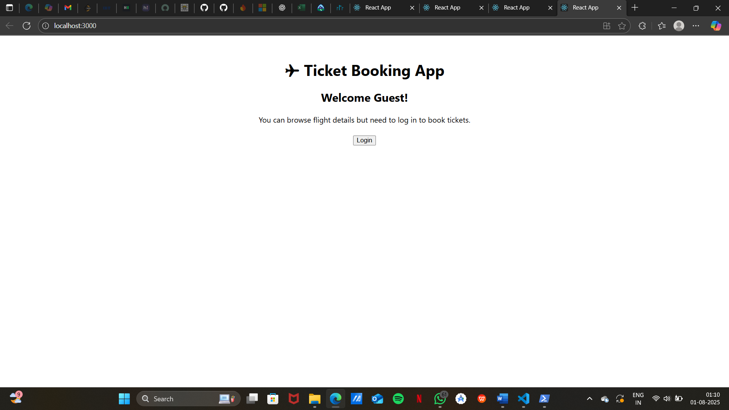

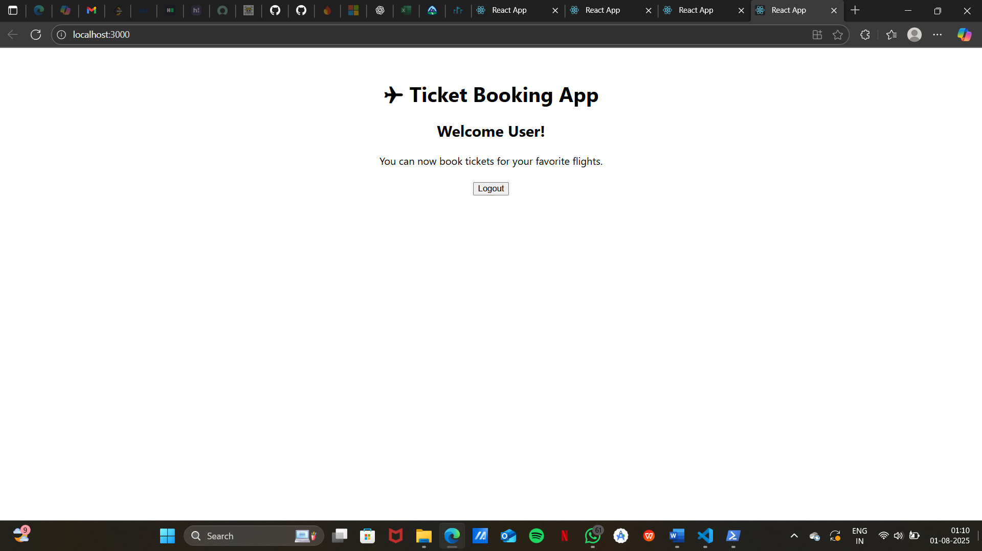

**13. ReactJS-HOL**

**BookDetails.js**

CODE:

import React from "react";

function BookDetails() {

const books = [

{ id: 1, title: "React Basics", author: "Dan Abramov" },

{ id: 2, title: "Node.js in Action", author: "Mike Cantelon" },

{ id: 3, title: "Learning JavaScript", author: "Ethan Brown" }

];

return (

<div>

<h2>Book Details</h2>

<ul>

{books.map((book) => (

<li key={book.id}>

{book.title} by {book.author}

</li>

))}

</ul>

</div>

);

}

export default BookDetails;

**BlogDetails.js**

CODE:

import React from "react";

function BlogDetails() {

const blogs = [

{ id: 1, title: "React Tips", content: "Hooks make React easier." },

{ id: 2, title: "NodeJS Performance", content: "Optimize event loops." }

];

return (

<div>

<h2>Blog Details</h2>

{blogs.map((blog) => (

<div key={blog.id}>

<h3>{blog.title}</h3>

<p>{blog.content}</p>

</div>

))}

</div>

);

}

export default BlogDetails;

**CourseDetails.js**

CODE:

import React from "react";

function CourseDetails() {

const courses = [

{ id: 1, name: "Full Stack Development", duration: "6 Months" },

{ id: 2, name: "React and NodeJS", duration: "3 Months" }

];

return (

<div>

<h2>Course Details</h2>

<ul>

{courses.map((course) => (

<li key={course.id}>

{course.name} - {course.duration}

</li>

))}

</ul>

</div>

);

}

export default CourseDetails;  
  
  
  
**App.js**

import React, { useState } from "react";

import BookDetails from "./BookDetails";

import BlogDetails from "./BlogDetails";

import CourseDetails from "./CourseDetails";

function App() {

const [showComponent, setShowComponent] = useState("books");

return (

<div style={{ textAlign: "center" }}>

<h1>📚 Blogger App</h1>

<div style={{ marginBottom: "20px" }}>

<button onClick={() => setShowComponent("books")}>Show Books</button>

<button onClick={() => setShowComponent("blogs")}>Show Blogs</button>

<button onClick={() => setShowComponent("courses")}>Show Courses</button>

</div>

{/* Different ways of conditional rendering */}

{showComponent === "books" && <BookDetails />}

{showComponent === "blogs" ? <BlogDetails /> : null}

{showComponent === "courses" && <CourseDetails />}

</div>

);

}

export default App;

**OUTPUT:**

