Week8_Handson
1. Git-HOL
Step 1: Git Configuration
1. Open Git Bash and check if Git is installed:
> git --version
2. Configure your Git user name and email:
> git config --global user.name "Sanjana Shetty"
> git config --global user.email "sanjanabalu04@gmail.com"
3. Verify the configuration:
> git config --global --list
Expected output:
user.name=Sanjana Shetty
user.email=sanjanabalu04@gmail.com
Step 2: Set Notepad++ as Default Git Editor
1. Install Notepad++ from: https://notepad-plus-plus.org/downloads/
2. Add Notepad++ to PATH:
- Go to: Control Panel > System > Advanced system settings > Environment Variables
- Under "User Variables", edit the 'Path' variable and add:
C:\Program Files\Notepad++\
3. Close and reopen Git Bash. Test if it works:
> notepad++
4. Set Notepad++ as Git's default editor:
> git config --global core.editor "notepad++ -multiInst -notabbar -nosession -noPlugin"
5. Verify:
> git config --global --list
Expected output includes:
core.editor=notepad++ -multiInst -notabbar -nosession -noPlugin
Step 3: Initialize Git Repository and Commit
1. Open Git Bash in your home folder or a chosen directory.
2. Create a folder and initialize Git:
> mkdir GitDemo
> cd GitDemo
> git init
3. Create and commit a file:
> echo "Welcome to Git hands-on lab" > welcome.txt
> git add welcome.txt
> git commit
(Write commit message in Notepad++, save and close)
4. Verify status:
> git status
Expected: nothing to commit, working tree clean
Step 4: Push to GitHub
1. Go to GitHub.com and create a new repository named 'GitDemo'. DO NOT initialize with a README.
2. Back in Git Bash, connect the local repo to GitHub:
> git remote add origin https://github.com/sanjana7064/GitDemo.git
3. If needed, remove incorrect origin first:
> git remote remove origin
4. Pull any remote data (if needed):
> git pull origin master --allow-unrelated-histories
5. Push to GitHub:
> git push origin master

Output:

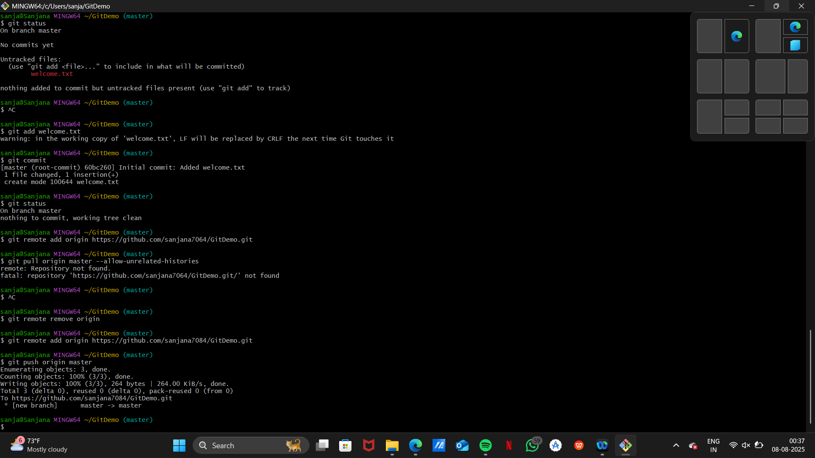

2. Git-HOL

Step 1: Open Your Git Project Folder
Open Git Bash and navigate to your project folder:
> cd ~/GitDemo
Step 2: Create Files and Folder to be Ignored
Create a .log file and a folder named log with a file inside:
> echo "This is a log file" > debug.log
> mkdir log
> echo "Log folder content" > log/log.txt
Then check what was created:
> ls
> ls log
Step 3: Create .gitignore File
Open the .gitignore file using Notepad++:
> notepad++ .gitignore
Add the following lines and save:
*.log
log/
Step 4: Check Git Status
Check Git status to ensure .log files and log/ folder are ignored:
> git status
Expected: Only .gitignore is visible as a new file.
Step 5: Add and Commit .gitignore
Stage and commit the .gitignore file:
> git add .gitignore
> git commit
Enter commit message in Notepad++:
Added .gitignore to ignore log files and folders
Step 6: Verify .gitignore is Working
Create additional test files and check status:
> echo "Another log file" > error.log
> mkdir log2
> echo "Test" > log2/logfile.txt
> git status

3. Git-HOL
1. Create a new branch
git branch GitNewBranch

2. List all branches (local & remote):
git branch -a
* indicates the current branch.
3. Switch to the new branch:
git checkout GitNewBranch
4. Create a file and add content:
echo "Branch content here" > branchfile.txt
5. Stage and commit the file:
git add branchfile.txt
git commit -m "Added file in GitNewBranch"
6. Check Git status:
git status
Merging Steps
1. Switch back to master:
git checkout master
2. Show command-line differences:
git diff GitNewBranch
3. Show visual diff (with P4Merge configured):
git difftool GitNewBranch
4. Merge the branch into master:
git merge GitNewBranch
5. View merge history:
git log --oneline --graph --decorate

6. Delete the branch after merge:
git branch -d GitNewBranch
7. Check final status:
git status.

4. Git-HOL
1. Verify if master is clean:
> git status
2. Create a new branch and add a file:
> git checkout -b GitWork
> echo "<message>Hello from branch</message>" > hello.xml
3. Check status and commit the file:
> git status
> git add hello.xml
> git commit -m "Added hello.xml in GitWork"
4. Switch to master:
> git checkout master
5. Create a conflicting version of hello.xml:
> echo "<note>Hello from master</note>" > hello.xml
6. Commit the master version:
> git add hello.xml
> git commit -m "Added conflicting hello.xml in master"
7. View the logs visually:
> git log --oneline --graph --decorate --all
8. Check diff from branch to master:
> git diff GitWork
9. For visual diff, use P4Merge:
> git difftool GitWork
10. Attempt to merge GitWork into master:
> git merge GitWork
11. Git will detect a conflict and mark the conflict in hello.xml
12. Open the file in a merge tool (e.g., P4Merge) and resolve conflict manually
13. After resolving, mark the file as resolved:
> git add hello.xml
14. Commit the resolved changes:
> git commit -m "Resolved merge conflict in hello.xml"
15. Check status:
> git status
16. Add backup files to .gitignore (if any like hello.xml.orig):
> notepad++ .gitignore
(Add line: *.orig)
17. Stage and commit the .gitignore file:
> git add .gitignore
> git commit -m "Ignored backup merge files"
18. List all branches:
> git branch
19. Delete the merged branch:
> git branch -d GitWork
20. View the final log:
> git log --oneline --graph --decorate

5. Git-HOL

1. Verify that the master branch is in a clean state:
git status
2. List all available branches:
git branch -a
3. Pull the latest updates from the remote:
git pull origin master
4. Push pending changes from Git-T03-HOL_002:
git push origin master
5. Confirm on GitHub or GitLab:
- Open your repository in the browser
- Check if the new commits or file changes are visible

