

Mini Project Report - 02
Master of Computer Application – GenAI
Semester – I

Sub: Front-End Framework and Technologies
Topic: Student Portfolio
By
Name: M.Sanjana
Reg no. : PROV/ASAC/MCA/7/26/077

Faculty Name: Veera Raghav Kathula

Faculty Signature: _______________
Department of Computer Application
Alliance University
Chandapura - Anekal Main Road, Anekal
Bengaluru - 562 106
August 2026

INDEX
SL. NO | NAME OF TOPIC | PG NO
1 | INTRODUCTION | 2
2 | INPUT CODE | 3-7
3 | OUTPUT CODE | 8-9
4 | CONCLUSION | 10

INTRODUCTION
The aim of this program is to create a simple and professional Resume webpage HTML and CSS using. HTML is used to structure the resume content, such as personal details, objective, qualifications, technical skills, soft skills, and certifications. CSS is used to improve the appearance of the webpage by adding colors, borders, spacing, fonts, and table formatting. This program demonstrates the basic use of HTML elements and internal CSS to design a well-structured resume.

INPUT CODE

<html>
<head>
<title>RESUME</title>
<style>
body{
font-family: 'Segoe UI', Arial, sans-serif;
max-width: 900px;
margin: 30px auto;
padding: 40px 50px;
line-height: 1.5;
color: #333333;
}
hr{
border: none;
border-top: 2px solid #1F4E79;
}
.l{
text-align: left;
}
h1{
color: #1F4E79;
margin-bottom: 5px;
}
h2{
color: #1F4E79;
}
h3{
margin-bottom: 2px;
}
table{
font-size: 15px;
}
th{
background-color: #1F4E79;
color: white;
padding: 8px;
}
td{
padding: 6px;
}
</style>
</head>
<body style="border:2px solid #1F4E79;">
<h1 class="name">M SANJANA</h1>
<p class="name">MCA Student | Aspiring AI | GenAI &amp; Backend Developer</p>
<p class="l">Address: Anekal, Bangalore, India</p>
<p class="l">Email: sanjana@gmail.com</p>
<p class="l">LinkedIn: linkedin.com/in/sanjana</p>
<hr>
<h2><u>Objective:</u></h2>
<p>Motivated MCA student with a strong interest in Artificial Intelligence, Generative AI, Python, and Backend Development. Currently building skills in programming, databases, APIs, and machine learning through academic learning and hands-on projects. Eager to apply technical knowledge to real-world problems and grow as a software/AI professional.</p>
<hr>
<h2><u>Qualifications:</u></h2>
<table border="1" style="border-collapse: collapse; width: 100%; text-align: center;">
<thead>
<tr>
<th width="10%">S.No</th>
<th width="30%">College Name</th>
<th width="15%">Year</th>
<th width="20%">Course Name</th>
<th width="25%">Percentage</th>
</tr>
</thead>
<tbody>
<tr>
<td>1</td>
<td>Lincoln Memorial School</td>
<td>2021</td>
<td>SSLC</td>
<td>80</td>
</tr>
<tr>
<td>2</td>
<td>Vishwa Chethana PU College</td>
<td>2023</td>
<td>PU</td>
<td>80</td>
</tr>
<tr>
<td>3</td>
<td>Vishwa Chethana Degree College</td>
<td>2026</td>
<td>BCA</td>
<td>80</td>
</tr>
</tbody>
</table>
<hr>
<h2><u>Technical Skills</u></h2>
<h3>&bull; Programming:</h3>
<p>Python, C/C++, Java</p>
<h3>&bull; AI/ML:</h3>
<p>Machine Learning Fundamentals, CNN, GenAI Fundamentals</p>
<h3>&bull; Backend:</h3>
<p>FastAPI, REST APIs, JSON</p>
<h3>&bull; Web:</h3>
<p>HTML, CSS, JavaScript</p>
<h3>&bull; Tools:</h3>
<p>Git, GitHub, Jupyter Notebook, VS Code</p>
<hr>
<h2><u>Soft Skills</u></h2>
<p>&bull; Communication &bull; Teamwork &bull; Problem Solving &bull; Time Management &bull; Adaptability</p>
<hr>
<h2><u>Certifications</u></h2>
<p>&bull; Communication Skills</p>
<p>&bull; Python Programming</p>
<p>&bull; Cinnamon Quality Prediction Data Science Project</p>
<hr>
<p>Date: _____________</p>
<p>Place: _____________</p>
<p>Signature: ____________</p>
</body>
</html>

OUTPUT
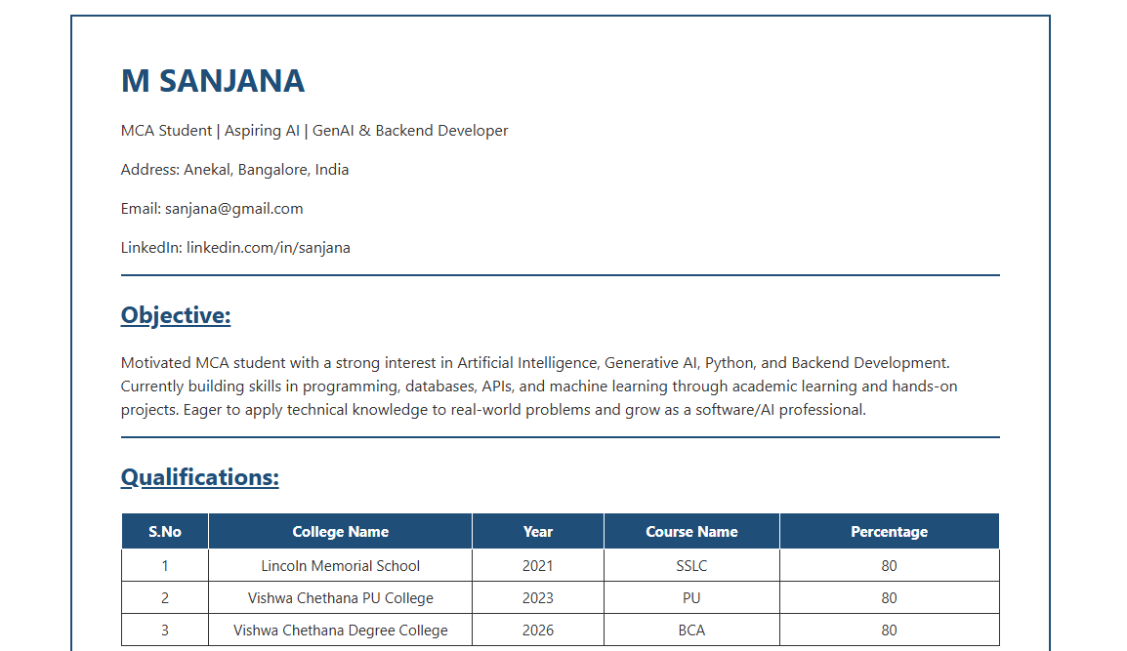

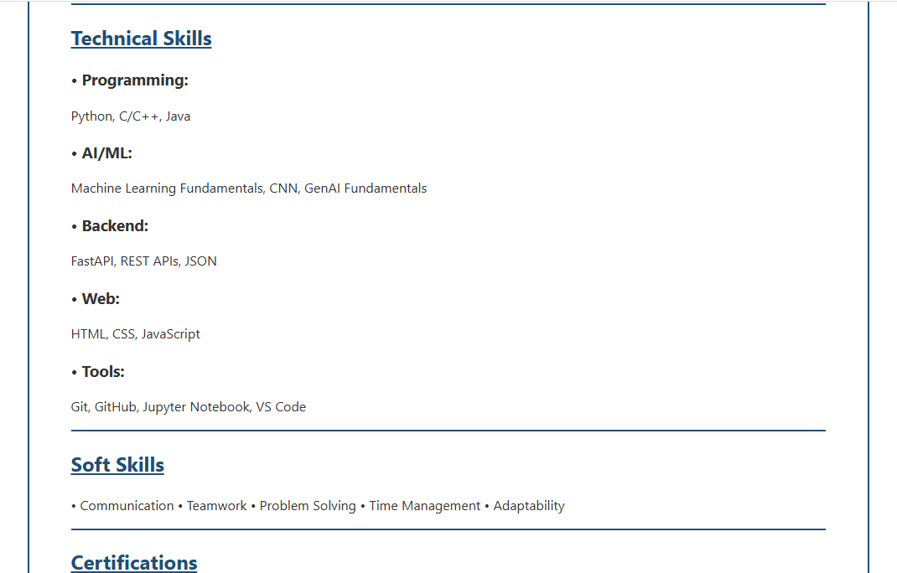

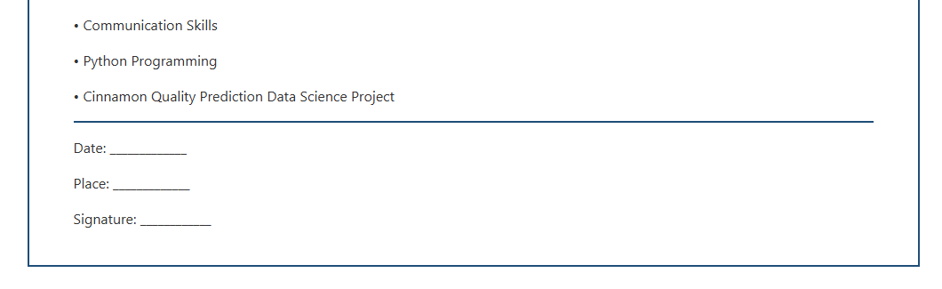

CONCLUSION

The resume webpage was successfully created using HTML and internal CSS. The program demonstrates the use of headings, paragraphs, tables, lists, borders, colors, and text formatting to organize resume information. CSS helps make the webpage more attractive, readable, and professional. Thus, this program provides a basic understanding of designing a structured resume using HTML and CSS.

