House Prices: Regression Techniques
Analysis of how house features add up to its price

Riya John
Department of Computer Science and Engineering
PES University
Bangalore, India
riyajk29@gmail.com
Sharanya R Chakravarthy
Department of Computer Science and Engineering
PES University
Bangalore, India
sharanyarc96@gmail.com
Sanjana S
Department of Computer Science and Engineering
PES University
Bangalore, India
sanjana0796@gmail.com
Shreyasi Chaudhary
Department of Computer Science and Engineering
PES University
Bangalore, India
shreyasi100@gmail.com

Abstract— We build a predictive function to determine the price of a house using the data available. A commonly used predictive modeling method is regression, which has been applied to a wide range of application domains. We propose to build a regression model for home prices using the Ames, Iowa dataset.
Keywords— regression; prediction; decision tree;

Introduction
The housing market has been a topic of attention for many decades and is influenced by a variety of social, political and economic events. Studies on home prices are being done using many models. Property agents and economists analyze trends in the housing markets of entire countries and make predictions based on factors such as market data, surveyor valuations and economic performance. These trends are of importance to those wishing to buy or sell property. They are also indicative of the condition of the economy.
The purchase or sale of a house is an important decision in the lives of many people. This decision is influenced by several factors, such as the affordability of the house, the desirability of the location, viability of the property as a long-term investment, quality of infrastructure, amenities available in the vicinity of the property and so on. Balancing each of these can prove a formidable task for buyers. Knowing what characteristics increase the value of a house can help those wishing to sell a house or make a sound investment.
The goal of our project is to use regression techniques to predict the price of a house given data on different characteristics of the house. To do so, we will use the dataset provided as part of a live challenge on Kaggle. [1]

Summary Of Literature Survey
While conducting the literature survey, we found that techniques such as multiple regression, logistic regression, random forests, Naϊve Bayes classifiers and Support Vector Machines had been used. Some of these did not perform well due to the nature of the data being modelled. Naϊve Bayes assumes that the effect of an attribute value on a given class is independent of the value of other attributes. However, as the dataset contains correlated variables, this assumption is incorrect. Dimensionality reduction and removal of highly correlated variables was also not performed.

Problem Statement
The challenge on Kaggle is based on the Ames Housing dataset. This dataset was compiled by Dean De Cock for use in data science education. It is a modernised and expanded version of the Boston Housing dataset which has long been used. It describes various aspects of residential homes in Ames, Iowa. We obtained training and testing data from the challenge. The training data consist of 1460 observations of 79 explanatory variables, one variable containing the sale price of each house and one containing observation identifiers. The testing data consist of 1459 observations of 80 variables. The goal is to predict the sale prices of the houses in the testing data. The data are from the years 2008, 2009 and 2010. Submissions on Kaggle are evaluated on the Root-Mean-Squared-Error between the logarithm of the actual price and the logarithm of the predicted price.
We will use cross validation techniques on the training data to evaluate the models that we obtain. This is required as the expected outcomes for the testing data are not available to us.
As the data consists of a mix of nominal, ordinal, discrete and continuous variables, some of the variables will have to be suitably transformed before modelling the data.

Proposed System
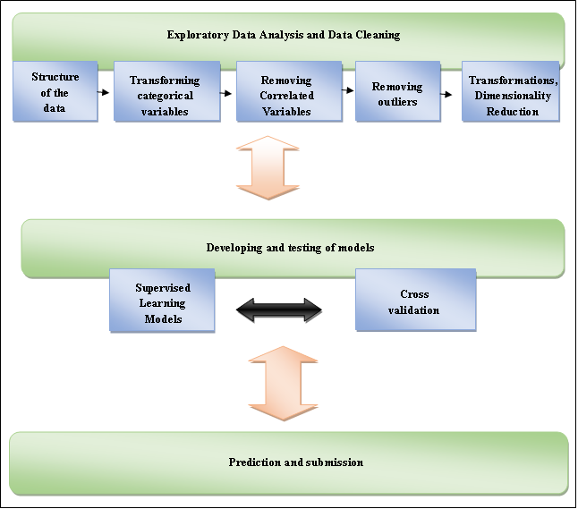
Figure 1 Proposed System
The above figure depicts the methods we used to make the prediction on the data.

System components

Exploratory Data Analysis and Data Cleaning

Structure of the data: The training dataset consists of 1460 observations of 81 variables. The columns include 23 nominal, 23 ordinal, 14 discrete and 20 continuous variables, and 1 observation identifier. Some of the features described by the variables are type of dwelling, zoning classification, size and shape of the lot, access to the property, utilities available, physical location, proximity to amenities, number of rooms, construction and remodelling dates and condition of the property. The value of some of these variables does not vary greatly across the dataset, and hence they are unlikely to influence the sale price of the property. Since a large portion of the variables are categorical, they will have to be transformed before developing models.
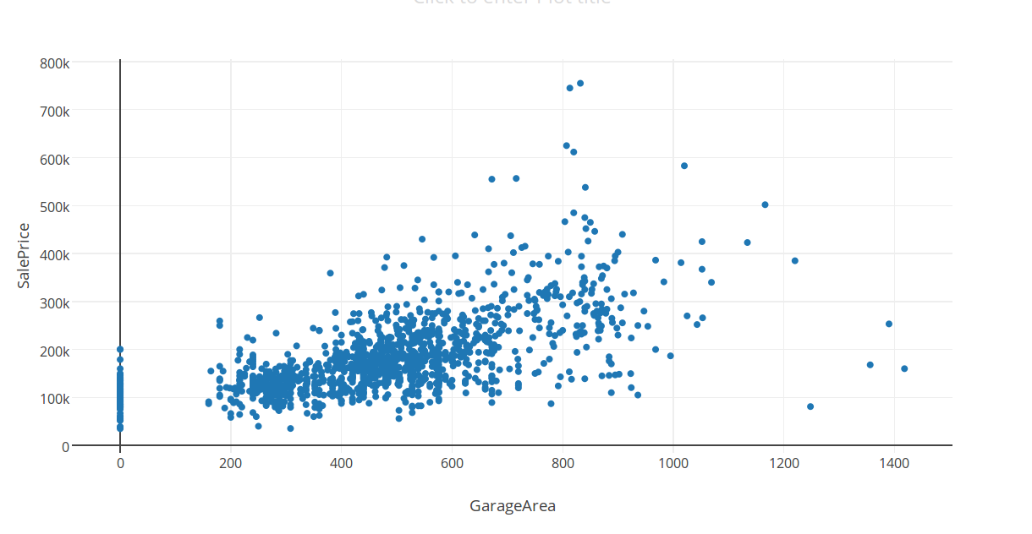
Figure 2 Spread of GarageArea vs. SalePrice

Transformation of Categorical Variables: Nominal variables have outcomes with no ordering between them. In such cases, we created a column for each outcome, with the value in the column being 1 if the outcome was observed and 0 otherwise. For instance, the variable ‘Roof Style’ which describes the type of roof, has the following outcomes: Flat, Gable, Gambrel, Hip Hip, Mansard and Shed (shown in Figure 3). A column would be created for each of these outcomes. An attribute containing ‘n’ attributes is transformed into ‘n’ dummy columns. For ordinal variables, the outcomes are mapped to numerical values that represent the ordering between them. Attributes such as BsmtCond which have values Excellent, Good and Average, are assigned the values 3,2 and 1.

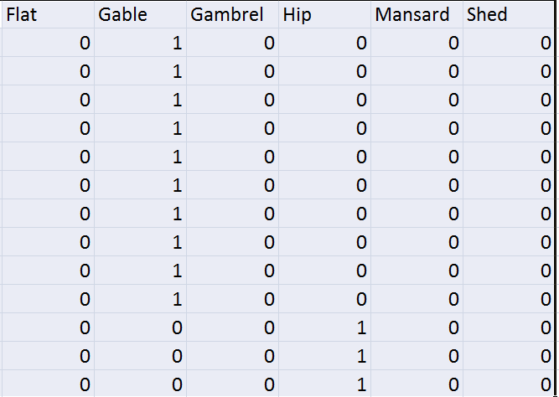
Figure 3 Creation of dummy variables
      - Removal of Correlated Variables: The number of columns in the dataset grew to 229, after transforming the categorical variables. On further inspection we noticed that some variables were highly correlated. Given pairs of columns with correlation greater than 0.9, we dropped one of the columns. Columns with correlation of less than 0.1 with the sale price were also dropped. The resultant dataset was reduced to 89.
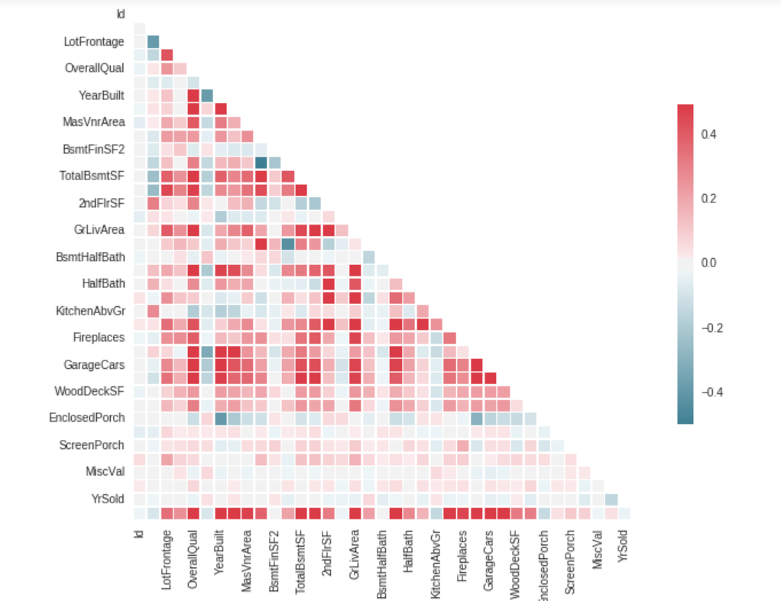
Figure 4 Sample correlations
      - Removing outliers: Regression methods such as multiple regression are sensitive to outliers. We removed outliers based on z-scores.
      - Logarithmic Transformations: Modelling techniques have difficulty with very wide data ranges. Variables representing monetary amounts can be highly skewed. The ideal relationship between input and output variables is linear. We applied logarithmic transformations on the sale price and on numeric attributes with absolute value of skew greater than 0.75. The transformation makes the distribution symmetric. This is shown in Figure 5 and Figure 6.
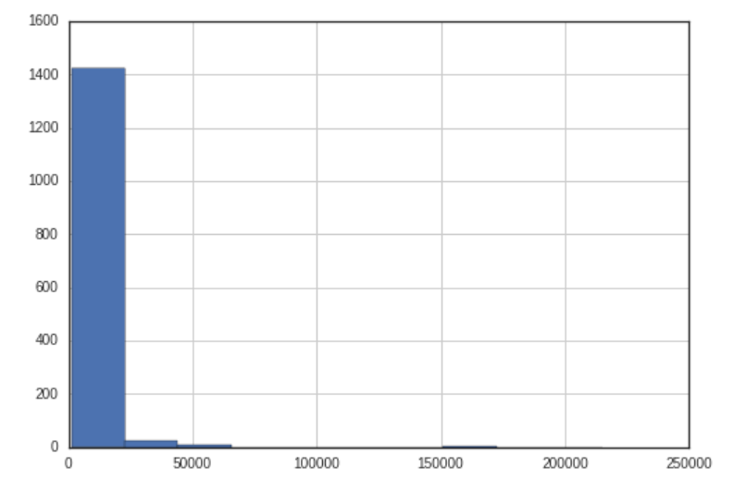
Figure 5 LotArea before log
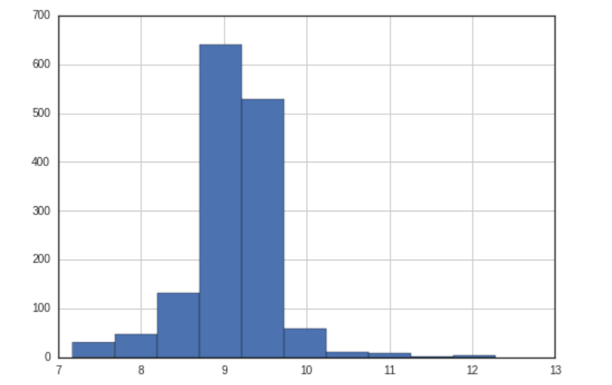
Figure 6 LotArea After log
      - Dimensionaltity Reduction: Dimensionality reduction was performed using the Boruta algorithm in R. Boruta is a feature selection algorithm. It works as a wrapper algorithm around Random Forest. It follows an all-relevant feature selection method where it captures all features which are in some circumstances relevant to the outcome variable.

Development and Testing Of Models

      - Supervised Learning Models: Supervised learning is a machine learning task which predicts a function to map inputs to outputs. The training dataset used is labeled. It consists of observations, each having an input vector and the desired output. We used the following supervised learning techniques to develop models:
- Multiple Regression
- Logistic Regression
- Lasso Regularization
- XGBoost
- Random Forests
- Ridge Regularization
      - K-Fold Cross Validation: In K-Fold cross validation, the training dataset is divided into k subsets or folds. k models are trained by using k-1 folds as the training dataset and 1 fold as the testing dataset. The root mean squared error is calculated as the average of RMSE values obtained from each prediction.

Prediction and Submission
We predicted the test data using all the models and also combined the outputs of different models to see if that improved the accuracy of the prediction. On Kaggle, the submission is evaluated by calculating Root-Mean-Squared-Error between logarithmically transformed actual and predicted values, so that larger sales prices do not contribute to large errors.

Experiments and results

Multiple Linear Regression
The goal of the project was to predict Sale Price from a list independent attributes that describe about a house. And so the first thing that comes into our mind is the most commonly used model – multiple linear regression model. This is because as a predictive analysis, the multiple linear regression is used to explain the relationship between one continuous dependent variable from two or more independent variables.
We split the train data into two sets as we cannot use the test data on Kaggle to verify our output. To build the best model we determined the correlations of each attribute with Sale Price and chose a subset of initial attributes set to build the model and after removing outliers in the given dataset, multiple linear regression was applied.
From the results we found that the R square value was pretty good, it was 0.897. From the adjusted R2 value we can report that about 89.7% of sale price of a house is explained by the model. The p-value obtained was definitely less than 0.05 and hence we can’t reject the model. From the prediction on the test data we got the root mean square error as 38541.04. The root-mean-square deviation (RMSD) or root-mean-square error (RMSE) is a frequently used measure of the differences between values (sample and population values) predicted by a model or an estimator and the values actually observed. The RMSD represents the sample standard deviation of the differences between predicted values and observed values. We believe this is good enough because root mean square error depends on the distribution of data and our sale price range is from 34500 to 755000.
Now to get better results it was found that we could do log transform on the data set and then build the model. So from this model the R square value that we got was around 0.91. And however after the predictions on test data we got root mean square error as 39464.36 which indicates that it is really not necessary to do log transformations on data because it is building a complicated model but not getting better results.

Logistic Regression
In the original dataset we had 43 categorical attributes of the total 76 attributes and most of them were nominal. So we also decided to do logistic regression as there were many binary data. We converted other independent attributes to 0 and 1 form and applied logistic regression.
And as expected it predicted the price range in which the sale price for the given specifications of the house belongs to. If the predicted value was 0 then the price of the house would be in the range 34200 to 395000. And if it is 1 then it will belong to the price range 395000 to 756000.

Lasso Regularisation
It is a form of regression analysis which does both regression and regularization. . Regularization refers to the process of introducing additional information in order to solve an ill-posed problem or to prevent overfitting. Overfitting occurs when the number of attributes is too large relative to the number of observations in the data. While ordinary least squares regression (OLS) gives the Best Linear Unbiased Estimate, the coefficients produced by Lasso regression are biased. If enough iterations are performed, the average of parameters obtained from OLS will be nearly equal to the population parameters. However the variance is lower for Lasso than for OLS as Lasso computes the coefficients subject to the constraint that the L1`Norm of the parameters is less than or equal to a value. This restricts the size of the parameters which in turn ensures that the variance is not too high. Using Lasso regression and k-fold cross validation, we got an average root mean squared error of 0.143302.

Ridge Regularisation
As ridge regression restricts the L2 norm it did not work well with the our data which contains a large number of columns.

XGBOOST
XGBoost creates a series of boosting trees and predicts results using these. The model created by xgboost is similar to the one created by random forests, but the method of training differs. The root mean squared error obtained on performing k-fold cross validation on the train data was 0.1433574.

Random Forests
Random forests are a learning method for regression, that operate by constructing multiple decision trees at training time and outputting the class that is the mean prediction (regression) of the individual trees. For this test data we are constructing 500 decision trees(passed as parameter to the random forest regressor) for prediction.

CONCLUSIONS
Of all the separate models, the best results were obtained from Lasso regression. Combinations of Lasso and XGboost in the ratio 7:3 gave the best overall results. Kaggle score obtained on submission is 0.14401 and a rank of 1032. Random forest predictor performed well on the training data but not on the testing data as a result of overfitting

Acknowledgment
We would like to thank Dr. Gowri Srinivasa, Dept. of Computer Science, PES University and the Department of Computer Science and Engineering, PES University, for giving us the opportunity to do this project.

References
- https://www.kaggle.com/c/house-prices-advanced-regression-techniques
[2] Practical Data Science With R

Contributions
Riya – Multiple Linear Regression, Logistic Regression.
Sanjana- Cleaning of data, Random Forests, combining results of models.
Sharanya – Lasso, Ridge and XGBOOST, report.
Shreyasi – Dimensionality reduction using Boruta, Multiple Linear Regression, removal of oultiers, compiling video.

