**Intelligent Submersible Pump for Irrigation Purposes**

Sanjana Kulkarni, [sanjanakulkarni1995@gmail.com](mailto:sanjanakulkarni1995@gmail.com), +91-9480184370

School of Computer Science and Engineering,

Reva University

Bangalore

***Abstract***

**India, with its villages and thriving agriculture sector, heavily relies on climate conditions for successful cultivation. Unfortunately, the insufficient availability of water sources during the monsoon season poses a challenge. To combat this issue, farmers have resorted to utilizing irrigation methods in their agricultural fields. Notably, bore well electric pumps and lift irrigation systems have become the go-to choices for irrigation in India. These electric pumps, ranging in capacity from 3HP to 15HP, are responsible for efficiently extracting and pumping water. However, many farmers in rural areas encounter multiple problems, such as unscheduled load shedding, under-voltage, over-voltage, dry run scenarios, and consequent motor failures. The high costs associated with motor replacements or repairs have raised concerns among farming communities. Consequently, ongoing research is focused on developing robust motor protection mechanisms to prevent these faults. By incorporating the Internet of Things (IoT) and advanced sensors, an intelligent protection and control system has been designed to safeguard electric motors in agricultural settings.**

Keywords: Internet of Things, Submersible Pump, Sensors, Agriculture Fields, Dry run, Under voltage, over Voltage

# INTRODUCTION

**India, being primarily an agricultural country, heavily relies on farming as the main occupation for a majority of its population. With approximately 70% of the people depending on agriculture, it contributes significantly to the nation's economy. However, despite the sector's crucial role, its share in the country's GDP has declined due to the growth of other sectors. To tackle various challenges faced by farmers, such as inadequate water supply and unreliable power sources, innovative solutions incorporating the Internet of Things (IoT) and intelligent pump control systems are being introduced.**

**In today's interconnected world, the utilization of Embedded Internet of Things (IoT) devices has become increasingly prevalent. These devices are equipped with Wi-Fi communication modules, enabling seamless connection to the Internet. Within the realm of IoT, we encounter various embedded systems such as STM32L4, which assists in discovering IoT nodes, and Node MCU esp8266, a reliable IoT component. Gathering environmental data, particularly temperature and humidity, is made possible through the application of the advanced DHT11 sensor. Employing C++ and similar low-level programming languages, developers can effectively craft IoT devices and implement IoT Cloud software. In this context, the IoT Cloud assumes significance, as it has been specifically modified to handle data processing emanating from IoT devices. With the evolution of IoT, the Cloud has transcended geographical boundaries and can be leveraged from any part of the world. For seamless integration and exchange of information between IoT devices or with the IoT Cloud, access to the Internet is imperative** [1]. In today's interconnected world, the utilization of Embedded Internet of Things (IoT) devices has become increasingly prevalent.. In this context, the IoT Cloud assumes significance, as it has been specifically modified to handle data processing emanating from IoT devices. With the evolution of IoT, the Cloud has transcended geographical boundaries and can be leveraged from any part of the world. For seamless integration and exchange of information between IoT devices or with the IoT Cloud, access to the Internet is imperative.[2].

I**n the revolutionary era of the Internet of Things (IoT), sensors play a pivotal role in enabling advanced environmental sensing, remote surveillance, and health monitoring. Through their sophisticated technology, sensors have become the instrumental link bridging physical objects with digital connectivity, ushering us into a new realm of transformative possibilities.** [3]. We regularly interact with the Internet of Things (IoT) due to the monitoring, measurement, and management of various objects through technologies like RFID, wireless, and WAN. In the field of electronic engineering, a significant number of commercial operations focus on embedded systems, and many embedded devices run code in C/C++. Traditional programming tasks in C/C++, such as text and graphics support for Windows and Linux, are common. C/C++ API built-in module sensors are utilized for liquid-level monitoring in storage tanks, containers, and tanks. Different liquid-level measurement techniques, including magnetic, radar, and ultrasonic, have been employed due to variations in the measurement range, installation conditions, and liquid type, which require different sensor specifications. Water level sensors are critical for monitoring the water level in storage tanks used in drinking water distribution systems.[4].

LITERATURE SURVEY

The Electric Submersible Pump (ESP) plays a vital role in achieving a high recovery percentage in the oil and gas industry. These pumps are commonly either low-speed progressive cavity pumps or multi-stage high-speed centrifugal pumps. Traditionally, an enclosed submersible induction motor (IM) is used to power the ESP. These pumps are typically employed to extract oil and gas from deep reservoirs. They are placed inside wells that can reach depths of hundreds or even thousands of feet underground. The ESP is powered by long cables connected to a variable speed drive (VSD) on the platform. Unfortunately, conventional IPM drives with position sensor-based speed controllers cannot be utilized by ESPs [4].A range of straightforward drivers for file systems, network, and easy-to-use APIs have been developed to enhance the input-output capabilities of the NXP1768 chip [5].

The submersible diaphragm pump finds extensive use in oil wells, but this utilization often leads to various issues such as wax deposition, corrosion of oil pipes, cable damage and obstruction in monitoring pump parameters. These damages result in expensive and easily worn pipe rods etc[6]. IMs have lower efficiency and thermal stability due to power losses in the rotor through slippage. The energy efficiency of ESP depends on the reduction of energy losses in the supply channel. Converters for energy-efficient SEM control are available in the country and abroad. PMSM-controlled ESPs offer better efficiency, smaller dimensions, wider operating range, lower heat generation, and superior performance than equivalently sized IM-controlled ESPs. However, PMSM-ESP faces control problems due to the nonlinearity of PM motors [7].

Inductive loads such as AC and DC motors are considered common in industrial applications. In industry, three-phase induction machines are popular, for domestic use, single-phase induction motors are preferred for their low maintenance, low operating costs, robust construction, and also for their efficiency and reliability. Motors can face damage such as cooling, temperature and vibration, lubrication, stator, rotor, bearing, winding failures. Even small problems will result in damages and financial losses. Monitoring of motors and their parameters is necessary to avoid damage. Thanks to IoT technology, engines can monitor and facilitate data communication between machines [8].

It is important to identify errors while they are still being created. According to the literature, the most damaging faults in electrical equipment are stator and bearing abnormalities, which account for more than 80% of induction motor problems. Stator rotation faults are caused by aging and damage to the windings, as well as other insulation techniques used in the construction of new motors. Once thresholds are exceeded, the insulation continues to degrade, resulting in thermal hot spots that affect stator rotation. Similarly, the main causes of bearing-related failures include aging, continuous loss of lubricant, and the viscosity of the lubricant used for this purpose. As a result, the rolling balls of the bearings begin to seize [9].

The Internet of Things (IoT) has recently received much study attention and has emerged as a very promising technological paradigm. The number of devices connected to the Internet of Things is expected to increase dramatically, from 26 to 50 billion in 2020 to a staggering 100 billion in 2030. Wireless sensor networks (WSNs) perform better when the Internet of Things (IoT) is used, especially in applications such as environmental and healthcare monitoring. IoT has made it easy for consumers to get real-time environmental and physiological data from anywhere, anytime through web browsers or mobile apps. The Internet of Things (IoT) enables seamless data collection, wireless networking, cloud storage, and analytics that are critical to the design and deployment of wearable sensor network systems. [10].

Wearable Body Area Network (WBAN), a specific kind of WSN, is widely used to monitor physiological signals and improve overall well-being and quality of life. For example, the study used WBANs to monitor safety-related variables such as temperature, humidity, and ultraviolet (UV) radiation levels. The design and deployment of a Wearable Sensor Network (WSN) using the Internet of Things (IoT) has a number of advantages for the wearable technology industry, some of which are specified below: 1. Data collection 2. Wireless connectivity 3. Storage on cloud platforms also enables data processing, analysis and long-term storage 4. Data analytics: Data analytics technologies that can process and analyze sensor-collected data are included in the IoT. Various machine learning algorithms can detect patterns and similarities in data to offer insightful information about people's health. [10]. Both IoT and automation are interconnected and used to provide highly efficient and cost-effective solutions for agricultural systems [11].

The effectiveness of IOT and automation is evident for the following reasons:

1. Diverse connectivity: IOT can connect and connect a wide range of devices, from mobile devices and tablets to stand-alone devices, enabling comprehensive monitoring and control

2. Reduced dependence on human labor: Both IOT and automation are essential to reduce the need for human resources and reduce the possibility of human error, leading to more reliable and consistent results.

3. Remote Monitoring: In agriculture, farmers can use a variety of equipment to remotely monitor crop and soil health from any location, enabling quick intervention and decision-making.

4. Time-saving: IOT and automation simplify the report generation and monitoring process, saving farmers valuable time and effort.

5. Advanced analytics: IoT and automation facilitate a wide range of analytics, such as monitoring average rainfall and evaluating soil condition gradients, providing valuable insights for informed agricultural decision-making.[11].

Arduino UNO: An open-source microcontroller board that features sets of analog and digital I/O pins, devices.

16x2 Liquid Crystal Display: An electronic device generally used as a screen in TVs, PCs, and smartphones, which helps to control the device independently and displays moving images.

pH sensor: One of the most important tools for water management. pH sensors measure the amount of acidity and alkalinity in water and other solutions. pH values ​​also help us find the deficiency or effectiveness of pesticides or fertilizers used.

DHT11: The DHT11 is a temperature and humidity sensor that provides a simple and easy-to-read interface for reading humidity and temperature. These can be used mainly in the fields to select a suitable environment for growing crops.

Soil Moisture Sensor: A device based on Ohm's Law that uses resistance to calculate soil moisture and display the moisture level in the crop.

GSM module: GSM modules are communication modules that use mobile networks to wirelessly receive and send data, creating a communication link between the device and the network.[11].

Ultrasonic sensor: An ultrasonic sensor is used to measure the distance from a certain point or location. A high frequency sound wave is emitted and at this point an echo is picked up from the object.

Wi-Fi Module: A device that allows Wi-Fi signals to be transmitted to smart devices such as laptops and phones, allowing users to gain high-speed network access. A popular example of such a module is the ESP8266 module. It enables us to meet the demands of the IoT industry [12].

The fault distance calculation is based only on local transient measurements and uses the reflection pattern of traveling waves generated by the fault. While in many other works the Rogowski coil is the preferred solution for step wave measurement, this work is based on the idea of ​​using capacitive voltage sensors in a medium voltage substation. [13].

Water can be saved without being wasted thanks to the Internet of Things and sensors; this system shuts off the motor when the water level reaches the top of the tank, reducing water wastage. Even though the water tank is full, constant use of the engine wastes both water and electricity. So the IOT will undo the man's mistakes by turning off the engine. The relay that connects the motor consists of an oscillator connected to the tank and an IC connected to the circuit that controls how the circuit turns on and off. [14].

IoT can be used to manage water resources, bringing with it a reliable and affordable method of monitoring water levels. A system for monitoring the water level and the ability to act quickly and autonomously to prevent losses. Applications for water level monitoring systems include food grain storage and residential areas. Pumps that can be completely submerged in water are referred to as submersible pumps, often known as electric submersible pumps. A 3-6V source is used for power supply [15].

ADVANCEMENTS

In this paper, it is planned to design a normal irrigation submersible pump to:

1. To automatically control the operations of the motor through mobile using IoT.
2. To control the pump set from getting burned due to dry run, detect the Water level inside the Borewell using the sensors and switch off the motor under no or low water conditions.
3. To have a safe operation of the pump set without any interruption.
4. To detect the under-voltage, over-voltage, phase-out faults, and temperature of the motor.
5. To detect the humidity of soil.
6. Provide the user with the parameter values on the above-mentioned input and alert the user on the occurrence of faults.

DESIGN

In this section, the solution with a project to overcome the problem of electric pumps getting damaged(burnt) due to under-voltage, over-voltage, and sometimes phase blank-out problems has been designed. An equivalent circuit approach is chosen for analysis. Water Level Sensors, Voltage sensors, and Temperature sensors are studied, and selected and require Timer, Atmega8 microcontroller, 16 BIT LCD, ADC, USART, Raspberry Pi, Electro Magnetic Relay are the components of the project prototype. The program for the operation of LCD, Relay data transmission, and display are programmed using embedded C language.

BLOCK DIAGRAM

Figure A: Block Diagram of Intelligent Submersible Pump

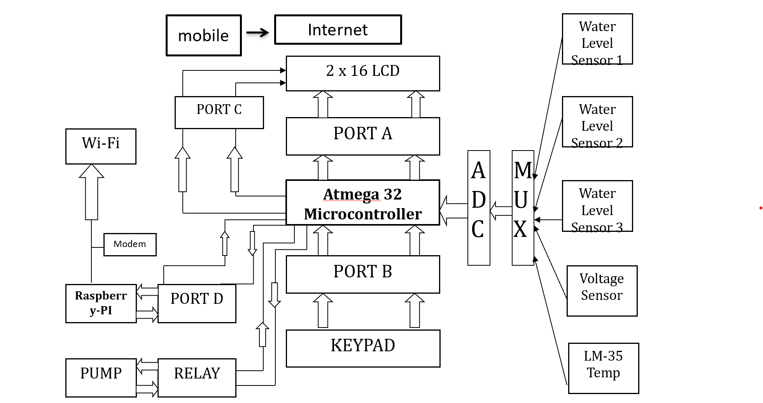

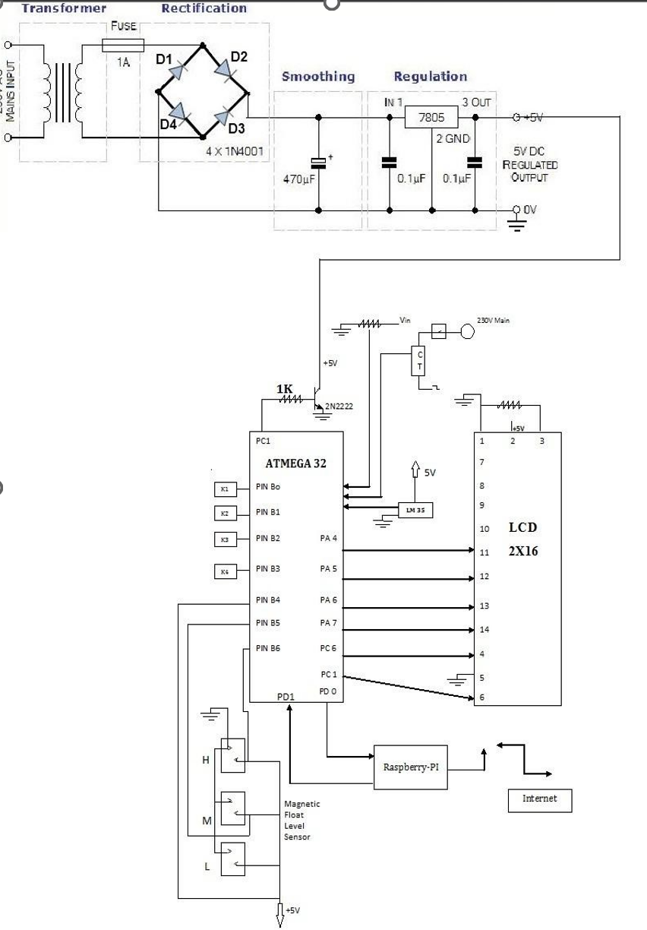CIRCUIT DIAGRAM IMPLEMENTATION

Figure B: Circuit Diagram Implementation of Intelligent Submersible Pump

The above Diagram represents circuit diagram of the module.

1. ATmega32 microcontroller.
2. LCD
3. Step down Transformer.
4. NPN Transistor.
5. Keyboard.
6. Rectifier
7. Water level sensors.
8. Temperature sensors.
9. Raspberry PI.
10. Voltage Sensor.

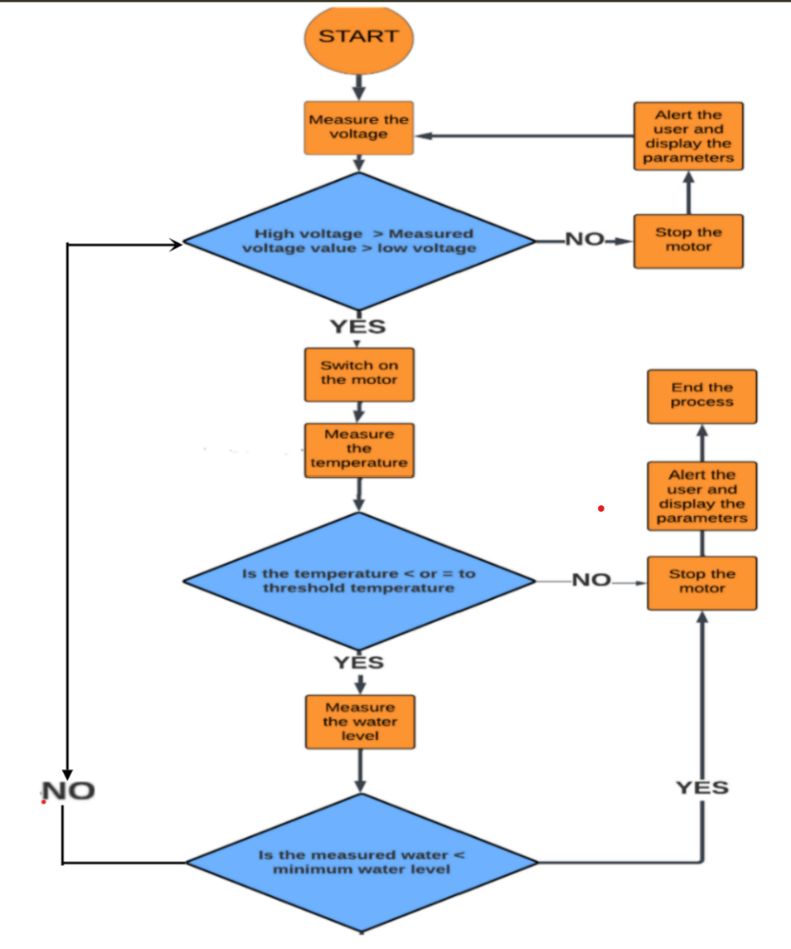FLOW CHART IMPLEMENTATION AND DEVICE DESIGN

Figure C: Flow Chart Implementation and Device Design of Intelligent Submersible Pump

ELECTRONIC COMPONENTS

Atmega32 Pin Diagram  Specifications

1. High-performance, Low-power AVR 8-bit Microcontroller.
2. Advanced RISC Architecture
   * + 131 Powerful Instructions – Most Single-clock Cycle Execution
     + 32 x 8 General Purpose Working Registers
     + Fully Static Operation
     + Up to 16 MIPS Throughput at 16 MHz
     + On-chip 2-cycle Multiplier
3. Non-volatile Program and Data Memories
   * + 32K Bytes of In-System Self-Programmable Flash

Endurance: 10,000 Write/Erase Cycles

* + - Optional Boot Code Section with Independent Lock Bits

In-System Programming by On-chip Boot Program

True Read-While-Write Operation

* + - 1024 Bytes EEPROM

Endurance: 100,000 Write/Erase Cycles

* + - 2K Byte Internal SRAM
    - Programming Lock for Software Security.

1. JTAG (IEEE std. 1149.1 Compliant) Interface
   * + Boundary-scan Capabilities According to the JTAG Standard
     + Extensive On-chip Debug Support
     + Programming of Flash, EEPROM, Fuses, and Lock Bits through the JTAG

Interface.

1. Peripheral Features
   * + Two 8-bit Timer/Counters with Separate Prescalers and Compare Modes
     + One 16-bit Timer/Counter with Separate Prescaler, Compare Mode, and Capture mode.
     + Real-Time Counter with Separate Oscillator
     + Four PWM Channels
     + 8-channel, 10-bit ADC
     + 8 Single-ended Channels
     + 7 Differential Channels in TQFP Package Only
     + 2 Differential Channels with Programmable Gain at 1x, 10x, or 200x
     + Byte-oriented Two-wire Serial Interface
     + Programmable Serial USART
     + Master/Slave SPI Serial Interface
     + Programmable Watchdog Timer with Separate On-chip Oscillator ➢ On-chip Analog Comparator.
2. Special Microcontroller Features
   * + Power-on Reset and Programmable Brown-out Detection
     + Internal Calibrated RC Oscillator
     + External and Internal Interrupt Sources
     + Six Sleep Modes: Idle, ADC Noise Reduction, Power-save, Power-down, Standby and Extended Standby.
3. I/O and Packages
   * + 32 Programmable I/O Lines
     + 40-pin PDIP, 44-lead TQFP, and 44-pad MLF.
4. Operating Voltages ➢ 2.7 - 5.5V for Atmega32L ➢ 4.5 - 5.5V for Atmega32.
5. Speed Grades
   * 0 - 8 MHz for Atmega32L
   * 0 - 16 MHz for Atmega32.
6. Power Consumption at 1 MHz, 3V, 25C for ATmega32L
   * Active: 1.1 mA
   * Idle Mode: 0.35 mA
   * Power-down Mode: < 1 μA.

PIN DIAGRAM

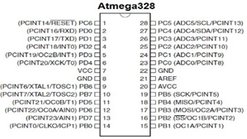Figure A represents a pin diagram of Atmega32.

Figure D: Pin configuration of Atmega 32

VCC: Digital supply voltage; GND: Ground.

Pin Configuration

1. Port A (PA7…. PA0): Port A serves as the analog input to the A/D Converter. Port A also serves as an 8-bit bi-directional I/O port, if the A/D Converter is not used. Port pins can provide internal pull-up resistors (selected for each bit). The Port A output buffers have symmetrical drive characteristics with both high sink and source capability. When pins PA0 to PA7 are used as inputs and are externally pulled low, they will source current if the internal pull-up resistors are activated. The Port A pins are tri-stated when a reset condition becomes active, even if the clock is not running.
2. Port B (PB7…. PB0): Port B is an 8-bit bi-directional I/O port with internal pull-up resistors (selected for each bit). The Port B output buffers have symmetrical drive characteristics with both high sink and source capability. As inputs, Port B pins that are externally pulled low will source current if the pull-up resistors are activated. The Port B pins are tri-stated when a reset condition becomes active, even if the clock is not running. Port B also serves the functions of various special features of the ATmega32 as listed.
3. Port C (PC7…. PC0): Port C is an 8-bit bi-directional I/O port with internal pull-up resistors (selected for each bit). The Port C output buffers have symmetrical drive characteristics with both high sink and source capability. As inputs, Port C pins that are externally pulled low will source current if the pull-up resistors are activated. The Port C pins are tri-stated when a reset condition becomes active, even if the clock is not running. If the JTAG interface is enabled, the pull-up resistors on pins PC5 (TDI), PC3 (TMS), and PC2 (TCK) will be activated even if a reset occurs. The TD0 pin is tri-stated unless TAP states that shift-out data are entered. Port C also serves the functions of the JTAG interface and other special features of the ATmega32 as listed.
4. Port D (PD7… PD0): Port D is an 8-bit bi-directional I/O port with internal pull-up resistors (selected for each bit). The Port D output buffers have symmetrical drive characteristics with both high sink and source capability. As inputs, Port D pins that are externally pulled low will source current if the pull-up resistors are activated. The Port D pins are tri-stated when a reset condition becomes active, even if the clock is not running. Port D also serves the functions of various special features of the ATmega32 as listed.
5. RESET: Reset Input. A low level on this pin for longer than the minimum pulse length will generate a reset, even if the clock is not running. Shorter pulses are not guaranteed to generate a reset.

## 

## Analog to Digital Converter

Features:

* 10-bit Resolution
* 0.5 LSB Integral Non-linearity
* ±2 LSB Absolute Accuracy
* 13 - 260 µs Conversion Time
* Up to 15 KSPS at Maximum Resolution
* 8 Multiplexed Single Ended Input Channels
* 7 Differential Input Channels
* 2 Differential Input Channels with Optional Gain of 10x and 200x(1)
* Optional Left adjustment for ADC Result Readout
* 0 - VCC ADC Input Voltage Range
* Selectable 2.56V ADC Reference Voltage
* Free Running or Single Conversion Mode
* ADC Start Conversion by Auto Triggering on Interrupt Sources ➢ Interrupt on ADC Conversion Complete.

Atmega32 features a 10-bit successive approximation ADC Figure 3.4 represents the circuit diagram of Atmega328. The ADC is connected to an 8-channel Analog Multiplexer which allows 8 single-ended voltage inputs constructed from the pins of Port A. The single-ended voltage inputs refer to 0V (GND). The device also supports 16 differential voltage input combinations. Two of the differential inputs (ADC1, ADC0, and ADC3, ADC2) are equipped with a programmable gain stage, providing amplification steps of 0 dB (1x), 20 dB (10x), or 46 dB (200x) on the differential input voltage before the A/D conversion. Seven differential analog input channels share a common negative terminal (ADC1), while any other ADC input can be selected as the positive input terminal. If 1x or 10x gain is used, an 8-bit resolution can be expected. If 200 x gains are used, a 7-bit resolution can be expected.

LCD (Liquid Crystal Display)

### Introduction to the LM018L

The Hitachi LM018L is a 40-character x 2-line reflective type Liquid Crystal character display module. It includes a built-in LSI controller HD44780 which provides a range of features mentioned below:

1. 192 5x7-dot characters plus 8 user-defined characters.
2. Instruction functions
3. Display Clear
4. Cursor Home
5. Display On/Off
6. Cursor On/Off
7. Character Display Blink
8. Cursor Shift
9. Display Shift

The module can be directly interfaced to a 4-bit or 8-bit MPU.

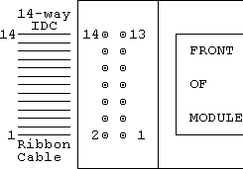Interfacing of LM018L

Figure E: Interfacing of LM018L

When the interface is 4 bits wide, data is transferred via DB4-DB7 only. DB0-DB3 are not used. Data transfer between the HD44780 and the MPU is complete when 4-bit data is transferred twice. Data of the higher order 4 bits (contents of DB4-DB7 when the interface is 8bits wide) is transferred first and then the lower order 4 bits (contents of DB0-DB3 when the interface is 8-bits wide) Figure B represents LM018L interfacing.

When the interface is 8-bits wide, data is transferred using DB0-DB7.

Absolute Maximum Ratings mentioned below:

1. Power supply for logic (Vdd - Vss) . . . 0v min, 6.5v max
2. Power supply for LCD drive (Vdd - Vo) . . . 0v min, 6.5v max

Electrical Characteristics:

1. Input "high" voltage . . . . . . . . . . 2.2v min
2. Input “low" voltage . . . . . . . . . . 0.6v max
3. Output "high" voltage . . . . . . . . . . 2.4v min
4. Output “low" voltage . . . . . . . . . . 0.4v max
5. Power supply current . . . . . . . . . . 2.0mA type, 3.0mA max

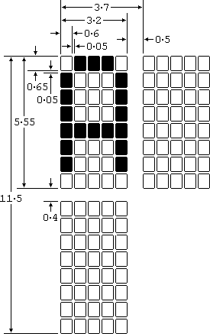LM018L displays pattern and character set and Figure C represents 5x7 dot character set.

Figure F: 5x7 dot Character Set

## 

## Rectifier

A rectifier is an electrical device that converts alternating current (AC), which periodically reverses direction, to direct current (DC), which flows in only one direction. The process is known as rectification since it "straightens" the direction of current, Figure C indicates the bridge rectifier.

Physically, rectifiers take a number of forms, including vacuum tube diodes, mercury-arc valves, stacks of copper and selenium oxide plates, semiconductor diodes, silicon-controlled rectifiers, and other silicon-based semiconductor switches.

Historically, even synchronous electromechanical switches and motors have been used. Rectifiers have many uses but are often found to serve as components of DC power supplies and high-voltage direct current power transmission systems.

A diode bridge is an arrangement of four (or more) diodes in a bridge circuit configuration that provides the same polarity of output for either polarity of input. When used in its most common application, for the conversion of an alternating current (AC) input into a direct current (DC) output, it is known as a bridge rectifier.

A bridge rectifier provides full-wave rectification from a two-wire AC input, resulting in lower cost and weight as compared to a rectifier with a 3-wire input from a transformer with a center-tapped secondary winding. The essential feature of a diode bridge is that the polarity of the output is the same regardless of the polarity at the input.

### Purpose

To convert the AC voltage into suitable DC voltage for the power supply of the microcontroller.

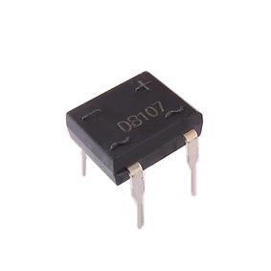

Figure G: DB105 Bridge Rectifier

## Voltage Sensor

Voltage sensors are used for voltage and current monitoring. Voltage sensors are widely used for the electronic measurement of currents: DC, AC, pulsed, and mixed, with a galvanic isolation between the primary circuit (high power) and the secondary circuit (electronic circuit); Figure D indicates the voltage sensor.

### Features

1. Closed loop (compensated) multi-range current transducer using the Hall effect
2. Unipolar voltage supply. Compact design for PCB mounting. Isolated plastic case recognized according to UL 94-V0
3. Incorporated measuring resistance. Extended measuring range.

Advantages

1. Excellent accuracy.
2. Very good linearity and very low-temperature drift.
3. Optimized response time and wide frequency bandwidth.
4. No insertion losses and high immunity to external Interference.
5. Current overload capability.

### Purpose

The Voltage sensor has been used to sense the over-voltage and under-voltage intern it sends the signal to the microcontroller.

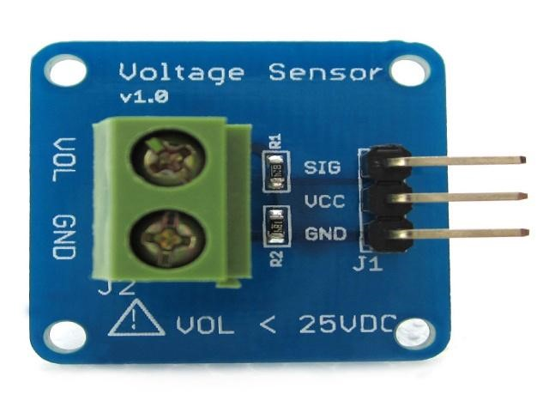

Figure H: Voltage Sensor

[-](http://cdn.buysnip.com/Voltage-detection-module-Voltage-Sensor-for-arduino-01.jpg)

## Submersible Pumps

Submersible pumps are magnetically driven pumps that are placed inside the tube well. They are efficient, convenient, and small, but come with a few caveats.

Specifications:

1. Voltage rating: 230V AC
2. Current rating: 3mA
3. Power: 7W
4. Quax: 450L/H

### Purpose

This pump is used as a demo pump to make it work as per our Control Designs.

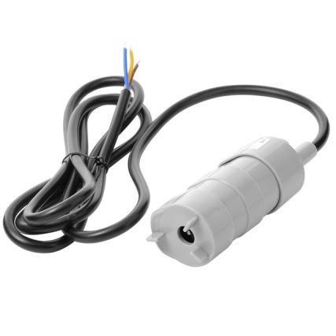

Figure I: Submersible Pump

## Raspberry PI

The Raspberry Pi is a series of small [single-board computers](https://en.wikipedia.org/wiki/Single-board_computer) developed in the [United Kingdom](https://en.wikipedia.org/wiki/United_Kingdom) by the [Raspberry Pi Foundation](https://en.wikipedia.org/wiki/Raspberry_Pi_Foundation) to promote the teaching of basic [computer science](https://en.wikipedia.org/wiki/Computer_science) in schools and in [developing countries.](https://en.wikipedia.org/wiki/Developing_countries) The Raspberry Pi Foundation recommends the use of [Raspbian,](https://en.wikipedia.org/wiki/Raspbian) a [Debian-](https://en.wikipedia.org/wiki/Debian)based [Linux](https://en.wikipedia.org/wiki/Linux) operating system. Most Raspberry Pi chips could be [over-clocked](https://en.wikipedia.org/wiki/Overclocking) to 800 MHz, and some to 1000 MHz There are reports the Raspberry Pi 2 can be similarly over-clocked, in extreme cases, even to 1500 MHz

Newer versions of the firmware contain the option to choose between five over-clock ("turbo") pre-sets that when used; attempt to maximize the performance of the SoC without impairing the lifetime of the board. This is done by monitoring the core temperature of the chip, the CPU load, and dynamically adjusting clock speeds and the core voltage. When the demand is low on the CPU or it is running too hot the performance is throttled, but if the CPU has much to do and the chip's temperature is acceptable, performance is temporarily increased with clock speeds of up to 1 GHz depending on the individual board and on which of the turbo settings is used, Figure G represents Raspberry Pi.

Purpose

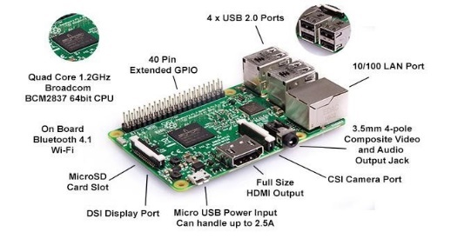Raspberry PI is used to monitor and control the operations of the put through wireless mode.

Figure J: Raspberry

## SUMMARY

This chapter gives a detailed explanation of the design and fabrication of the power module and control circuit using IoT. It will also provide brief explanations and information on Relays, ATmega32 microcontrollers, Bridge rectifiers, Raspberry PI, Solar panels, and Small Submersible pumps. This chapter also speaks about the complete working principle and mechanism of the design and fabrication of the intelligent Pump. It includes the details of the various components used in the fabrication of the prototype. The specifications of each component are in detail, and ratings of various components are finalized to obtain the expected output.

## CONCLUSIONS

In this project, an intelligent protection and control system has been designed and developed for the protection of ielectric motors/pumps used for irrigation purposes using IoT and sensors. The prototype model has been developed, which protects the motor against under-voltage, over-voltage, temperature, and dry run. The project is designed for the detection of water levels, voltage levels, and temperature levels of submersible pumps and to perform safer operation and protection of the system against various faults. The usage of the Raspberry Pi system provides information to the user about the operating condition of the pump and also to control the submersible pump through wireless mode. The project aims to work efficiently by using magnetic fluid level sensors, voltage level sensors, and LM35 temperature sensors to reduce the interruptions for the working of submersible pumps.

In this project, the motor used for irrigation purposes is automatically protected from various faults such as over-voltage, Under Voltage, High temperature, and Dry run of motor. The operating conditions of the complete system will be received by the user with the help of Internet.

FUTURE WORK

* Mobile applications can be developed for easier operations with advanced features.
* Advanced temperature sensors and motor vibration sensors can be used for high-rating pumps to detect mechanical faults in the pump.
* The idea for an autonomous pump system in the future with solar-powered irrigation systems, windmills, and natural energy usage systems that will not require any human intervention can be adopted.

References:

1. Neven Nikolov and Ognyan Nakov, "Research of Communication Between IoT CloudStructure, Android Application and IoT DeviceUsing TCP Sockets", Electronica 2019, Bulgaria, 1000 Sofia, Proc. X National Conference with International Participation "Electronica 2019", May 16 - 17, 2019, Sofia, Bulgaria,978-1-7281-3622-6/19 ©2019 IEEE.
2. Dr.M.Thiyagarajan,ChaitanyaRaveendra "INTEGRATION IN THE PHYSICAL WORLD I IoT USING ANDROID MOBILE APPLICATION ",India ,Tamil Nadu,978-1-4673-7910-6/15 @c 2015 IEEE.
3. Saswat Kumar Ram,Shubham Chourasia,Banee Bandana Das,Ayas Kanta Swain,Kamalakanta Mahapatra,Saraju P. Mohanty ,"A Solar Based Power Module for Battery-Less IoT Sensors Towards Sustainable Smart Cities", IEEE DOI, Rourkela, India,2159-3477/20 ©2020 IEEE DOI 10.1109/ISVLSI49217.2020.00-14.
4. Thomas R. Brinner, “Induction versus permanent-magnet motors for electric submersible pump field and laboratory comparisons,” IEEE Transactions on Industry, Applications, vol. 50, pp. 174-181, 2014.
5. James O. Hamblen, Zachery C. Smith, and Winne W. Woo, "Introducing Embedded Systems in the first C/C++ Programming Class", Atlanta, Georgia USA,978-1-4799-0142-5/13 ©2013 IEEE.
6. Xiaoke Ji, Mao Li*, Wangming Zhou, Yazhou Liu, Na Liang, Xiangqian Xu "Application Research of submersible diaphragm pump based on nonmetal coiled tubing “, Xi’an, China, 2021 IEEE 6th International Conference on Intelligent Computing and Signal Processing (ICSP 2021).
7. Rabbi, S. F., Rahman, M. A., Sarker, M. M., & Butt, S. D. (2015, September). Modeling and performance evaluation of a hysteresis IPM motor drive for electric submersible pumps. In *2015 IEEE Energy Conversion Congress and Exposition (ECCE)* (pp. 4105-4112). IEEE.
8. Abid, G., Shaikh, S. A., Shaikh, M. F., Rajput, S. H., Majeed, U. A., & Shaikh, A. M. (2020, January). IOT based Smart Industrial panel for controlling Three-phase Induction motor. In *2020 3rd International Conference on Computing, Mathematics and Engineering Technologies (iCoMET)* (pp. 1-8). IEEE.
9. Surya, G. N., Ballal, M. S., & Khan, Z. J. (2017, December). Application of observer coil technique for detection of stator turn fault and damaged bearing in cage motors. In *2017 National Power Electronics Conference (NPEC)* (pp. 296-301). IEEE.
10. Wu, F., Wu, T., & Yuce, M. R. (2019, April). Design and implementation of a wearable sensor network system for IoT-connected safety and health applications. In *2019 IEEE 5th World Forum on Internet of Things (WF-IoT)* (pp. 87-90). IEEE..
11. Puranik, V., Ranjan, A., & Kumari, A. (2019, April). Automation in agriculture and IoT. In *2019 4th international conference on internet of things: smart innovation and usages (IoT-SIU)* (pp. 1-6). IEEE.
12. Suresh, M., Anbarasi, M. S., & PraveenKumar, V. (2020, July). An intelligent smart street light system with predictive model. In *2020 International Conference on System, Computation, Automation and Networking (ICSCAN)* (pp. 1-4). IEEE.
13. Ismail, S., Dawoud, D. W., Ismail, N., Marsh, R., & Alshami, A. S. (2022). IoT-Based Water Management Systems: Survey and Future Research Direction. *IEEE Access*, *10*, 35942-35952.
14. Reddy, P. J. P., Viswanadh, G., & Singh, S. K. (2021, April). IOT based Smart Water Pump Switch. In *2021 2nd International Conference on Intelligent Engineering and Management (ICIEM)* (pp. 534-538). IEEE.
15. Kulkarni, S. A., Raikar, V. D., Rahul, B. K., Rakshitha, L. V., Sharanya, K., & Jha, V. (2020, December). Intelligent water level monitoring system using IoT. In *2020 IEEE International Symposium on Sustainable Energy, Signal Processing and Cyber Security (iSSSC)* (pp. 1-5). IEEE.