**Abstract:**

Agriculture is the primary source of income for India's largest population and a significant contributor to the country's economy. The Internet of Things (IoT) is a technology that allows a mobile device to monitor a gadget's function. The Internet of Things (IoT) is a network technology that senses data from various sensors and allows anything to connect to the Internet to exchange data. This will be accomplished via a more advanced communication device, such as a Wi-Fi module. The information gathered by the sensors is transformed into useful information and transmitted to the user. A handheld device, such as a cell phone or a tablet or a laptop, can be used to see the data

**Introduction:**

India is a village-based country, and agriculture is critical to the country's prosperity. Agriculture in our country is reliant on the monsoons, which are in short supply. As a result, irrigation is utilised in the agricultural sector. Water is delivered to plants in an irrigation system based on the soil type. In agriculture, two things are critical: first, obtaining information on voltage, and second, measuring the temperature content of the coil winding. Different solutions are now available for irrigation, which are utilised to lessen the reliance on rain. Electrical power and on/off scheduling are the primary drivers of this strategy. Temperature and humidity sensors are put near the motor, as well as near the module and gateway unit handles, in this strategy

# **METHODOLOGY**

The main objective of this project is to develop an IoT based controlling of water pump based on the following parameters and to analyze sensors data to take certain precautions on field. Automated systems need fewer manual procedures, are more reliable, flexible, and accurate. We'll build a smart agricultural monitoring system that can collect vital agricultural data and transfer it in real time to an IoT platform called Thingspeak, where it can be documented and analysed. Because the data in Thingspeak is in graphical format , a botanist or a relatively knowledgeable farmer may analyse the data to make appropriate modifications in the given resources in order to achieve precautionary measures of water pump.

**HARDWARE USED**

* + - NodeMCU ESP8266
    - DHT11
    - Voltage controlling circuit
    - Water pump
    - 5V Relay
    - Piezo electric Buzzer

**NODE MCU ESP8266**

**Pin details**

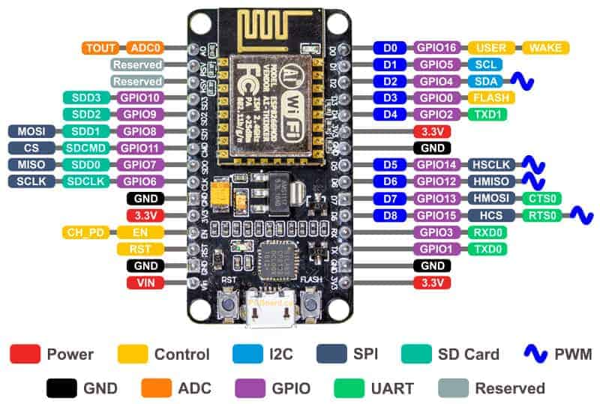

#### 

.

#### RELAY

#### Relays - Single Channel Relay Manufacturer from Chennai

#### A 5v relay is an automatic switch that is commonly used in an automatic control circuit and to control a high-current using a low-current signal. The input voltage of the relay signal ranges from 0 to 5V.

### Relay Pin Configuration

The pin configuration of the 5V relay is shown below. This relay includes 5-pins where each pin and its functionality are shown below.

#### Relay Pin Diagram

**Pin1 (End 1):** It is used to activate the relay; usually this pin one end is connected to 5Volts whereas another end is connected to the ground.

**Pin2 (End 2):** This pin is used to activate the Relay.

**Pin3 (Common (COM)):** This pin is connected to the main terminal of the Load to make it active.

**Pin4 (Normally Closed (NC)):** This second terminal of the load is connected to either NC/ NO pins. If this pin is connected to the load, then it will be ON before the switch.

**Pin5 (Normally Open (NO)):** If the second terminal of the load is allied to the NO pin, then the load will be turned off before the switch.

### Features

The **features of the 5V relay** include the following.

* Normal Voltage is 5V DC
* Normal Current is 70mA
* AC load current Max is 10A at 250VAC or 125V AC
* DC load current Max is 10A at 30V DC or 28V DC
* It includes 5-pins & designed with plastic material
* Operating time is 10msec
* Release time is 5msec
* Maximum switching is 300 operating per minute

#### 5V Relay Module Pin Configuration

The pin configuration of the 5V relay module is shown below. This module includes 6-pins where each pin and its functionality are discussed below.

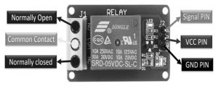

**Normally Open (NO):** This pin is normally open unless we provide a signal to the relay modules signal pin. So, the common contact pin smashes its link through the NC pin to make a connection through the NO pin

**Common Contact:** This pin is used to connect through the load that we desire to switch by using the module.

**Normally Closed (NC):** This NC pin is connected through the COM pin to form a closed circuit. However, this NC connection will break once the relay is switched through providing an active high/low signal toward the signal pin from a [microcontroller](https://www.elprocus.com/atmega16-next-generation-micro-controller/).

**Signal Pin:** The signal pin is mainly used for controlling the relay. This pin works in two cases like active low otherwise active high. So, in active low case, the relay activates once we provide an active low signal toward the signal pin, whereas, in an active high case, the relay will trigger once we provide a high signal toward the signal pin.

However, these modules generally work on an active high signal which will strengthen the relay coil to make contact with the common terminal with the normally open terminal.

**5V VCC:** This pin needs 5V DC to work. So 5V DC power supply is provided to this pin.

**Ground:** This pin connects the GND terminal of the power supply.

### 5Volts 1-Channel Relay Module Components

The components in a 5v relay module with a single channel include a relay, output terminal, status LED, power LED, [freewheeling diode](https://www.elprocus.com/freewheeling-or-flyback-diode-circuit-working-functions/), input connector & switching transistor.

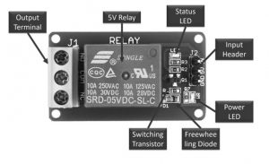

#### Relay

A 5V relay is coated with blue color plastic material. For both AC & DC loads, the utmost operating voltage & current are also displayed on the relay. This relay operates with 5V, so it is called a 5V relay.

#### Output Terminal

The output terminal of the relay module is located at the left-hand side, used to fix an AC/DC load & AC/DC i/p power source. Every o/p connector’s terminal is connected through NC, COM pins & NO of the relay.

The relay module consists of screws that are used to connect wires & cables. The max current supported by this module is 10A & the max contact voltage is 250V AC & 30V DC. Thick main cables are mainly used whenever high voltage & current load is used.

#### Status LED

Status LED is connected by using a current limiting resistor that is located on the top right side of the relay module. So this LED illustrates the relay status by activating the relay & coil through a signal pin. The DC supplies throughout a relay coil.

#### Power LED

Power LED shows the condition of the power source that is connected through the single channel module. If we provide the above 5V source toward both the pins of the module like Vcc & GND, the LED will be damaged due to high voltage.

#### Freewheeling Diode

The connection of this diode can be done across the coil to keep away from the back EMF effect, so-called a flyback diode. The type of coil used in the relay is the inductive type. Once the current supplies throughout an inductive load, then it generates a back EMF voltage, which may harm the circuit. So, this diode is mainly used to keep away from this effect.

#### Input Connector

The input connector is located on the right side of the module. This connector is mainly used to supply a 5V power supply & input signal. In addition, it also supplies power supply toward the power LED, relay coil & status LED.

#### Switching Transistor

Generally, the input signal which is given to a relay is from the I/O pins of microcontrollers like ESP32, TM4C123, Arduino, etc. However, the highest current sourcing capacity of GPIO pins is usually below 20mA.

Therefore, a switching transistor is used in this module is to strengthen the current to the requirement of the minimum current level of the relay coil. A switching transistor is used to control the 5V relay from the microcontroller’s GPIO pin.

Some kinds of relay modules are available with an optoisolator like a switching device to give optical isolation among high & low voltage circuits.

However, if you are utilizing a separate relay exclusive of a module & you want to utilize several relays within your projects, then a relay driver IC can be used to drive several arrays from the pins of GPIO in a microcontroller.

### **Specifications**

The specifications of a 1- channel relay module include the following.

* Voltage supply ranges from 3.75V – 6V
* Quiescent current is 2mA
* Once the relay is active then the current is ~70mA
* The highest contact voltage of a relay is 250VAC/30VDC
* The maximum current is 10A

#### Working

The relay uses the current supply for opening or closing switch contacts. Usually, this can be done through a coil to magnetize the switch contacts & drags them jointly once activated. A spring drives them separately once the coil is not strengthened.

By using this system, there are mainly two benefits, the first one is, the required current for activating the relay is less as compared to the current used by relay contacts for switching. The other benefit is, both the contacts & the coil are isolated galvanically, which means there is no electrical connection among them.

### **How to Use/Relay Module Circuit Diagram**

The circuit diagram of the single-channel relay module circuit is shown below. In this circuit, we can observe that how the relay module is activated and deactivated through a digital signal. This signal is applied to a control pin of the relay module. The following circuit diagram is the internal 5V single channel relay module diagram.

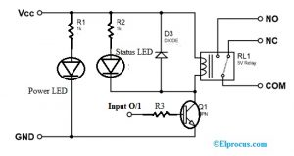

In the above circuit diagram, the single-channel relay module includes resistors-2, transistors, LEDs-2 & a 5V relay. Relay modules are available in two types based on the control signal type used for activation of the relay.

One relay module comes with an NPN transistor whereas another module comes with a [PNP transistor](https://www.elprocus.com/difference-between-npn-and-pnp-transistor/). If the relay module uses an NPN Transistor, then it will activate the relay by applying an active high signal to the control pin. Alternatively, if a PNP is used then the relay will be activated through an active low signal on the control pin.

It’s working in proteus simulation software is, when we provide an active high signal toward the control pin in a relay module, then the coil in the relay activates to make the relay active through the connection of the NO pin through the COM pin.

Likewise, once we provide an active low no signal toward the relay’s control pin, then the coil deactivates using a freewheeling diode so that the relay will be deactivated.

In the same way, for PNP based relay module, the relay is activated through an active low signal, whereas an active high signal will deactivate the relay.

The controlling of a 5v single channel relay module can be done by interfacing any kind of microcontroller. For that, we use a GPIO pin like a digital o/p pin which gives an active high & low signal toward the control pin. Once the relay activates, we can listen to an audible sound that comes from the module.

### **Advantages**

The **advantages of the relay module** include the following.

* A remote device can be controlled easily
* It is triggered with less current but it can also trigger high power machines
* Easily contacts can be changed
* At a time, several contacts can be controlled using a single signal
* Activating part can be isolated
* It can switch AC or DC
* At high temperatures, it works very well

### **Disadvantages**

The **disadvantages of the relay module** include the following.

* When contacts of relay modules are used overtime then they may damage
* Noise can be generated through the opening & closing of the contacts.
* Time taken for switching is High

### **Applications**

Relay modules are used in different applications which include the following.

* Used in over voltage/under voltage protection system
* Mains Switching
* Speed control of motors through start-delta converters
* Automatic electrical appliances
* Electrical isolation in between high & low power sources
* Lights
* AC voltage load switching using less voltage DC
* Delivery of Isolated power
* Home [automation projects](https://www.elprocus.com/home-automation-projects-engineering-students/)
* Switching with High Current

#### BUZZER

An audio signaling device like a beeper or buzzer may be electromechanical or [piezoelectric](https://www.elprocus.com/what-is-a-piezoelectric-material-working/) or mechanical type. The main function of this is to convert the signal from audio to sound. Generally, it is powered through DC voltage and used in timers, alarm devices, printers, alarms, computers, etc. Based on the various designs, it can generate different sounds like alarm, music, bell & siren.

#### Buzzer Pin Configuration

#### The **pin configuration of the buzzer** is shown below. It includes two pins namely positive and negative. The positive terminal of this is represented with the ‘+’ symbol or a longer terminal. This terminal is powered through 6Volts whereas the negative terminal is represented with the ‘-‘symbol or short terminal and it is connected to the GND terminal.

### Specifications

The **specifications of the buzzer** include the following.

* Color is black
* The frequency range is 3,300Hz
* Operating Temperature ranges from – 20° C to +60°C
* Operating voltage ranges from 3V to 24V DC
* The sound pressure level is 85dBA or 10cm
* The supply current is below 15mA

#### Water Pump

#### 

#### Mini Pump, delicate and light, very perfect for experiment, aquarium, fish tank and fountain etc. Make the water level higher than the pump, too low water level may cause high temperature and noise of the pump. Item only includes the pump without power supply , please adapt it to 5V power supply.

#### Specifications:

* Operating Voltage: 5V DC
* Rated Current: 100mA – 200mA
* Flow rate: 80-100L / H
* Wire Length: ~22 cm
* Material: plastic
* Mode driving: brushless cc design, magnetic driving

#### ****Applications:****

* Controlled fountain water flow
* Controlled Garden watering systems
* Hydroponic Systems
* Fresh water intake or exhaust systems for fish aquarium

#### DHT11

#### Introduction to DHT11 - The Engineering Projects

The DHT11 is a basic, ultra low-cost digital temperature and humidity sensor. It uses a capacitive humidity sensor and a thermistor to measure the surrounding air, and spits out a digital signal on the data pin (no analog input pins needed). Its fairly simple to use, but requires careful timing to grab data. You can get new data from it once every 2 seconds, so when using the library from Adafruit, sensor readings can be up to 2 seconds old.

Comes with a 4.7K or 10K resistor, which you will want to use as a pullup from the data pin to VCC.

**Specifications**:

* 3 to 5V power and I/O
* 2.5mA max current use during conversion (while requesting data)
* Good for 20-80% humidity readings with 5% accuracy
* Good for 0-50 °C temperature readings +-2 °C accuracy
* No more than 1 Hz sampling rate (once every second)
* Body size 15.5mm x 12mm x 5.5mm
* 4 pins with 0.1" spacing
* Adafruit Learning Documentation for DHTxx Sensors
* RoHS compliant

**SOFTWARE REQUIREMENT**

The system designing requires the following software

* + - Arduino IDE
    - IOT platform

##### **ARDUINO SOFTWARE (IDE)**

The Arduino Integrated Development Environment - or Arduino Software (IDE) - contains a text editor for writing code, a message area, a text console, a toolbar with buttons for

common functions and a series of menus. It connects to the Arduino and Genuino hardware to upload programs and communicate with them.



Arduino Tool

##### **Writing Sketches**

A program composed utilizing Arduino Software (IDE) is called portrays. These representations are composed in the content tool and are spared with the document expansion “. ino”. The proofreader has highlights for cutting/gluing and for looking/supplanting content. The message zone gives criticism while sparing and sending out and furthermore shows blunders. The comfort shows content yield by the Arduino Software (IDE), including complete blunder messages and other data. The base right hand corner of the window shows the arranged board and serial port. The toolbar catches permit you to check and transfer programs, make, open, and spare outlines, and open the serial screen.

|  |  |
| --- | --- |
| https://www.arduino.cc/en/uploads/Guide/export.png | ***Upload***  Accumulates your code and transfers it to the designed board. See transferring beneath for points of interest.  Note: If you are utilizing an outer software engineer with your board, you can hold down the "move" key on your PC when utilizing this symbol. The content will change to "Transfer utilizing Programmer" |
| https://www.arduino.cc/en/uploads/Guide/new.png | ***New*** |
|  | Creates a new sketch. | |
| https://www.arduino.cc/en/uploads/Guide/open.png | ***Open***  Presents a menu of all the representations in your sketchbook. Clicking one will open it inside the present window overwriting its substance.  Note: because of a bug in Java, this menu doesn't scroll; on the off  chance that you have to open a draw late in the rundown, utilize the File | Sketchbook menu. | |
| https://www.arduino.cc/en/uploads/Guide/save.png | ***Save***  Saves your sketch. | |
| https://www.arduino.cc/en/uploads/Guide/serial_monitor.png | ***Serial Monitor***  *Opens the* [*serial monitor*](http://ouo.io/s/P52hoMCo/?s=https%3A%2F%2Fwww.arduino.cc%2Fen%2Fguide%2Fenvironment%23serialmonitor). | |

Additional commands are found within the five menus:

***Fil****e*Edit**

**Sketch *****Tool**



***** **Help**.

The menus are setting delicate, which implies just those things significant to the work as of now being done are accessible.

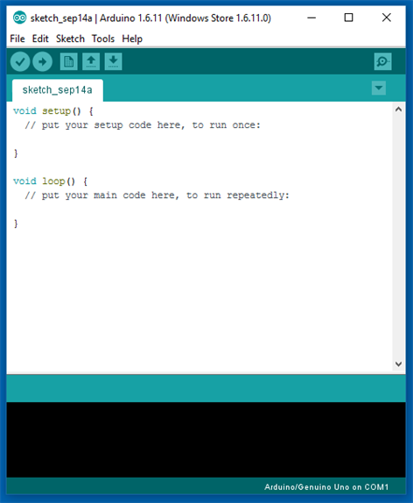

Arduino Software

##### **FILE**

###### New

Makes another occasion of the editorial manager, with the absolute minimum structure of an outline already set up.

###### Open

Permits to stack an outline document perusing through the PC drives and

envelopes.

###### Open Recent

Provides a short list of the most recent sketches, ready to be opened.

###### Sketchbook

Demonstrates the current portrays inside the sketchbook envelope structure;

tapping on any name opens the relating sketch in another proofreader example.

###### Examples

Any case gave by the Arduino Software (IDE) or library appears in this menu thing. Every one of the cases are organized in a tree that permits simple access by topic or library.

###### Close

Closes the instance of the Arduino Software from which it is clicked.

###### Save

Spares the draw with the present name. On the off chance that the record hasn't been named some time recently, a name will be given in a "Spare as." window.

###### Save as

Allows to save the current sketch with a different name.

###### Page Setup

It shows the Page Setup window for printing.

###### Print

Sends the current sketch to the printer according to the settings defined in Page Setup.

###### Preferences

Opens the Preferences window where some settings of the IDE may be customized, as the language of the IDE interface.

###### Quit

Shuts all IDE windows. The same representations open when Quit was picked will be automatically revived whenever you begin the IDE

##### **EDIT**

###### Undo/Redo

Backpedals of at least one stages you did while altering; when you backpedal, you may go ahead with Redo.

###### Cut

Expels the chose content from the supervisor and spots it into the clipboard

###### Copy

Copies the chose message in the manager and spots it into the clipboard

###### Copy for Forum

Duplicates the code of your portray to the clipboard in a frame appropriate for presenting on the discussion, finish with sentence structure shading.

###### Copy as HTML

Duplicates the code of your draw to the clipboard as HTML, reasonable for Implanting in website pages.

###### Paste

Puts the substance of the clipboard at the cursor position, in the editorial manager.

###### Select All

Chooses and highlights the entire substance of the editorial manager.

###### Comment/Uncomment

Puts or evacuates the/remark marker toward the start of each chose line.

###### Increase/Decrease Indent

Includes or subtracts a space toward the start of each chose line, moving the text one space on the privilege or dispensing with a space toward the start.

###### Find

Opens the Find and Replace window where you can indicate content to seek inside the current draw as indicated by a few choices.

###### Find Next

Highlights the following event - if any - of the string indicated as the pursuit thing in the Find window, with respect to the cursor position.

###### Find Previous

Highlights the past event - if any - of the string indicated as the hunt item in the Find window with respect to the cursor position.

##### **SKETCH**

###### Verify/Compile

Checks your outline for blunders arranging it; it will report memory utilization for code and factors in the reassure territory.

###### Upload

Arranges and stacks the twofold document onto the designed board through the configured Port.

###### Upload Using Programmer

This will overwrite the boot loader on the board; you should utilize Tools > Burn Boot loader to reestablish it and have the capacity to Upload to USB serial port once more. In any case, it permits you to utilize the full limit of the Flash memory for your sketch. It would be ideal if you take note of that this summon won't consume the wires. To do as such a Tools - > Burn Boot loader charge must be executed.

###### Export Compiled Binary

Spares a .hex document that might be kept as chronicle or sent to the board utilizing different tools.

###### Show Sketch Folder

Opens the current sketch folder.

###### Include Library

Adds a library to your portray by embeddings #include explanations toward the begin of your code. For more points of interest, see libraries underneath.

Furthermore, from this menu thing you can get to the Library Manager and import new libraries from .compress records.

###### Add File...

Adds a source record to the outline (it will be duplicated from its present area). The new document shows up in another tab in the portray window.

Documents can be expelled from the portray utilizing the tab menu available tapping on the little triangle symbol beneath the serial screen one on the correct side of the toolbar.

##### **TOOLS**

###### Auto Format

This organizations your code pleasantly: i.e. indents it so that opening and shutting wavy braces line down, and that the announcements inside wavy supports are indented more.

###### Archive Sketch

Documents a duplicate of the present draw in .zip arrange. The file is set in the same index as the draw.

###### Fix Encoding & Reload

Fixes conceivable errors between the supervisor burn outline and other operating frameworks scorch maps.

###### Serial Monitor

Opens the serial screen window and starts the trading of information with any connected board on the at present chose Port. This as a rule resets the board, if the board bolsters Reset over serial port opening.

###### Board

Select the board that you're utilizing. See beneath for depictions of the different boards.

###### Port

This menu contains all the serial gadgets (genuine or virtual) on your

machine. It should consequently revive each time you open the top-level instruments menu.

###### Programmer

For choosing a hardware software engineer when programming a board or chip and not using the locally available USB-serial association. Typically you won't require this, however in the event that you're consuming a boot

###### loader to another microcontroller, you will utilize this. Burn Boot loader

The things in this menu permit you to consume a boot loader onto the microcontroller on an Arduino board. This is not required for ordinary utilization of

an Arduino or Genuino board however is valuable in the event that you buy another ATmega microcontroller Ensure that you've chosen the right board from the Boards menu before consuming the boot loader on the objective board. This charge additionally set the correct circuits.

##### **HELP**

Here you find simple access to various reports that accompany the Arduino Software (IDE). You have entry to Getting Started, Reference generation, characteristics, collection and transportation. The proposed system would be able to monitor the solid waste collection process and management the overall collection process. This technique would provide solid waste collection in time and also overcome all the disadvantages which are as use of minimum route, low fuel use, clean and green environment and available vehicle. The technologies which are used in the proposed system are good enough to ensure the practical and perfect for solid waste collection process monitoring and management for green Environment.

**IOT PLATFORMS:**

* Things Speak

#### Things Speak:

According to its developers, "**ThingSpeak** is an open source Internet of Things (IoT) application and API to store and retrieve data from things using the HTTP protocol over the Internet or via a Local Area Network. ThingSpeak enables the creation of sensor logging applications, location tracking applications, and a social network of things with status updates.

### **What IoT means for the developers?**

There have been few paradigm shift in computer industry. From Text operating system to Windows 3.1, then Windows 95, then internet revolution, the Google search engine revolution, eCommerce, Mobile phone, iPhone, Android. Each of these technological changes has seen many new opportinities being opened up for those who is eager to adopt to the changes. IoT is one such paradigm shift knocking our doors. It is opening up host of opportunities at both hardware as well as software level and would open up more standards in coming years. Hardwares will boil down to handfull of good baords, wearable will include few killing devices and platforms will have it's own popular choice like Visual Studio.Net and Eclipse of current computing platforms.

So, IoT really means that there is no stangancy and some cool opportunities calling the smart minds who can see it coming and can be ready by the time IoT actually takes the next giant leap.