Intelligent Submersible Pump for Irrigation Purposes

Miss Sanjana Kulkarni   
*Dept. of CSE,   
REVA* *University*Bangalore, India

Sanjanakulkarni1995@gmail.com

Dr Laxmi B Rananavare  
*Dept. of CSE*,  
*REVA University,*   
Bangalore, India  
[laxmib.rananavare@reva.edu.in](mailto:laxmib.rananavare@reva.edu.in)

***Abstract***— **India, with its villages and thriving agriculture sector, heavily relies on climate conditions for successful cultivation. Unfortunately, the insufficient availability of water sources during the monsoon season poses a challenge. To combat this issue, farmers have resorted to utilizing irrigation methods in their agricultural fields. Notably, bore well electric pumps and lift irrigation systems have become the go-to choices for irrigation in India. These electric pumps, ranging in capacity from 3HP to 15HP, are responsible for efficiently extracting and pumping water. However, many farmers in rural areas encounter multiple problems, such as unscheduled load shedding, under-voltage, over-voltage, dry run scenarios, and consequent motor failures. The high costs associated with motor replacements or repairs have raised concerns among farming communities. Consequently, ongoing research is focused on developing robust motor protection mechanisms to prevent these faults. An intelligent protection and control system is developed for safeguarding electric motors in agricultural environments, leveraging the Internet of Things (IoT) and cutting-edge sensors.**

Keywords— ***Internet of Things, Submersible Pump, Sensors, Agriculture Fields, Dry run, Under voltage, over Voltage***

# Introduction

India, being primarily an agricultural country, heavily relies on farming as the main occupation for a majority of its population. With approximately 70% of the people depending on agriculture, it contributes significantly to the nation's economy. However, despite the sector's crucial role, its share in the country's GDP has declined due to the growth of other sectors. To tackle various challenges faced by farmers, such as inadequate water supply and unreliable power sources, innovative solutions incorporating the Internet of Things (IoT) and intelligent pump control systems are being introduced.

In the latest interconnected environment, utilization of Embedded Internet of Things (IoT) devices has become increasingly prevalent. These devices are equipped with Wi-Fi communication modules, enabling seamless connection to the Internet. Within the realm of IoT, we encounter various embedded systems such as STM32L4, which assists in discovering IoT nodes, and Node MCU esp8266, a reliable IoT component. Gathering environmental data, particularly temperature and humidity, is made possible through the application of the advanced DHT11 sensor. Employing C++ and similar low-level programming languages, developers can effectively craft IoT devices and implement IoT Cloud software. In this context, the IoT Cloud assumes significance, as it has been specifically modified to handle data processing emanating from IoT devices. With the evolution of IoT, the Cloud has transcended geographical boundaries and can be leveraged from any part of the world. For seamless integration and exchange of information between IoT devices or with the IoT Cloud, access to the Internet is imperative[1]. In today's interconnected world, the utilization of Embedded Internet of Things (IoT) devices has become increasingly prevalent. In this context, the IoT Cloud assumes significance, as it has been specifically modified to handle data processing emanating from IoT devices. With the evolution of IoT, the Cloud has transcended geographical boundaries and can be leveraged from any part of the world. For seamless integration and exchange of information between IoT devices or with the IoT Cloud, access to the Internet is imperative [2].

In the revolutionary era of the IoT, sensors play a crucial part in the process of facilitating advanced environmental sensing, remote surveillance, and health monitoring. Through their sophisticated technology, sensors have become the instrumental link bridging physical objects with digital connectivity, ushering us into a new realm of transformative possibilities [3]. We regularly interact with IoT technology due to the monitoring, measurement, and management of various objects through technologies like RFID, wireless, and WAN. In the field of electronic engineering, a significant number of commercial operations focus on embedded systems, and many embedded devices run code in C/C++. Common tasks in traditional C/C++ programming include providing text and graphics support for Windows and Linux. C/C++ API modules are used for sensor integration, particularly for monitoring liquid levels in tanks used for storage purposes and containers. Various techniques used for measuring the level of liquid such as magnetic, radar, and ultrasonic are employed based on factors like measurement range, constraints of installation, and type of liquid, each requiring specific sensor requirements Sensors measuring water level are important in tanks used in distribution of water supplied for drinking purposes [4].

# LITERATURE SURVEY

The Electric Submersible Pump (ESP) plays a vital role in achieving a high recovery percentage in the oil and gas industry. These pumps are commonly either low-speed progressive cavity pumps or multi-stage high-speed centrifugal pumps. Traditionally, an enclosed submersible induction motor (IM) is used to power the ESP. Typically, these pumps are utilized for process of removing gas and oil from underground geological formations, situated within wells underground of 100-1000 ft. Powering the ESP is achieved through long cables connected to variable frequency drive or adjustable frequency drive or VSD on surface installation or platform. Unfortunately, conventional IPM drives with position sensor-based speed controllers cannot be utilized by ESPs [4].

A range of straightforward drivers for file systems, networks, and easy-to-use APIs have been developed to enhance the input-output capabilities of the NXP1768 chip [5].

The submersible diaphragm pump finds extensive use in oil wells, but this utilization often leads to various issues such as wax deposition, corrosion of oil pipes, cable damage, and obstruction in monitoring pump parameters, results in expensive and easily worn pipe rods etc [6].

IMs have lower efficiency and thermal stability due to power losses in the rotor through slippage. The energy efficiency of ESP depends on the reduction of energy losses in the supply channel. Converters for energy-efficient SEM control are available in the country and abroad. The permanent Magnet Synchronous Motor (PMSM)-controlled Electric Submersible Pumps (ESPs) provide enhanced efficiency, reduced dimensions, expanded operating ranges, lower heat production, and superior performance compared to equivalently size Induction Motor (IM)-controlled ESPs. Nonetheless, PMSM-ESPs encounter control challenges attributed to the nonlinearity inherent in Permanent Magnet (PM) motors [7].

Inductive loads such as AC and DC motors are considered common in industrial applications. In industry, three-phase induction machines are popular, for domestic use, single-phase induction motors are preferred for their low maintenance, low operating costs, robust construction, and also for their efficiency and reliability. Motors can face damage such as cooling, temperature and vibration, lubrication, stator, rotor, bearing, and winding failures. Even small problems will result in damages and financial losses. Monitoring of motors and their parameters is necessary to avoid damage. Thanks to IoT technology, engines can monitor and facilitate data communication between machines [8].

It is important to identify errors while they are still being created. According to the literature, the most damaging faults in electrical equipment are stator and bearing abnormalities, which account for more than 80% of induction motor problems. Stator rotation faults are caused by aging and damage to the windings, as well as other insulation techniques used in the construction of new motors. Once thresholds are exceeded, the insulation continues to degrade, resulting in thermal hot spots that affect stator rotation. Similarly, the main causes of bearing-related failures include aging, lubricant and its viscosity diminishes over time. As a result, the rolling balls of the bearings begin to seize [9].

The Internet of Things technology has lately received much study attention and has emerged as a very promising technological paradigm. The quantity of devices linked to the Internet of Things is projected to surge significantly, rising from 26 billion in 2020 to a remarkable 100 billion by 2030 .. Wireless sensor networks (WSNs) perform better when the IoT is used, especially in requirements which requires environmental and healthcare monitoring. IoT has made it easy for consumers to get continuously updated information about the conditions and characteristics of the environment and the physiological state data from anywhere, anytime through web browsers or mobile software application. The Internet of Things (IoT) enables seamless data collection, wireless networking, cloud storage, and analytics that are critical to the design and deployment of these systems. [10].Wearable Body Area Network ,WSN type is widely used to monitor physiological signals and improve overall well-being and quality of life. For example, the study used WBANs to monitor safety-related variables such as temperature, humidity, and ultraviolet (UV) radiation levels. The design and deployment of a Wearable Sensor Network by utilizing the technology IoT has several advantages for the wearable technology industry, some of which are specified below: 1. Data collection 2. Wireless connectivity 3. Storage on cloud platforms also enables data processing, analysis, and long-term storage 4. Data analytics: Data analytics technologies that can process and analyse sensor-collected data are included in the IoT. Various machine learning algorithms can detect patterns and similarities in data to offer insightful information about people's health. [10].

The effectiveness of IOT and automation is evident for the following reasons:

1. Diverse connectivity: IoT can connect and connect a wide range of devices, from mobile devices and tablets to stand-alone devices, enabling comprehensive monitoring and control

2. Reduced dependence on human labour: Both IoT and automation are essential to decrease the human interference and completely rule out the possibility of human error, leading to more reliable and consistent results.

3. Remote Monitoring: In agriculture, farmers can use a variety of equipment to remotely monitor crop and soil health from any location, enabling quick intervention and decision-making.

4. Time-saving: IOT and automation simplify the report generation and monitoring process, saving farmers valuable time and effort.

5. Advanced analytics: IoT and automation facilitate a wide range of analytics, such as monitoring average rainfall and evaluating soil condition gradients, providing valuable insights for informed agricultural decision-making.[11].

Arduino UNO: An open-source microcontroller board that features sets of analog and digital I/O pins, and devices.

16x2 Liquid Crystal Display: An electronic device generally used as a screen in TVs, PCs, and smartphones, which helps to control the device independently and displays moving images.

DHT11: The DHT11 is a combination of humidity and temperature sensor that provides a simple,easy-to-read interface for reading humidity and temperature. These can be used mainly in the fields to select a suitable environment for growing crops[11].

GSM module: GSM modules are communication modules that use mobile networks to wirelessly receive and send data, creating a data transfer between the device and the network [11].

Wi-Fi Module: A device that allows Wi-Fi signals to be transmitted to smart devices such as laptops and phones, allowing users to gain high-speed network access. A popular example of such a module is the ESP8266 module. It enables us to meet the demands of the IoT industry [12]

The system for calculating fault distance relies only on measuring original flash events and analysing the reflection pattern of traveling waves caused by the fault. Unlike other approaches that generally uses Rogowski coils for measuring step waves, this particular system explores the operation of Capacitive voltage detectors within a medium voltage substation [13].

Water can be saved without being wasted with help of to the Internet of Things and sensors; this system shuts down the motor in situation when water reaches the top level in the tank, reducing water wastage. When the water level reaches full in 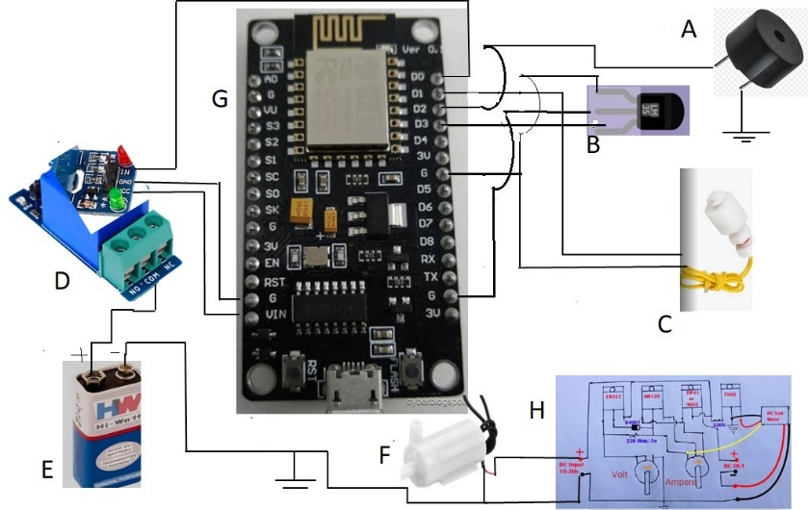the tank, continuous usage of the motor wastes water and electricity. So IoT turns off the engine by reducing human interference. The relay that connects the motor consists of an oscillator connected to the tank and an IC connected to the circuit that controls how the circuit turns on and off. [14]. Requirements for water level monitoring systems include residential areas etc. Pumps that can be completely submerged in water are referred to as submersible pumps, often known as electric submersible pumps. A 3-6V source is used for power supply [15].

# ADVANCEMENTS

In this paper, it is planned to design a smart irrigation submersible pump :

• To automatically control the operations of the motor through mobile/tab etc using IoT.

• To detect the under-voltage, over-voltage, and phase-out faults during motor operations and automatically turn off the motor/pump and alert the user.

• To control the pump set from getting burned due to dry run issues, detect the Water level inside the Bore well using the water sensors, switch off the motor under no or low water conditions, and alert the user.

• To detect damages like winding worn-out issues and any winding issues using temperature sensors and alert the user when the issue is diagnosed.

• To have a safe operation of the pump set without any interruption.

• To detect the humidity of soil.

• Provide the user with the parameter values on the above-mentioned input and alert the user on the occurrence of any above-mentioned faults.

# METHODOLOGY

This research’s main objective is to devise an Internet of Things technology based system for controlling a water pump. This system will use specific parameters and analyze sensor data to implement safety measures in real-time. Our main focus is on creating a smart irrigational pump monitoring solution that is capable of gathering essential data for irrigation purposes, and then it will be transmitted instantly to the Thingspeak IoT platform for documentation and analysis. By showcasing the data in a graphical format on Thingspeak, individuals like botanists or knowledgeable farmers can effectively interpret the information to make necessary adjustments to optimize the irrigation process and ensure the safety of the water pump.

A, B, C, D, E, F, G, H represent the following components in Circuit Diagram respectively:

1. Buzzer
2. LM35 Temperature Sensor
3. Water Level Sensor
4. Really
5. Battery
6. Load (here: small Aquarium pump)
7. Node MCU ESP8266
8. Voltage Regulator

In the above provided Circuit Diagram , Node MCU ESP8266 pin D1 is connected to + terminal of Water Level Sensors and its other terminal is connected to GND as shown .D2 is connected to + terminal of Buzzer ,this terminal is connected for voltage supply of 3V and – end terminal is

grounded by connecting to G pin of Node MCU .The DTH11 sensor has 3 pins one is VCC, one is for data transfer( which is sensed from external environment ) is connected to D3 pin of Node MCU and GND pin of sensor is connected to G pin of the MC i.e GND pin. The 5V Relay has 6 terminals. Signal pin, VCC pin and GND pin of relay is connected to D0 pin for Relay controlling, VIN pin for 12V supply and G pin of Node MCU respectively. The Battery’s “+” terminal is connected to Common Contact of the Relay’s pin and NC pin is in earlier stages connected to the COM pin, forming a closed circuit. However, this connection is down broken once the relay is triggered by a high/low signal sent to the signal pin from a microcontroller. The load (here aquarium pump) “+” terminal is connected to DC Input voltage of Voltage Regulator. The “-” terminals of Battery, Load and Voltage Regulator are grounded.

Software is designed and flashed into Node MCU chip.

The coding is done by keeping the following constraints noted.

In this experiment, When Voltage falls below the limit or if it exceeds the limit, the Pump/Load is switched off .Thus saving pump during voltage issues.

When the DHT11 temperature senses the value more than 25 degree Celsius, the Pump/Load is switched off.

In this experiment the water level is monitored. When the Water-Level in tank, well or in any storage falls below the minimum limit, the MC is notified on this and the pump will be switched off with the help of relay as relay will be controlled by MC.

In all the 3 constraints, the user will be notified with the beep alarm i.e with the buzzer. Cause for the fault will be mentioned and will be sent to the registered mail ID with help of IoT platform “Thingspeak”.

With help of “Thingspeak” we can turn the motor automatically ON or OFF

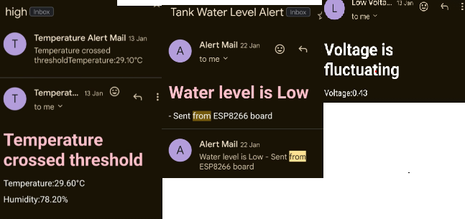

Figure B: Alert Email Messages from Thingspeak

# HARDWARE USED

## NodeMCU ESP8266

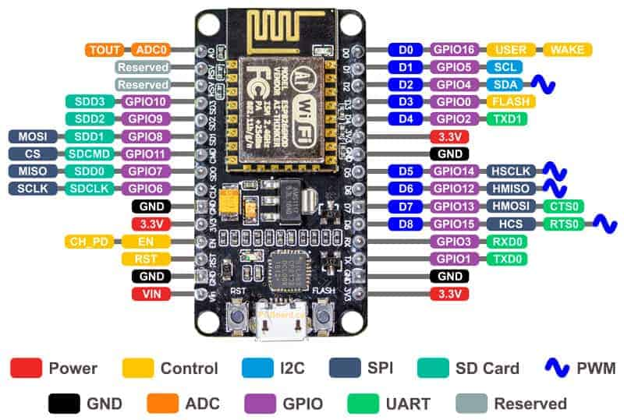

The NodeMCU ESP8266 is a versatile development board that integrates the ESP8266 Wi-Fi module. It enables easy prototyping and development of IoT (Internet of Things) projects. Here's a simple description of its pin configuration:

The NodeMCU ESP8266 typically has a set of GPIO (General Purpose Input/Output) pins, which can be configured for various tasks such as digital input/output, analog input, or communication with other devices. Additionally, it includes power and ground pins for supplying power to the board.

Here's a basic breakdown of its pin configuration:

Power Pins: These include pins for connecting to power sources such as VCC (typically 3.3V) and GND (ground).

GPIO Pins: These are general-purpose pins that can be configured as digital input or output pins. The NodeMCU ESP8266 usually has several GPIO pins, labeled GPIO0, GPIO1, GPIO2, and so on.

Analog Pins: Some pins may support analog input, allowing you to read analog signals from sensors or other devices. The number of analog pins may vary depending on the specific NodeMCU board variant.

Special Pins: There may be additional pins with special functions, such as the Reset pin (RST), which is used to reset the board, and the Serial pins (TX and RX), which are used for serial communication.

Overall, the NodeMCU ESP8266 provides a convenient platform for building IoT projects, offering a range of pins for interfacing with various components and sensors while leveraging the power of Wi-Fi connectivity.

## RELAY

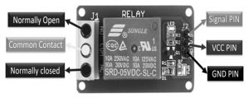

Figure D: Pin Configuration of 5V Relay

A 5V relay is coated with a blue color material plastic. For both the AC & DC loads, the top of the utmost operating voltage & current are also made to be displayed on the relay. Works with 5V, so it is known to be a 5V relay.

The 5V relay module includes six pins, where each operating for a different function in its operation. First, there is the Normally Open port, which remains open until a signal is applied to the relay module's signal pin. When activated or made to work, the common contact pin makes a connection through the NO pin. Then, the Common Contact pin is used to link the load that requires switching via the module. Later, the Normally Closed (NC) pin is in earlier stages connected to the COM pin, forming a closed circuit. These pins together facilitate the operation of the relay module, allowing efficient control of the connected devices /connected circuits.

**Signal Pin**: It is used for relay control and operates in two cases. During active low case, the relay activates once if an active low signal is given to the signal pin, whereas in an active high case, the relay would activate once if a high signal is given to the signal pin.

**5V VCC**: A 5V Direct Current supply is given for this pin to work.

**Ground**: Links to the Ground terminal of the main supply.

The specifications of a 1-channel relay module are

* The range of supply is between 3.75V – 6V.
* State if inactivity current is 2mA
* When the relay is active then the current is approximately 70mA
* 250VAC/30VDC is relay’s contact voltage
* 10A is maximum current

## Buzzer Pin ConfigurationBUZZER

Figure F: Buzzer

This is an audio signaling device (such as a buzzer, beeper) which takes signals in the form of electromechanical, piezoelectric, and mechanical. Its principal focus involves converting audio waveforms into sound. Generally, it works using Direct Current voltage and observes appeal in chronometers and alert mechanisms, etc.

It consists of 2 pins. The positive terminal is marked ‘+' and is longer requires 6V power. The negative terminal is marked ‘-’ and is shorter, connected to the GND.

The specifications of the buzzer are.

* It is black
* It has 3,300Hz frequency.
* – 20° C - +60°C is the range of operation
* 3-24V DC is the operating range

85dBA or 10cm is the sound pressure level

* supply current <15mA

## Water Pump

Figure G: Small Aquarium Water Pump

Mini Pump, sensitive and light in weight made of light plastic, good suite for experiment and is usually used in aquarium, fish tank and fountain etc. Works with 5V power supply.

Specifications:

* Rated Current: 100mA – 200mA
* Flow rate: 80-100L / H
* Wire Length: ~22 cm
* Mode driving: brushless cc design, magnetic driving

## Introduction to DHT11 - The Engineering ProjectsDHT11

Figure H: Temperature Sensor (DHT11)

The digital sensor DHT11 is created to measures temperature and humidity. It is made by combining a thermistor and a capacitive humidity sensor to estimate the temperature and humidity of the environment. A digital signal is produced by the sensor on the data pin. It is designed with a 4.7K or 10K resistor.

Specifications:

* 3V to 5V power with I/O
* Maximum current use of 2.5-microampere during conversion
* Suitable temperature readings range from 0 to 50°C with an accuracy of +- 2°C
* 1 Hz of maximum sampling rate per second
* Gadget dimensions (15.5)mm x (12)mm x (5.5)mm
* 4 pins spacing 0.1 inches
* RoHS compliant

## WATER SENSOR

A float switch is a tool that provides facility to monitor the liquid level in a any type of container. It enables various responses like switching On/OFF of a pump, enabling an indicator, alarm sound etc . Float switches are flexible and are used in hydroponic setups, water storage tank, agricultural use etc.

Specifications:

* Its Maximum Load is 50W and Voltage is 100V DC with 0.5A of current.
* Range is -20°~ 80° C temperature
* Maximum Load current is 1A
* Maximum Contact Resistance is 0.4 ohms

# Software Requirements

## ARDUINO SOFTWARE (IDE)

##### C:\Users\Hp\Desktop\apps.43938.13510798887551775.4304b217-d411-4397-9963-5d891b68d0f8.png

Figure J: Arduino Software Window

The Arduino IDE uses sketches for code, saved with the file name followed by ".” and “ino". Its text editor enables editing, cutting, pasting, and searching. The message area provides feedback and shows errors. The console displays output along with error messages. In the toolbar buttons features like verify, upload, and manage sketches, for open and save options, and the serial monitor is also available.

## IOT PLATFORM:

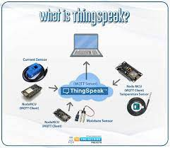

Figure K: Thingspeak as IoT Platform

In this project plan, ThingSpeak is used as IoT platform. It is an IoT applied, open-sourced API designed to store and retrieve data from connected devices by utilizing the HTTP protocol over the Internet or within a Local Area Network. This IoT platform offers for the development of sensor logging applications, and a social network of connected devices with updates."

# CONCLUSION

In this project, an intelligent protection and control system has been designed and developed for the protection of electric motors/pumps used for irrigation purposes using IoT and sensors. The prototype model has been developed, which protects the motor against under-voltage, over-voltage, temperature, and dry run. The project is designed for the detection of water levels, voltage levels, and temperature levels of submersible pumps and to perform safer operation and protection of the system against various faults. The usage of the Raspberry Pi system provides information to the user about the operating condition of the pump and also to control the submersible pump through wireless mode. The project aims to work efficiently by using magnetic fluid level sensors, voltage level sensors, and LM35 temperature sensors to reduce the interruptions for the working of submersible pumps.

# FUTURE WORK

For the same project idea, we can use different type of technologies like AI etc to apply it in the future on a large scale.

* Mobile applications can be developed for easier operations with advanced features.
* Advanced temperature sensors and motor vibration sensors can be used for high-rating pumps to detect mechanical faults in the pump.
* The idea for an autonomous pump system in the future with solar-powered irrigation systems, windmills, and natural energy usage systems that will not require any human intervention can be adopted.

# acknowledgement

Special thanks to REVA University for their support and resources."

# References

1. Nikolov, N., & Nakov, O. (2019, May). Research of communication between IoT cloud structure, android application and IoT device using TCP sockets. In 2019 X National Conference with International Participation (ELECTRONICA) (pp. 1-4). IEEE.
2. Thiyagarajan, M., & Raveendra, C. (2015, October). Integration in the physical world in IoT using android mobile application. In 2015 International Conference on Green Computing and Internet of Things (ICGCIoT) (pp. 790-795). IEEE.
3. Ram, S. K., Chourasia, S., Das, B. B., Swain, A. K., Mahapatra, K., & Mohanty, S. (2020, July). A solar based power module for battery-less IoT sensors towards sustainable smart cities. In 2020 IEEE Computer Society Annual Symposium on VLSI (ISVLSI) (pp. 458-463). IEEE.
4. Brinner, T. R., McCoy, R. H., & Kopecky, T. (2013). Induction versus permanent-magnet motors for electric submersible pump field and laboratory comparisons. IEEE Transactions on Industry Applications, 50(1), 174-181.
5. Hamblen, J. O., Smith, Z. C., & Woo, W. W. (2013, June). Introducing embedded systems in the first C/C++ programming class. In 2013 IEEE International Conference on Microelectronic Systems Education (MSE) (pp. 1-4). IEEE.
6. Ji, X., Li, M., Zhou, W., Liu, Y., Liang, N., Xu, X., & Ding, X. (2021, April). Application Research of submersible diaphragm pump based on nonmetal coiled tubing. In 2021 6th International Conference on Intelligent Computing and Signal Processing (ICSP) (pp. 1355-1358). IEEE.
7. Rabbi, S. F., Rahman, M. A., Sarker, M. M., & Butt, S. D. (2015, September). Modeling and performance evaluation of a hysteresis IPM motor drive for electric submersible pumps. In 2015 IEEE Energy Conversion Congress and Exposition (ECCE) (pp. 4105-4112). IEEE.
8. Abid, G., Shaikh, S. A., Shaikh, M. F., Rajput, S. H., Majeed, U. A., & Shaikh, A. M. (2020, January). IOT based Smart Industrial panel for controlling Three-phase Induction motor. In 2020 3rd International Conference on Computing, Mathematics and Engineering Khaliq, Muhammad Mahad, and Rafia Mumtaz. "Enhancing NDVI Calculation of Low-Resolution Imagery using ESRGANs." 2022 24th International Multitopic Conference (INMIC). IEEE, 2022.
9. Surya, G. N., Ballal, M. S., & Khan, Z. J. (2017, December). Application of observer coil technique for detection of stator turn fault and damaged bearing in cage motors. In 2017 National Power Electronics Conference (NPEC) (pp. 296-301). IEEE.
10. Wu, F., Wu, T., & Yuce, M. R. (2019, April). Design and implementation of a wearable sensor network system for IoT-connected safety and health applications. In 2019 IEEE 5th World Forum on Internet of Things (WF-IoT) (pp. 87-90). IEEE.
11. Puranik, V., Ranjan, A., & Kumari, A. (2019, April). Automation in agriculture and IoT. In 2019 4th international conference on internet of things: smart innovation and usages (IoT-SIU) (pp. 1-6). IEEE.
12. Suresh, M., Anbarasi, M. S., & PraveenKumar, V. (2020, July). An intelligent smart street light system with predictive model. In 2020 International Conference on System, Computation, Automation and Networking (ICSCAN) (pp. 1-4). IEEE.
13. Ismail, S., Dawoud, D. W., Ismail, N., Marsh, R., & Alshami, A. S. (2022). IoT-Based Water Management Systems: Survey and Future Research Direction. IEEE Access, 10, 35942-35952.
14. Reddy, P. J. P., Viswanadh, G., & Singh, S. K. (2021, April). IOT based Smart Water Pump Switch. In 2021 2nd International Conference on Intelligent Engineering and Management (ICIEM) (pp. 534-538). IEEE.
15. Kulkarni, S. A., Raikar, V. D., Rahul, B. K., Rakshitha, L. V., Sharanya, K., & Jha, V. (2020, December). Intelligent water level monitoring system using IoT. In 2020 IEEE International Symposium on Sustainable Energy, Signal Processing and Cyber Security (iSSSC) (pp. 1-5). IEEE.