Assignment 1

AI Assisted Coding Name:-B.Sanjana

HTNO: 2303A52306

Task 1:
Prompt:
#Book Class Generation
Generate a Python class Book with attributes title, author, and a summary() method.
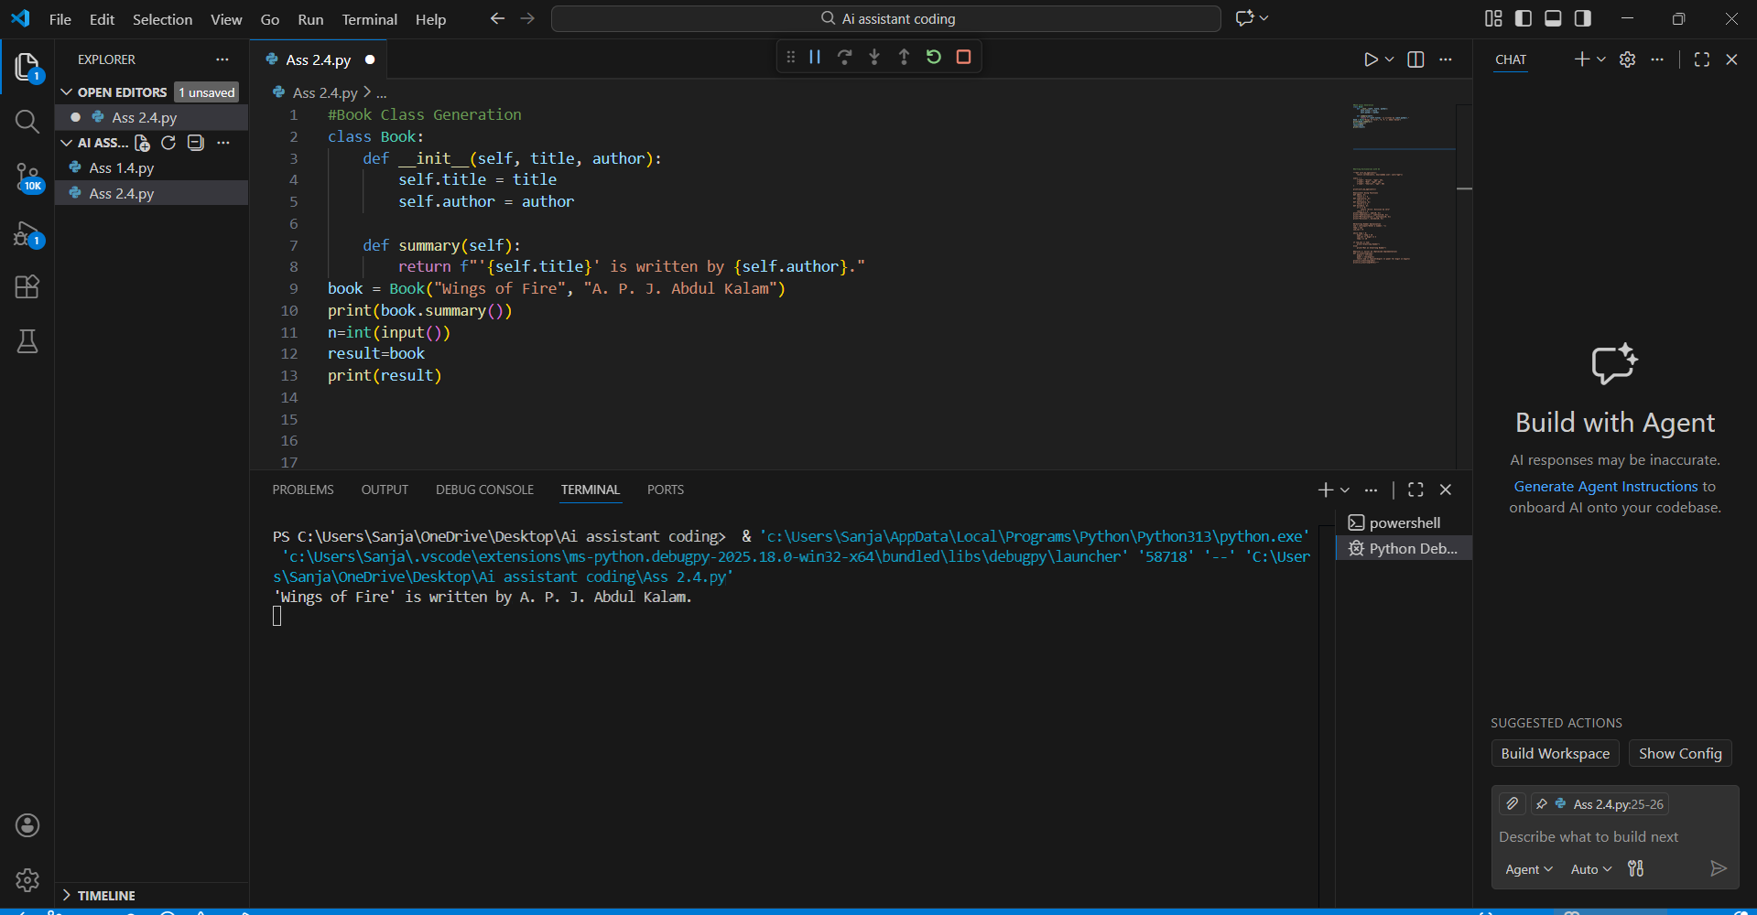

Observation:
- The generated Book class follows proper object-oriented programming principles.
- The constructor ( init ) is correctly used to initialize the title and author attributes.
- The summary() method provides a meaningful and readable description of the book object.
- The code is simple, clean, and easy to understand, making it suitable for beginners.
- Use of formatted strings (f-strings) improves output clarity and readability.
- The class design supports reusability and scalability in a library management system.
- The code lacks input validation, which could be improved for real-world applications.

Task 2:
#Sorting Dictionaries with AI Prompt:
Generate Python code to sort a list of dictionaries by age.

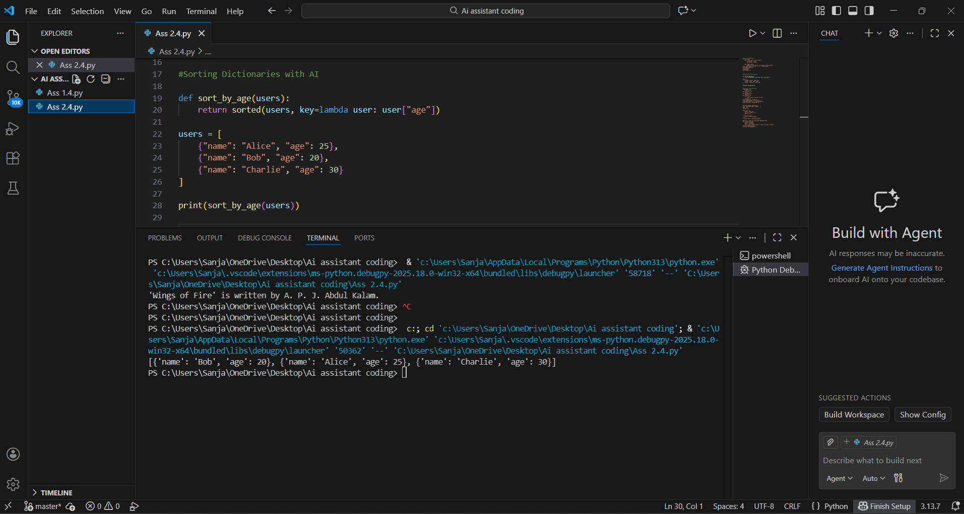

Observation:
- Both Gemini AI and Cursor AI correctly use Python’s built-in sorted() function.
- Sorting is performed using a lambda function as the key, ensuring concise logic.
- The time complexity for both implementations is O(n log n), which is efficient.
- Gemini AI’s solution is shorter and suitable for quick scripting tasks.
- Cursor AI’s solution improves code clarity and reusability by using a function.
- Cursor AI output is more maintainable for large or scalable applications.
- Both approaches preserve the original data structure while returning sorted results.
- Overall performance is similar, but Cursor AI provides better readability and structure.

Task 3: Calculator Using Functions Prompt:
#Generate a basic calculator using functions and explain how it works.
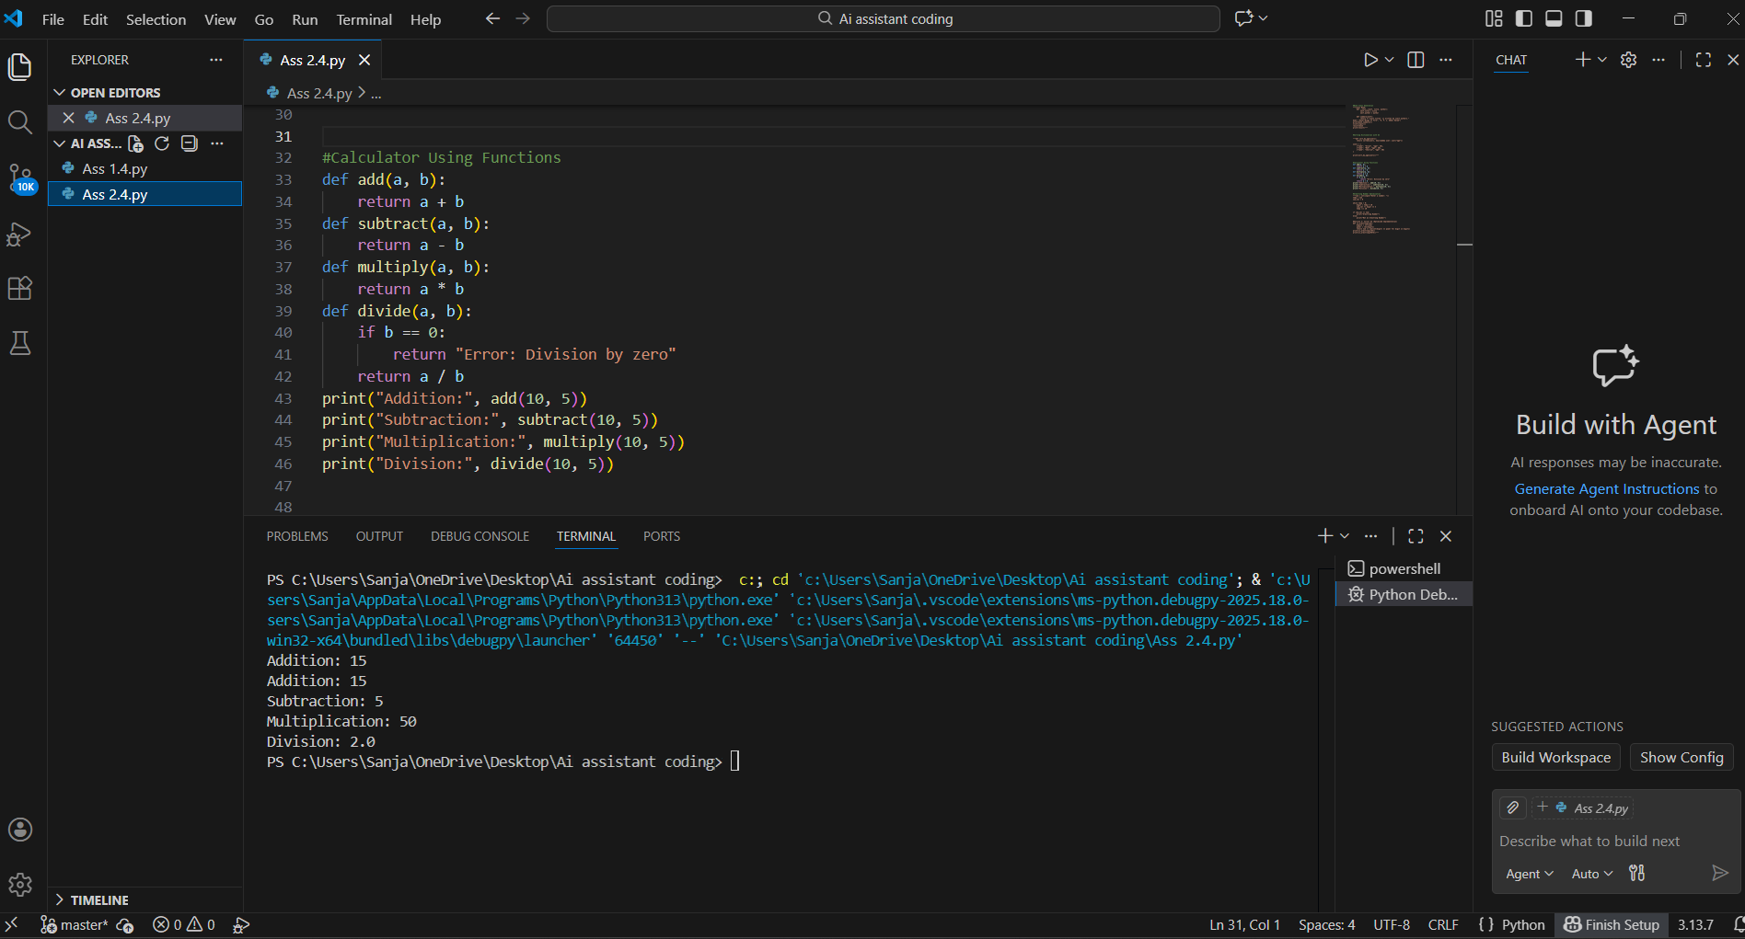
Observation:
- The calculator is implemented using separate functions for each arithmetic operation.
- Each function performs a single, well-defined task, improving clarity.
- The divide() function includes error handling to avoid division by zero.
- This modular design makes the program easy to understand, test, and maintain.
- Functions can be reused in other programs without modification.
- Overall, the calculator follows good programming practices and clean structure
Task 4: Armstrong Number Optimization Scenario
An existing solution for checking Armstrong numbers is inefficient and limited.

Prompt Used (Gemini AI)
Generate a Python program to check whether a number is an Armstrong number.

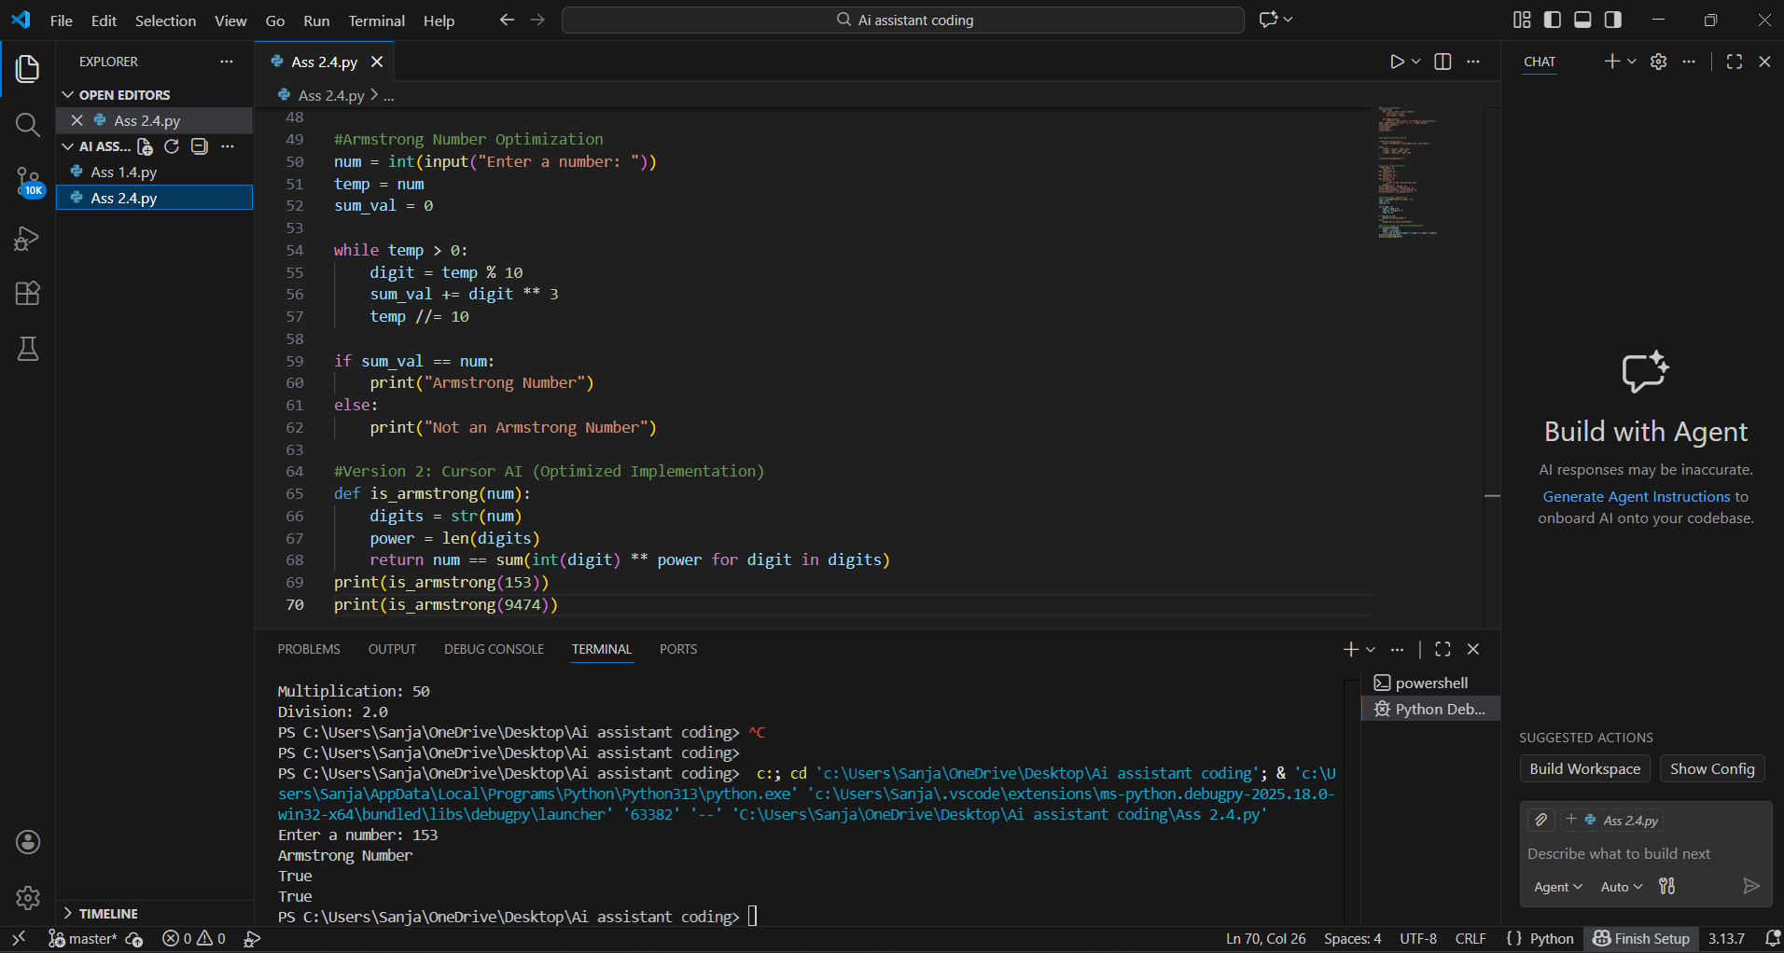

Observation:
- The optimized version supports Armstrong numbers of any length, not just 3-digit numbers.
- It replaces manual loops with generator expressions, making the code concise.
- Readability is improved through meaningful function naming.
- Temporary variables are reduced, lowering the chance of logical errors.
- The optimized solution is more scalable and reusable.
- Code execution is faster and easier to maintain.

