MinProject Report - 01

Master of Computer Application – General
Semester – I

Sub: Forntend framework and Technologies

Topic: RESUME
By
Name: Sanjana S R
Reg no:- 2511022250097

Faculty Name: VEERA RAGHAV K

Faculty Signature: _______________

Department of Computer Application
Alliance University
Chandapura – Anekal Main Road, Anekal
Bengaluru – 562 106
August 2025

INDEX

FIG NO | NAME OF TABLE | PG NO
1 | INTRODUCTION | 1
2 | INPUT CODE | 2-4
3 | OUTPUT | 5
4 | CONCLUSION | 6

🔹 Introduction
The program is designed using HTML and CSS to create a simple resume webpage. HTML is used for structuring the content such as name, contact details, education, technical skills, projects, and certifications, while CSS is applied for basic styling like alignment, padding, borders, and colors. This program demonstrates how a personal resume can be presented in a clean and readable format on a web page.

INPUT

<html>
<head>
<title>Resume</title>
<style>
body {
/* text-align: center; */
color: black;
background-color: rgb(255, 255, 255);
}
h1 {
text-align: center;
color: black;
background-color: rgb(255, 255, 255);
text-decoration: underline;
}
h3 {
text-decoration: underline;
}
table ,th, td,tr {
border: 1px solid black;
padding: 5px;
}
table{
width: 100%;
border-collapse: collapse;
text-align: center;

}
</style>
</head>
<body>
<h1>RESUME</h1>

<p>Name:Sanjana</p>
<p>Email: sanjanaasingh.05@gmail.com</p>
<p>Phoneno: +917338336512</p>
<hr>

<h3>Career objective:</h3>
<p>Lorem ipsum dolor sit amet consectetur, adipisicing elit. A magnam dolore reiciendis unde incidunt veritatis possimus! Numquam officiis saepe similique fugit unde placeat sit repellendus illum sapiente obcaecati veritatis fugiat, recusandae dolorem officia maxime consequuntur incidunt eaque ipsa autem qui? Maxime eos eaque commodi doloremque at quod minus ratione aperiam.</p>
<hr>

<h3>Educational Qualifications:</h3>
<table>
<thead>
<th>SiNo</th>
<th>Course</th>
<th>College</th>
<th>YOP</th>
<th>CGPA</th>
</thead>
<tbody>
<tr>
<td>1</td>
<td>SSLC</td>
<td>New Jyothi vidya samaste</td>
<td>2020</td>
<td>89</td>
</tr>
<tr>
<td>2</td>
<td>PUC</td>
<td>Narayan Pu college</td>
<td>2022</td>
<td>97</td>
</tr>
<tr>
<td>3</td>
<td>BCA</td>
<td>Sahyadri degree College</td>
<td>2025</td>
<td>98</td>
</tr>
<tr>
<td>4</td>
<td>MCA</td>
<td>Alliance university</td>
<td>2027</td>
<td>..</td>
</tr>
</table>

<hr>

<h3>Skills:</h3>
<ul>
<li>Languages Known: Java,python</li>
<li>Web Technologies: HTML,CSS,JavaScript</li>
<li>Database Management:System: MySQL</li>
</ul>
<hr>

<h3>projects:</h3>
<p>Lorem ipsum, dolor sit amet consectetur adipisicing elit. Voluptate mollitia similique omnis quo quia, vero, illo dicta est ad accusamus officia animi impedit nemo officiis possimus voluptatem nobis doloribus labore?</p>
<hr>

<h3>Hobbies:</h3>
<ul>
<li>Reading Books</li>
<li>Listening Music</li>
<li>Playing Badminton</li>

</ul>
<hr>

<h3>Certifications:</h3>
<ul>
<li>Data analytics</li>
<li>Full stack web development</li>

</ul>
<hr>

<p>Date:__________________________</p>
<p>Place:_________________________</p>
<p>Signature:_____________________</p>

</body>
</html>

OUTPUT

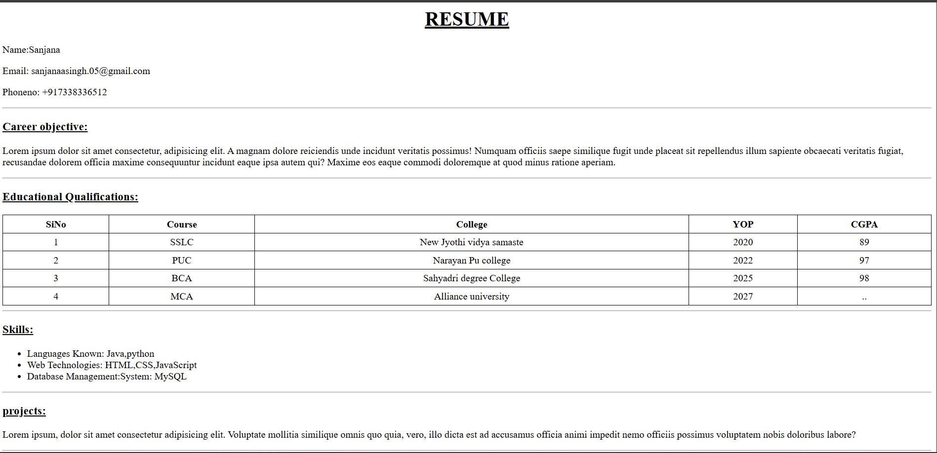
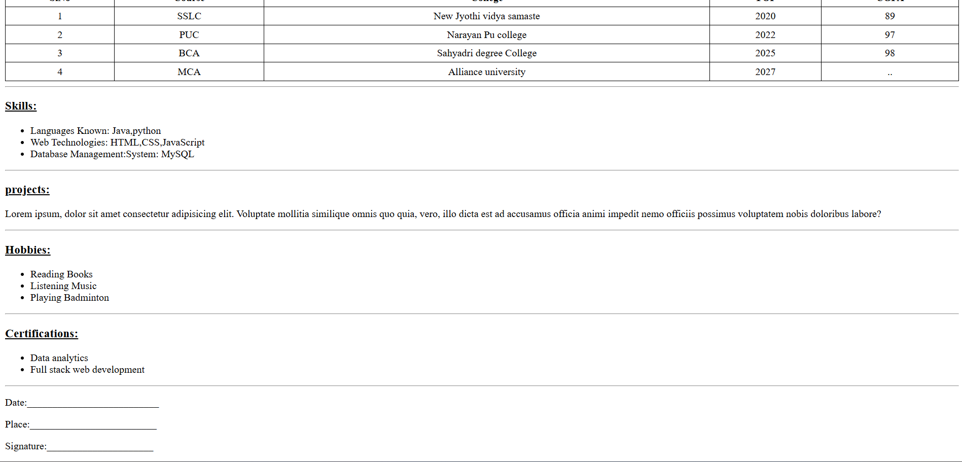

Conclusion
The program successfully demonstrates how HTML and CSS can be used to design a professional resume layout. It highlights key personal and academic information while also showcasing technical skills and achievements. This kind of structured webpage can be further enhanced with advanced CSS or JavaScript to make it more interactive and visually attractive.

