1. Use windows 7,8 10
2. Download AutoHotKey app from <https://autohotkey.com/download/> and install it on your pc.
3. Open index.html file on webbrowser.
   1. Input your source code in javascript, react, ruby, etc. anything.
   2. Click “Convert” button. Then hotkeys will be generated.
   3. Copy hotkeys
4. Create a hotkey file on desktop on your pc.

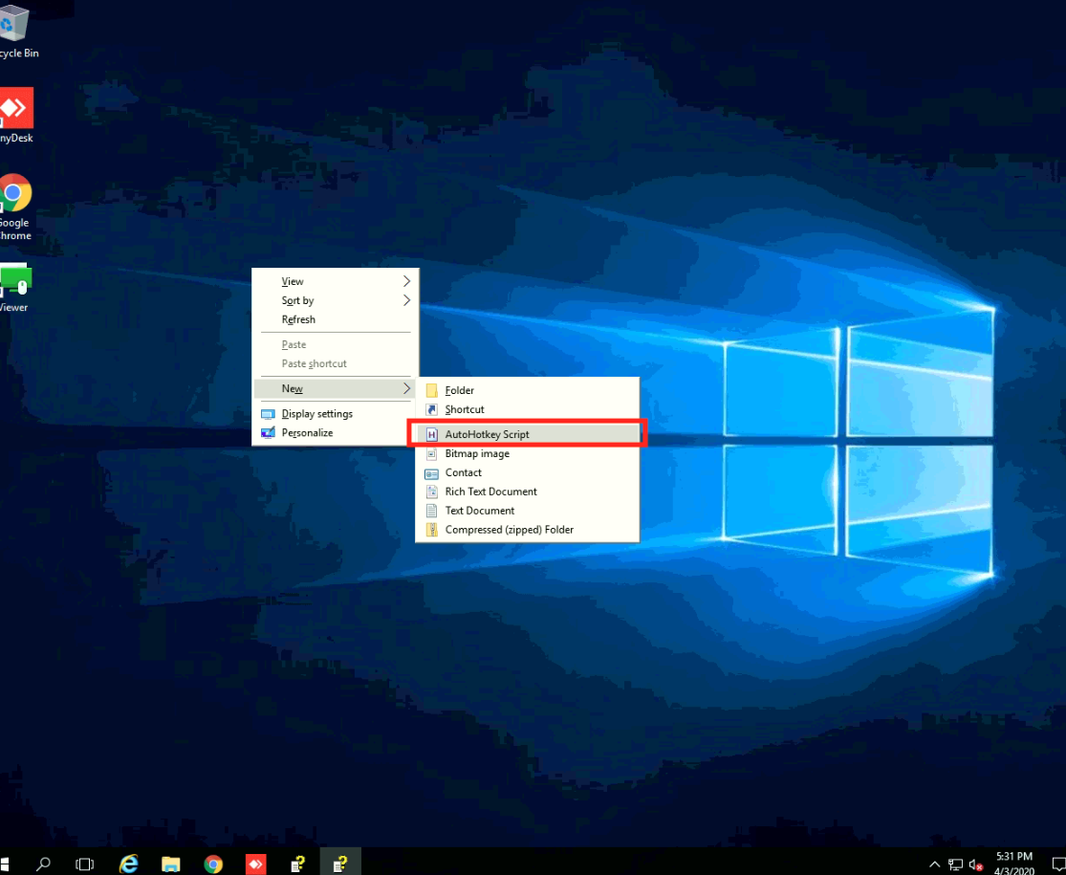

1. Edit the hotkey file and paste hotkeys.

* Firstly, add this code:

#NoEnv ; Recommended for performance and compatibility with future AutoHotkey releases.

; #Warn ; Enable warnings to assist with detecting common errors.

SendMode Input ; Recommended for new scripts due to its superior speed and reliability.

SetWorkingDir %A_ScriptDir% ; Ensures a consistent starting directory.

F2::Pause

F1::

Sleep, 3000

return

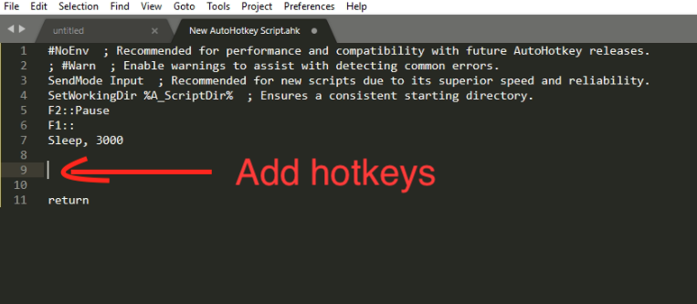

* Secondly, add the hotkeys in between “F1::” and “Sleep, 3000”

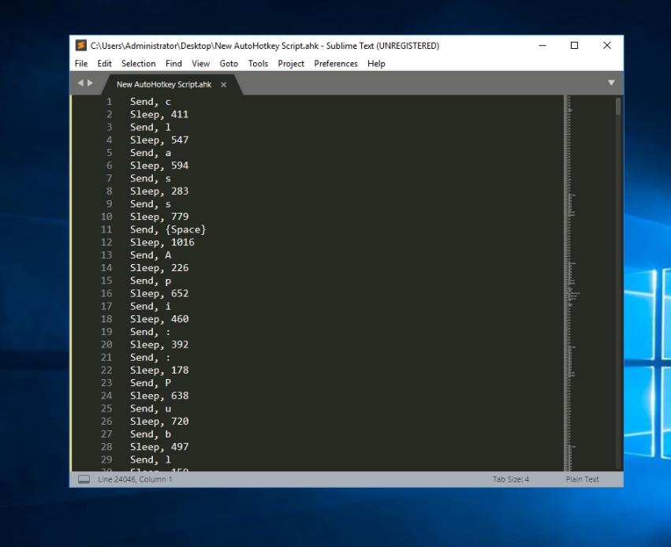

1. Double click the new hotkey file and run it.

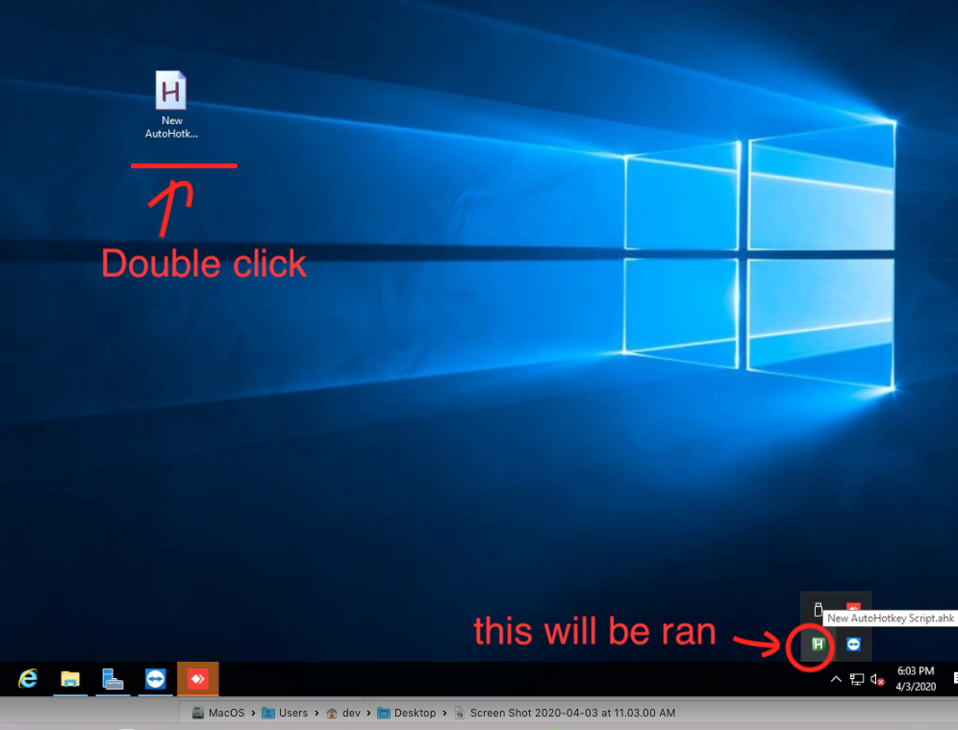

1. Open target app which you gonna send key. For example, you can Sublime editor on your local pc, or Sublime editor of remote pc inside of TeamViewer, AnyDesk or VM.
2. Click F2 on outside of TeamViewer (your local pc). After that, click mouse inside of Sbulime editor of remote pc.
3. Then hotkeys will be sent to remote sublime.
4. Note: you can customzie mouse events in index.html file.