Cleveland Clinics, OH
Runbook — Local Docker Track (PostgreSQL)

1. Overview
This runbook documents the setup and execution steps for the Cleveland Clinics, OH ETL pipeline and automated reporting job, run entirely locally via Docker Compose with PostgreSQL as the target database. All evidence in Section 4 consists of real screenshots captured from an actual docker compose up --build session on Windows (Docker Desktop, PowerShell) — not illustrative examples.

Architecture
Three containers, one shared network, defined in docker-compose.yml:
- db — official postgres:16 image. Exposes port 5433 on the host (mapped to 5432 in the container) and persists data in a named Docker volume.
- etl — built from the project's Dockerfile (Python 3.11 + pandas + SQLAlchemy + psycopg2). Waits for db to report healthy, then runs etl_pipeline.py to create the schema and load all 8 source CSVs.
- report — built from the same Dockerfile. Waits for etl to exit successfully (not just start), then runs report_generator.py in summary mode, writing its output to a host-mounted sample_output/ folder.

2. Prerequisites
- Docker Desktop installed and running (Windows/Mac) or Docker Engine + Docker Compose plugin (Linux). Verify with: docker --version
- No local PostgreSQL installation is required — the database runs entirely inside the db container.
- Approximately 500 MB of free disk space for the Postgres and Python base images.

3. Setup & Execution Steps

Step 1 — Unzip and enter the project folder
unzip ClevelandClinics_OH_LocalDockerTrack_Submission.zip
cd cleveland

Step 2 — Build and start all containers
docker compose up --build
This single command builds the Python image, starts PostgreSQL, waits for its health check to pass, runs the ETL job to completion, and only then starts the report job. Expected duration: 1-2 minutes on first run (image downloads/build), under 15 seconds on subsequent runs.

Step 3 — Confirm the ETL load succeeded
Watch the etl service's log output for a line per table ending in "ETL run complete." A successful run loads:
Table | Rows Extracted | Rows Loaded
patients | 2,300 | 2,300
doctors | 200 | 200
branches | 100 | 100
appointments | 12,000 | 11,994
billing | 5,000 | 5,000
lab_reports | 7,500 | 7,500
prescriptions | 9,000 | 9,000
surgeries | 1,500 | 1,500

The 6-row gap in appointments is expected — 6 duplicate Case IDs are collapsed by the pipeline's primary-key dedup step. This exact table matches Screenshot 5 in Section 4, captured directly from clinic.etl_load_log after a real run.

Step 4 — Confirm the report job succeeded
The report service prints a full text report to its log and also writes it to ./sample_output/ on the host (mounted from the container). Check it with:
cat sample_output/daily_report_summary_*.txt
# PowerShell: Get-Content sample_output/daily_report_summary_*.txt

Step 5 — (Optional) Inspect the database directly
docker exec -it cleveland_clinics_db psql -U postgres -d cleveland_clinics_oh -c "SET search_path TO clinic; SELECT * FROM etl_load_log ORDER BY load_id DESC LIMIT 8;"
This is the strongest single piece of evidence that the pipeline ran correctly — it queries the database directly rather than trusting script output alone. Expected result: 8 rows, all status = SUCCESS (see Screenshot 5).

Step 6 — Stop and clean up
docker compose down # stop containers, keep data volume
docker compose down -v # stop containers AND delete the data volume

Re-running the pipeline
docker compose up (with or without --build) only re-executes a service's container if its image or configuration has changed since the last run. Because etl and report are one-shot job containers rather than long-running services, an unchanged re-run of docker compose up will leave them sitting in their previous Exited state instead of re-running them — this can look like the command "did nothing" the second time. To force a genuine fresh run:
docker compose down
docker compose up --build

# or, to re-run just one job on demand without touching the database:
docker compose run --rm etl
docker compose run --rm report
docker compose run --rm always executes a fresh container regardless of whether anything changed, and removes it afterward — this is the more reliable way to invoke etl or report individually once the environment is already set up.

4. Evidence of a Real Run
The five screenshots below were captured consecutively during a single docker compose up --build session (14:19-14:21 IST, timestamps visible in each screenshot's taskbar clock and in the log lines themselves) and are also included as standalone image files in the screenshots/ folder of this submission.

Screenshot 1 — Build and container creation
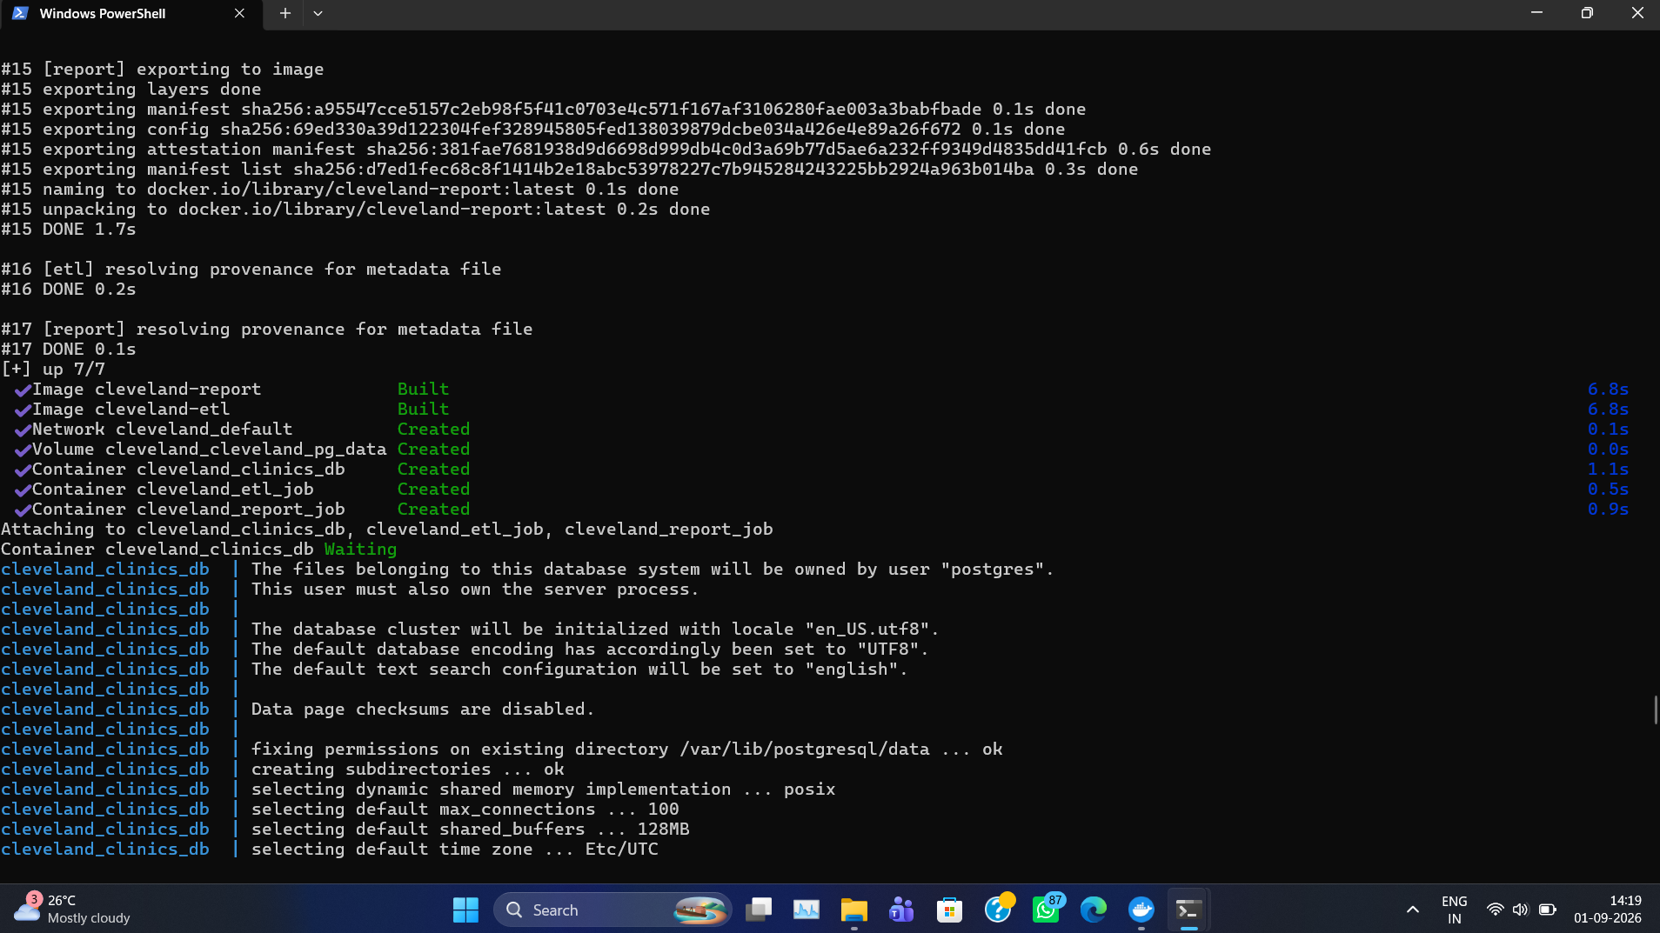
docker compose up --build: both images built, all 3 containers created, Postgres initializing.

Screenshot 2 — Postgres healthy, ETL loading tables
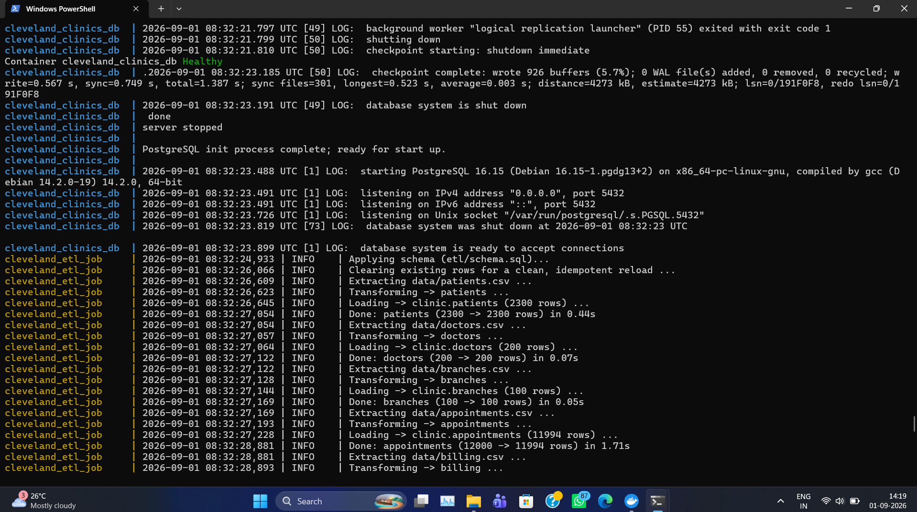
cleveland_clinics_db reports Healthy; cleveland_etl_job applies the schema and loads patients, doctors, branches, and appointments (11,994 rows).

Screenshot 3 — Referential-integrity checks and report start
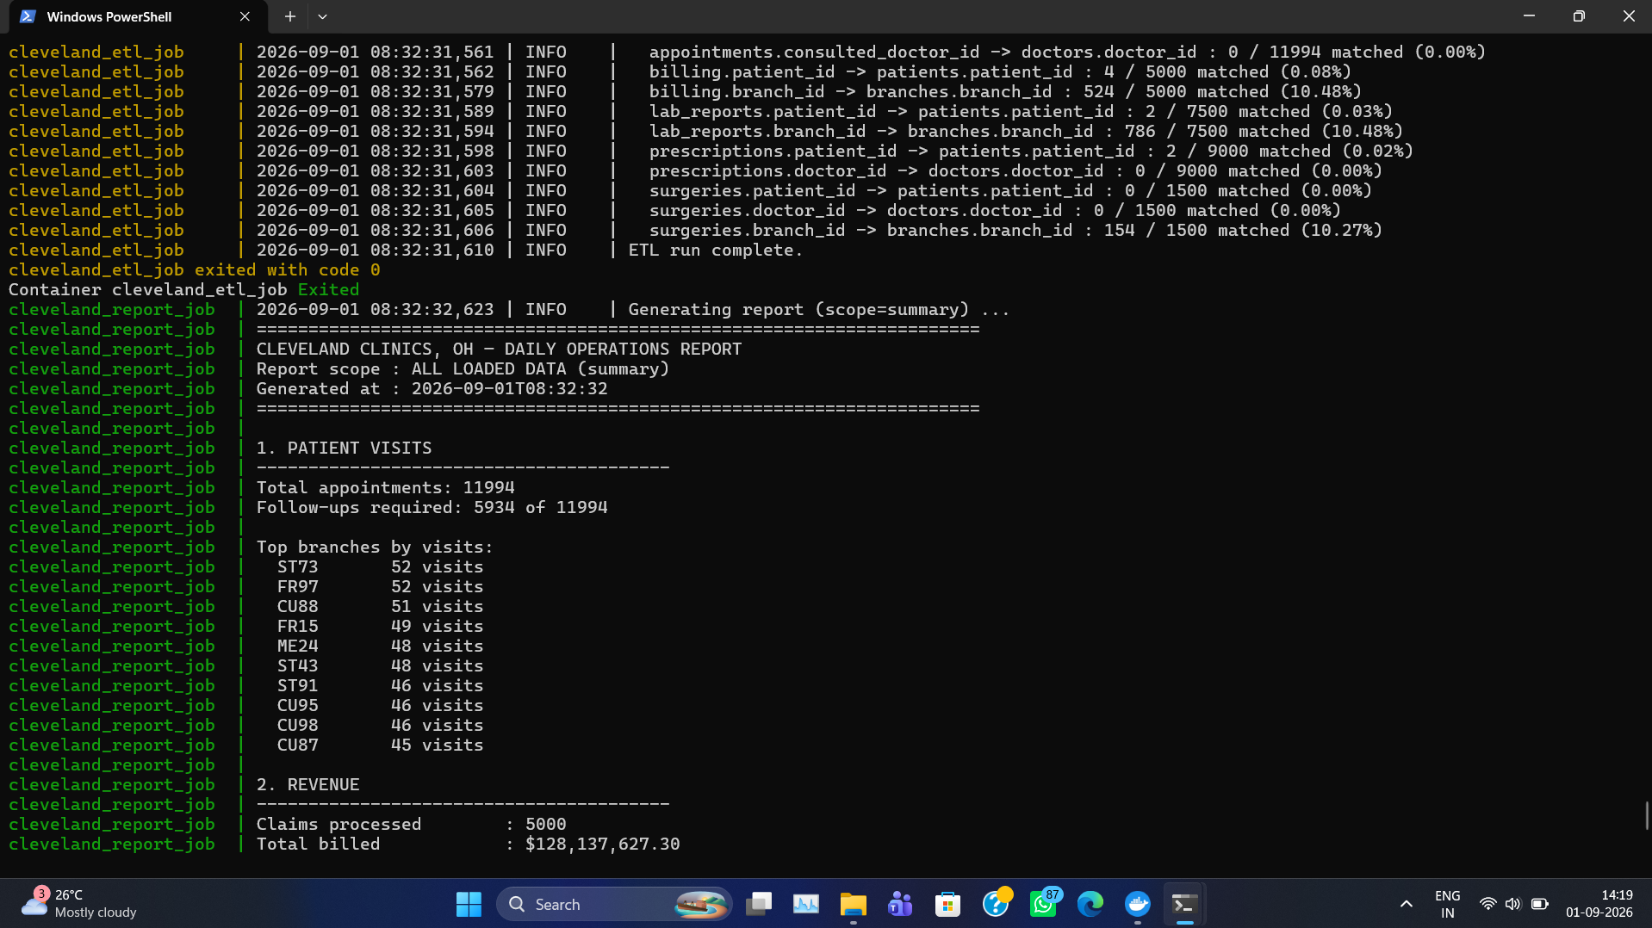
ETL completes all 12 referential-integrity checks, exits with code 0, and cleveland_report_job begins generating its report immediately after — confirming the depends_on fix works correctly.

Screenshot 4 — Revenue, diagnoses, and clean exit
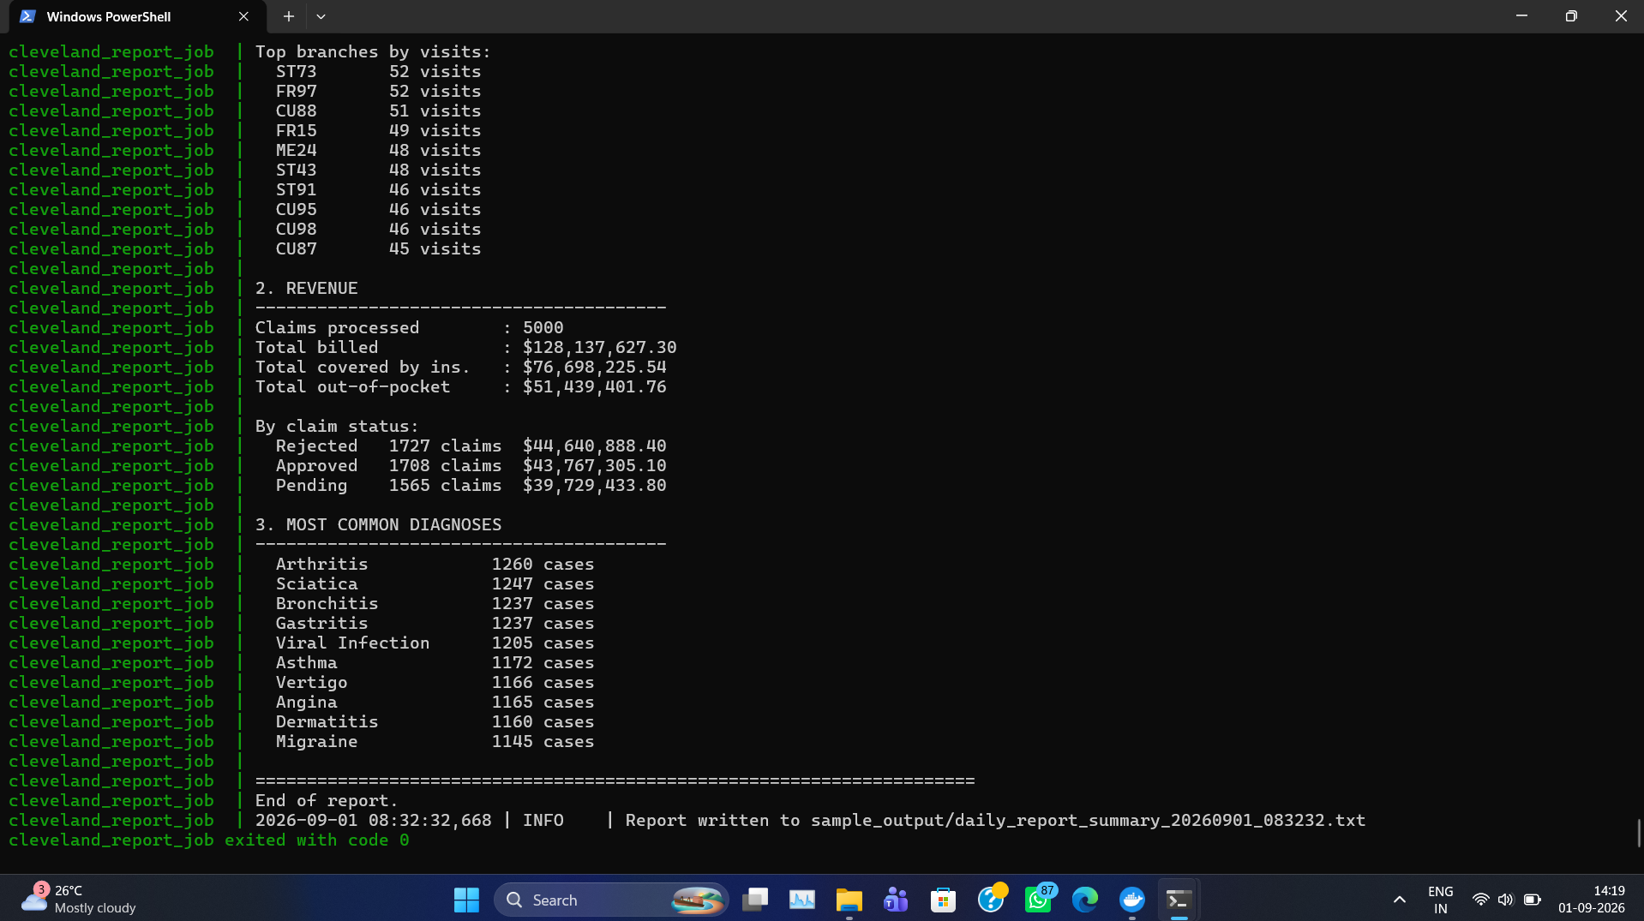
Report output: revenue by claim status and top 10 diagnoses; cleveland_report_job exits with code 0.

Screenshot 5 — File listing and direct database verification
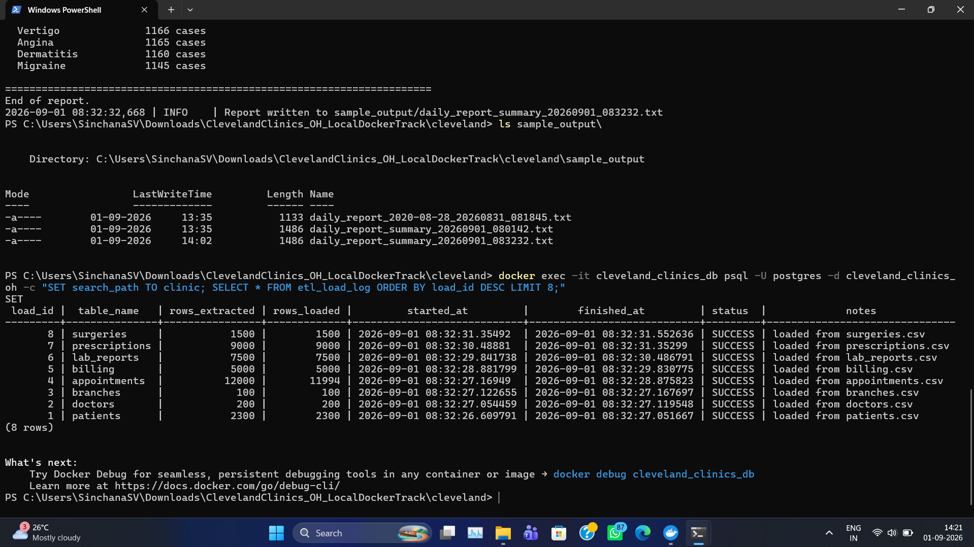
sample_output/ contains multiple timestamped reports from repeated runs; a direct psql query against clinic.etl_load_log returns 8 rows, all status = SUCCESS, independent of any script's own reporting.

5. Issue Found & Fixed During Verification
An initial run of this project surfaced a real orchestration bug, which is documented here for transparency rather than omitted.

Problem
The original docker-compose.yml declared the report service's dependency on etl using the short form depends_on: [etl], which only waits for the etl container to start — not to finish. Because both containers start in parallel, report attempted to query clinic.appointments before etl had created the table, causing report to crash with psycopg2.errors.UndefinedTable while etl continued running successfully in the background. Both containers still exited with code 0 in that scenario (report's failure is a Python-level exception, not a container-level one caught by Compose), which made the failure easy to miss from exit codes alone — the mismatch was only caught by checking the containers' actual log output.

Fix
docker-compose.yml (included in this submission) now uses the long-form condition:
report:
build: .
container_name: cleveland_report_job
depends_on:
etl:
condition: service_completed_successfully
This makes Compose wait for etl to exit successfully before starting report. Screenshot 3 in Section 4 confirms the fix: cleveland_etl_job exited with code 0 appears immediately before cleveland_report_job begins generating its report.

6. Key Finding Surfaced by This Run
The data-quality checks built into the pipeline (Screenshot 3, and the etl_load_log query in Screenshot 5) show that patient_id and doctor_id essentially never match between the fact tables (appointments, billing, lab_reports, prescriptions, surgeries) and their corresponding dimension tables (patients, doctors) — match rates of 0.00% to 0.08%. branch_id fares better but still only matches 10-12% of the time. This is why schema.sql intentionally does not enforce FOREIGN KEY constraints on the fact tables: doing so would silently reject the vast majority of rows on load. Instead, the pipeline measures and logs the real match rate on every run so the gap stays visible.

