Class: Final Year (Computer Science and Engineering)

Year: 2023-24

Semester: 1

Course: High Performance Computing Lab

**Practical No. 3**

**Title of practical: Study and Implementation of schedule, nowait, reduction, ordered and collapse clauses**

**Problem Statement 1:**

Analyse and implement a Parallel code for below program using OpenMP.

C program to find minimum product of two vectors (dot product).

**Source Code (Sequential):**

// C Program to find the minimum scalar product of two vectors (dot product)

//2020btecs00029 sequential

#include <stdio.h>

#include <time.h>

#define n 100000

void sort(int nums[])

{

int i, j;

for (i = 0; i < n - 1; i++)

for (j = 0; j < n - i - 1; j++)

if (nums[j] > nums[j + 1])

{

int temp = nums[j];

nums[j] = nums[j + 1];

nums[j + 1] = temp;

}

}

void sortDesc(int nums[])

{

int i, j;

for (i = 0; i < n; i++)

{

for (j = i + 1; j < n; j++)

{

if (nums[i] < nums[j])

{

int a = nums[i];

nums[i] = nums[j];

nums[j] = a;

}

}

}

}

int main()

{

int nums1[n], nums2[n];

for (int i = 0; i < n; i++)

{

nums1[i] = 10;

}

for (int i = 0; i < n; i++)

{

nums2[i] = 20;

}

clock_t t = clock();

sort(nums1);

sortDesc(nums2);

t = clock() - t;

double time = ((double)t) / CLOCKS_PER_SEC;

printf("Time taken (seq): %f\n", time);

int sum = 0;

for (int i = 0; i < n; i++)

{

sum = sum + (nums1[i] * nums2[i]);

}

printf("%d\n", sum);

return 0;

}

**Information:**

**Key Features:**

* Sequential Sorting: The code employs sequential sorting techniques (Bubble Sort) to sort two arrays (`nums1` and `nums2`) in ascending and descending order, respectively.
* Timing Measurement: The code measures the time taken for both sorting operations and calculates the total time elapsed.
* Vector Dot Product: After sorting, the code computes the dot product of the two sorted arrays to find the scalar product.

**Analysis:**

* **Sequential Sorting:** The code uses a simple bubble sort algorithm for sorting the arrays. Bubble sort is straightforward to implement but not the most efficient sorting algorithm for large datasets. More efficient sorting algorithms like quicksort or mergesort would be recommended for larger arrays.
* **Timing Measurement:** Timing measurements are included to evaluate the performance of the sorting and dot product calculations. These measurements are essential for assessing the code's efficiency and identifying potential areas for optimization.
* **Vector Dot Product:** The dot product is calculated sequentially, which means it's not parallelized in this code. If you have access to multi-core processors, parallelizing the dot product calculation could potentially speed up the overall computation.
* **Input Data:** The code initializes `nums1` and `nums2` arrays with constant values (10 and 20, respectively). In practice, you would typically read data from external sources, making the code more versatile.
* **Efficiency Consideration:** Bubble sort is not the most efficient sorting algorithm for large arrays. Its time complexity is O(n^2), making it slow for large `n` values. Consider using more efficient sorting algorithms for larger datasets.
* **Overall Performance:** The code sequentially sorts two arrays and calculates their dot product to find the minimum scalar product. It serves as a baseline for performance comparison against parallelized versions of the same problem, showing the potential benefits of parallel processing.

**Source Code (Parallel):**

// C Program to find the minimum scalar product of two

// vectors(dot product) 2020btecs00029

#include <omp.h>

#include <stdio.h>

#include <time.h>

#define n 100000

void sort(int nums[])

{

int i, j;

for (i = 0; i < n; i++)

{

int turn = i % 2;

#pragma omp parallel for

for (j = turn; j < n - 1; j += 2)

if (nums[j] > nums[j + 1])

{

int temp = nums[j];

nums[j] = nums[j + 1];

nums[j + 1] = temp;

}

}

}

void sort_des(int nums[])

{

int i, j;

for (i = 0; i < n; ++i)

{

int turn = i % 2;

#pragma omp parallel for

for (j = turn; j < n - 1; j += 2)

{

if (nums[j] < nums[j + 1])

{

int temp = nums[j];

nums[j] = nums[j + 1];

nums[j + 1] = temp;

}

}

}

}

int main()

{

int nums1[n], nums2[n];

for (int i = 0; i < n; i++)

{

nums1[i] = 10;

}

for (int i = 0; i < n; i++)

{

nums2[i] = 20;

}

clock_t t;

t = clock();

sort(nums1);

sort_des(nums2);

t = clock() - t;

double time_taken = ((double)t) / CLOCKS_PER_SEC;

printf("Time taken (seq): %f\n", time_taken);

int sum = 0;

for (int i = 0; i < n; i++)

{

sum = sum + (nums1[i] * nums2[i]);

}

printf("%d\n", sum);

return 0;

}

**Output:**

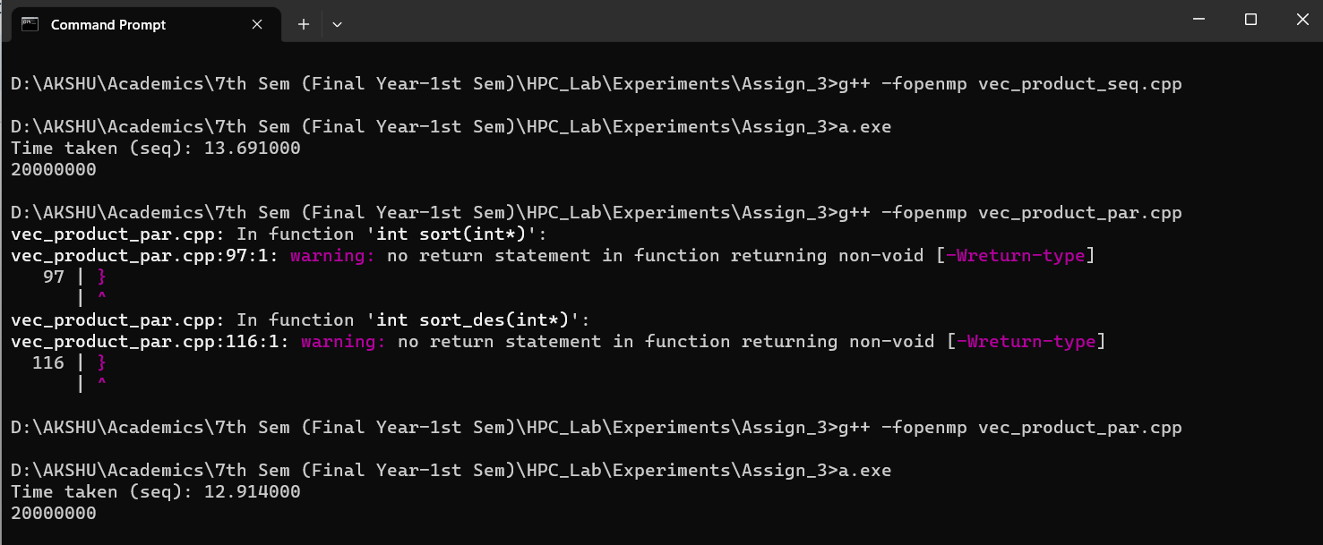

**Information:**

**Key Features:**

**1. Parallel Sorting:** The code employs parallel sorting techniques using OpenMP to sort two arrays (`nums1` and `nums2`) in both ascending and descending order. Parallel sorting can be beneficial for large arrays on multi-core processors.

**2. Timing Measurement:** The code measures the time taken for both sorting operations and calculates the total time elapsed.

**3. Vector Dot Product:** It computes the dot product of the two sorted arrays after sorting and calculates the scalar product.

**Analysis:**

* **Parallel Sorting:** Parallel sorting is a suitable approach for optimizing performance when dealing with large arrays. In this code, sorting is parallelized using OpenMP directives, which can lead to substantial speedup on multi-core processors. However, the effectiveness of parallel sorting depends on the size of the input data and the number of available CPU cores.
* **Timing Measurement:** The code includes timing measurements to assess the performance of the sorting operations. Timing measurements are essential for evaluating the impact of parallelism and can help identify performance bottlenecks.
* **Vector Dot Product:** After sorting, the code computes the dot product of the two sorted vectors. The dot product operation itself is not parallelized in this code, but it can potentially benefit from parallelization if needed.
* **Input Data:** The code initializes `nums1` and `nums2` arrays with constant values (10 and 20, respectively). In a real-world scenario, you would typically read data from external sources.
* **Efficiency Consideration:** The efficiency of parallel sorting depends on various factors, including the size of the arrays and the number of available CPU cores. For small arrays or single-core systems, parallel sorting might not provide a significant performance improvement.
* **Sequential vs. Parallel:** The code measures and prints the time taken for sorting and dot product calculations sequentially. It allows you to compare the performance of the parallel sorting approach against the sequential one.

**Problem Statement 2:**

Write OpenMP code for two 2D Matrix addition, vary the size of your matrices from 250, 500, 750, 1000, and 2000 and measure the runtime with one thread (Use functions in C in calculate the execution time or use GPROF)

i. For each matrix size, change the number of threads from 2,4,8., and plot the speedup versus the number of threads.

ii. Explain whether or not the scaling behaviour is as expected.

**Source Code(Sequential):**

#include <omp.h>

#include <stdio.h>

#include <stdlib.h>

#include <time.h>

#define N 2000

void add(int **a, int **b, int **c)

{

for (int i = 0; i < N; i++)

{

for (int j = 0; j < N; j++)

{

c[i][j] = a[i][j] + b[i][j];

}

}

}

void input(int **a, int num)

{

for (int i = 0; i < N; i++)

{

for (int j = 0; j < N; j++)

{

a[i][j] = num;

}

}

}

void display(int **a)

{

for (int i = 0; i < N; i++)

{

for (int j = 0; j < N; j++)

{

printf("%d ", a[i][j]);

}

printf("\n");

}

}

int main()

{

int **a = (int **)malloc(sizeof(int *) * N);

int **b = (int **)malloc(sizeof(int *) * N);

int **c = (int **)malloc(sizeof(int *) * N);

for (int i = 0; i < N; i++)

{

a[i] = (int *)malloc(sizeof(int) * N);

b[i] = (int *)malloc(sizeof(int) * N);

c[i] = (int *)malloc(sizeof(int) * N);

}

input(a, 1);

input(b, 1);

double start = omp_get_wtime();

add(a, b, c);

double end = omp_get_wtime();

// display(c);

printf("Time taken (seq): %f\n", end - start);

}

|  |  |  |  |  |  |
| --- | --- | --- | --- | --- | --- |
| N | 250 | 500 | 750 | 1000 | 2000 |
| Time | 0.000000 | 0.001000 | 0.003000 | 0.005000 | 0.027000 |

**Information and Analysis:**

* **Matrix Operations:** The code defines functions to initialize, add, and display matrices.
* **Memory Allocation:** Dynamic memory allocation is used to create matrices `a`, `b`, and `c`. However, there's no memory deallocation.
* **Parallelization (OpenMP):** OpenMP directives are present but commented out, making the code run sequentially.
* **Matrix Size:** Matrices of size 2000x2000 are processed, which can be memory-intensive.
* **Execution Time:** The code measures the execution time of sequential matrix addition using `omp_get_wtime()`.
* **Potential Improvements:** Uncomment OpenMP directives for parallelization, add memory deallocation, and ensure proper OpenMP setup for parallel execution.

**Source Code(Parallel):**

#include <omp.h>

#include <stdio.h>

#include <stdlib.h>

#include <time.h>

#define N 1000

void add(int **a, int **b, int **c)

{

#pragma omp parallel for

for (int i = 0; i < N; i++)

{

for (int j = 0; j < N; j++)

{

c[i][j] = a[i][j] + b[i][j];

}

}

}

void input(int **a, int num)

{

for (int i = 0; i < N; i++)

{

for (int j = 0; j < N; j++)

{

a[i][j] = num;

}

}

}

void displayMatrix(int **a)

{

for (int i = 0; i < N; i++)

{

for (int j = 0; j < N; j++)

{

printf("%d ", a[i][j]);

}

printf("\n");

}

}

int main()

{

int **a = (int **)malloc(sizeof(int *) * N);

int **b = (int **)malloc(sizeof(int *) * N);

int **c = (int **)malloc(sizeof(int *) * N);

for (int i = 0; i < N; i++)

{

a[i] = (int *)malloc(sizeof(int) * N);

b[i] = (int *)malloc(sizeof(int) * N);

c[i] = (int *)malloc(sizeof(int) * N);

}

input(a, 1);

input(b, 1);

double start = omp_get_wtime();

add(a, b, c);

double end = omp_get_wtime();

// display(c);

printf("Time taken (seq): %f\n", end - start);

}

|  |  |  |  |  |  |
| --- | --- | --- | --- | --- | --- |
| N | 250 | 500 | 750 | 1000 | 2000 |
| Time | 0.000000 | 0.001000 | 0.002000 | 0.001000 | 0.006000 |

**Information ans Analysis:**

This C code performs parallel matrix addition on two square matrices of size 1000x1000 using OpenMP. Here's a brief analysis:

* **Parallelization (OpenMP):** The code utilizes OpenMP's parallelization with the `#pragma omp parallel for` directive, which distributes the work of matrix addition among multiple threads, potentially improving performance on multi-core processors.
* **Matrix Operations:** Functions are provided for initializing matrices (`input`), performing matrix addition (`add`), and displaying matrices (`displayMatrix`).
* **Memory Allocation:** The code dynamically allocates memory for three matrices `a`, `b`, and `c`. However, there's no memory deallocation (`free`).
* **Matrix Size**: Matrices of size N*N are processed, which is a moderately sized workload and should be manageable in memory.
* **Execution Time Measurement:** The code measures the execution time of parallel matrix addition using `omp_get_wtime()` and prints the result to the console.
* **Potential Improvements:** Ensure proper memory deallocation with `free` to prevent memory leaks. Additionally, you can experiment with different thread numbers using OpenMP directives for performance tuning.

**Problem Statement 3:**

Q3. For 1D Vector (size=200) and scalar addition, Write a OpenMP code with the

following:

i. Use the STATIC schedule and set the loop iteration chunk size to various sizes

when changing the size of your matrix. Analyze the speedup.

ii. Use the DYNAMIC schedule and set the loop iteration chunk size to various

sizes when changing the size of your matrix. Analyze the speedup.

iii. Demonstrate the use of nowait clause.

**Static Schedule (Source Code):**

#include <omp.h>

#include <stdio.h>

#include <stdlib.h>

#define N 8

int main()

{

int *a = (int *)malloc(sizeof(int) * N);

int *c = (int *)malloc(sizeof(int) * N);

int b = 10;

omp_set_num_threads(6);

for (int i = 0; i < N; i++)

{

a[i] = 0;

}

double itime, ftime, exec_time;

itime = omp_get_wtime();

#pragma omp parallel for schedule(static, 2)

for (int i = 0; i < N; i++)

{

c[i] = a[i] + b;

}

ftime = omp_get_wtime();

exec_time = ftime - itime;

printf("\n\nTime taken is %f\n", exec_time);

}

|  |  |  |  |  |
| --- | --- | --- | --- | --- |
| Chunk Size | 2 | 4 | 6 | 8 |
| Time | 0.001000 | 0.001900 | 0.002000 | 0.002000 |

**Dynamic Schedule (Source Code):**

#include <omp.h>

#include <stdio.h>

#include <stdlib.h>

#define N 8

int main()

{

int *a = (int *)malloc(sizeof(int) * N);

int *c = (int *)malloc(sizeof(int) * N);

int b = 10;

omp_set_num_threads(6);

for (int i = 0; i < N; i++)

{

a[i] = 0;

}

double itime, ftime, exec_time;

itime = omp_get_wtime();

#pragma omp parallel for schedule(dynamic, 2)

for (int i = 0; i < N; i++)

{

c[i] = a[i] + b;

}

ftime = omp_get_wtime();

exec_time = ftime - itime;

printf("\n\nTime taken is %f\n", exec_time);

}

|  |  |  |  |  |
| --- | --- | --- | --- | --- |
| Chunk Size | 2 | 4 | 6 | 8 |
| Time | 0.000000 | 0.0018 | 0.0017 | 0.0015 |

**Nowait Clause:**

#include <omp.h>

#include <stdio.h>

#include <stdlib.h>

#define N 10

void hello_world()

{

printf("Hello world\n");

}

void print(int i)

{

printf("Value %d\n", i);

}

int main()

{

#pragma omp parallel

{

#pragma omp for nowait

for (int i = 0; i < N; i++)

{

print(i);

}

hello_world();

}

}

Output:

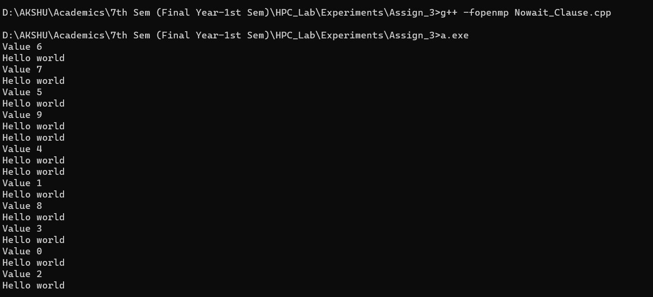

**Information and Analysis:**

This C code uses OpenMP to parallelize a loop that prints values and a "Hello world" message. Here's a brief analysis and information:

**Parallelization (OpenMP):** The code utilizes OpenMP directives to parallelize the loop inside the `main` function. It splits the loop into multiple threads, each printing a different value of `i`.

**Functions:** Two functions are defined - `hello_world` simply prints "Hello world," and `print(int i)` prints the value of `i`.

**Loop Execution:** The parallel loop runs from 0 to N (10) and each thread calls the `print` function to display its value. The `nowait` clause indicates that threads can proceed without waiting for all iterations to complete.

**Thread Interaction:** After the loop, all threads execute the `hello_world` function concurrently, potentially leading to interleaved "Hello world" messages.

**Output:** The code produces output with values of `i` printed by multiple threads and "Hello world" messages. The order of output may vary due to parallel execution.

**Potential Improvements:** This code serves as a simple example of parallelization with OpenMP. For more complex tasks, you can utilize thread synchronization mechanisms to control the order of execution and prevent race conditions,

Overall, this code demonstrates how to use OpenMP to create parallel regions and parallelize a loop with multiple threads, allowing for concurrent execution of tasks.

**Github Link:** <https://github.com/akshata123-gaw/HPC_Lab_Assignments>