BSI IT-Grundschutz Assistant
Backend Architecture & Technology Stack
Document version: 1.0 | Application: bsi_assistant_app_2.py

1. Executive Summary
The BSI IT-Grundschutz Assistant is a Streamlit web application that supports industrial security architects in two complementary workflows: (1) conversational querying of the BSI Compendium via an OpenAI Assistant with file search, and (2) deterministic generation of VDI 2182 threat impact matrices from predefined system architectures.
The backend follows a hybrid design: LLM-powered retrieval for flexible Q&A, combined with rule-based aggregation and structured YAML/JSON knowledge stores for auditable, repeatable compliance outputs.

2. System Architecture

Figure 1 — High-level system architecture

3. Technology Stack
Layer | Technology | Purpose
Frontend / UI | Streamlit | Chat interface, sidebar navigation, editable threat matrix (data_editor), CSV export
LLM & RAG | OpenAI Assistants API + File Search | Grounded Q&A over BSI Compendium PDF hosted in OpenAI vector store
Component mapping | RapidFuzz + Regex | Map free-text names (PLC, SPS, sensors) to standardized IND modules
Data processing | pandas | Threat matrix as DataFrame; change detection for expert edits
Knowledge store | YAML + JSON | Synonyms, architectures, threats, VDI mappings, expert templates
Configuration | python-dotenv / Streamlit Secrets | API keys and Assistant ID for local and cloud deployment
Runtime | Python 3.10+ | Core application logic

4. Data Layer
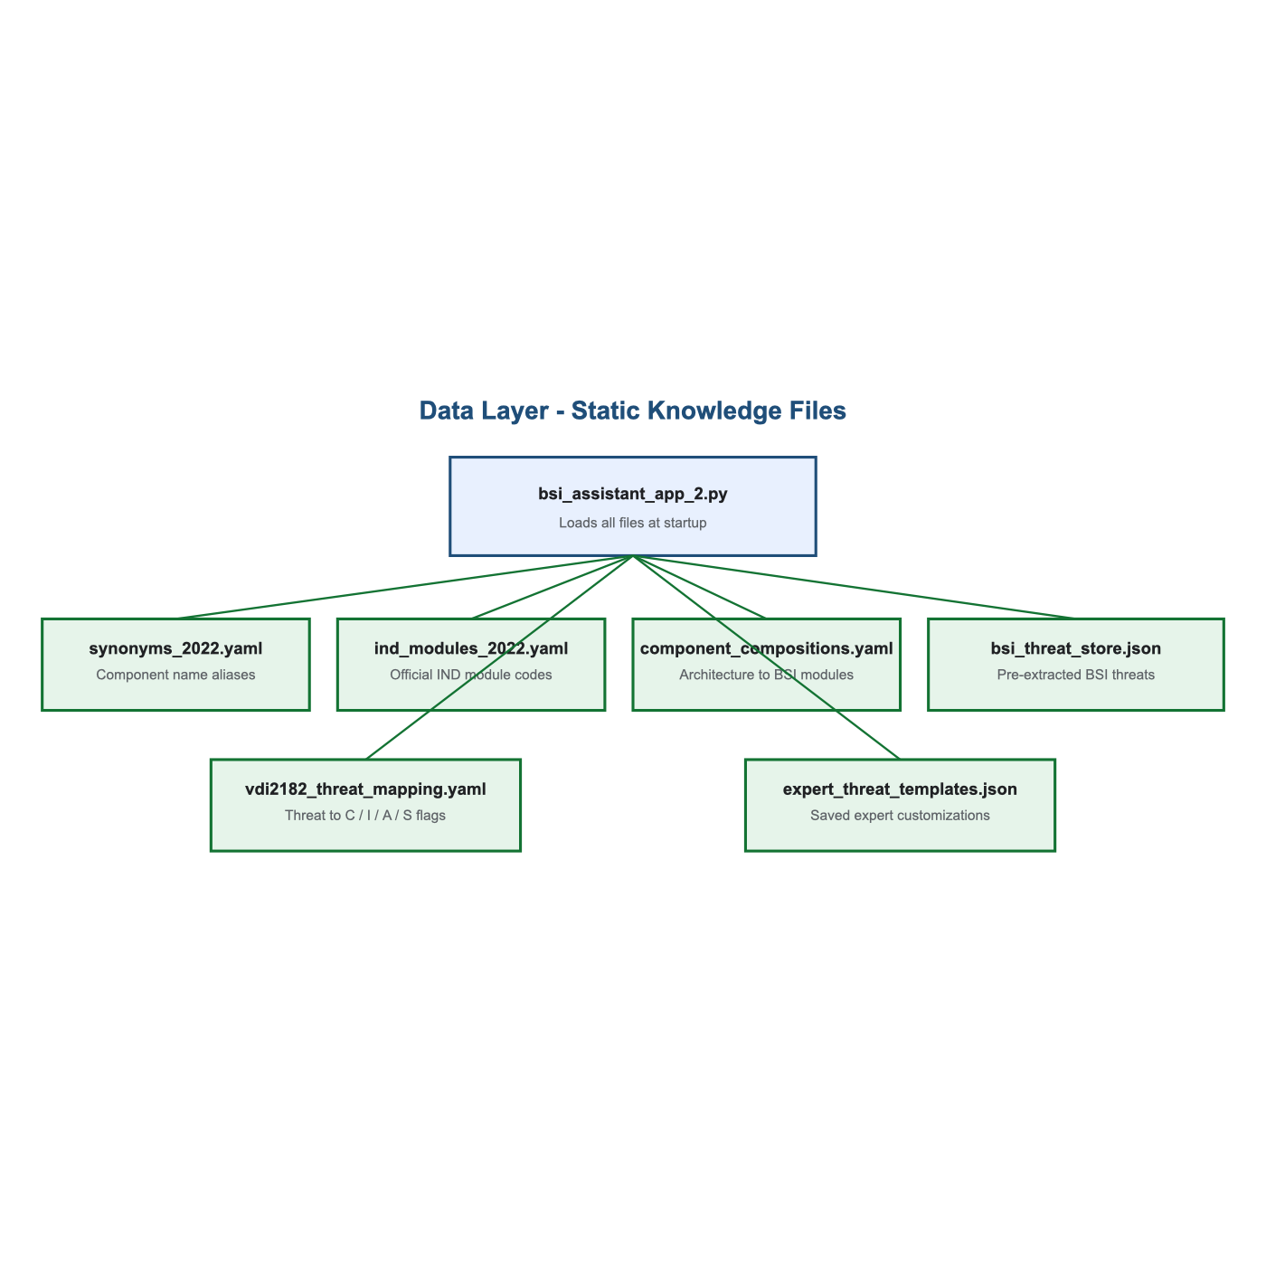
Figure 2 — Static knowledge files loaded at startup
File | Description
synonyms_2022.yaml | Canonical component names and aliases (e.g. SPS → PLC)
ind_modules_2022.yaml | Authoritative BSI IND module codes and titles
component_compositions.yaml | Predefined architectures mapped to BSI modules
bsi_threat_store.json | Pre-extracted threat titles per IND module with citations
vdi2182_threat_mapping.yaml | Deterministic C / I / A / S impact flags per threat
expert_threat_templates.json | Persisted expert-added or customized threats

5. Backend Flow — Chat Mode (Phases 1–3)
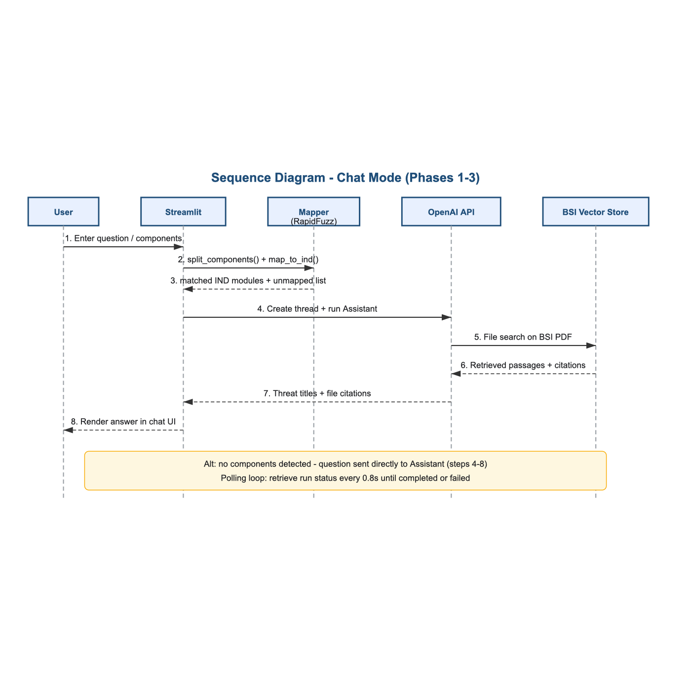
Figure 3 — Sequence diagram: chat and component mapping flow
- User submits a natural-language question or component list via st.chat_input.
- split_components() parses input on delimiters (comma, semicolon, newline, 'and').
- map_to_ind() resolves components using regex, exact synonym lookup, and fuzzy matching (≥86% score).
- If components are found: structured prompts are sent per component to the OpenAI Assistant.
- Assistant performs file search on the BSI PDF and returns threat titles with file citations.
- If no components are detected: the full question is sent directly to the Assistant.
- Responses are assembled and displayed in the chat UI; session state preserves conversation history.

6. Backend Flow — Matrix Mode (Phases 4–5)
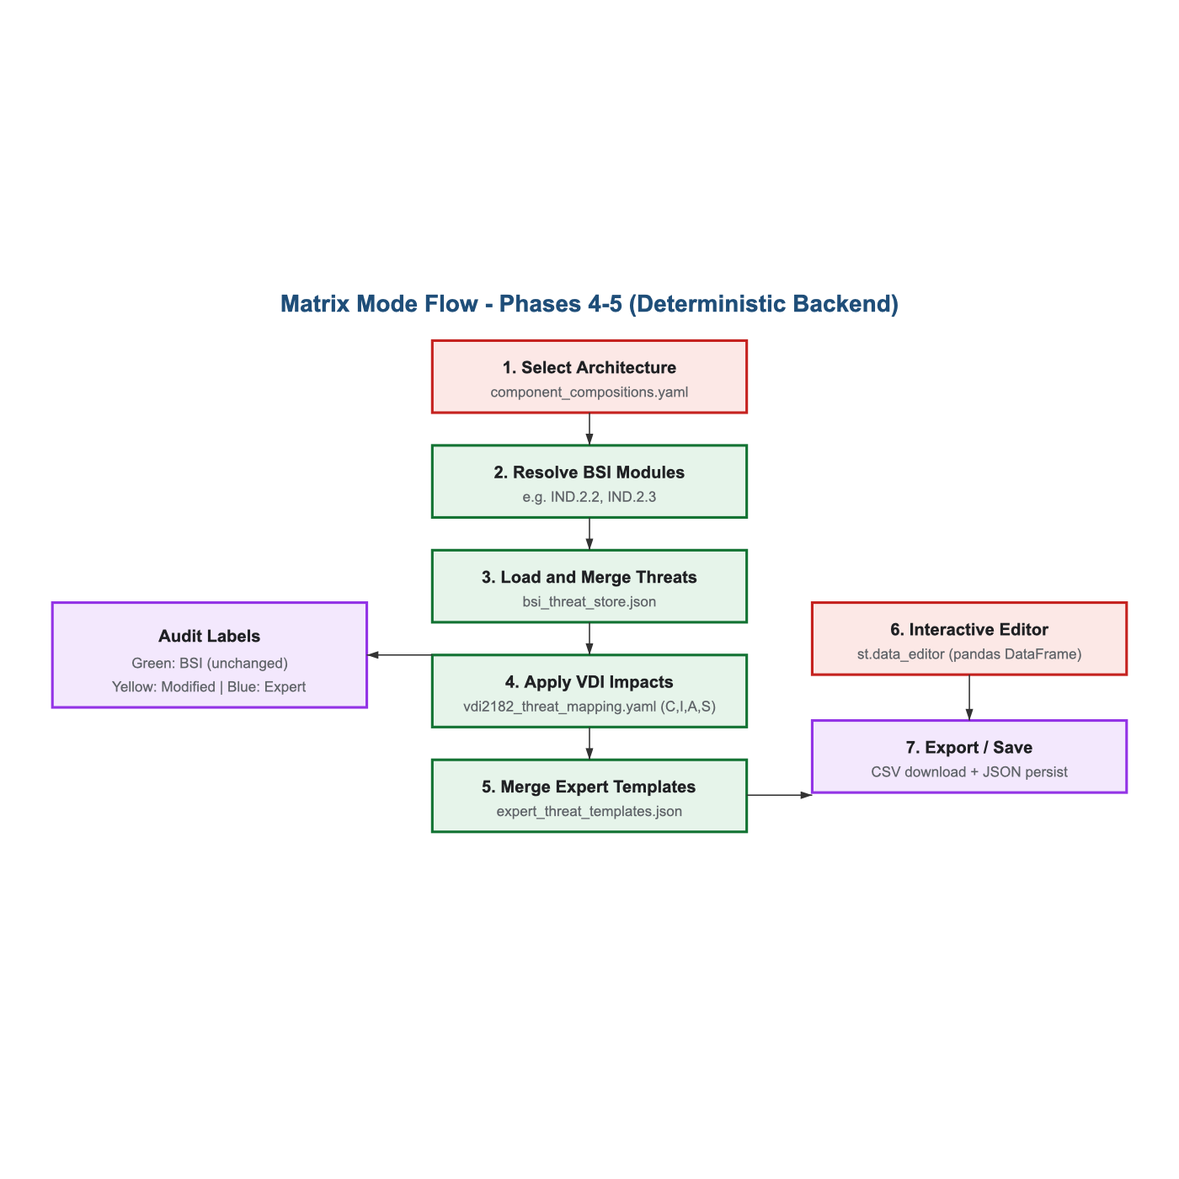
Figure 4 — Deterministic threat matrix pipeline
- User selects an architecture from the sidebar (e.g. plc_basic, plc_with_field_devices).
- aggregate_threats() collects threats from bsi_threat_store.json for all linked BSI modules.
- Duplicate threats are merged; source modules are tracked per row.
- VDI impact flags (C, I, A, S) are applied from vdi2182_threat_mapping.yaml — no LLM involved.
- Expert templates from expert_threat_templates.json are merged as additional rows.
- Matrix is rendered in st.data_editor; edits are diffed against the original for audit labels.
- Output: CSV download and optional JSON persistence of expert templates.

7. Key Design Principles
- Hybrid intelligence: LLM for reading/explaining; rules for scoring and aggregation.
- Auditability: Every matrix row tagged as BSI, Modified, or Expert origin.
- Anti-hallucination: VDI flags and architecture mappings are human-reviewed YAML, not LLM-generated.
- Separation of modes: Chat = exploratory; Matrix = structured deliverable.

8. Deployment Notes
The application deploys to Streamlit Cloud via GitHub. Secrets (OPENAI_API_KEY, OPENAI_ASSISTANT_ID) are configured in Streamlit Secrets — not committed to the repository. The BSI PDF resides in the OpenAI vector store attached to the Assistant; it is not bundled in the repo.

9. Limitations
- Chat quality depends on Assistant configuration and PDF coverage.
- Expert JSON saves may not persist on Streamlit Cloud (ephemeral filesystem); CSV export is recommended.
- Threat store and VDI mappings require periodic human review for production use.

