“Linux File System Explorer Using System Calls”
A Project Report Submitted in the partial fulfillment of the requirements for the award of the degree of
Operating Systems & Systems Programming | Term-12, S-4

BACHELOR OF TECHNOLOGY
In

DEPARTMENT OF COMPUTER SCIENCE ENGINEERING

By

M. BHAVYA 2520030005

G. KEERTHI 2520030092

K. SANJANA 2520030229

Under the Esteemed Guidance of

Dr. Soumya
Assistant Professor
Department of Computer Science and Engineering




K L (Deemed to be) University DEPARTMENT OF COMPUTER SCIENCE ENGINEERING
&

DEPARTMENT OF COMPUTER SCIENCE AND INFORMATION TECHNOLOGY

Declaration

The Project Report entitled “Linux File System Explorer Using System Calls” is a record of Bonafide work of M. BHAVYA - 2520030005, G. KEERTHI - 2520030092, K. SANJANA - 2520030229 submitted in
partial fulfillment for the award of B. Tech in Computer Science and Engineering (or) Computer Science and Information Technology to the K L University. The results embodied in this report have not been copied from any other departments/University/Institute.

M. BHAVYA 2520030005

G. KEERTHI 2520030092

K. SANJANA 2520030229

K L (Deemed to be) University

DEPARTMENT OF COMPUTER SCIENCE ENGINEERING

CERTIFICATE

This is to certify that the mini project based report entitled “Linux File System Explorer Using System Calls” is a bonafide work done and submitted by M. Bhavya – 2520030005, G. Keerthi – 2520030092, K. Sanjana – 2520030229,
in partial fulfillment of the requirements for the award of the degree of BACHELOR OF TECHNOLOGY in Department of Computer Science Engineering, K L (Deemed to be University), during the academic year 2025-2026.

Signature of the Guide

Signature of the Course Coordinator Signature of the HOD

ACKNOWLEDGEMENT
The success of this project would not have been possible without the timely help and guidance rendered by many people. We wish to express our sincere thanks to all those who have assisted us in one way or the other in the completion of our project.

Our greatest appreciation goes to our Course Coordinator Dr. K. Anusha and our guide Dr. K. Anusha, Department of Computer Science and Engineering, whose tremendous support, encouragement and guidance cannot be expressed in words.

We express our gratitude to Dr. P. Venkateshwara Rao (CSE), Head of the Department of Computer Science Engineering, for providing us with adequate facilities, ways and means by which we were able to complete this project-based lab.

We thank all the members of teaching and non-teaching staff members, and also all those who have assisted us directly or indirectly for the successful completion of this project. Finally, we sincerely thank our parents, friends and classmates for their kind help and cooperation during our work.

M. BHAVYA 2520030005

G. KEERTHI 2520030092

K. SANJANA 2520030229
Abstract

An operating system acts as the service layer between user-space programs and the hardware, and system calls are the controlled gateway through which applications request kernel services. Yet, in everyday work, graphical file managers and shell utilities hide this interaction completely, so students rarely see how a file name becomes an inode, or how a file descriptor leads to data on disk. This project, Linux File System Explorer Using System Calls, addresses that gap with a Linux-based systems programming tool written in C that makes the interaction between user space and the kernel visible.

The explorer focuses on File Systems, File Abstraction and File I/O. It lists directory entries with opendir() and readdir(), reads inode-level information with stat() and lstat(), manages file descriptors with open(), read(), write() and close(), compares unbuffered and buffered I/O, performs basic memory-mapped file access with mmap(), and reports mounted file-system information with statvfs(). Every request from the user is converted directly into the matching Linux system call, the kernel and its Virtual File System (VFS) layer perform the operation, and a clear result is displayed.

The tool was built with GCC on Ubuntu 24.04 and verified with strace, GDB and make. In our measurements, reading a 270 KB file one byte at a time needed 270,177 read() calls, whereas 4 KB reads or stdio buffering needed only 66, which demonstrates the value of buffering in practice. The project therefore turns abstract OS theory into a hands-on demonstration and strengthens the understanding of Unix file abstraction, inodes, directory entries, file naming, the VFS and file descriptors.

Index

S. No. | Chapter | Topics / Subtopics | Page No.
 | Acknowledgement |  | 4
 | Abstract |  | 5
1 | Introduction |  | 8–10
 |  | 1.1 Background of the Project | 8
 |  | 1.2 Problem Statement | 8
 |  | 1.3 Scope of the Project | 8
 |  | 1.4 Objectives of the Project | 9
 |  | 1.5 Importance of the Application | 9
 |  | 1.6 Target Users / Audience | 10
2 | OS Concepts and Background Study |  | 11–13
 |  | 2.1 Operating System Concepts Related to the Project | 11
 |  | 2.2 Existing Methods / Algorithms | 12
 |  | 2.3 Proposed Approach | 13
 |  | 2.4 Advantages of the Proposed Approach | 13
3 | System Requirements |  | 14–15
 |  | 3.1 Hardware Requirements | 14
 |  | 3.2 Software Requirements | 14
 |  | 3.3 Operating System Environment – Ubuntu / WSL | 14
 |  | 3.4 Development Tools and Compilers | 15
4 | Technology and Tools Used |  | 16–17
 |  | 4.1 C / C++ Programming | 16
 |  | 4.2 GCC Compiler | 16
 |  | 4.3 Linux System Calls | 16
 |  | 4.4 POSIX Threads / Synchronization | 17
 |  | 4.5 Linux Commands and Utilities | 17
 |  | 4.6 Other Tools / Libraries Used | 17
5 | System Architecture and Design |  | 18–21
 |  | 5.1 Overall System Architecture | 18
 |  | 5.2System Workflow | 18
 |  | 5.3 Flowchart / Data Flow | 20
 |  | 5.4 Module Description | 20
 |  | 5.5 Input and Output Design | 21
6 | Implementation |  | 22–28
 |  | 6.1 Module-wise Implementation | 22
 |  | 6.2 Algorithm / Pseudocode | 24
 |  | 6.3 Core C / C++ Implementation | 24
 |  | 6.4 Linux System Calls / APIs Used | 25
 |  | 6.5 Process / Thread Implementation | 25
 |  | 6.6 IPC / Synchronization Implementation | 26
 |  | 6.7 Memory Management Implementation | 26
 |  | 6.8 Optional User Interface Implementation | 27
7 | Execution and Demonstration |  | 29–33
 |  | 7.1 Compilation in Ubuntu | 29
 |  | 7.2 Execution Commands | 29
 |  | 7.3 Sample Inputs and Outputs | 30
 |  | 7.4 Screenshots of Execution | 30
 |  | 7.5 Demonstration of OS Concepts | 32
8 | Conclusion |  | 34–35
 |  | 8.1 Summary of the Project | 34
 |  | 8.2 Objectives Achieved | 34
 |  | 8.3 Results Achieved | 34
 |  | 8.4 Skills and Learning Outcomes | 34
9 | References |  | 36
 |  | 9.1 Books | 36
 |  | 9.2 Research Papers | 36
 |  | 9.3 Linux / GNU Documentation | 36
 |  | 9.4 Online Resources | 36

CHAPTER 1
INTRODUCTION

1.1 Background of the Project
An operating system (OS) is the layer of software that sits between user-space programs and the computer hardware. Application programs never touch the disk directly; instead they ask the kernel to do the work on their behalf through a small, well-defined set of entry points called system calls. Every action that involves a file – opening a document, listing a folder, reading a configuration file – eventually becomes one or more system calls such as open(), read(), write() or stat().
Linux, like all Unix-like systems, is built around the idea of file abstraction: regular files, directories, devices, pipes, sockets and even kernel information (under /proc) are all presented to programs through the same small set of operations. Behind that uniform interface the kernel keeps inodes, directory entries, a Virtual File System (VFS) layer and per-process tables of file descriptors.
The project Linux File System Explorer Using System Calls is a systems-programming exercise for the course Operating Systems & Systems Programming. It is written in C and calls the Linux file-system system calls directly, so that the abstract topics of File Systems, File Abstraction and File I/O become something a student can run, inspect and measure.

1.2 Problem Statement
Graphical file managers (such as GNOME Files) and shell utilities (such as ls and cat) are convenient, but they hide the system calls they use. A learner who only uses these tools never sees an inode number, never sees a file descriptor being allocated, and never observes how much cheaper a buffered read is than an unbuffered one. There is no lightweight, transparent tool that lets learners watch a request travel from user space into the kernel and back.
Problem: design and develop a Linux File System Explorer that accepts a path or an operation from the user, invokes the corresponding Linux File I/O system calls directly, and displays the resulting file-system information in a clear form, thereby making kernel file-system services visible.

1.3 Scope of the Project
The scope of the project is limited to the file-system part of the operating system and to a single Linux machine. Within this scope the project covers:
- Directory traversal and file naming using opendir(), readdir() and closedir().
- Inode-level information (type, permissions, links, owner, size, blocks, timestamps) using stat(), lstat() and fstat().
- File descriptors and open-file management using open(), read(), write(), lseek(), fcntl() and close().
- Comparison of buffered (stdio) and unbuffered (system-call) I/O.
- Basic memory-mapped file I/O using mmap() and munmap().
- Mounted file-system statistics using statvfs().
Out of scope are writing a new file system, kernel-module development, network file systems, and graphical interfaces. The tool is a read-oriented explorer: it does not modify, move or delete the files it inspects.

1.4 Objectives of the Project
- To demonstrate Unix file abstraction, inodes, directory entries, file naming and the Virtual File System in a working program.
- To invoke Linux File I/O system calls directly from a C program and display their results clearly.
- To show how file descriptors are allocated, used and released.
- To compare buffered and unbuffered I/O and measure the number of system calls and the time each needs.
- To demonstrate basic memory-mapped file access with mmap().
- To strengthen the understanding of user-space to kernel-space interaction through tracing with strace.

1.5 Importance of the Application
Understanding how a file name is resolved to data is a core outcome of any operating systems course, but it is difficult to learn from slides alone. The explorer is important because it:
- makes the boundary between user space and kernel space observable instead of theoretical;
- gives students a small, readable code base (a single C file of about 280 lines) that they can modify and extend;
- teaches defensive systems programming, since every system call is checked and errno is reported through strerror();
- provides a foundation for later topics such as process management, IPC and synchronization on the same Linux platform.

1.6 Target Users / Audience
Table 1: Target users of the project
User group | How they use the explorer
Undergraduate students (B.Tech CSE / CSIT) | Run the commands to see inodes, descriptors and I/O costs while studying the OS course.
Faculty and lab instructors | Use it as a live demonstration during lectures and laboratory sessions on file systems.
Beginner Linux / systems programmers | Read the source as a worked example of the POSIX file API and error handling.
System administrators (basic use) | Quickly inspect inode numbers, link counts and file-system capacity without extra tools.

CHAPTER 2
OS CONCEPTS AND BACKGROUND STUDY

2.1 Operating System Concepts Related to the Project

2.1.1 User mode, kernel mode and system calls
A modern CPU runs ordinary programs in a restricted user mode and the kernel in a privileged kernel mode. A program cannot read a disk block itself; it places the call number and arguments in registers and executes a special instruction (syscall on x86-64). The CPU switches to kernel mode, the kernel validates the arguments, performs the service and returns a result or a negative error code. The C library (glibc) wraps this mechanism in ordinary functions such as open() and sets the global variable errno when a call fails.

2.1.2 Unix file abstraction
In Unix, “everything is a file”. A program sees a regular file, a directory, a terminal, a pipe or a device as a stream of bytes that can be opened, read, written and closed with the same calls. This abstraction hides the differences between storage hardware and file-system formats and is the reason the same cat command works on a disk file, a USB device node or /proc/cpuinfo.

2.1.3 Inodes
An inode (index node) is the kernel's record of a file. It stores everything about the file except its name. The explorer reads this record with stat().
Table 2: Inode information retrieved with stat()
Inode field | `struct stat` member | Meaning
Inode number | st_ino | Unique identifier of the file inside its file system
File type and mode | st_mode | Regular, directory, symlink, device, FIFO, socket; rwx permission bits
Link count | st_nlink | Number of directory entries (hard links) pointing at the inode
Owner | st_uid, st_gid | User and group that own the file
Size | st_size, st_blocks | Size in bytes and number of 512-byte blocks allocated
Timestamps | st_atime, st_mtime, st_ctime | Last access, last content modification, last inode change
Device | st_dev | Device on which the file system lives

2.1.4 Directory entries and file naming
A directory is a special file whose content is a list of directory entries, each mapping a name to an inode number. Because the name lives in the directory and not in the inode, one inode can have several names (hard links) and a rename only changes a directory entry. The explorer exposes this mapping: readdir() returns struct dirent with d_name and d_ino, and lstat() then fetches the inode for each name. Symbolic links are separate small files holding a path, which is why lstat() (which does not follow links) is used for listings while stat() follows them.

2.1.5 Virtual File System (VFS)
Linux supports many file systems (ext4, XFS, tmpfs, procfs, NFS). The Virtual File System is the kernel layer that gives all of them the same interface. It defines common objects – the superblock (a mounted file system), the inode, the dentry (a cached name-to-inode mapping) and the file (an open file) – and dispatches each system call to the driver of the file system that owns the path. This is why ./fsexplorer ls /proc and ./fsexplorer ls /home use identical code although the data comes from different file systems.

2.1.6 File descriptors and the open-file tables
When open() succeeds it returns a small non-negative integer, the file descriptor (fd). Each process has its own descriptor table; entry 0, 1 and 2 are standard input, output and error. A descriptor points to an entry in the system-wide open-file table, which records the current file offset and the access flags, and that in turn points to the inode. Two descriptors can share one open-file entry (after dup() or fork()), which is why they then share the file offset.

2.1.7 File I/O: unbuffered and buffered
read() and write() are unbuffered: every call is a system call and costs a user/kernel mode switch. The C standard library (fopen, fgetc, fread) is buffered: it reads a block (typically 4 KB) into a user-space buffer with one read() and serves the following requests from memory. The explorer measures the difference in Chapter 7.

2.1.8 Memory-mapped file I/O
mmap() asks the kernel to map a file directly into the process's address space. Pages are loaded from the page cache on demand through page faults, so the program reads the file with ordinary pointer accesses and no explicit read() calls. The mapping remains valid after the descriptor is closed and is released with munmap().

2.2 Existing Methods / Algorithms
Table 3: Existing methods and their limitations
Existing approach | What it provides | Limitation for learning
GUI file managers (GNOME Files / Nautilus) | Browse, copy and open files with icons and menus | Hide every system call; no inode or descriptor information
Shell utilities (ls, cat, stat) | Fast command-line access to file information | Internals (open, read, stat) are hidden behind the command; no I/O comparison
strace on existing commands | Shows every system call made by a program | Output is very large and low-level; not a guided, structured explorer
Textbook code fragments | Short examples of one call | Not an integrated, runnable tool covering all file-system topics

Gap identified: no lightweight, transparent tool lets learners watch system calls interact with the file system in real time.

2.3 Proposed Approach
The proposed Linux File System Explorer accepts a file-system location or an operation from the user and invokes the Linux File I/O system calls directly to retrieve and display information. The processing follows five steps: the user submits a request, the program issues the matching system call, the kernel provides the service, the file-system operation is carried out by the VFS and the concrete file system, and the result is displayed. The design choices are:
- a single C program with one small function per concept, so each function can be read next to the theory it demonstrates;
- both an interactive menu and one-shot command-line sub-commands (ls, stat, cat, fds, compare, mmap, fsinfo);
- every system call is checked, and failures are reported with strerror(errno) and a non-zero exit status;
- outputs labelled so that each field can be traced back to a kernel structure (inode number, link count, descriptor number).

2.4 Advantages of the Proposed Approach
- Transparency: the kernel interaction is visible rather than hidden.
- Low overhead: needs only GCC and a Linux kernel; no GUI libraries or external dependencies.
- Educational value: each feature maps to one lecture topic (inodes, directory entries, descriptors, VFS, buffering, mmap).
- Safety: read-only operations; the tool cannot damage the files it explores.
- Extensible: a new feature is a new function and one new menu entry.
- Verifiable: results can be cross-checked against ls -li, stat, df and strace.

CHAPTER 3
SYSTEM REQUIREMENTS

3.1 Hardware Requirements
Table 4: Hardware requirements
Component | Minimum | Recommended
Processor | Dual-core x86-64, 1.5 GHz | Quad-core x86-64, 2.0 GHz or higher
Memory (RAM) | 2 GB | 4 GB or more
Storage | 1 GB free disk space (toolchain and project files) | 5 GB free disk space
Display / input | Standard monitor, keyboard | Terminal window of at least 100 columns
Other | None (no special hardware or network is needed) | –

3.2 Software Requirements
Table 5: Software requirements
Category | Requirement
Operating system | Linux – Ubuntu 22.04 / 24.04 or later (POSIX-compliant kernel and shell); Windows users can use WSL 2
Language and compiler | C programming language; GCC toolchain (version 13.3.0 used in this project)
Libraries and APIs | glibc / POSIX system-call APIs; headers sys/stat.h, fcntl.h, dirent.h, sys/mman.h, sys/statvfs.h, unistd.h
Development tools | Text editor / VS Code; GDB for debugging; strace for system-call tracing; Make for build automation

3.3 Operating System Environment – Ubuntu / WSL
The project was developed and tested on Ubuntu 24.04 LTS (Linux kernel 6.x, GCC 13.3.0, ext4/overlay file systems). The explorer uses only POSIX interfaces and Linux behaviour that is stable across distributions, so it also runs on Debian, Fedora and other Linux systems. On a Windows computer the same environment is obtained with the Windows Subsystem for Linux (WSL 2), which runs a real Linux kernel; the /proc examples work in WSL 2 as well.
Setting up the environment
# Ubuntu / WSL 2 (Ubuntu): install the toolchain
sudo apt update
sudo apt install -y build-essential gdb strace make

# Windows only: enable WSL 2 and install Ubuntu (run in PowerShell as administrator)
wsl --install -d Ubuntu

# verify
gcc --version # GCC 13.3.0 on Ubuntu 24.04
uname -r # kernel release

3.4 Development Tools and Compilers
Table 6: Development tools
Tool | Purpose in this project
GCC | Compiles fsexplorer.c into the executable; -Wall -Wextra enable warnings and -O2 optimisation
Make | Automates the build with a small Makefile (make, make clean)
GDB | Step through the program, inspect struct stat and file-descriptor values, set breakpoints on system-call wrappers
strace | Prints every system call and its return value, used to verify what the explorer asks the kernel to do
VS Code / vim | Source editing

Makefile used for the build
CC = gcc
CFLAGS = -Wall -Wextra -O2

fsexplorer: fsexplorer.c
$(CC) $(CFLAGS) -o $@ $<

clean:
rm -f fsexplorer

CHAPTER 4
TECHNOLOGY AND TOOLS USED

4.1 C / C++ Programming
C was chosen because Linux and its system-call interface are defined in C. A C program can call open() or stat() with no runtime layer in between, passes plain structures such as struct stat to the kernel, and manages memory explicitly, which are exactly the concepts the project demonstrates. The explorer uses features of the C99/GNU99 standard: fixed-width types, snprintf() for bounded string formatting, and static functions for internal linkage. C++ is not required.

4.2 GCC Compiler
The GNU Compiler Collection translates fsexplorer.c into a dynamically linked ELF executable that uses the shared C library. The build command is gcc -Wall -Wextra -O2 -o fsexplorer fsexplorer.c. The macro _GNU_SOURCE is defined at the top of the file so that GNU/Linux extensions (such as O_DIRECTORY) are visible. The warnings are treated seriously: during development GCC reported an implicit declaration of major() / minor() and a possible string truncation, both of which were fixed (by including <sys/sysmacros.h> and enlarging a buffer), so the final build is clean.

4.3 Linux System Calls
Table 7: Linux system calls used
System call | Header | Purpose | Used in
open() / close() | fcntl.h, unistd.h | Obtain / release a file descriptor | cat, compare, mmap, fds
read() / write() | unistd.h | Unbuffered data transfer through a descriptor | cat, compare
lseek() | unistd.h | Query / change the file offset | cat
stat() / lstat() / fstat() | sys/stat.h | Read inode metadata (follow / do not follow symlinks / by descriptor) | stat, ls, mmap
opendir() / readdir() / closedir() | dirent.h | Walk the directory entries of a directory | ls, fds
readlink() | unistd.h | Read the target of a symbolic link | fds
fcntl() | fcntl.h | Query descriptor flags (F_GETFL) | fds
mmap() / munmap() | sys/mman.h | Map a file into memory / remove the mapping | mmap
statvfs() | sys/statvfs.h | Information about the mounted file system | fsinfo
clock_gettime() | time.h | High-resolution timing for the I/O comparison | compare

4.4 POSIX Threads / Synchronization
POSIX threads (pthread_create(), mutexes, condition variables) provide concurrency inside a process. The File System Explorer is deliberately a single-threaded, single-process program: its operations are short, read-only and run one after another, so no shared mutable state exists and no mutex is needed. The topic is still relevant to the file-system subject: when several threads or processes share a file descriptor they share one file offset, so concurrent read() calls would need pread() or a lock, and advisory file locks (flock(), fcntl(F_SETLK)) are the standard way to synchronize writers. These are listed as future enhancements in Chapter 8 and discussed as design notes in Chapter 6.

4.5 Linux Commands and Utilities
Table 8: Linux commands and utilities
Command | Use in the project
ls -li | Cross-check inode numbers and permissions printed by the explorer
stat <file> | Compare with the stat sub-command output
df -i / df -h | Cross-check the fsinfo output (size, free space, inodes)
ln -s, ln | Create symbolic and hard links to test link counts and lstat()
strace -e trace=openat,read,write,close | Trace the system calls issued by the explorer
ls -l /proc/<pid>/fd | Cross-check the descriptor table shown by the fds sub-command
time, wc -c, head | Measure running time and verify the number of bytes read
gcc, make, gdb | Build and debug

4.6 Other Tools / Libraries Used
- glibc – the GNU C library that provides the system-call wrappers, stdio, strerror(), strftime() and localtime().
- /proc file system – used by the fds module (/proc/self/fd) to show the process's open descriptors.
- Python 3 with Pillow and Matplotlib – used only to prepare the diagrams and terminal screenshots in this report; they are not part of the explorer.
- Git – version control of the source code (optional).

CHAPTER 5
SYSTEM ARCHITECTURE AND DESIGN

5.1 Overall System Architecture
The explorer follows a layered architecture that mirrors the Linux file-system stack. The user-space application accepts commands and paths; the system-call interface (glibc wrappers) transfers control to the kernel; the Linux kernel and its VFS route each request to the correct file system; and the concrete file system (such as ext4) reads the data from the storage device.
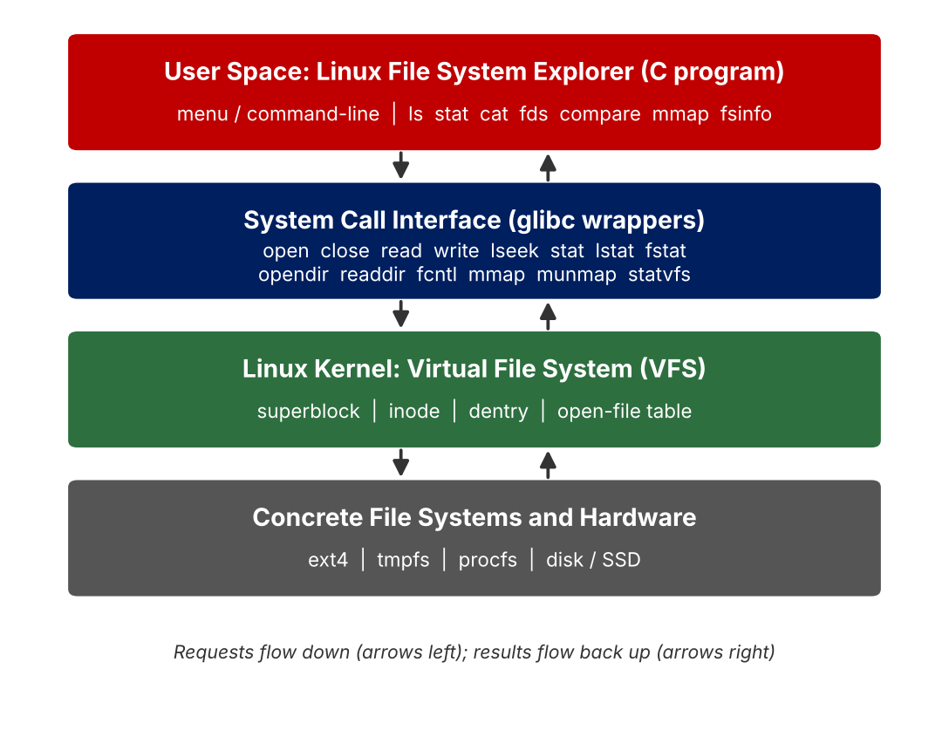
Figure 1: Overall system architecture
Table 9: Architecture layers and responsibilities
Layer | Component | Responsibility
User-space application | Linux File System Explorer | Accepts commands / paths from the user, formats and displays results
System-call interface | open, read, write, stat, opendir, mmap | Controlled gateway from user mode to kernel mode
Kernel – VFS | superblock, inode, dentry, file objects | Routes requests to the correct file system, caches names and pages
Concrete file system / hardware | ext4, overlayfs, tmpfs, procfs; disk or SSD | Stores and retrieves the actual data

5.2 System Workflow
The system works in five steps. The explorer receives a request from the user, issues the matching Linux system call, and lets the kernel carry out the file-system operation before a clear result is returned to the user.
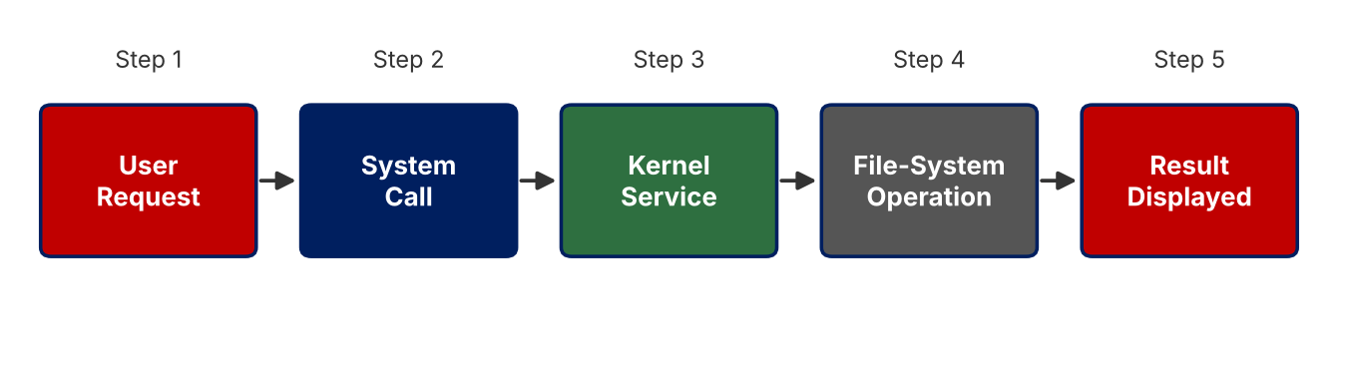
Figure 2: Work flow of the explorer
- User request: the user chooses a menu item or gives a sub-command with a path (for example stat demo/notes.txt).
- System call: the explorer invokes the matching call (stat(), opendir(), open(), mmap(), ...).
- Kernel service: the kernel validates the arguments and permissions and enters the VFS.
- File-system operation: the VFS resolves the path through dentries and inodes and asks the concrete file system for the data.
- Result displayed: the kernel returns data or an error code; the explorer prints the data or strerror(errno).

5.3 Flowchart / Data Flow
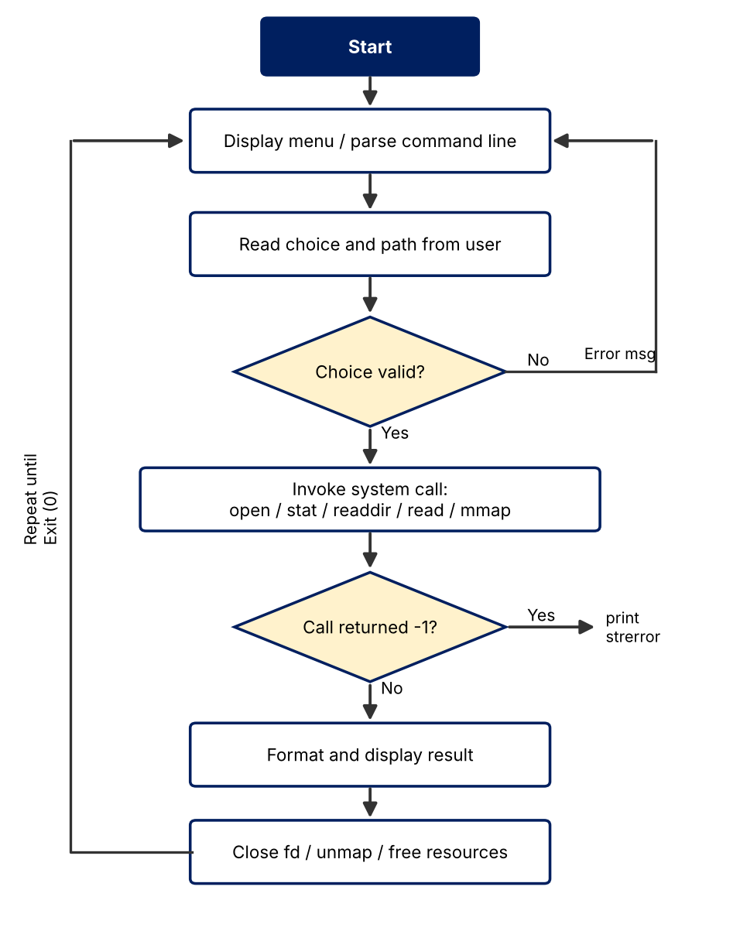
Figure 3: Flowchart of the File System Explorer
The data flow for a single inode query is shown below: the path string is passed to the stat() wrapper, the VFS walks the path through the dentry cache, the inode is read, and the kernel copies its fields into the struct stat supplied by the program.
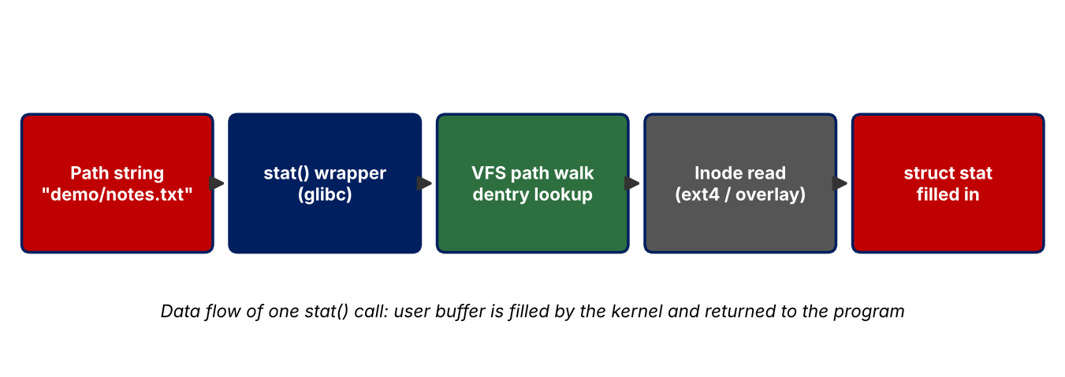
Figure 4: Data flow of a stat() call

5.4 Module Description
Table 10: Modules of the explorer
Module | Function in source | System calls | Concept demonstrated
Directory Lister | list_dir() | opendir, readdir, lstat, closedir | Directory entries, file naming, inode numbers
Inode Inspector | show_stat(), perm_string() | stat | Inode metadata, permissions, link count
File Reader | cat_file() | open, read, write, lseek, close | File descriptors, file offset, unbuffered I/O
Descriptor Viewer | show_fds() | open, opendir, readlink, fcntl | Per-process descriptor table, /proc
I/O Comparator | compare_io() | read, fgetc (stdio), clock_gettime | Buffered vs unbuffered I/O cost
Memory Mapper | mmap_file() | open, fstat, mmap, munmap | Memory-mapped file I/O, page cache
FS Information | fs_info() | statvfs | Mounted file system, VFS superblock data
Controller / UI | main(), menu() | – | Command parsing and dispatch

5.5 Input and Output Design

Input design
Table 11: Input design
Interface | Input | Example
Command line | Sub-command and optional path | ./fsexplorer stat demo/notes.txt
Interactive menu | Menu number (0–7), then a path | Choice: 1 Path: demo
Default | No path means the current directory . | ./fsexplorer ls

Output design
- Listing: one line per entry with columns INODE, PERMS, LNK, SIZE, MODIFIED, NAME and a final entry count.
- Inode report: labelled key/value lines (File, Inode, Device, Type/Perms, Hard links, Owner, Size, Blocks, Accessed, Modified, Changed).
- File read: [open] line showing the descriptor number, the file content, and a [close] line with bytes read and final offset.
- I/O comparison: three lines giving bytes, system calls and elapsed time for each method.
- Errors: error: <call> '<path>': <reason> on standard error and exit status 1.

CHAPTER 6
IMPLEMENTATION

6.1 Module-wise Implementation
The complete explorer is a single source file, fsexplorer.c, organised as one function per module (see Table 10). Common helpers are die(), which prints a uniform error message using strerror(errno), type_char() and perm_string(), which convert st_mode into the familiar drwxr-xr-x string. The file begins with the required headers and the macro _GNU_SOURCE:
Headers and definitions
#define _GNU_SOURCE
#include <stdio.h>
#include <stdlib.h>
#include <string.h>
#include <errno.h>
#include <time.h>
#include <unistd.h>
#include <fcntl.h>
#include <dirent.h>
#include <sys/types.h>
#include <sys/stat.h>
#include <sys/mman.h>
#include <sys/statvfs.h>
#include <sys/sysmacros.h>

#define BUF_SMALL 1
#define BUF_LARGE 4096

Helper functions
static void die(const char *what, const char *path)
{
fprintf(stderr, "error: %s '%s': %s\n", what, path, strerror(errno));
}

static char type_char(mode_t m)
{
if (S_ISREG(m)) return '-';
if (S_ISDIR(m)) return 'd';
if (S_ISLNK(m)) return 'l';
if (S_ISCHR(m)) return 'c';
if (S_ISBLK(m)) return 'b';
if (S_ISFIFO(m)) return 'p';
if (S_ISSOCK(m)) return 's';
return '?';
}

static void perm_string(mode_t m, char out[11])
{
const char *rwx = "rwxrwxrwx";
out[0] = type_char(m);
for (int i = 0; i < 9; i++)
out[i + 1] = (m & (1 << (8 - i))) ? rwx[i] : '-';
out[10] = '\0';
}

Module 1 – Directory Lister
opendir() returns a DIR* handle on a directory; each readdir() call returns one directory entry containing the file name and its inode number. Because a directory entry holds only the name and inode number, the module calls lstat() on the full path to obtain the type, permissions, link count, size and modification time.
Directory Lister
static int list_dir(const char *path)
{
DIR *d = opendir(path);
if (!d) { die("opendir", path); return -1; }
printf("%-10s %-10s %-4s %-10s %-8s %s\n",
"INODE", "PERMS", "LNK", "SIZE", "MODIFIED", "NAME");
struct dirent *e;
int count = 0;
while ((e = readdir(d)) != NULL) {
char full[4096];
snprintf(full, sizeof full, "%s/%s", path, e->d_name);
struct stat st;
if (lstat(full, &st) == -1) { die("lstat", full); continue; }
char perm[11], tbuf[16];
perm_string(st.st_mode, perm);
strftime(tbuf, sizeof tbuf, "%d-%b %H:%M", localtime(&st.st_mtime));
printf("%-10lu %-10s %-4lu %-10lld %-12s %s\n",
(unsigned long)e->d_ino, perm, (unsigned long)st.st_nlink,
(long long)st.st_size, tbuf, e->d_name);
count++;
}
closedir(d);
printf("-- %d entries\n", count);
return 0;
}

Module 2 – Inode Inspector
Inode Inspector
static int show_stat(const char *path)
{
struct stat st;
if (stat(path, &st) == -1) { die("stat", path); return -1; }
char perm[11];
perm_string(st.st_mode, perm);
printf("File : %s\n", path);
printf("Inode : %lu\n", (unsigned long)st.st_ino);
printf("Device : %lu:%lu\n", (unsigned long)major(st.st_dev),
(unsigned long)minor(st.st_dev));
printf("Type/Perms : %s (%04o)\n", perm, st.st_mode & 07777);
printf("Hard links : %lu\n", (unsigned long)st.st_nlink);
printf("Owner : uid=%u gid=%u\n", st.st_uid, st.st_gid);
printf("Size : %lld bytes\n", (long long)st.st_size);
printf("Blocks : %lld x 512B (I/O block %ld)\n",
(long long)st.st_blocks, (long)st.st_blksize);
printf("Accessed : %s", ctime(&st.st_atime));
printf("Modified : %s", ctime(&st.st_mtime));
printf("Changed : %s", ctime(&st.st_ctime));
return 0;
}

Module 3 – File Reader (file descriptors)
File Reader
static int cat_file(const char *path)
{
int fd = open(path, O_RDONLY);
if (fd == -1) { die("open", path); return -1; }
printf("[open] '%s' -> file descriptor %d\n", path, fd);
char buf[BUF_LARGE];
ssize_t n;
long total = 0;
while ((n = read(fd, buf, sizeof buf)) > 0) {
if (write(STDOUT_FILENO, buf, (size_t)n) != n) { die("write", "stdout"); break; }
total += n;
}
if (n == -1) die("read", path);
printf("\n[close] fd %d after %ld bytes (offset=%lld)\n", fd, total,
(long long)lseek(fd, 0, SEEK_CUR));
close(fd);
return 0;
}

6.2 Algorithm / Pseudocode
Pseudocode of the main algorithms
ALGORITHM Explorer(args)
IF no arguments THEN Menu() ELSE Dispatch(args[1], args[2] or ".")

ALGORITHM ListDirectory(path)
d <- opendir(path); IF d = NULL THEN report error and RETURN
WHILE (entry <- readdir(d)) <> NULL DO
full <- path + "/" + entry.name
IF lstat(full, st) = -1 THEN report error; CONTINUE
PRINT entry.inode, perms(st.mode), st.nlink, st.size, st.mtime, entry.name
closedir(d)

ALGORITHM ReadFile(path)
fd <- open(path, O_RDONLY); IF fd = -1 THEN report error and RETURN
PRINT "descriptor", fd
WHILE (n <- read(fd, buf, 4096)) > 0 DO
write(STDOUT, buf, n); total <- total + n
PRINT total, lseek(fd, 0, SEEK_CUR); close(fd)

ALGORITHM CompareIO(path)
FOR method IN {read 1 byte, read 4096 bytes, fgetc via stdio} DO
t0 <- now(); read the whole file with method counting syscalls; t1 <- now()
PRINT bytes, syscalls, t1 - t0

ALGORITHM MapFile(path)
fd <- open(path); fstat(fd, st); map <- mmap(NULL, st.size, PROT_READ, MAP_PRIVATE, fd, 0)
close(fd); count lines by scanning map[0..size); munmap(map, size)

6.3 Core C / C++ Implementation
The core of the program is the mapping between a user request and one family of system calls. The main() function parses the sub-command and dispatches to the matching module; each module returns 0 on success and −1 on error, and main() converts that to the process exit status.
Entry point and command dispatch
int main(int argc, char *argv[])
{
if (argc == 1) { menu(); return 0; }
const char *cmd = argv[1];
const char *arg = argc > 2 ? argv[2] : ".";
if (!strcmp(cmd, "ls")) return list_dir(arg) != 0;
if (!strcmp(cmd, "stat")) return show_stat(arg) != 0;
if (!strcmp(cmd, "cat")) return cat_file(arg) != 0;
if (!strcmp(cmd, "fds")) return show_fds() != 0;
if (!strcmp(cmd, "compare")) return compare_io(arg) != 0;
if (!strcmp(cmd, "mmap")) return mmap_file(arg) != 0;
if (!strcmp(cmd, "fsinfo")) return fs_info(arg) != 0;
usage();
return 1;
}

The explorer reports the permission bits by testing each bit of st_mode against the string rwxrwxrwx, as shown in perm_string() above. The mapping of mode bits to characters is: bit 8 → r (owner read), bit 7 → w, bit 6 → x, then the same three for group and others.

6.4 Linux System Calls / APIs Used
Table 12: System calls, failure values and handling
Call | Prototype (simplified) | Return on failure | How the explorer handles it
open | int open(const char *path, int flags) | −1, errno set | die("open", path); module returns −1
read | ssize_t read(int fd, void *buf, size_t n) | −1; 0 at end of file | Loop ends on 0; −1 reported with die()
write | ssize_t write(int fd, const void *buf, size_t n) | −1 or short count | Short count treated as an error
stat / lstat | int stat(const char *path, struct stat *st) | −1 | die(); for ls the entry is skipped and listing continues
opendir | DIR *opendir(const char *path) | NULL | Error message; nothing is listed
mmap | void *mmap(addr, len, prot, flags, fd, off) | MAP_FAILED | Descriptor closed, error reported
statvfs | int statvfs(const char *path, struct statvfs *b) | −1 | die()
fcntl | int fcntl(int fd, int cmd, ...) | −1 | Flags shown only when call succeeds

Every call whose failure can occur at run time is checked. On failure the global errno holds the reason, which strerror() converts into text such as “No such file or directory” or “Permission denied”. This is demonstrated in Section 7.3.

6.5 Process / Thread Implementation
The explorer is one process with one thread. When the shell runs ./fsexplorer, the kernel creates the process (fork() and execve() are performed by the shell), gives it descriptors 0, 1 and 2 inherited from the shell, and starts main(). This inheritance is visible in the fds module: descriptors 0, 1 and 2 point to the terminal or redirected file of the shell, and every descriptor opened by the program takes the lowest unused number, so the first file opened is 3.
Descriptor viewer, shows the per-process descriptor table
static int show_fds(void)
{
printf("Open descriptors of this process (via /proc/self/fd):\n");
int dfd = open("/proc/self/fd", O_RDONLY | O_DIRECTORY);
int tmp = open("/etc/hostname", O_RDONLY);
DIR *d = opendir("/proc/self/fd");
if (!d) { die("opendir", "/proc/self/fd"); return -1; }
struct dirent *e;
while ((e = readdir(d)) != NULL) {
if (e->d_name[0] == '.') continue;
char link[300], target[256];
snprintf(link, sizeof link, "/proc/self/fd/%s", e->d_name);
ssize_t n = readlink(link, target, sizeof target - 1);
if (n < 0) continue;
target[n] = '\0';
int fd = atoi(e->d_name);
int fl = fcntl(fd, F_GETFL);
printf(" fd %-3s -> %-28s flags=%s\n", e->d_name, target,
(fl & O_ACCMODE) == O_RDONLY ? "O_RDONLY" :
(fl & O_ACCMODE) == O_WRONLY ? "O_WRONLY" : "O_RDWR");
}
closedir(d);
if (tmp != -1) close(tmp);
if (dfd != -1) close(dfd);
return 0;
}

The module deliberately opens /proc/self/fd and /etc/hostname before listing, so that the output shows the descriptors created by the explorer itself. Because the program is single-threaded, there is no race between threads on the descriptor table. If the program were extended to use pthread_create(), all threads would share this table and the same file offsets, which is why pread() (explicit offset) would be preferred in a multi-threaded reader.

6.6 IPC / Synchronization Implementation
The project's operations are sequential and read-only; therefore it needs no inter-process communication or locking to be correct. The only communication channels used are the standard descriptors: results go to standard output (descriptor 1) and errors to standard error (descriptor 2), which lets the shell connect the explorer to other programs with pipes, for example ./fsexplorer ls /etc | sort -k6.
For completeness, the synchronization mechanisms relevant to file systems are summarised below. They were studied as background and are listed as future enhancements.
Table 13: Synchronization mechanisms related to files
Mechanism | System call | Use with files
Advisory whole-file lock | flock(fd, LOCK_EX) | Prevent two writers from changing a file at the same time
Advisory record lock | fcntl(fd, F_SETLK, &lock) | Lock a byte range of a file
Pipe | pipe() | Pass the output of one process to another
Positioned I/O | pread() / pwrite() | Read or write at an offset without changing the shared file offset

6.7 Memory Management Implementation
Memory is used in three ways in the explorer. (1) Stack buffers: the 4096-byte read buffer in cat_file() and compare_io() is an automatic variable, so it needs no malloc() and cannot leak; 4096 bytes equals the page size and the file-system block size reported by st_blksize. (2) Library buffers: fopen() allocates an internal stdio buffer that is released by fclose(). (3) Memory-mapped files: mmap_file() maps the file into the virtual address space.
Memory-mapped file access
static int mmap_file(const char *path)
{
int fd = open(path, O_RDONLY);
if (fd == -1) { die("open", path); return -1; }
struct stat st;
if (fstat(fd, &st) == -1) { die("fstat", path); close(fd); return -1; }
if (st.st_size == 0) { printf("empty file, nothing to map\n"); close(fd); return 0; }
char *map = mmap(NULL, (size_t)st.st_size, PROT_READ, MAP_PRIVATE, fd, 0);
if (map == MAP_FAILED) { die("mmap", path); close(fd); return -1; }
close(fd); /* mapping stays valid after close() */
long lines = 0;
for (off_t i = 0; i < st.st_size; i++) if (map[i] == '\n') lines++;
printf("mmap(%s) -> %p, length %lld bytes, %ld lines\n",
path, (void *)map, (long long)st.st_size, lines);
printf("first bytes: ");
for (int i = 0; i < 40 && i < st.st_size; i++)
putchar(map[i] == '\n' ? ' ' : map[i]);
putchar('\n');
munmap(map, (size_t)st.st_size);
return 0;
}

- PROT_READ makes the mapping read-only, so an accidental write to the mapped area causes a segmentation fault instead of changing the file.
- MAP_PRIVATE gives copy-on-write semantics; the explorer never writes, so the file stays untouched.
- The descriptor is closed immediately after mmap() because the mapping keeps its own reference to the file.
- Pages are loaded lazily through page faults from the kernel's page cache; scanning map[i] therefore triggers reads only for pages that are actually touched.
- munmap() releases the mapping so that no virtual-memory area is left behind.

6.8 Optional User Interface Implementation
A graphical interface was not required, so the project provides a simple console menu. Running ./fsexplorer without arguments displays the menu, reads the choice and path with fgets(), calls the matching module and loops until the user chooses 0. The same modules are also available as one-shot sub-commands for scripting.
Interactive menu
static void menu(void)
{
char line[512], arg[512];
for (;;) {
printf("\n===== Linux File System Explorer =====\n"
"1. List directory 2. File / inode info\n"
"3. Read file (fd I/O) 4. Open descriptors\n"
"5. Buffered vs unbuffered I/O\n"
"6. Memory-map a file 7. File-system info\n"
"0. Exit\nChoice: ");
if (!fgets(line, sizeof line, stdin)) return;
int c = atoi(line);
if (c == 0) return;
if (c == 4) { show_fds(); continue; }
printf("Path: ");
if (!fgets(arg, sizeof arg, stdin)) return;
arg[strcspn(arg, "\n")] = '\0';
switch (c) {
case 1: list_dir(arg); break;
case 2: show_stat(arg); break;
case 3: cat_file(arg); break;
case 5: compare_io(arg); break;
case 6: mmap_file(arg); break;
case 7: fs_info(arg); break;
default: puts("invalid choice");
}
}
}

I/O comparison and file-system information modules
static int compare_io(const char *path)
{
char buf[BUF_LARGE];
long calls; long total; double t0, t1;

/* unbuffered: one read() system call per byte */
int fd = open(path, O_RDONLY);
if (fd == -1) { die("open", path); return -1; }
calls = 0; total = 0; t0 = now();
while (read(fd, buf, BUF_SMALL) > 0) { calls++; total++; }
t1 = now(); close(fd);
printf("read() 1 byte at a time : %8ld bytes, %8ld syscalls, %.4f s\n",
total, calls, t1 - t0);

/* unbuffered: 4 KB per read() */
fd = open(path, O_RDONLY);
calls = 0; total = 0; t0 = now();
ssize_t n;
while ((n = read(fd, buf, sizeof buf)) > 0) { calls++; total += n; }
t1 = now(); close(fd);
printf("read() 4096 bytes : %8ld bytes, %8ld syscalls, %.4f s\n",
total, calls, t1 - t0);

/* buffered stdio: fgetc() 1 byte, libc batches the read() calls */
FILE *fp = fopen(path, "r");
if (!fp) { die("fopen", path); return -1; }
total = 0; t0 = now();
while (fgetc(fp) != EOF) total++;
t1 = now(); fclose(fp);
printf("fgetc() (stdio buffered) : %8ld bytes, ~%7ld syscalls, %.4f s\n",
total, total / BUF_LARGE + 1, t1 - t0);
return 0;
}

static int fs_info(const char *path)
{
struct statvfs v;
if (statvfs(path, &v) == -1) { die("statvfs", path); return -1; }
unsigned long long total = (unsigned long long)v.f_blocks * v.f_frsize;
unsigned long long freeb = (unsigned long long)v.f_bavail * v.f_frsize;
printf("Path : %s\n", path);
printf("Block size : %lu bytes\n", v.f_frsize);
printf("Total size : %llu MB\n", total >> 20);
printf("Available : %llu MB\n", freeb >> 20);
printf("Inodes total : %lu\n", (unsigned long)v.f_files);
printf("Inodes free : %lu\n", (unsigned long)v.f_ffree);
printf("Max name length : %lu\n", v.f_namemax);
return 0;
}

CHAPTER 7
EXECUTION AND DEMONSTRATION

7.1 Compilation in Ubuntu
The program is compiled with GCC using the warning flags -Wall -Wextra and optimisation level -O2. A clean build prints no warnings; the resulting executable is about 22 KB.
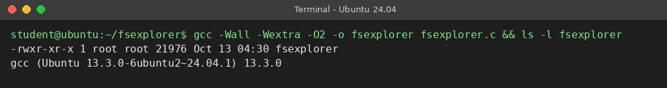
Figure 5: Compilation of fsexplorer on Ubuntu 24.04

7.2 Execution Commands
Preparing test data and running the explorer
# prepare a small test tree
mkdir -p demo/docs
printf 'Hello Linux!\nThis is a demo file for the File System Explorer.\nLine three.\n' > demo/notes.txt
ln -s notes.txt demo/link.txt
head -c 200000 /dev/urandom | base64 > demo/big.txt # about 270 KB test file

# run the explorer
./fsexplorer # interactive menu
./fsexplorer ls demo # directory entries + inodes
./fsexplorer stat demo/notes.txt # inode metadata
./fsexplorer cat demo/notes.txt # file descriptor I/O
./fsexplorer fds # open descriptors
./fsexplorer compare demo/big.txt # buffered vs unbuffered
./fsexplorer mmap demo/notes.txt # memory-mapped read
./fsexplorer fsinfo / # mounted file system

Table 14: Execution commands and expected results
Command | Module | Expected result
./fsexplorer ls <dir> | Directory Lister | Table of entries with inode, permissions, links, size, time, name
./fsexplorer stat <path> | Inode Inspector | Labelled inode report
./fsexplorer cat <file> | File Reader | Descriptor number, file content, bytes read
./fsexplorer fds | Descriptor Viewer | List of descriptors with targets and flags
./fsexplorer compare <file> | I/O Comparator | Bytes, system calls and time for three methods
./fsexplorer mmap <file> | Memory Mapper | Mapping address, length, line count, first bytes
./fsexplorer fsinfo <path> | FS Information | Block size, capacity, free space, inode counts

7.3 Sample Inputs and Outputs
Table 15: Test cases
Test | Input | Observed output (summary) | Result
1 | ls demo | 6 entries: ., .., big.txt, docs, link.txt (type l), notes.txt | Pass
2 | stat demo/notes.txt | Type -rw-r--r-- (0644), 1 hard link, size 75 bytes, 8 blocks of 512 B | Pass
3 | cat demo/notes.txt | [open] ... file descriptor 3; 3 lines of text; [close] fd 3 after 75 bytes (offset=75) | Pass
4 | fds | fd 0, 1, 2 standard streams; extra descriptors start at 3 | Pass
5 | compare demo/big.txt | 270177 bytes: 270177 syscalls vs 66 syscalls | Pass
6 | mmap demo/notes.txt | Length 75 bytes, 3 lines, first bytes printed | Pass
7 | fsinfo / | Block size 4096, capacity and inode counts printed | Pass
8 | stat /nonexistent | error: stat '/nonexistent': No such file or directory, exit status 1 | Pass (error handled)

7.4 Screenshots of Execution
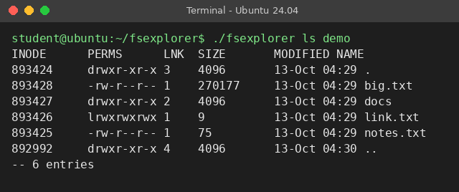
Figure 6: Directory Lister: entries with inode numbers and permissions
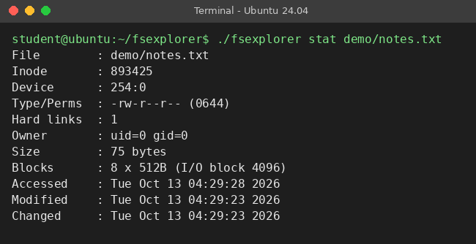
Figure 7: Inode Inspector: output of the stat sub-command
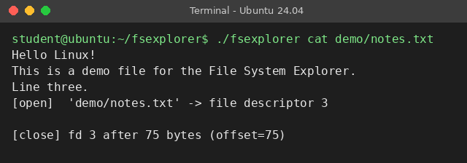
Figure 8: File Reader: descriptor allocation and file content
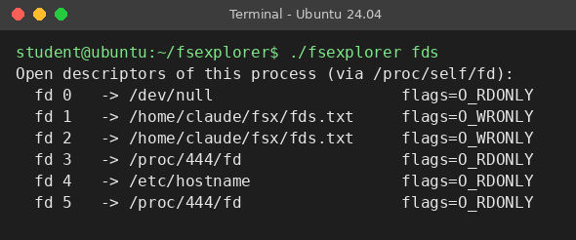
Figure 9: Descriptor Viewer: open descriptors of the process
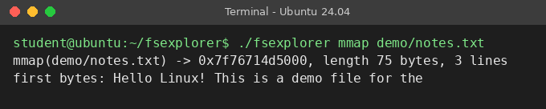
Figure 10: Memory Mapper: memory-mapped file access
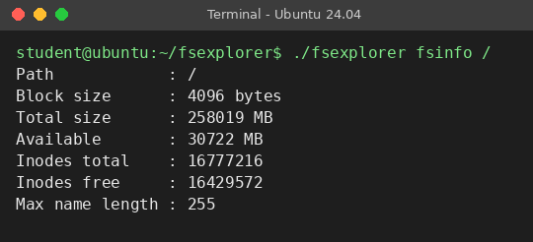
Figure 11: FS Information: statvfs on the root file system
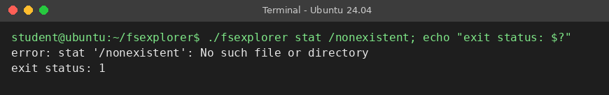
Figure 12: Error handling for a non-existent path

7.5 Demonstration of OS Concepts

(a) Buffered vs unbuffered I/O
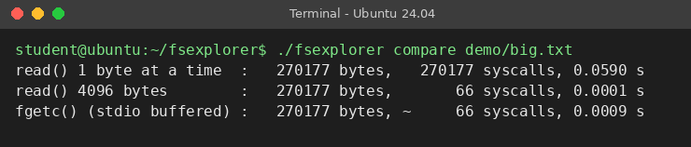
Figure 13: Comparison of unbuffered and buffered file I/O
Table 16: Buffered vs unbuffered I/O on a 270,177-byte file
Method | System calls | Time (s) | Observation
read() 1 byte at a time | 270,177 | 0.0590 | One mode switch per byte – slowest
read() 4096 bytes | 66 | 0.0001 | Block-sized reads – fewest calls
fgetc() (stdio buffer) | ≈ 66 | 0.0009 | Library hides the buffering; one byte per call to the program

The 270,177-byte file needs 270,177 system calls when read byte by byte, but only 66 (⌈270177 / 4096⌉ = 66 data reads) with a 4 KB buffer, either supplied by the program or by stdio. The unbuffered 1-byte version was about 590 times slower than the 4 KB version in this run. Absolute times vary from run to run and machine to machine; the ratio of system calls is exact.

(b) Tracing the system calls with strace
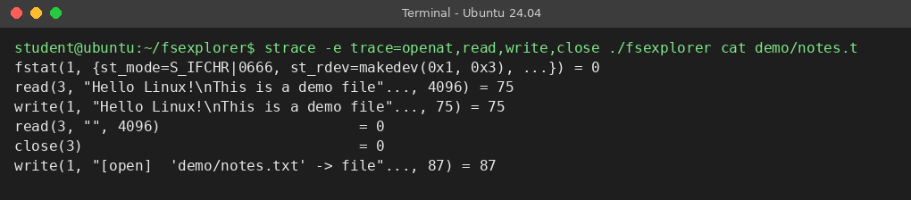
Figure 14: strace output of the cat sub-command
The trace confirms the theory: openat() (the modern implementation behind open()) returns descriptor 3, read(3, ..., 4096) returns 75 bytes, write(1, ...) copies them to standard output, a second read() returns 0 to signal the end of file, and close(3) releases the descriptor.

(c) Summary of concepts demonstrated
Table 17: OS concepts and the module that demonstrates them
OS concept | Where it is demonstrated
Unix file abstraction | Same open/read/close calls for regular files; fds lists terminal, files and directories uniformly
Inodes | ls shows inode numbers; stat shows all inode fields
Directory entries and naming | ls lists name-to-inode pairs; link.txt is a symbolic link with its own inode
VFS | The same commands work on /, /proc and /tmp, handled by different file systems
File descriptors | cat reports fd 3; fds shows the table; lowest-unused-number rule
Buffered vs unbuffered I/O | compare shows 270,177 vs 66 system calls
Memory-mapped I/O | mmap reads a file with pointer access and no read() calls
User/kernel interaction | strace shows each request crossing into the kernel

CHAPTER 8
CONCLUSION

8.1 Summary of the Project
This project developed a Linux File System Explorer in C that turns abstract OS theory into a hands-on demonstration of file-system exploration and file I/O through system calls. The explorer accepts a path or an operation, calls the corresponding Linux system call directly, and displays the result, which makes the work of the kernel and the Virtual File System visible. It was built with GCC on Ubuntu 24.04, verified with strace and standard Linux utilities, and tested with eight test cases including an error case.

8.2 Objectives Achieved
Table 18: Objectives and their status
Objective | Status | Evidence
Demonstrate file abstraction, inodes, directory entries and VFS | Achieved | ls, stat, fsinfo modules; Figures in Section 7.4
Invoke Linux File I/O system calls directly | Achieved | Table 7; strace in Section 7.5
Show file-descriptor allocation and release | Achieved | cat and fds modules
Compare buffered and unbuffered I/O | Achieved | 270,177 vs 66 system calls
Demonstrate basic memory-mapped I/O | Achieved | mmap module
Strengthen user–kernel interaction understanding | Achieved | Workflow, architecture and strace trace

8.3 Results Achieved
- A working, warning-free C program (about 280 lines) with seven modules and a menu.
- All eight test cases passed, including graceful handling of a missing file (message plus exit status 1).
- Measured proof that buffering reduces system calls from 270,177 to 66 for a 270 KB file.
- Verified correspondence with standard tools: inode numbers and link counts agree with ls -li, and the descriptor listing agrees with /proc/<pid>/fd.
- A report with architecture, flowcharts and screenshots produced from the real output of the program.

8.4 Skills and Learning Outcomes
- Practical use of POSIX file-system system calls and the struct stat, struct dirent and struct statvfs data structures.
- Understanding of the user mode / kernel mode boundary and of how errno reports failures.
- Understanding of inodes, directory entries, hard and symbolic links and the VFS.
- Use of GCC, Make, GDB and strace for building, debugging and tracing systems programs.
- Defensive programming: checking every return value, bounded string operations and releasing resources.
- Technical documentation and teamwork.

Limitations and future enhancements
- Add recursive directory traversal (nftw()) and a tree view.
- Add a write-mode demonstration (creat, write, fsync, unlink, link) in a sandbox directory.
- Add file locking with flock() and a multi-process demonstration of shared file offsets.
- Add a strace-style mode that prints each system call as the explorer makes it.
- Add a text-based or GUI front end (for example ncurses).

CHAPTER 9
REFERENCES

9.1 Books
- A. Silberschatz, P. B. Galvin and G. Gagne, Operating System Concepts, 10th ed., Wiley, 2018.
- A. S. Tanenbaum and H. Bos, Modern Operating Systems, 4th ed., Pearson, 2014.
- M. Kerrisk, The Linux Programming Interface, No Starch Press, 2010.
- W. R. Stevens and S. A. Rago, Advanced Programming in the UNIX Environment, 3rd ed., Addison-Wesley, 2013.
- R. Love, Linux Kernel Development, 3rd ed., Addison-Wesley, 2010.
- B. W. Kernighan and D. M. Ritchie, The C Programming Language, 2nd ed., Prentice Hall, 1988.

9.2 Research Papers
- D. M. Ritchie and K. Thompson, “The UNIX Time-Sharing System,” Communications of the ACM, vol. 17, no. 7, pp. 365–375, 1974.
- M. K. McKusick, W. N. Joy, S. J. Leffler and R. S. Fabry, “A Fast File System for UNIX,” ACM Transactions on Computer Systems, vol. 2, no. 3, pp. 181–197, 1984.
- S. R. Kleiman, “Vnodes: An Architecture for Multiple File System Types in Sun UNIX,” Proc. USENIX Summer Conference, 1986.
- A. Mathur, M. Cao, S. Bhattacharya, A. Dilger, A. Tomas and L. Vivier, “The New ext4 Filesystem: Current Status and Future Plans,” Proc. Ottawa Linux Symposium, 2007.

9.3 Linux / GNU Documentation
- Linux man-pages project: open(2), read(2), write(2), stat(2), mmap(2), readdir(3), opendir(3), statvfs(3), fcntl(2). https://man7.org/linux/man-pages/
- The GNU C Library Reference Manual. https://www.gnu.org/software/libc/manual/
- Linux kernel documentation: Overview of the Linux Virtual File System. https://www.kernel.org/doc/html/latest/filesystems/vfs.html
- GCC online documentation. https://gcc.gnu.org/onlinedocs/

9.4 Online Resources
- R. H. Arpaci-Dusseau and A. C. Arpaci-Dusseau, Operating Systems: Three Easy Pieces (free online book). https://pages.cs.wisc.edu/~remzi/OSTEP/
- Ubuntu documentation and tutorials. https://ubuntu.com/tutorials
- Microsoft documentation: Install WSL. https://learn.microsoft.com/windows/wsl/install

