Customer Engagement & Product Utilization Analytics for Retention Strategy
European Bank Customer Churn Analysis — 2025 Dataset

1. Executive Overview
This project analyses 10,000 European Bank customer records to identify behavioural and product-usage factors associated with customer churn. The overall churn rate is 20.4%, meaning 2,037 customers exited while 7,963 were retained. The analysis deliberately focuses on engagement, product utilization and relationship depth rather than relying only on demographic variables.

2. Background and Context
Banks increasingly recognize that customer behaviour and engagement—not demographics alone—drive long-term retention. A customer can have a strong balance or salary and still churn because of low engagement, limited product adoption or a weak relationship with the bank. This project therefore reframes churn as a behavioural and relationship-strength problem.

3. Objectives
- Perform exploratory data analysis (EDA) on customer engagement, product utilization and churn.
- Identify customer segments with elevated churn risk.
- Develop decision-oriented KPIs for retention strategy.
- Translate analytical findings into practical banking recommendations.
- Provide a Streamlit dashboard for interactive monitoring.

4. Dataset and Methodology
The dataset contains 10,000 customer records and 14 fields covering credit score, geography, gender, age, tenure, balance, number of products, credit-card ownership, active-member status, estimated salary and churn outcome. The target variable is Exited (1 = churned, 0 = retained). Derived indicators were created for retention, engagement status, high balance and relationship strength.

5. Key Performance Indicators (KPIs)
KPI | Value | Interpretation
Engagement Retention Ratio | 1.17x | Active-member retention divided by inactive-member retention.
Product Depth Index | 0.57 | Average retention across product-count groups relative to overall retention.
High-Balance Disengagement Rate | 32.3% | Churn among high-balance customers who are also inactive.
Credit Card Stickiness Score | 0.6 pp | Retention difference between cardholders and non-cardholders.
Relationship Strength Index | 1.06 | Retained-customer relationship score relative to the full customer base.

6. Exploratory Data Analysis
Overall retention is 79.6% and churn is 20.4%. The analysis shows that engagement is one of the clearest behavioural separators.
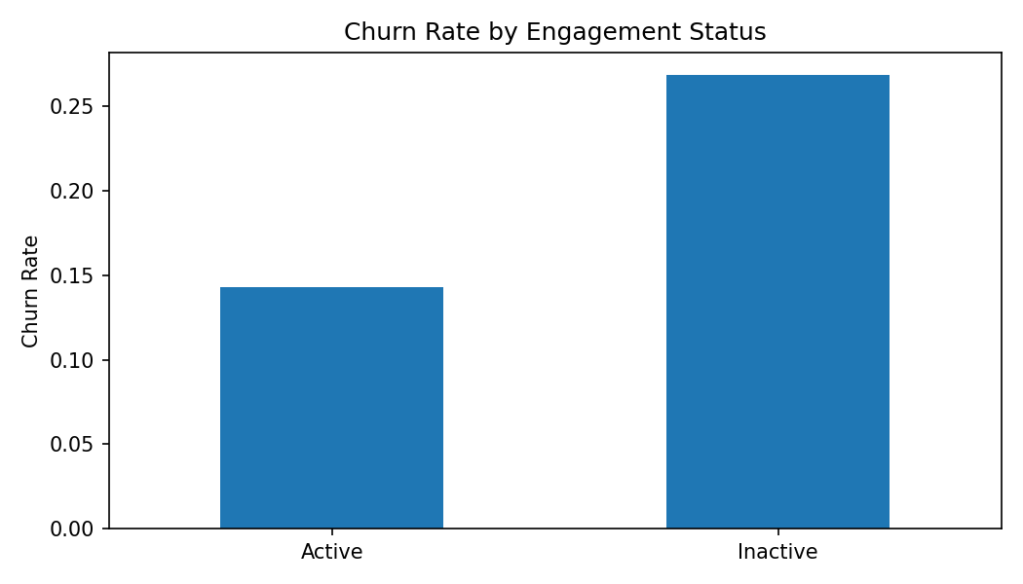
Active customers have a retention rate of 85.7%, compared with 73.1% for inactive customers. This supports prioritizing engagement interventions before churn becomes irreversible.
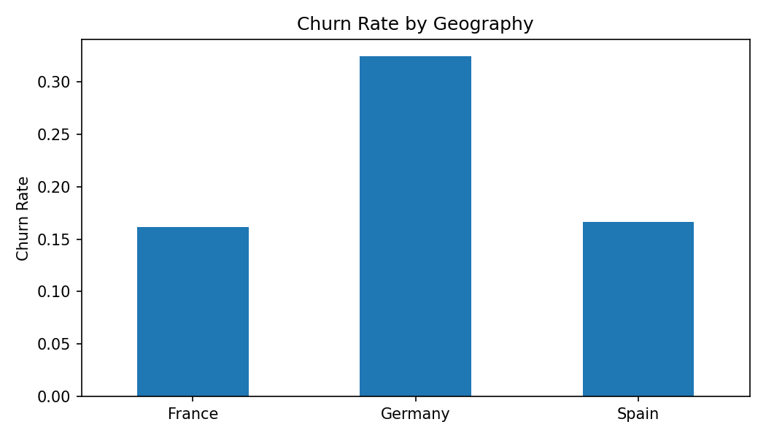
Geographically, Germany has the highest observed churn rate at 32.4%, while France has the lowest at 16.2%. Geography should be treated as a segmentation signal, not a causal explanation.
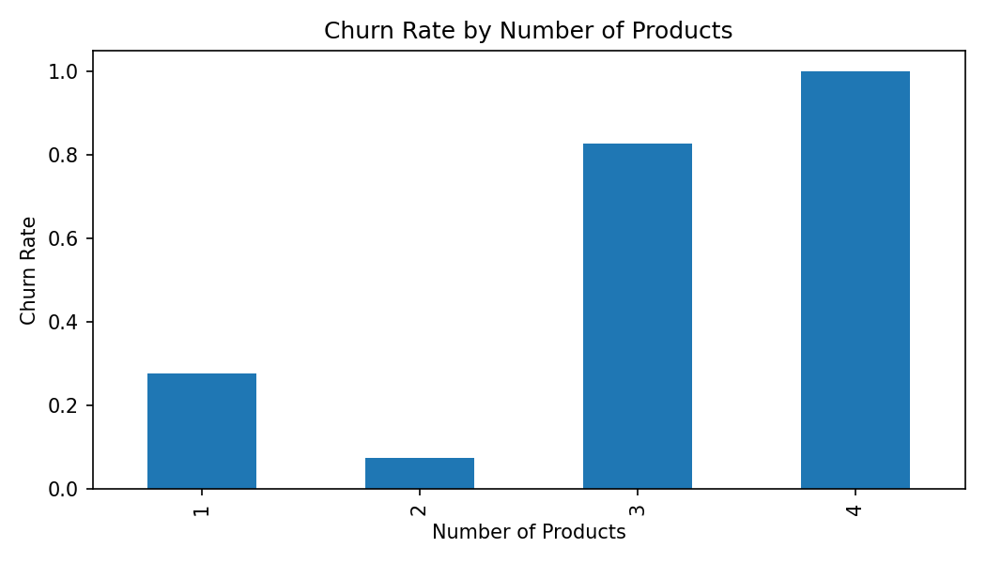
Product count is highly uneven in its relationship with churn. The 4-product segment has the highest churn rate at 100.0%. Extremely low or unusual product counts should be monitored because product breadth can indicate relationship depth—or, in some cases, product complexity.

7. Customer Engagement Findings
- Active customers retain at 85.7% versus 73.1% for inactive customers.
- The active-to-inactive retention ratio is 1.17x, making engagement a strong retention signal.
- A disengaged customer with a high balance is not automatically safe; inactivity can expose the bank to avoidable attrition.
- Retention strategy should therefore trigger while customers are still present and behaviourally disengaging, rather than waiting for an account to close.

8. Product Utilization Findings
- 1 product(s): 5,084 customers; churn 27.7%; retention 72.3%.
- 2 product(s): 4,590 customers; churn 7.6%; retention 92.4%.
- 3 product(s): 266 customers; churn 82.7%; retention 17.3%.
- 4 product(s): 60 customers; churn 100.0%; retention 0.0%.

9. Recommendations
Build an engagement early-warning system: Flag inactive customers with deteriorating activity and route them into targeted digital, relationship-manager or service campaigns.
Deepen relationships selectively: Promote relevant second-product adoption to customers with a shallow relationship, but avoid indiscriminate cross-selling.
Protect high-value disengaged customers: Create a priority segment for high-balance inactive customers and intervene before churn.
Use product-count signals carefully: Investigate customers with unusually high product counts rather than assuming more products always mean stronger loyalty.
Measure retention by behaviour: Track the five project KPIs monthly and compare movement across geography, engagement and product segments.

10. Streamlit Dashboard
The accompanying Streamlit application provides interactive filters for geography, engagement status, product count and churn. It displays the core KPIs, customer-level summaries and charts so stakeholders can move from portfolio-level results to actionable segments.

11. Limitations
- The dataset is observational; the analysis identifies associations, not causal effects.
- The data contains a single Year value, so this project should not be interpreted as a time-series retention study.
- The custom KPI definitions are analytical constructs designed for this project and should be validated against the bank's internal definitions before production use.

12. Conclusion
This project reframes customer churn from a behavioural and relationship-strength perspective. By focusing on engagement and product utilization rather than demographics alone, it provides actionable insights for retention strategy design, product optimization and customer loyalty enhancement.

