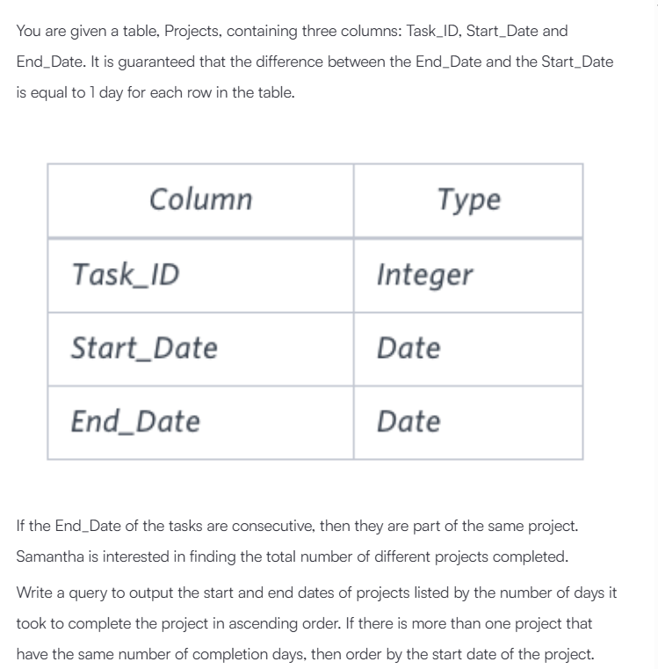

Solution : SELECT Start_Date, min(End_Date)
FROM
(SELECT Start_Date FROM Projects WHERE Start_Date NOT IN (SELECT End_Date FROM Projects)) a ,
(SELECT End_Date FROM Projects WHERE End_Date NOT IN (SELECT Start_Date FROM Projects)) b
WHERE Start_Date < End_Date
GROUP BY Start_Date
ORDER BY DATEDIFF(min(End_Date), Start_Date) ASC, Start_Date ASC;

