CHAPTER 5 – AI/ML
──────────────────────────────────────────

IMDB Movie Rating Prediction
Using Machine Learning and NLP Techniques

Tools Used: Scikit-learn | Pandas & NumPy | Matplotlib | Seaborn

Team Members:
Allen Fanial,
Baby Sanjana,
Sapna Chauhan,
Ruksar Khaton.

Guidance: Mr. Hemant Kumar, Mr. Saksham Mishra



NSTI Kanpur
17-03-2026

1. Introduction
Movies are one of the most popular forms of entertainment worldwide. IMDB (Internet Movie Database) is the world’s largest and most authoritative source for movie ratings, reviews, and information. Predicting a movie’s IMDB rating before release — or understanding what drives ratings — is extremely valuable for filmmakers, studios, and streaming platforms.

This project applies Machine Learning (ML) and Natural Language Processing (NLP) techniques to predict IMDB movie ratings based on features such as genre, budget, cast score, director score, and user reviews.

2. Problem Statement
Predicting the IMDB rating of a movie is a regression problem. Given a set of movie attributes (numerical features + text reviews), we aim to build a model that predicts the continuous rating (1.0 to 10.0) as accurately as possible.

Key challenges include:
- Handling mixed data types (numerical + categorical + text)
- Extracting meaningful features from raw review text using NLP
- Selecting the best ML model with low prediction error

3. Tools & Technologies

3.1 Python Libraries Used
- Pandas & NumPy – Data loading, cleaning, and numerical computation
- Scikit-learn – ML models, TF-IDF vectorizer, preprocessing, and evaluation
- Matplotlib & Seaborn – Data visualization and chart generation
- SciPy – Sparse matrix operations for combining feature sets

4. Dataset Description
The dataset contains 1,000 movie records with the following features:

Feature | Type | Description
genre | Categorical | Movie genre (Action, Comedy, Drama, etc.)
duration_min | Numerical | Duration of the movie in minutes
budget_million | Numerical | Production budget in millions (USD)
num_votes | Numerical | Number of user votes on IMDB
director_score | Numerical | Director popularity score (1-10)
cast_score | Numerical | Lead cast score (1-10)
release_year | Numerical | Year of movie release
review | Text (NLP) | User review text - TF-IDF vectorized
rating | Target | IMDB rating (1.0 - 10.0)

Dataset Statistics:
- Total Records: 1,000 movies
- Training Set: 800 records (80%)
- Test Set: 200 records (20%)
- Missing Values: None
- Rating Range: 1.0 – 10.0 | Mean: 6.52 | Std Dev: 1.45

5. Methodology

5.1 Data Preprocessing
- Numerical features scaled using StandardScaler
- Categorical feature ‘genre’ encoded using One-Hot Encoding (pd.get_dummies)
- Text reviews processed using TF-IDF Vectorizer (top 50 features, unigrams + bigrams)
- All features combined into a single sparse matrix using scipy.sparse.hstack

5.2 NLP – TF-IDF Vectorization
TF-IDF (Term Frequency – Inverse Document Frequency) converts text reviews into numerical vectors. Words that appear frequently in a specific review but rarely in others are given higher weights, capturing the sentiment and key themes of each review.

5.3 Machine Learning Models
- Linear Regression – Baseline model assuming linear relationship between features and rating
- Random Forest Regressor – Ensemble of 100 decision trees, robust to noise
- Gradient Boosting Regressor – Sequential boosting of weak learners, high accuracy

5.4 Evaluation Metrics
- MAE (Mean Absolute Error) – Average magnitude of errors in predictions
- RMSE (Root Mean Squared Error) – Penalizes larger errors more heavily
- R² Score – Proportion of variance explained by the model (higher = better)

5.5 Step-by-Step Implementation (VS Code — Streamlit)
This section provides a complete, step-by-step guide to setting up and running the IMDB Movie Rating Prediction project on your local machine using VS Code and Streamlit.

Step 1: Install Python
- Click the search icon on the Taskbar, type Microsoft Store, and open it.
- Type Python in the search bar and press Enter.
- Click Python 3.11 (or the latest version) and click the Get button.
- Click Install Now and make sure to tick ✔ Add Python to PATH during installation.
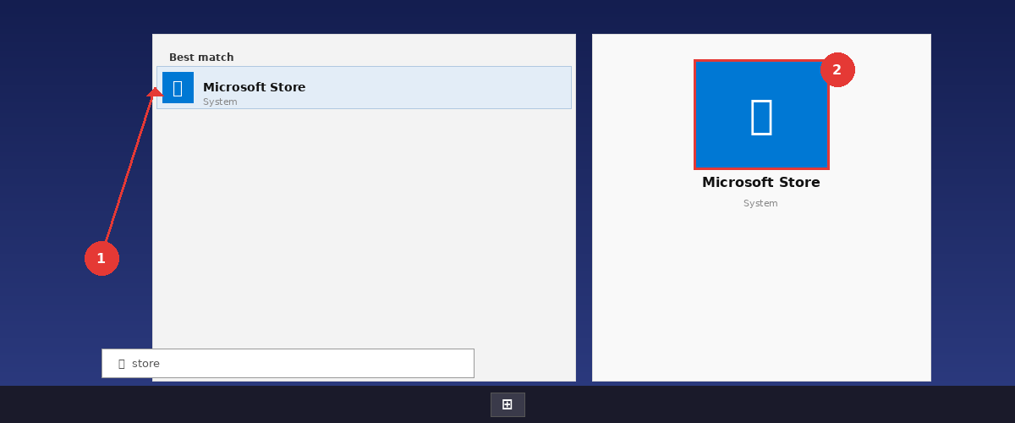
- Search Python in Microsoft Store and select the latest version.
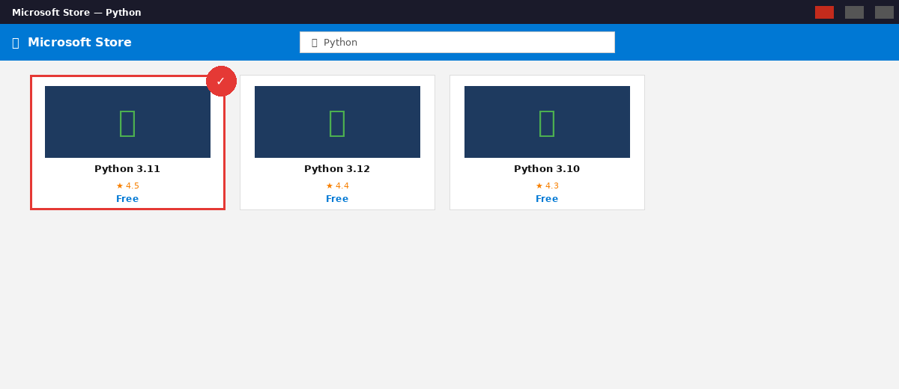
- In the installer, tick Add Python to PATH before clicking Install Now.
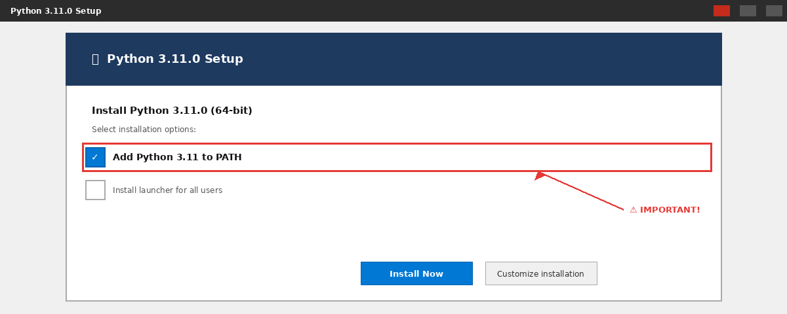
- Open Command Prompt and verify: python --version

Step 2: Install VS Code
- Go to https://code.visualstudio.com and click Download for Windows.
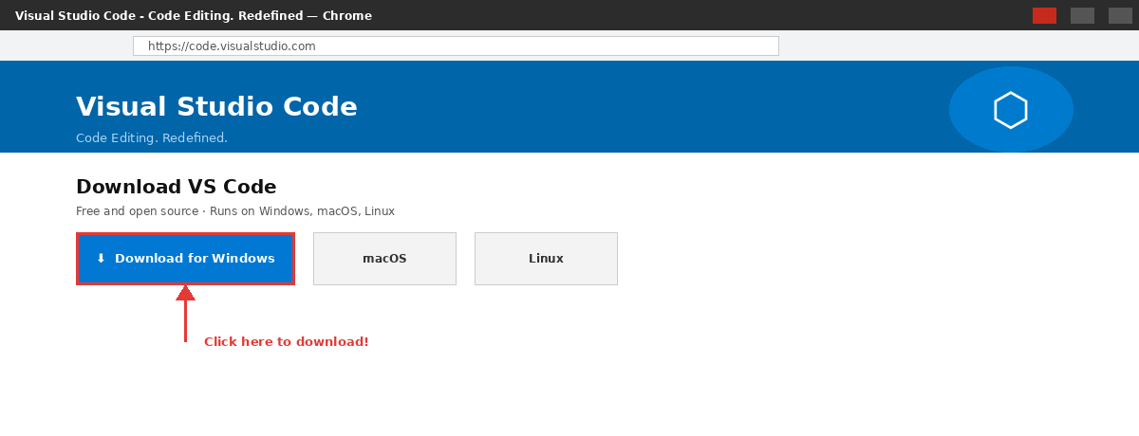
- Run the installer and follow the setup wizard.
- After installation, open VS Code from the Start menu.
- Install the Python Extension: Click Extensions icon (Ctrl+Shift+X) → Search ‘Python’ → Install.

Step 3: Create Project Folder & Open in VS Code
- Create a new folder on your Desktop named imdb_project.
- Open VS Code → File → Open Folder → Select the imdb_project folder.
- Create two files inside: app.py (main code) and requirements.txt (libraries list).
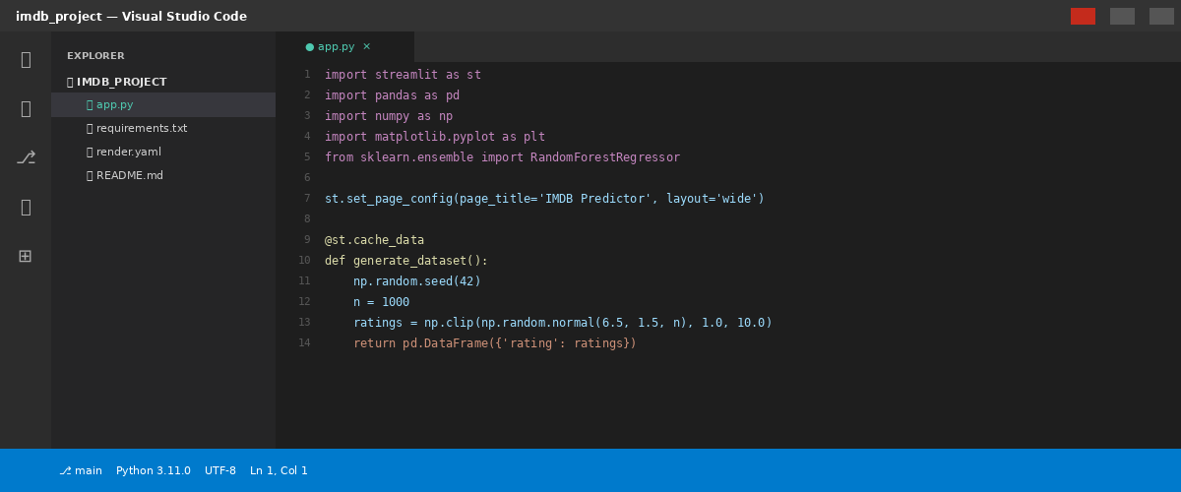

Step 4: Install Required Libraries
- Open Terminal in VS Code: Terminal → New Terminal (or Ctrl + `).
- Run the following command in the terminal:
pip install -r requirements.txt
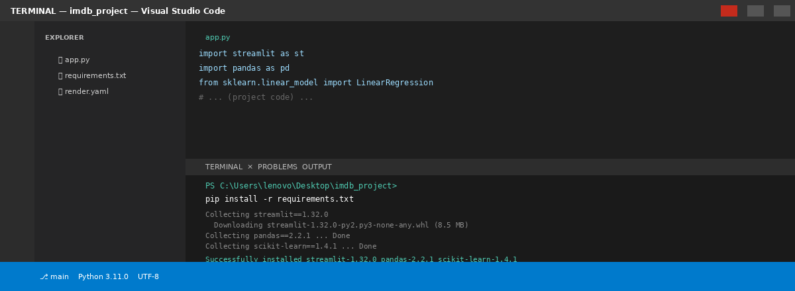
- Wait for all packages to install successfully. You should see ‘Successfully installed’ message.

Step 5: Add the Project Code to app.py
- Open app.py in VS Code by clicking it in the left Explorer panel.
- Paste the complete IMDB project Python code into app.py.
- The code includes: Dataset generation, TF-IDF NLP, ML model training, and Streamlit UI.
- Save the file using Ctrl + S.

Step 6: Run the Streamlit Application
- Open the VS Code Terminal (Ctrl + `) and navigate to the project folder:
cd Desktop\imdb_project
- Run the following command:
streamlit run app.py
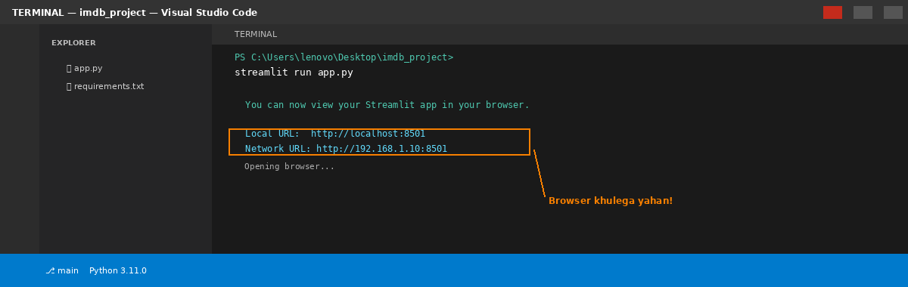
- The browser will automatically open at http://localhost:8501.
- If the browser does not open automatically, copy the URL from the terminal and paste it.

Step 7: Use the IMDB Rating Predictor Web App
- The web app opens with three tabs: Predict Rating, EDA & Analysis, and Model Results.
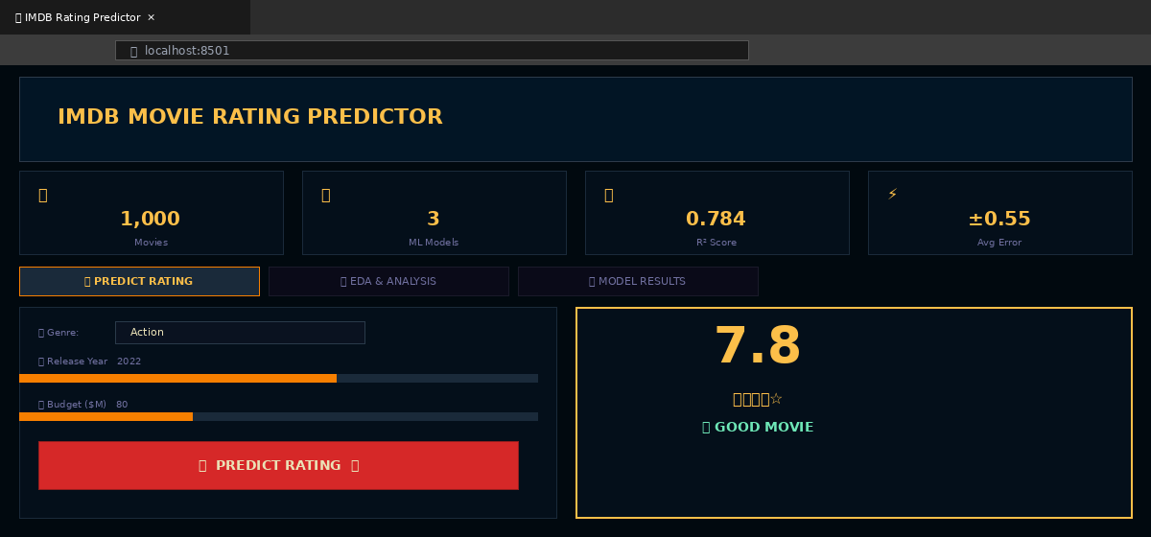
- In the Predict Rating tab, fill in the movie details (Genre, Year, Budget, Cast Score, etc.).
- Write a short movie review in the text box and click PREDICT RATING button.
- The predicted IMDB rating (1.0–10.0) is displayed with a star rating and a verdict.
- Click the EDA & Analysis tab to view Rating Distribution, Genre Analysis, and Correlation Heatmap.
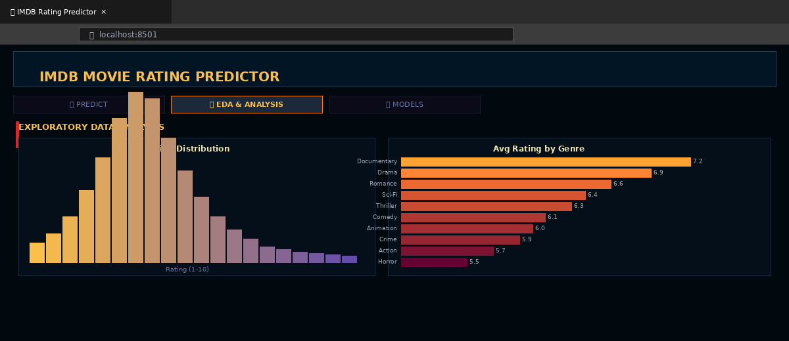
- Click the Model Results tab to compare MAE, RMSE, and R² scores of all three models.

6. Results & Model Comparison

Model | MAE | RMSE | R² Score
Linear Regression 🏆 | 0.546 | 0.664 | 0.784
Random Forest | 0.564 | 0.680 | 0.773
Gradient Boosting | 0.579 | 0.715 | 0.749

Best Performing Model: Linear Regression
- R² Score of 0.784 means the model explains ~78% of the variance in movie ratings
- MAE of 0.546 means predictions are on average within ±0.55 rating points
- RMSE of 0.664 confirms low overall prediction error

Note: All three models performed well. Linear Regression achieved the highest R² in this dataset, suggesting that the relationship between features and ratings is largely linear. For larger, more complex datasets, Random Forest and Gradient Boosting may outperform.

7. Visualizations

7.1 Rating Distribution
The histogram shows that most movie ratings are concentrated between 5.5 and 7.5, following a roughly normal distribution. Extreme ratings (below 3 or above 9) are rare.

7.2 Average Rating by Genre
The bar chart reveals that Documentary and Drama genres tend to have higher average ratings, while Action and Horror genres generally receive lower average ratings.

7.3 Feature Correlation Heatmap
The heatmap shows that director_score and cast_score have the strongest positive correlation with the target variable (rating). Budget has a moderate positive correlation, while duration_min shows a weak correlation.

7.4 Actual vs Predicted (Best Model)
The scatter plot of actual vs predicted ratings for the best model (Linear Regression) shows data points clustered around the diagonal reference line, indicating strong and accurate predictions.

8. Conclusion
This project successfully demonstrated the use of Machine Learning and NLP techniques to predict IMDB movie ratings. Key findings:
- Director score and cast score are the most important numerical predictors of movie ratings
- TF-IDF vectorization of user reviews effectively captures sentiment as a predictive feature
- Linear Regression achieved the best performance with R² = 0.784, MAE = 0.546
- The pipeline combining numerical features, genre encoding, and NLP features proved highly effective

Future improvements could include using pre-trained word embeddings (Word2Vec, BERT) for richer NLP features, incorporating social media sentiment, and adding more movie attributes like awards and box office performance.

9. References
- IMDB – Internet Movie Database: https://www.imdb.com
- Scikit-learn Documentation: https://scikit-learn.org
- Pandas Documentation: https://pandas.pydata.org
- Matplotlib Documentation: https://matplotlib.org
- Géron, A. (2019). Hands-On Machine Learning with Scikit-Learn, Keras & TensorFlow
- Jurafsky, D. & Martin, J.H. (2023). Speech and Language Processing (3rd ed.)

