Ex.no:9 | MINI PROJECT – FINANCE / BANKING  DATA ANALYTICS

Domain and Problem Statement:
Domain: Banking Analytics & Financial Fraud Detection
Problem Statement: Financial institutions face capital loss and operational risk due to undetected transaction fraud, inefficient channel utilization, and poor visibility into state-level liquidity distribution. This project addresses these challenges by transforming raw transaction records into structured business intelligence across Power BI and Tableau to evaluate financial performance, geographic risk distribution, and fraud exposure across banking channels.

Dataset Description:
Dataset Name: Indian Banking Transactions Dataset
Granularity: Each row represents a single banking transaction.
Timeframe Covered: 2019 to 2024.
Key Entities & Attributes:
- Demographics & Account: customer_id, state, credit_score, has_loan, loan_type, kyc_status, account_type, channel.
- Transaction Details: transaction_id, transaction_date, transaction_time, transaction_hour, transaction_type, transaction_direction, merchant_category, transaction_status.
- Financials & Risk: transaction_amount, account_balance, emi_amount, is_fraud.

Data Source:
Primary Source: Kaggle Open Datasets (Indian Banking Transactions).
Storage Infrastructure: Cleaned transactional records hosted within a local MySQL database instance (banking_analytics).

Architecture:
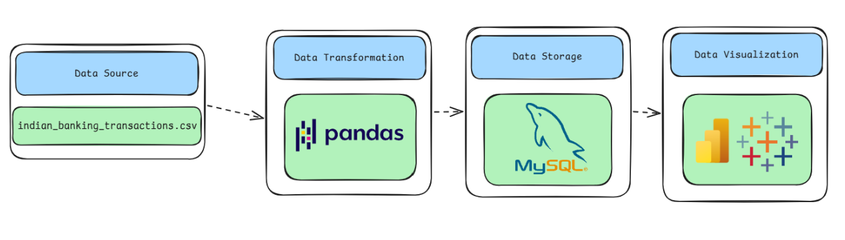

Program:
1. Python – Data Cleaning & Transformation
import pandas as pd
from sqlalchemy import create_engine, text
# Load dataset
df = pd.read_csv("indian_banking_transactions.csv")
bank = df.copy()

# Handle missing values
bank["customer_id"] = bank["customer_id"].fillna("Unknown")
bank["transaction_type"] = bank["transaction_type"].fillna("Unknown")
bank["account_type"] = bank["account_type"].fillna("Unknown")
bank["merchant_category"] = bank["merchant_category"].fillna("Unknown")
bank["transaction_direction"] = bank["transaction_direction"].fillna("Unknown")
bank["transaction_amount"] = bank["transaction_amount"].fillna(0)
bank["account_balance"] = bank["account_balance"].fillna(0)

# Remove duplicates
bank.drop_duplicates(inplace=True)

# Convert date column
bank["transaction_date"] = pd.to_datetime(
bank["transaction_date"], errors="coerce"
)

# Standardize column names
bank.columns = (
bank.columns.str.lower().str.strip().str.replace(" ", "_")
)
print("Original Shape:", df.shape)
print("Cleaned Shape:", bank.shape)
bank.head()
2. MySQL – Database and Data Loading
MySQL Command Prompt:
net start MySQL80
mysql -u root -p
MySQL:
CREATE DATABASE IF NOT EXISTS hotel_analytics;
Python/Jupyter:
# Database Server Credentials
username = "root"
password = "YOUR_MYSQL_PASSWORD"
host = "localhost"
port = 3306

# Create Database
server_engine = create_engine(
f"mysql+pymysql://{username}:{password}@{host}:{port}"
)
with server_engine.connect() as connection:
connection.execute(
text("CREATE DATABASE IF NOT EXISTS banking_analytics")
)

# Connect to target DB and export table
db_engine = create_engine(
f"mysql+pymysql://{username}:{password}@{host}:{port}/banking_analytics"
)

bank.to_sql(
"banking_transactions",
con=db_engine,
if_exists="replace",
index=False,
chunksize=5000,
)

# Verification
print(
pd.read_sql(
"SELECT COUNT(*) AS total_rows FROM banking_transactions", db_engine
)
)

Procedure:

Step 1: Data Preparation & Preprocessing (Python / Pandas)
- Load raw transactional dataset using pd.read_csv().
- Validate non-null constraints across mandatory fields (transaction_id, customer_id, transaction_amount).
- Format temporal values and export cleaned records into MySQL (banking_analytics.banking_transactions) via SQLAlchemy.
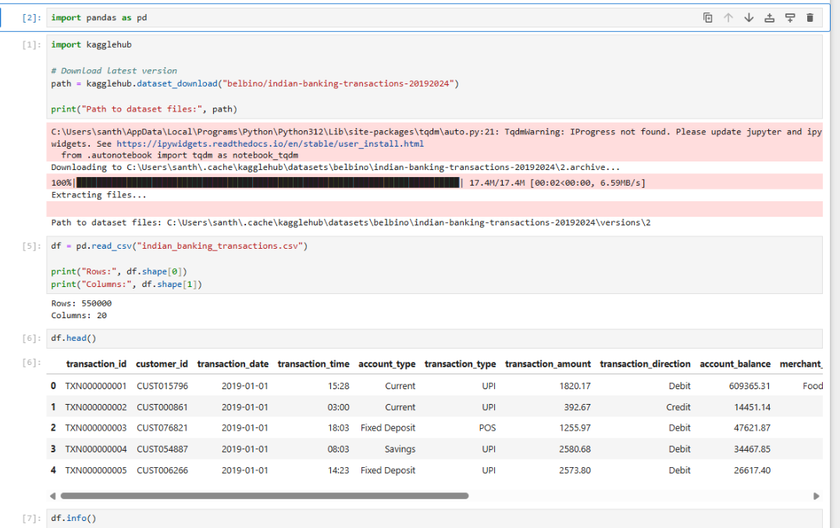

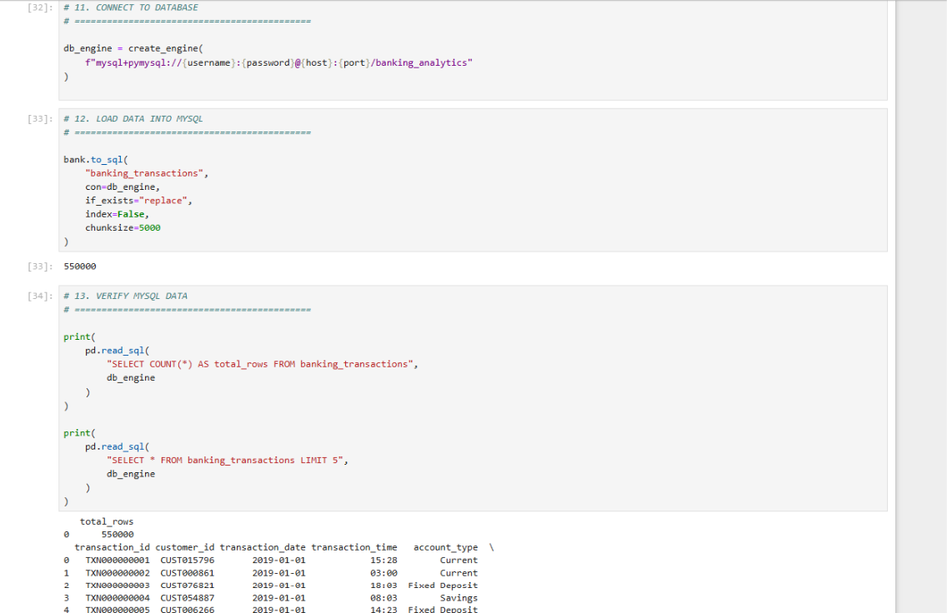

Step 2: SQL Database Connection & Data Ingestion
- Open Power BI Desktop $→$ Click Get Data $→$ Select MySQL Database.
- Enter Server (localhost:3306) and Database Name (banking_analytics).
- Authenticate with root credentials, select banking_transactions, and click Transform Data to launch Power Query.
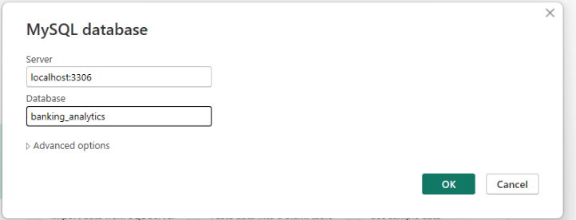

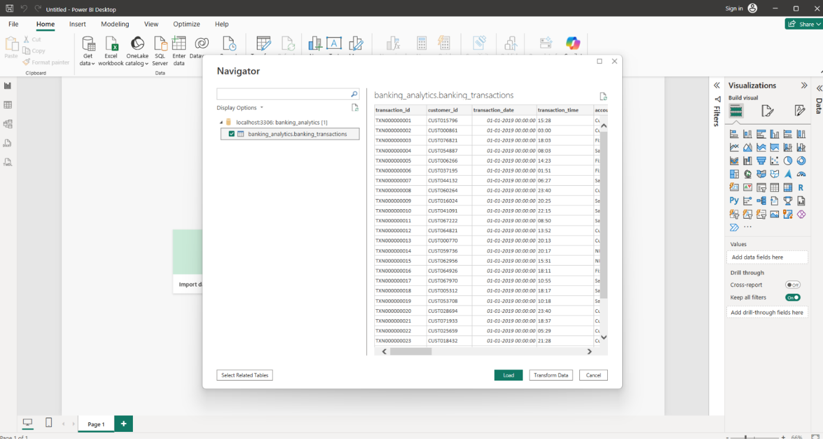

Step 3: Star Schema Data Modeling (Power BI)
- Table Splitting in Power Query:
Duplicate raw query banking_transactions into 3 separate entities: Fact_Transactions, Dim_Customer, and Dim_Account.
Dim_Customer: Retain customer_id, state, credit_score, has_loan, loan_type, kyc_status. Remove duplicates on customer_id ($79,916$ unique rows).
Dim_Account: Retain account_type and channel. Remove duplicates and add an Index Column named AccountKey.
Fact_Transactions: Merge with Dim_Account on account_type and channel to pull in AccountKey. Then remove redundant text columns (state, credit_score, has_loan, loan_type, kyc_status, account_type, channel).
- Establishing Relationships in Model View:
Connect Dim_Customer[customer_id] $→$ Fact_Transactions[customer_id] ($1:*$).
Connect Dim_Account[AccountKey] $→$ Fact_Transactions[AccountKey] ($1:*$).
Hide foreign key columns inside Fact_Transactions to enforce clean report pane structure.

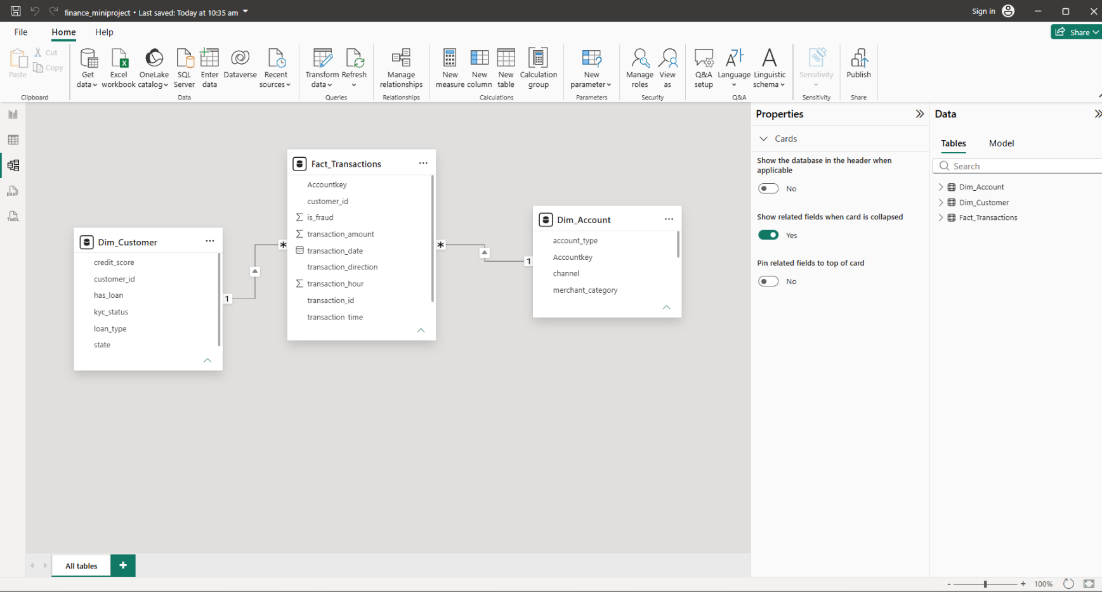

Step 4: Core Calculations & Measures (DAX)
Power BI Measures (DAX)
Create a dedicated _Measures table and add the following DAX calculations:
- Total Transactions:

- Total Transaction Amount:

- Average Transaction:

- Total Customers:

- Fraud Transactions:

- Fraud Rate (%):

Step 5: Power BI Final Executive Dashboard & Drill-Through
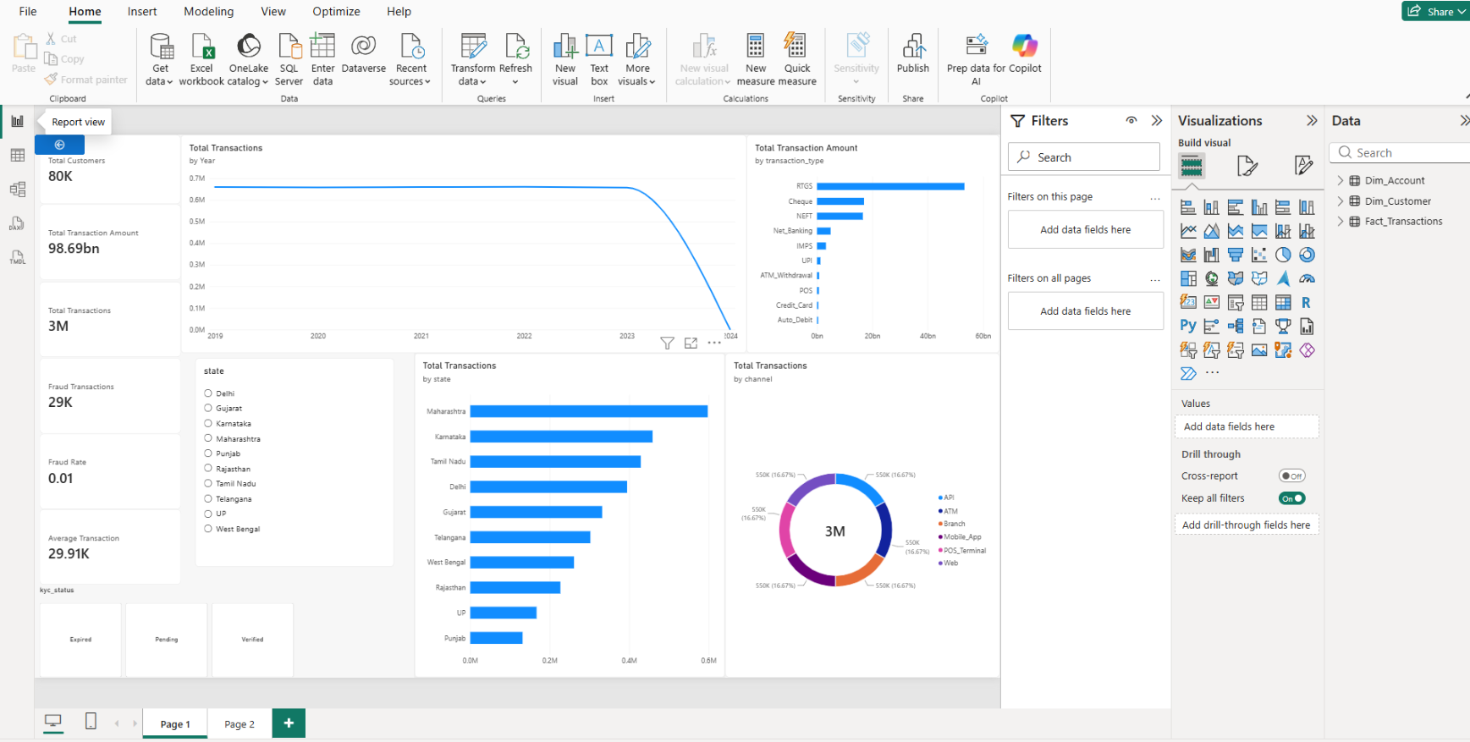

- Executive Canvas:
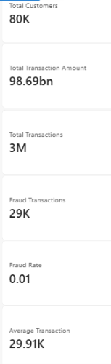
  - Place Card Visuals across the top: Total Customers, Total Transaction Amount, Total Transactions, Fraud Transactions, Fraud Rate, Average Transaction

  - Add a Line Chart mapped to Total Transactions by Year.
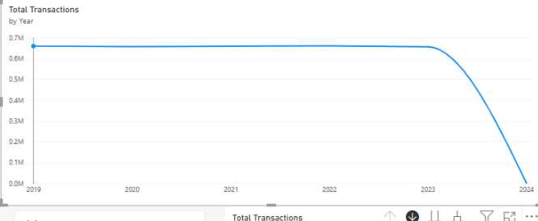

  - Add a Clustered Bar Chart for for Total Transactions by state

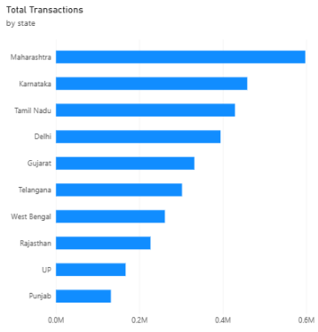
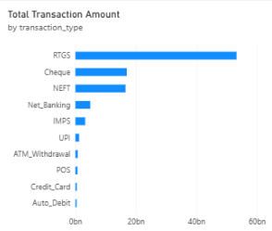

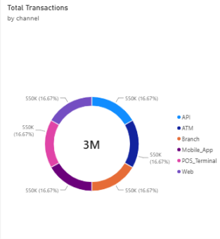
  - Add a Donut Chart for Total Transactions by channel.

  - Add Slicers for state and kyc_status
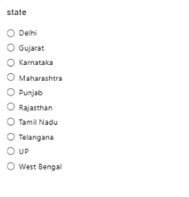

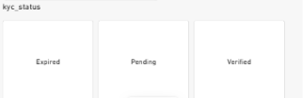

- State Details Drill-Through Page:
  - Create a second page named Country Details.
  - Drag Dim_Customer[country] into the Drill-through field bucket.
  - Add a detailed Matrix/Table visual showing country, Total Bookings, Total Revenue, and Cancellation Rate
  - Create a second page named Page 2.
  - Drag Dim_Customer[state] into the Drill-through field bucket.
  - Add a detailed Matrix/Table visual showing state, Total Transaction Amount, Total Transactions, Fraud Rate, and Fraud Transactions.
  - Add a Bar Chart for Total Transaction Amount by merchant_category.
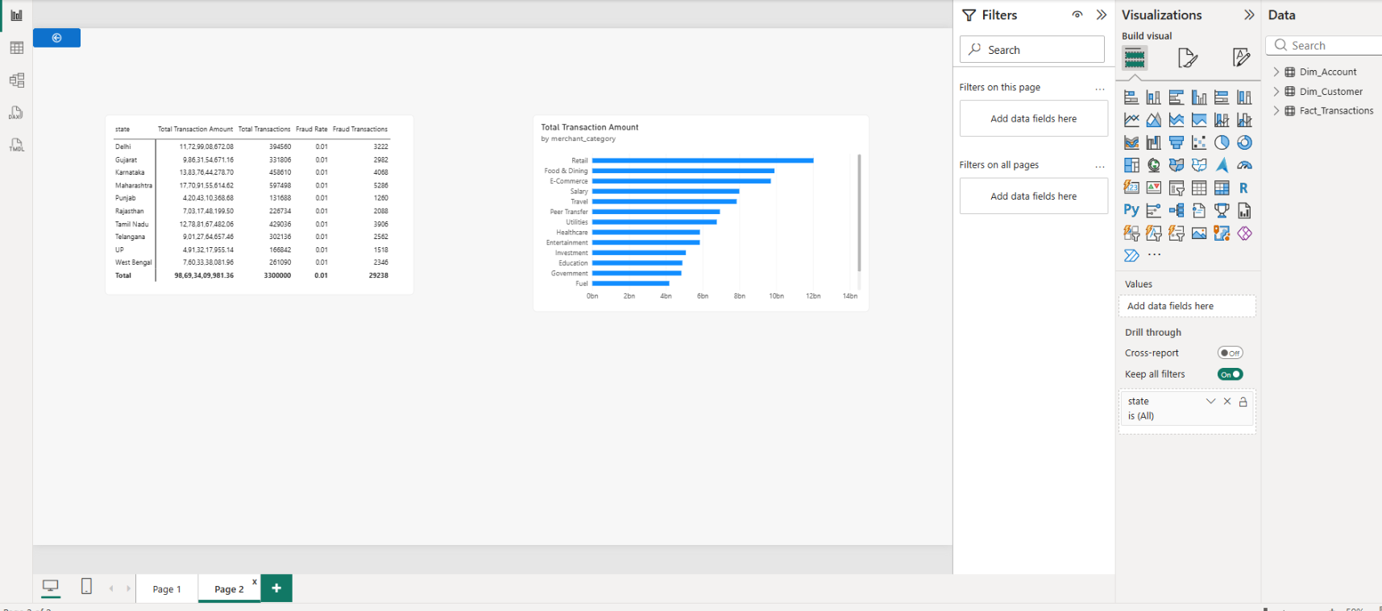

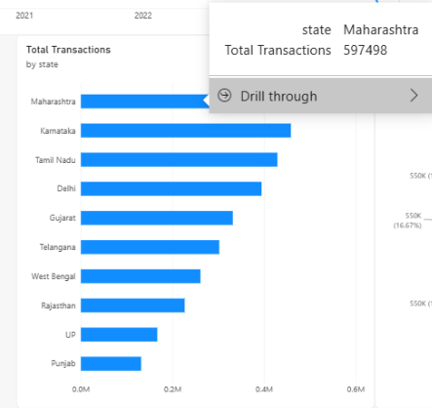

Step 6: Tableau Data Connection & Preparation
- Open Tableau Desktop / Tableau Public.
- Under To a Server, select MySQL.
- Enter Server (localhost), Database (banking_analytics), and user credentials to pull the cleaned dataset onto the canvas.
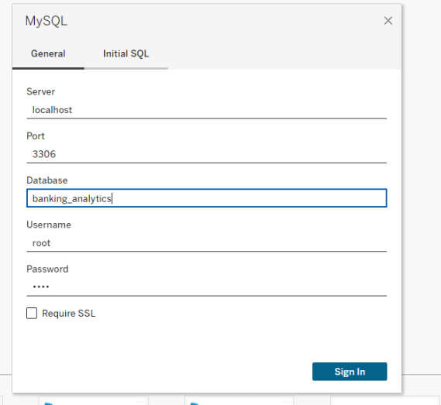

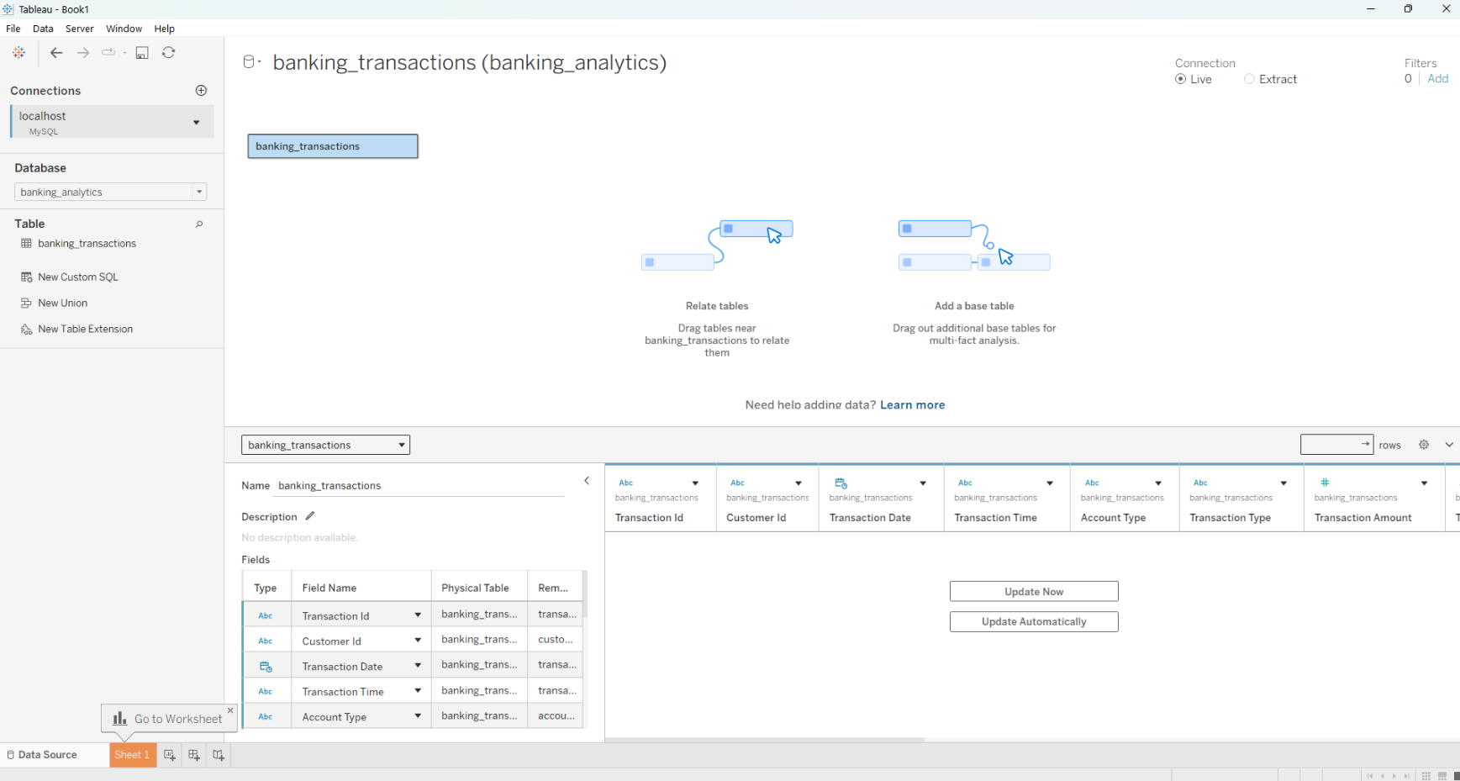

- Go to any sheet and build calculated fields:
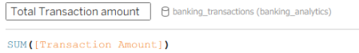
- Total Transaction amount:

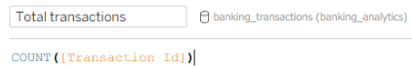
- Total trnsactions:

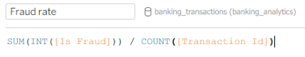
- Fraud rate:

- Select Banking Metric Parameter: String list containing "Total Transaction amount", "Total trnsactions", "Fraud rate".
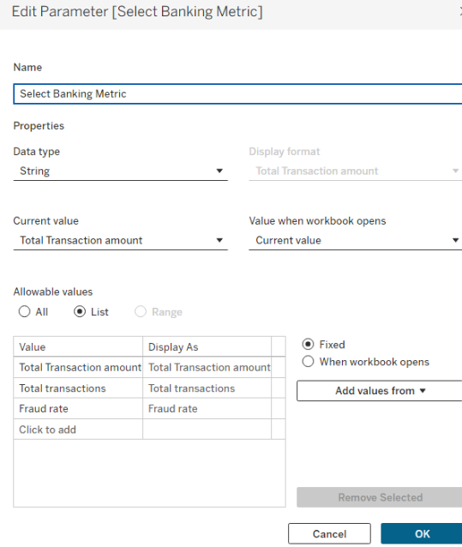

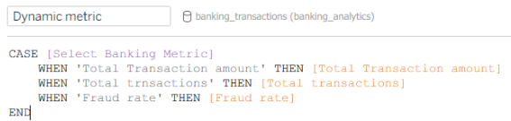
- Dynamic Metric Formula:

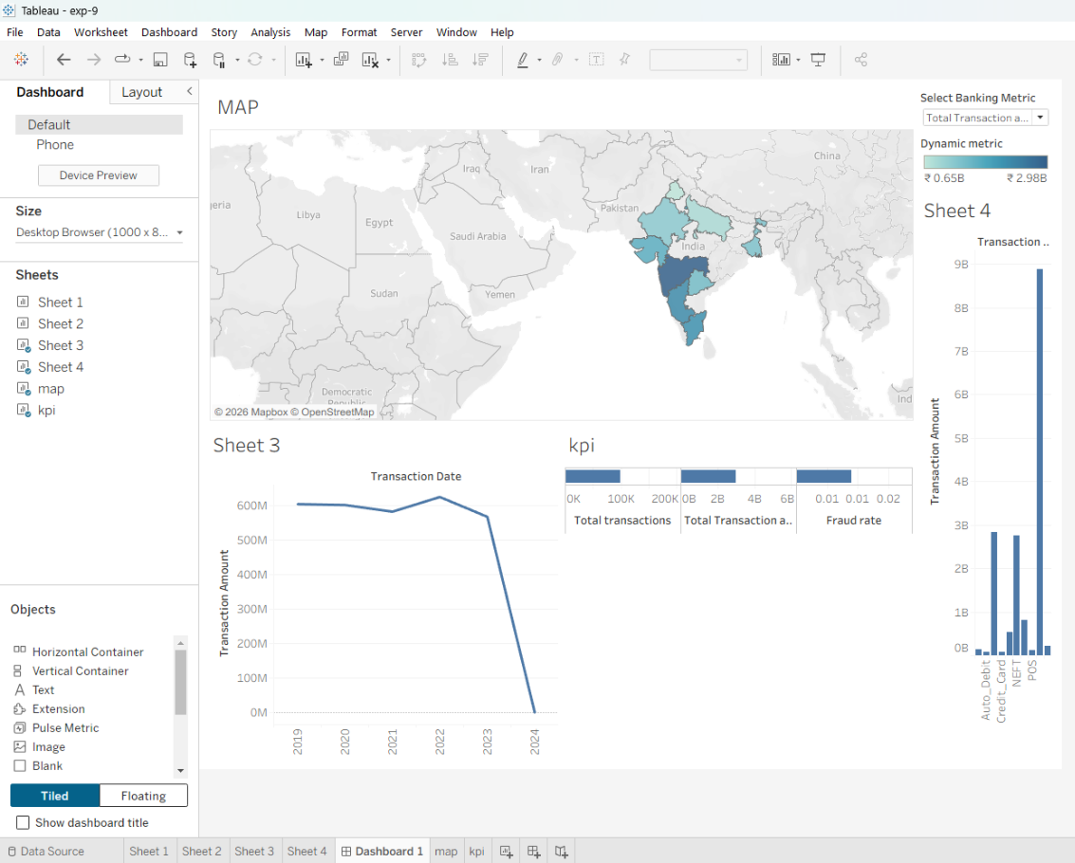
Step 7: Tableau Companion Dashboard & Interactive Story

- Worksheets: Build KPI sheet, Hourly Trend Line Chart (using Dynamic Metric), Channel Breakdown Bar Chart , and State Map.
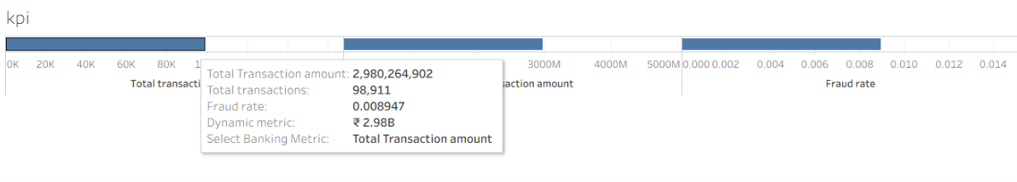

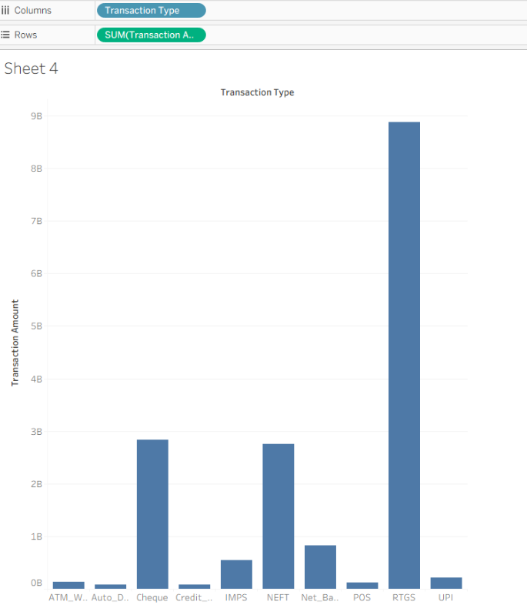
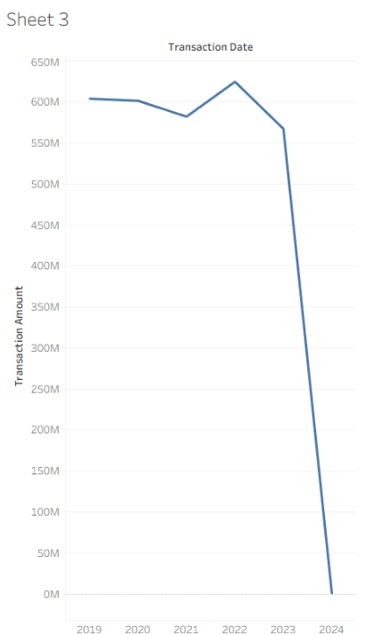

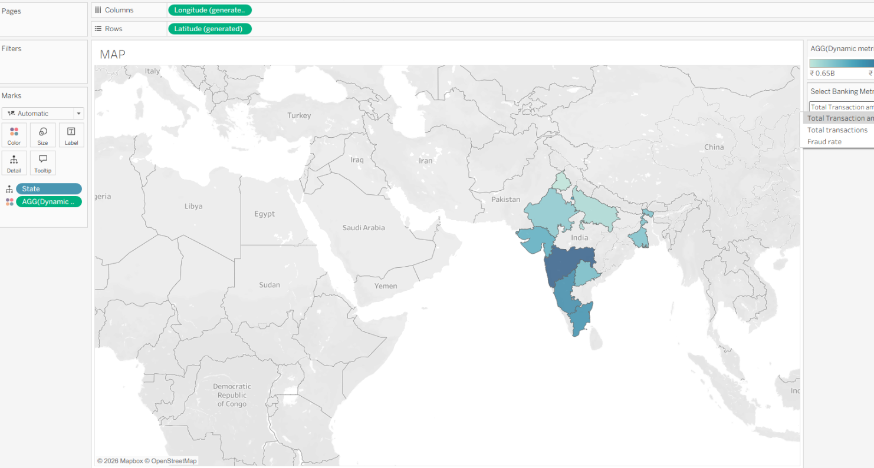

- Global Filters & Actions:
  - Add Parameter control for Select Banking Metric to the dashboard.
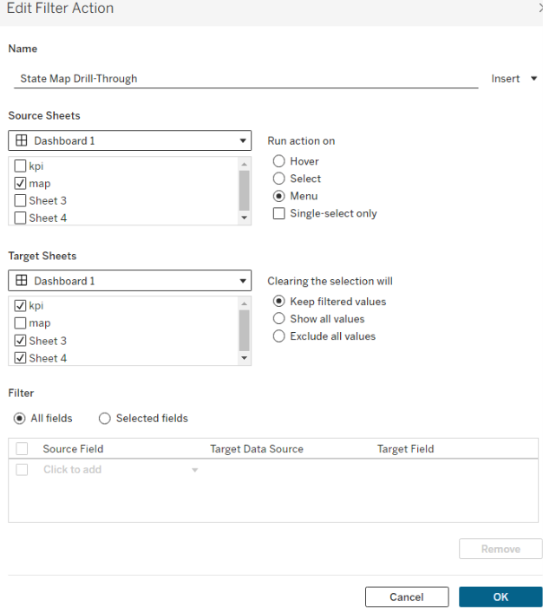
  - Drag sheets onto a new Dashboard tab and click the Use as Filter funnel icon on the State Map visual.

- Drill-down map:
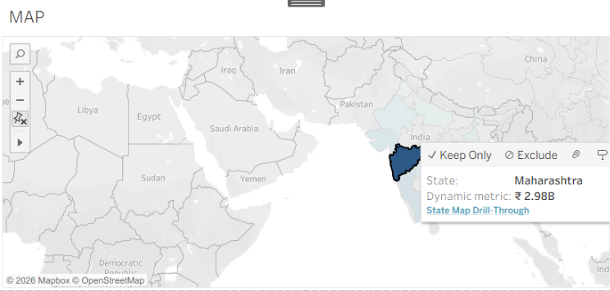

Observed Insights:
- Portfolio Transaction Volume: The dataset records 3 Million total transactions generating ₹98.69 Billion in gross transaction volume across 80,000 unique customers.
- Fraud Risk Exposure: Total fraudulent transactions stand at 29,000, maintaining an overall portfolio Fraud Rate of 0.01. High-value payment types like RTGS, Cheque, and NEFT account for the vast majority of movement.
- Geographical & Channel Distribution: Transaction volume is heavily concentrated in tier-1 commercial hubs led by Maharashtra, Karnataka, Tamil Nadu, and Delhi. Channel distribution is evenly split across API, ATM, Branch, Mobile App, POS Terminal, and Web.
- Merchant Engagement: Retail, Food & Dining, and E-Commerce lead spending volume across all merchant categories

