Technical Write-Up: AI-Assisted Translation Technologies for Indian Languages

MigotoAI Translation Engine — Novac Technology Solutions Pvt. Ltd. (Immerz Division)

RFB No. IN-KBL-543730-NC-RFB | iGOT Karmayogi Platform — Karmayogi Bharat (SPV)

1. Executive Summary
Novac Technology Solutions proposes to deliver all translation and dubbing requirements of the iGOT Karmayogi platform using the MigotoAI Translation Engine — a proprietary, India-sovereign, end-to-end AI localisation system built and operated by the Immerz Division of Novac.
The MigotoAI Translation Engine is not an integration layer over public translation APIs. It is a purpose-built, closed-loop media localisation pipeline that runs Novac-owned, domain-fine-tuned neural models for Indic ASR (Automatic Speech Recognition), Neural Machine Translation (NMT), and neural Text-to-Speech (TTS), orchestrated by a multi-stage pipeline with automated quality gates and human linguist checkpoints.
Three capabilities directly addressed by this write-up, as required under the RFB evaluation criteria:
- Machine Translation — proprietary fine-tuned model stack with three-engine fallback, factual token protection, and language-aware routing for all 22 scheduled Indian languages.
- Contextual Post-Editing — Translation Memory with exact and fuzzy matching, optional LLM-based post-edit enhancement, and a structured human review and correction loop that feeds back into model training.
- Glossary and Terminology Management — per-language domain glossaries enforced at inference, a Do-Not-Translate (DNT) registry for protected entities, and a government Translation Memory seeded with verified administrative terminology.
All components run locally on India-resident infrastructure. No KB course content is transmitted to any external API, cloud service, or third-party model at any stage.
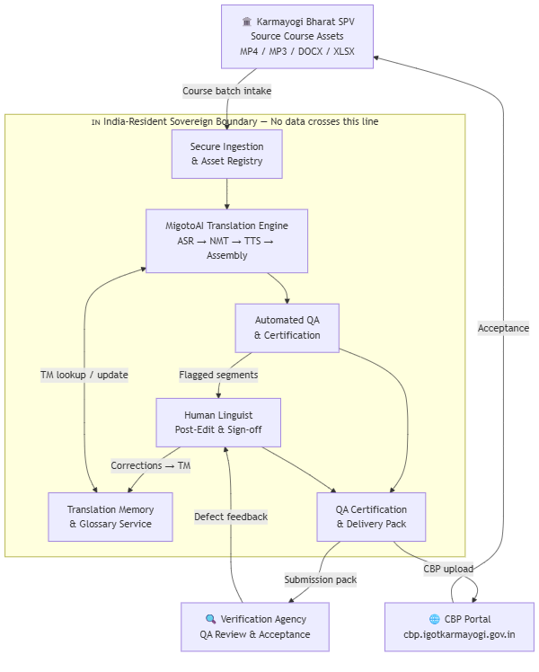

2. Machine Translation

2.1 Engine Architecture — Three-Layer Fallback Chain
The translation core of MigotoAI is built on three sequential engines. Each engine is attempted in order; if the primary produces output below the quality threshold or is unavailable for a given language pair, the system automatically falls through to the next:
Layer 1 — IndicTrans2 (Primary) AI4Bharat's IndicTrans2, fine-tuned by Novac on domain-specific Indian administrative, governance, civil-service training, and Mission Karmayogi-adjacent corpora. This is the primary engine for 19 of the 22 target languages. The fine-tuned checkpoints are maintained at checkpoints/indictrans/en_indic/best/ (English → Indic), indic_en/best/ (Indic → English), and indic_indic/best/ (Indic → Indic), and are loaded preferentially over the base model weights.
Layer 2 — SeamlessM4Tv2 (First Fallback) Meta's SeamlessM4Tv2 serves two roles: (a) text translation fallback when IndicTrans2 output fails quality scoring, and (b) a Speech-to-Speech (S2ST) fast-path for Indic-to-Indic pairs (hin/ben/kan/tel/urd), which bypasses the ASR → translate → TTS chain entirely when a direct voiced output is available — reducing latency and preserving natural prosody for those pairs.
Layer 3 — NLLB-200 (Final Fallback) Meta's No Language Left Behind 200-language model serves as the final fallback, and as the primary engine for three languages (Kashmiri, Sindhi, Konkani) where its coverage exceeds IndicTrans2's.
Language routing table:
Language Group | Primary | Fallback 1 | Fallback 2
hin, ben, tam, tel, kan, mal, mar, guj, pan, ory, asm, urd, nep, mai, doi, bod | IndicTrans2 (fine-tuned) | SeamlessM4T | NLLB-200
mni, sat, san | IndicTrans2 via Hindi pivot | NLLB-200 | —
kok, snd, kas | NLLB-200 (primary) | — | —
S2ST pairs (hin↔ben↔kan↔tel↔urd) | SeamlessM4T direct speech output | Full ASR→NMT→TTS chain | —

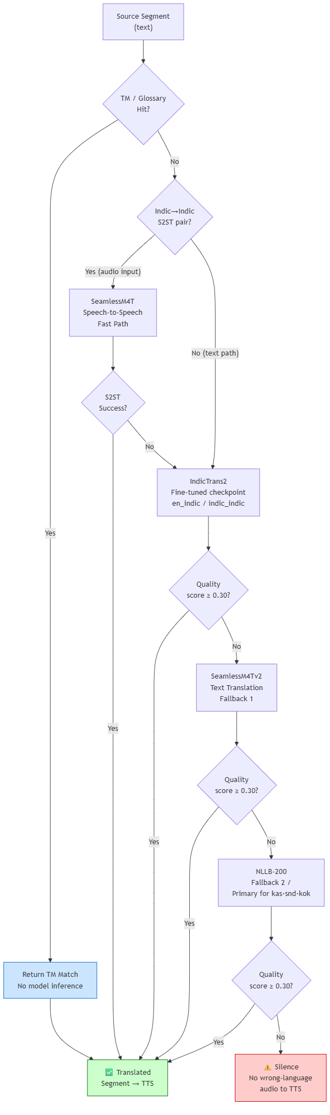

2.2 Domain Fine-Tuning
The IndicTrans2 base model is adapted using Novac's curated parallel training corpus stored at datasets/parallel/<lang_code>/ with train.jsonl, dev.jsonl, and test.jsonl splits for all 22 languages. Fine-tuning uses the finetune/finetune_indictrans.py script with DeepSpeed ZeRO-3 configuration (finetune/ds_zero3.json) for multi-GPU training.
Domain adaptation ensures that:
- Indian administrative register, honorifics, and scheme names are handled natively rather than literally transliterated
- Course-specific terminology introduced through the Glossary and Translation Memory is reflected in model outputs
- Human post-edit corrections are captured as supervised training pairs and folded back into the adapter refresh cycle, so accuracy improves continuously across the contract period

2.3 Factual Token Protection
A key failure mode in MT for educational content is corruption of numbers, dates, currency, measurements, and statutory references during translation. MigotoAI implements a three-tier token protection system applied before any text reaches a translation engine:
Factual tokens — integers, decimals, percentages, years, ordinals, dates (DD/MM/YYYY, ISO, Month-name), times, and currency amounts (₹/$) are detected by regex and replaced with indexed placeholders (__F0__, __F1__, ...) before translation. The original values are restored verbatim after translation. This guarantees that "₹15,000" does not become "₹15000" or a transliteration, and that "2024-03-31" survives unchanged in any target language.
Non-translatable tokens — URLs, file paths, shell commands, code identifiers, email addresses, hashtags, @mentions, and filenames are replaced with __NT0__, __NT1__, ... placeholders. These pass through the translation engine invisible and are restored post-translation.
Format / template tokens — programming placeholders ({name}, %s, ${value}, {{jinja}}, <PLACEHOLDER>) are protected with __FMT0__, __FMT1__, ... to prevent translation engines from corrupting interpolation syntax in translated UI strings, quiz templates, and metadata fields.
Segments where ≥ 90% of non-space characters belong to non-translatable tokens are bypassed entirely and returned unchanged — no compute is wasted on pure-code or pure-URL segments.
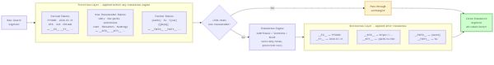

2.4 GPU Batch Translation and Multi-GPU Parallelism
All pending segments for a given target language are assembled into a single GPU batch and translated in one forward pass through the NMT model, rather than one segment at a time. This is what makes the 125 output-hour peak months economically feasible.
For full 22-language course processing, MigotoAI's parallel worker architecture distributes languages across available GPUs:
- ASR runs once in the main process; the result is cached and shared to all language workers
- Languages are round-robin distributed (e.g., 22 languages → ~5–6 per GPU on a 4-GPU node)
- Workers use multiprocessing.spawn (not fork — platform-safe on Windows and Linux) with each worker assigned exclusive GPU access via the PIPELINE_GPU environment variable
- Workers run independently: translate → TTS → assemble, with no inter-worker dependency after the shared ASR cache handoff
This architecture means the 11 mandatory target languages can be processed concurrently on a single multi-GPU node, with the remaining 11 scheduled languages queued as the next batch.
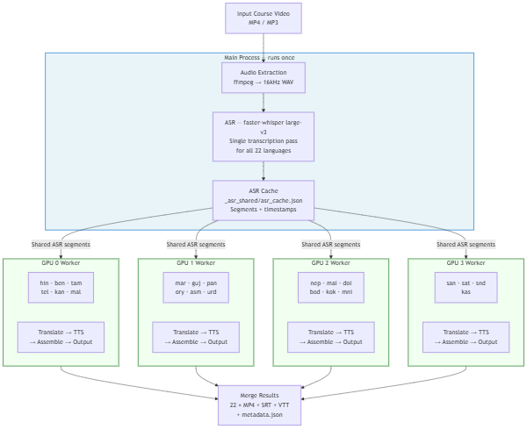

3. Contextual Post-Editing
Contextual post-editing in MigotoAI operates at three levels: automated memory matching before inference, optional LLM-assisted post-edit after inference, and a structured human correction loop that feeds back into both the memory and the training pipeline.

3.1 Translation Memory (TM) — Exact and Fuzzy Matching
The MigotoAI Translation Memory (scripts/translation_memory.py) maintains two stores per language:
- Government TM (translation_memory/govt_tm.jsonl) — verified translations of administrative, governance, and domain-specific terms. Seeded from government reference documents and course-specific approved terminology.
- Human Feedback store (translation_memory/human_feedback.jsonl) — every correction made by a human reviewer is written here with the original wrong translation, the corrected translation, the reviewer's identity, and a timestamp. This store takes priority over the govt TM on every lookup.
Lookup priority at inference time:
- Exact match in human feedback corrections (highest trust — a human already fixed this)
- Exact match in govt TM
- Fuzzy match at ≥ 85% similarity via SequenceMatcher across both stores
- ML engine translation (if no TM hit)
When a TM hit is found before the segment reaches the NMT engine, the translation is returned directly — no model inference is needed. This enforces terminology consistency across all 61 courses and all language runs, and materially accelerates later batches as TM coverage grows.
Correction audit trail: Every human correction is simultaneously written to translation_memory/correction_log.jsonl as an immutable audit record including the source text, wrong translation, correct translation, reviewer name, and timestamp. This record supports the joint-accountability regime at Clause 5.1(D) of the ToR.

3.2 LLM-Assisted Post-Edit Enhancement (Optional Layer)
For segments that pass through the NMT engine without a TM hit, MigotoAI supports an optional LLM post-edit step via pipeline/llm_enhancer.py. This layer is activated only when an API key is configured in the environment and is explicitly disabled for air-gapped deployments.
When active, the LLM post-editor (supporting Groq / Gemini / OpenRouter as provider options, all configurable) receives the source text, the NMT-produced translation, and a prompt that instructs it to:
- Fix grammar, word order, and unnatural phrasing
- Preserve all proper nouns, scheme names, and numbers exactly as-is
- Return only the corrected translation, no commentary
Batch enhancement is supported — multiple segments are sent as a single JSON array in one LLM call, with strict output validation (array length must match input length; on mismatch, the raw NMT output is retained). The system is fault-tolerant: any LLM call failure silently falls back to the raw NMT translation, so the pipeline never blocks on the optional enhancement layer.
Important: The LLM enhancement layer is a post-edit assistant, not the translation engine. The NMT models are always the primary translators; the LLM only refines fluency. This distinction preserves the proprietary, offline-capable nature of the platform — the core pipeline functions fully without LLM connectivity.

3.3 Human Review and Correction Loop
The MigotoAI platform includes a structured human review interface (ui/reviewer.py, exposed as the Human Review tab in the Gradio-based platform UI) where native language reviewers can:
- Review translated segments alongside the source text
- Approve, correct, or reject individual segments
- Add inline comments
- Export a signed review certificate (DOCX) attributing review to a named reviewer
Every correction submitted through the review interface is written to the human feedback store (Section 3.1) and simultaneously captured as a supervised training pair for the model improvement loop.
Training feedback loop: When human feedback records are exported for fine-tuning via export_for_finetuning(), human-corrected pairs are upweighted 3× relative to government TM entries — reflecting the higher signal value of a domain-specific correction over a general reference translation. This ensures the model improves precisely on the failure modes it encounters in KB course content.
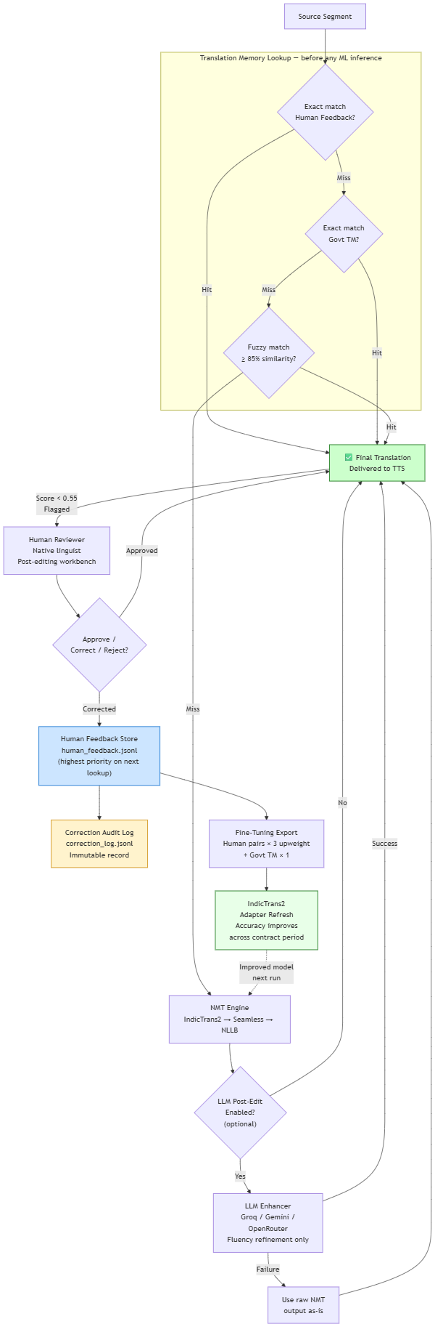

4. Glossary and Terminology Management

4.1 Per-Language Domain Glossaries
MigotoAI maintains a dedicated glossary file for each of the 22 target languages at glossary/<lang_code>.json. Each glossary is a curated map of English source terms to their standardised translations in the target language, covering:
- Indian administrative and governance terminology (scheme names, ministry titles, statutory terms)
- iGOT Karmayogi platform-specific vocabulary (competency framework terms, learning outcome labels)
- Civil-service training domain terms
- Technical and professional terms with approved translations
At inference time, the GlossaryManager (pipeline/glossary.py) injects glossary terms into the translation call, ensuring that approved terminology is used consistently regardless of which NMT engine handles the segment. Glossary enforcement is applied before quality scoring, so a segment using an approved glossary term is not incorrectly flagged for terminology inconsistency.

4.2 Do-Not-Translate (DNT) Registry
The DNT registry is implemented as part of the non-translatable token protection layer (Section 2.3). Protected entity categories include:
- Trademark and product names
- Government scheme and programme names (PMMY, PMJDY, Mission Karmayogi, iGOT, etc.)
- Statutory titles and designations
- Acronyms defined in the source
- URLs, file paths, and system identifiers
- Numeric codes, reference numbers, and measurements
DNT enforcement is deterministic — entities are masked before the text reaches any translation engine and restored verbatim after. No model sampling or probabilistic translation can alter a DNT-protected string. This is the engineering guarantee behind the claim that "scheme names and statutory titles survive translation unchanged."

4.3 Translation Memory as Terminology Seed
The government TM (govt_tm.jsonl) functions as both a translation cache and a terminology seed layer. Domain terms added to the TM via:
python scripts/translation_memory.py add \ --src "Competency Framework" \ --tgt "दक्षता ढांचा" \ --tgt-lang hin \ --domain government
...are immediately available for exact and fuzzy matching on the next pipeline run for that language, without requiring a model retrain. This allows rapid onboarding of KB-supplied terminology updates between monthly batches.

4.4 End-of-Contract Glossary Export
The consolidated, standardised glossary of translated terms — required as Deliverable 4.6 under the ToR — is generated by generate_completion_report() and included in the Completion Report DOCX with a three-column table: English Term | Language | Standardised Translation, covering all approved terms across all delivered languages.

5. Proprietary Platform — Evidence of Ownership and Capability

5.1 What Makes This Proprietary
MigotoAI is distinguished from off-the-shelf or API-dependent translation solutions on five dimensions:
1. Novac-owned fine-tuned model weights The IndicTrans2 checkpoints used by the pipeline are not the public base model weights. They are fine-tuned checkpoint files maintained at checkpoints/indictrans/en_indic/best/, indic_en/best/, and indic_indic/best/. The fine-tuning pipeline (finetune/finetune_indictrans.py), training data (datasets/parallel/<lang>/), and DeepSpeed multi-GPU training configuration (finetune/ds_zero3.json) are Novac-developed and maintained.
2. Custom quality scoring pipeline The automated quality estimation system (pipeline/quality.py) is a Novac-developed multi-rule scorer with eight heuristic checks, ChrF character n-gram scoring, and a back-translation semantic drift detector. It is not a third-party QE tool. The scoring thresholds (Pass ≥ 0.55, Review 0.30–0.55, Fail < 0.30) are tuned for the Indian-language administrative translation context.
3. Proprietary token protection system The three-tier placeholder system (__F__, __NT__, __FMT__) is a Novac-built preprocessing layer. It is applied before any translation engine and restored after, across all three engines in the fallback chain. This is what guarantees factual correctness regardless of which NMT model handles a given segment.
4. Integrated Translation Memory and correction loop The TM architecture (scripts/translation_memory.py) — including the dual-store design (govt TM + human feedback), the 85% fuzzy match threshold, the 3× correction upweighting for fine-tuning export, and the immutable correction audit trail — is entirely Novac-built.
5. Complete offline pipeline The end-to-end pipeline (ASR → translate → TTS → audio assembly → subtitle generation → output packaging → CBP upload) runs with zero external API calls. All model weights are local. This is what satisfies GoI data residency requirements without any architectural compromise.

5.2 Platform Architecture Summary

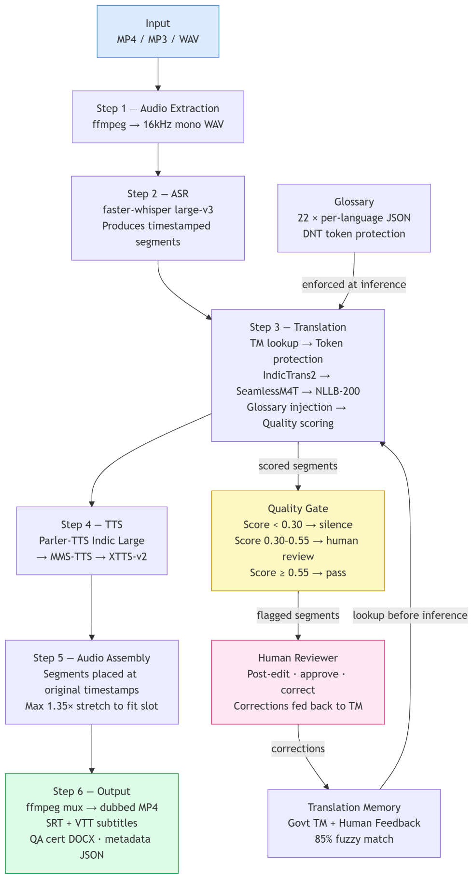

5.3 Supported Languages and Model Coverage
All 22 constitutionally scheduled Indian languages are covered:
# | Language | Code | Script | Primary Engine
1 | Assamese | asm | Bengali | IndicTrans2
2 | Bengali | ben | Bengali | IndicTrans2
3 | Bodo | bod | Devanagari | IndicTrans2 (brx_Deva)
4 | Dogri | doi | Devanagari | IndicTrans2
5 | Gujarati | guj | Gujarati | IndicTrans2
6 | Hindi | hin | Devanagari | IndicTrans2
7 | Kannada | kan | Kannada | IndicTrans2
8 | Kashmiri | kas | Arabic | NLLB-200
9 | Konkani | kok | Devanagari | NLLB-200
10 | Maithili | mai | Devanagari | IndicTrans2
11 | Malayalam | mal | Malayalam | IndicTrans2
12 | Manipuri | mni | Bengali | IndicTrans2 (pivot)
13 | Marathi | mar | Devanagari | IndicTrans2
14 | Nepali | nep | Devanagari | IndicTrans2 (npi_Deva)
15 | Odia | ory | Odia | IndicTrans2
16 | Punjabi | pan | Gurmukhi | IndicTrans2
17 | Sanskrit | san | Devanagari | IndicTrans2 (pivot)
18 | Santhali | sat | Ol Chiki | IndicTrans2 (pivot)
19 | Sindhi | snd | Arabic | NLLB-200
20 | Tamil | tam | Tamil | IndicTrans2
21 | Telugu | tel | Telugu | IndicTrans2
22 | Urdu | urd | Arabic | IndicTrans2

