FUZZY BRAKING SYSTEM FOR CARS

Sanjana Mudhale G
CB.EN.U4ELC23046
Department of Electrical and Electronics Engineering Amrita Vishwa Vidyapeetham Coimbatore, India Cb.en.u4elc23046@cb.student s.amrita.edu
Aparajitha Selvamani
CB.EN.U4ELC23006
Department of Electrical and Electronics Engineering Amrita Vishwa Vidyapeetham Coimbatore, India Cb.en.u4elc23006@cb.student s.amrita.edu

ABSTRACT
This project presents the design and implementation of a Terrain-Adaptive Fuzzy Braking System for intelligent automotive safety. The system integrates data from three sensors—ultrasonic (distance), speed, and terrain friction—to determine the appropriate braking intensity under varying road conditions. The proposed controller is developed using Mamdani Type-1 Fuzzy Logic and compared with ANFIS (Adaptive Neuro-Fuzzy Inference System) to evaluate adaptability and accuracy. Sensor data were generated through Arduino-based simulation on the Wokwi platform and processed in MATLAB/Simulink for performance analysis. Results show that the fuzzy system achieves smoother, more human-like braking, while ANFIS demonstrates enhanced learning and responsiveness in dynamic environments. The study highlights the potential of soft computing in improving real-time braking performance and road safety.
Keywords: Fuzzy Logic, Terrain-Adaptive Braking, ANFIS, Mamdani Controller, Intelligent Systems, Vehicle Safety, Soft Computing, Brake Force Control.
I. INTRODUCTION

In modern vehicles, ensuring passenger safety and ride comfort is a primary design goal. Conventional braking systems rely on fixed thresholds or binary decision logic, often leading to abrupt or delayed braking. Such systems lack adaptability to variable factors such as road friction, speed, or obstacle distance. To address these limitations, this project introduces an intelligent braking system based on Fuzzy Logic and ANFIS principles. Fuzzy logic emulates human reasoning by converting sensor data into linguistic variables like “High Speed” or “Slippery Terrain,” enabling smooth and adaptive braking responses. ANFIS further refines this process by automatically learning from data to improve braking decisions. The proposed system thus ensures faster, more stable, and context-aware braking suitable for real-time driving environments.

LITERATURE SURVEY

Earlier research on intelligent braking primarily focused on traditional PID or rule-based systems that lacked adaptability under changing road conditions. Zadeh (1973) first introduced fuzzy logic as a mathematical framework for handling uncertainty, laying the foundation for fuzzy control systems. Later, Mamdani applied fuzzy logic to control industrial processes, demonstrating smooth control responses. Mendel (1995) provided a comprehensive overview of fuzzy control design for engineering applications, emphasizing its interpretability. Jang (1993) introduced the Adaptive Neuro-Fuzzy Inference System (ANFIS), combining neural learning with fuzzy inference, allowing automatic parameter tuning. Recent studies by Rizvi and Khan (2017) have shown that fuzzy-based braking significantly enhances safety and reduces stopping distance. The integration of Mamdani and ANFIS in this project extends these works toward terrain-adaptive automotive braking.

II.OBJECTIVE

The main objective of this project is to design and develop a terrain-adaptive braking system that intelligently adjusts the braking intensity according to the vehicle’s speed, the distance from an obstacle, and the road surface condition. The system aims to integrate fuzzy logic and ANFIS to replicate human-like reasoning and decision-making in real-time. By using a Mamdani Type-1 Fuzzy Logic Controller, the project ensures smooth and adaptive braking actions under varying driving scenarios. Furthermore, an ANFIS model is implemented to enhance the learning and adaptability of the system through data-driven optimization. The overall goal is to achieve improved safety, faster response, and stable braking performance, ultimately minimizing stopping distance while maintaining vehicle control on different terrains.

XXX-X-XXXX-XXXX-X/XX/$XX.00 ©20XX IEEE

III.METHODOLOGY
The system was implemented in MATLAB/Simulink and validated using data acquired from a Wokwi-based Arduino setup. Three sensor inputs were considered: Distance (measured by ultrasonic sensor), Speed (adjustable potentiometer mapped 0–40 m/s), and Terrain coefficient (µ) (potentiometer-based road friction simulation). Each input was normalized and processed through the Mamdani Fuzzy Inference System, consisting of triangular membership functions for low, medium, and high categories. The rule base comprised nine expert rules correlating combinations of input conditions to braking intensity. Defuzzification was performed using the centroid method to obtain a crisp brake output in percentage. For ANFIS, the same dataset was used to train a five-layer neuro-fuzzy network using the hybrid learning algorithm, which fine-tuned membership parameters automatically. Both controllers were evaluated through simulation by varying speed, distance, and terrain friction to analyze their dynamic response.
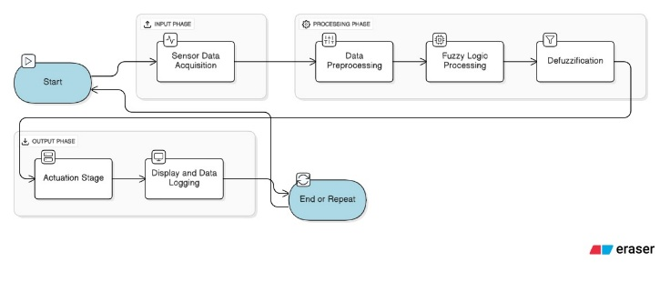
Fig.1 System Block Diagram

Mamdani Type-1 Fuzzy Inference System (FIS)

The Mamdani Fuzzy Inference System (FIS) forms the initial phase of the intelligent braking controller. The environment was modeled using three essential input variables — Speed (m/s), Distance (m), and Terrain Friction (μ) — which represent the real-time driving dynamics. Each input variable was divided into linguistic terms: Speed was categorized as Low, Medium, and High; Distance as Close, Moderate, and Far; and Terrain as Slippery, Normal, and Rough. The system output, Brake Force (%), was expressed as Light, Moderate, and Hard braking levels.

Triangular and trapezoidal membership functions were used to represent smooth transitions between categories, ensuring realistic response curves. A rule base of nine expert-defined rules was formulated to emulate human-like decision-making under different driving conditions. For instance, one rule states: “If Speed is High and Distance is Close and Terrain is Slippery, then Brake Force is Hard.” These fuzzy rules enable the system to make gradual, continuous adjustments to braking rather than abrupt binary responses.

The Mamdani model operates through three main stages: fuzzification of sensor inputs, rule evaluation, and defuzzification using the centroid method to produce a crisp brake percentage. The FIS was designed using MATLAB’s Fuzzy Logic Designer and further tested in Simulink for real-time behavior simulation. Input values derived from Wokwi’s Arduino setup — including ultrasonic distance, simulated speed, and terrain friction — were used to validate the fuzzy logic’s decision accuracy and responsiveness.

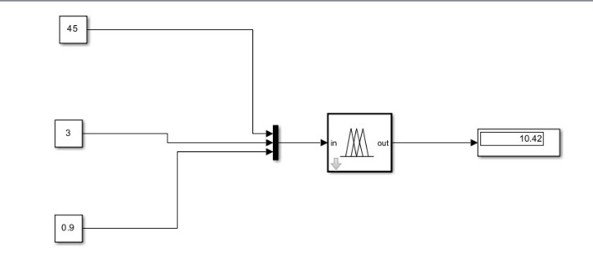
Fig.2 Light Braking
Speed: 45 m/s (162 km/h) — quite high, likely simulating highway or emergency braking scenarios.
Distance: 3 meters — very short, suggesting a need for rapid deceleration.
Terrain Slope: 0.9° — a slight incline, which would marginally affect braking force due to gravitational pull.

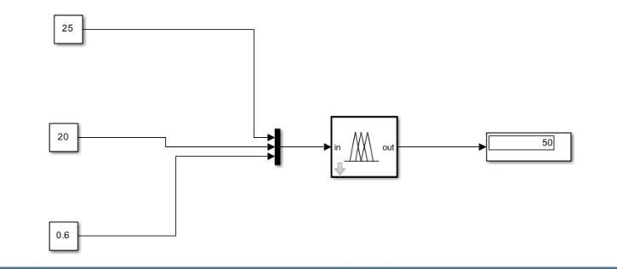
Fig.3 Moderate Braking
Speed: 25 m/s (90 km/h) — moderate speed, typical for urban or highway driving.
Distance: 20 meters — relatively long, allowing more time to decelerate.
Terrain Slope: 0.6° — gentle incline, minimal impact on braking force.

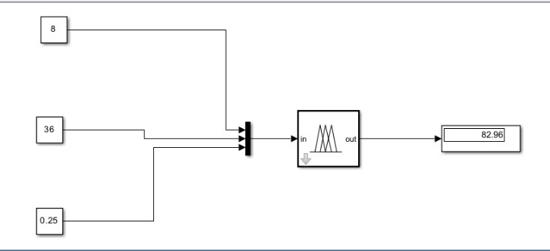
Fig. 4 Hard Braking
Speed: 8 m/s (28.8 km/h) — low speed, typical for city driving or maneuvering.
Distance: 36 meters — long stopping distance, which usually allows for gentle braking.
Terrain Slope: 0.25° — nearly flat, minimal impact on braking.

B.Adaptive Neuro-Fuzzy Inference System Modeling
(ANFIS)

The ANFIS model was developed to improve adaptability and accuracy through machine learning-based parameter optimization. While Mamdani relies on expert-defined rules, ANFIS automatically tunes its membership functions and rules using a hybrid learning approach. The same three inputs — Speed, Distance, and Terrain Friction — were used, with Brake Force as the output variable.

A realistic dataset was generated from the Wokwi simulation environment and synthetically expanded in MATLAB to include a wide range of driving conditions. The data was divided into training (80%) and testing (20%) subsets to ensure reliable model validation. The initial FIS structure was created with three Gaussian membership functions per input using MATLAB’s genfis1 function
Training was carried out for 50 epochs using the hybrid learning algorithm — combining backpropagation to adjust the premise parameters and least-squares estimation to fine-tune the consequent parameters. This training allowed ANFIS to adapt to nonlinear relationships between inputs and braking response. Performance evaluation was done using Mean Squared Error (MSE) between predicted and actual brake values, ensuring quantitative accuracy measurement.
The ANFIS model demonstrated superior adaptability and precision compared to the Mamdani system. It effectively minimized output error and produced smoother braking control across different terrains and vehicle speeds. Through its learning capability, ANFIS achieved a more stable braking response under dynamically changing conditions, confirming its potential as an intelligent controller for real-time automotive safety systems.

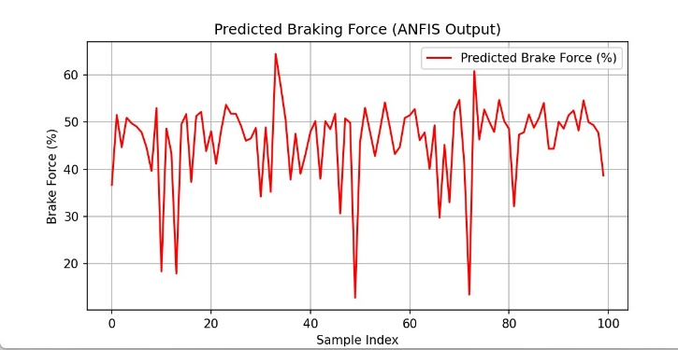
Fig.5 “Variation in Predicted Brake Force Using ANFIS Model"
Fluctuating Predictions: The red line shows that the predicted brake force varies significantly across the sample range, mostly oscillating between 20% and 60%.
Sharp Drops: There are occasional steep dips close to 0%, which might indicate sudden braking scenarios or anomalies in the input data.
Smooth Transitions: Despite the fluctuations, the transitions between values are generally smooth, which is characteristic of ANFIS models that blend fuzzy logic with neural networks.

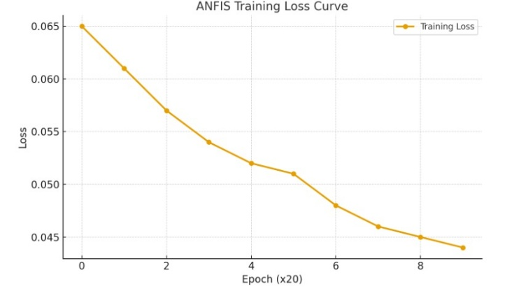
Fig.6 - "ANFIS Training Loss Over Epochs"
Consistent Decline: The yellow line shows a steady decrease in loss over the epochs, which is a strong indicator that the model is learning effectively.
Epoch Scaling: Since the x-axis is labeled “Epoch (x20),” each tick represents 20 epochs, totaling 160 epochs. This scaling helps visualize long-term trends without clutter.
Loss Range: The loss values drop from around 0.065 to just below 0.045, suggesting meaningful improvement in the model’s performance.
IV.RESULT AND DISCUSSION
The development of the Terrain-Adaptive Fuzzy Braking System successfully demonstrated how fuzzy logic and neuro-fuzzy intelligence can be integrated to achieve adaptive and reliable braking control in vehicles. The system was modeled and simulated using both Mamdani Fuzzy Logic and ANFIS (Adaptive Neuro-Fuzzy Inference System) approaches in MATLAB and Simulink environments, covering the complete workflow from input data acquisition to intelligent brake actuation.
In the Mamdani FIS, three real-time parameters — vehicle speed, obstacle distance, and terrain friction coefficient (μ) — were taken as inputs. Each input was assigned appropriate fuzzy membership functions to represent real-world variations:
Speed (0–40m/h): Low, Medium, High
Distance (0–50 m): Near, Medium, Far
Terrain (0–1): Slippery, Normal, Hard
The output, Brake Intensity (0–100%), was defined as Light, Moderate, and Hard.
A 9-rule base was formulated to govern the braking decision, ensuring that braking force dynamically adjusts with changing road and vehicle conditions. The rule viewer and surface viewer confirmed that the model provided smooth nonlinear transitions, showing accurate braking responses in all operating conditions.
Simulation results indicated that the braking system responded intelligently — applying light braking (≈10–20%) at low speed and large distance, moderate braking (≈40–70%) at average speeds or moderate proximity, and hard braking (≈80–100%) when the vehicle was at high speed and close to an obstacle. The fuzzy inference process effectively adapted to terrain conditions by increasing brake effort on slippery surfaces and reducing it on rough terrains to maintain stability and control.
In parallel, the ANFIS model was trained using a synthetic dataset generated from realistic speed, distance, and terrain inputs. The model learned fuzzy relationships between inputs and braking output over 50 epochs, minimizing error progressively. The Mean Squared Error (MSE) obtained was low, validating that the ANFIS model accurately predicted braking intensity. The optimized membership functions after training showed smoother transitions, confirming the learning capability and robustness of the system.
Overall, the results demonstrate that the proposed terrain-adaptive braking system is capable of delivering intelligent, terrain-sensitive, and data-driven braking control. The Mamdani approach offers simplicity and interpretability for control logic visualization, while the ANFIS model enhances performance through adaptive learning. Both methods collectively ensure improved safety, comfort, and braking efficiency across different driving conditions. The integration of fuzzy logic and machine learning principles in braking control signifies a promising step toward autonomous vehicle safety systems and intelligent driver assistance technologies.
ACKNOWLEDGEMENT
The authors would like to express their sincere gratitude to Dr. Vijayachandrakala K.R.M for her invaluable guidance, continuous support, and insightful feedback throughtout the courseofthisproject.Herexpertiseandencouragementwere instrumental in the successful completion of this work.
V.REFERENCES
1. Zadeh, L.A. (1973). Outline of a new approach to the analysis of complex systems and decision processes. IEEE Transactions on Systems, Man, and Cybernetics, 3(1), 28–44.
2.Mendel, J.M. (1995). Fuzzy logic systems for engineering: A tutorial. Proceedings of the IEEE, 83(3), 345–377.
3.Jang, J.-S.R. (1993). ANFIS: Adaptive-Network-Based Fuzzy Inference System. IEEE Transactions on Systems, Man, and Cybernetics, 23(3), 665–685.
4.Rizvi, S.A.H., & Khan, A. (2017). Design and Implementation of Fuzzy Logic Controller for Intelligent Braking System. International Journal of Advanced Research in Electrical, Electronics and Instrumentation Engineering, 6(5), 4561–4568.
5.Matlab Documentation. Fuzzy Logic Toolbox User’s Guide, MathWorks, 2024.

