

Foundations of Programming

Lab Assignment No. : 03

PROBLEM STATEMENT:
Write a program in C to generate multiplication tables for a given number.
OBJECTIVES:
- To understand the use of looping statements in C.
- To generate multiplication tables using loops.
- To improve program logic and execution flow understanding.

THEORY:
Syntax for for loop example program
Solution: for (initialization_expression; test_condition; update_expression){
// code block to be executed in each iteration
}

Syntax for while loop example program
Solution: while (condition) {
// Code to be executed in the loop body
// This part should include a way to eventually make the condition false
}

Syntax for do while loop example program
Solution: do {
// Body of the loop (statements to be executed)
// Update expression (e.g., increment/decrement counter)
} while (condition);

ALGORITHM:
Step 1: Start.
Step 2: Take n as an input from the user whose multiplication table we want in variable n.
Step 3: for(int i=1; i<=10; i++) {
printf(“%d x %d = %d \n”, n, i, n*i);
}
Step 4: Stop.

FLOWCHART:
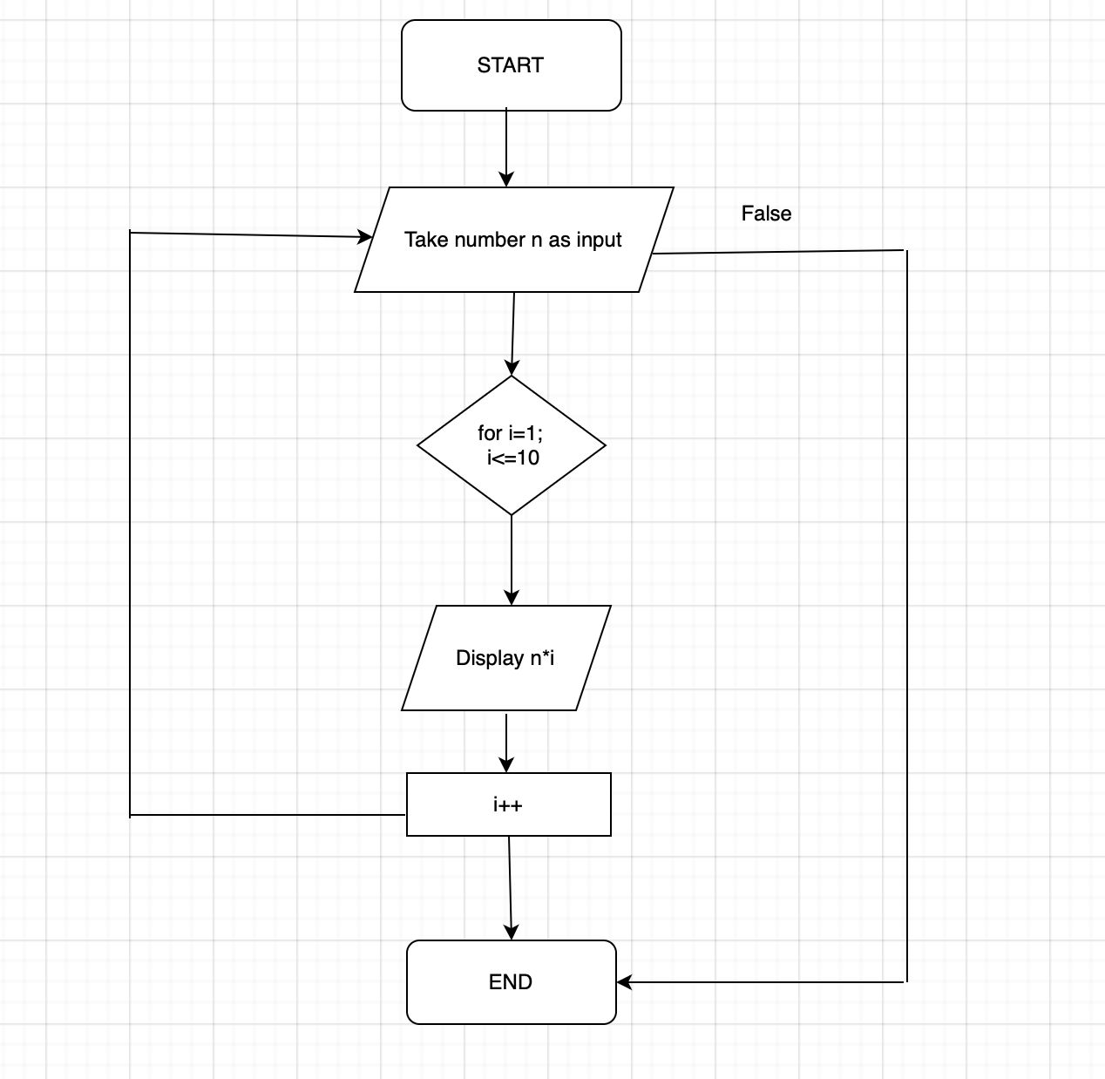
Type Program (Multiplication table):
#include <stdio.h>
int main() {
printf(“Enter the number: ”);
float n;
scanf(“%f”, &n);

for(int i=1; i<=10; i++) {
printf(“%d x %d = %d \n”, n, i, n*i);
}
return 0;
}

PLATFORM:
Linux

INPUT:
2

OUTPUT:
2 x 1 = 2
2 x 2 = 4
2 x 3 = 6
2 x 4 = 8
2 x 5 = 10
2 x 6 = 12
2 x 7 = 14
2 x 8 = 16
2 x 9 = 18
2 x 10 = 20

CONCLUSION:
Thus, the menu driven program in C successfully performs basic arithmetic operations using switch–case statements.

FAQs:
- Which loop is best suited for generating multiplication tables?
- What is the role of loop initialization?
- Difference between for loop, while loop and do while loop?
- Can a do–while loop be used to generate multiplication tables? Explain.
- Why is the do–while loop called an exit-controlled loop?

