;l

Foundations of Programming

Assignment No. : 4
- PROBLEM STATEMENT: Write a C Program to calculate the salary of an employee given his basic pay (taken as input from the user). Calculate gross salary of employee. Let HRA be 10 % of basic pay and TA be 5% of basic pay. Let employees pay professional tax as 2% of total salary. Calculate net salary payable after deductions.

OBJECTIVE:

- To understand the importance of flowchart for any programming model.
- To learn simple flowchart symbols and arrows to define relationships.
- To understand and develop visual representations of flow of data.

THEORY:
- Define Algorithm.
Solution: Algorithm programming is the process of creating a precise, step-by-step plan (an algorithm) to solve a specific problem and then translating that plan into a programming language that a computer can execute. The algorithm itself is the underlying logic or "recipe", separate from the actual code.

- What are the different characteristics of an algorithm.
Solution: Key characteristics of an algorithm include:
- Input: An algorithm accepts zero or more well-defined, externally supplied inputs.
- Output: It produces at least one, but possibly more, clearly defined results.
- Definiteness (Unambiguous): Each step must be precisely defined, unambiguous, and have only one clear interpretation.
- Finiteness: The algorithm must terminate after a finite number of steps and not run in an infinite loop.
- Effectiveness (Feasibility): Every step must be basic enough to be carried out practically, using available resources.
- Language Independence: The steps should be designed logically, independent of any specific programming language.
- Correctness: The algorithm should provide the correct, expected output for all valid inputs.
- Efficiency: A good algorithm should solve the problem with minimal time and memory resources.

Algorithm:
Step 1: Start.
Step 2: Take basic pay as an input from the user.
Step 3: Declare variable HRA and calculate 10% of basic pay in it. (basic salary * 0.1)
Step 4: Declare variable TA and calculate 5% of basic pay in it (basic salary * 0.05)
Step 5: Calculate gross salary = basic pay + HRA + TA.
Step 6: Declare variable tax and calculate 2% of gross salary (gross salary * 0.02)
Step 7: Calculate net salary = gross salary - tax.
Step 8: Display net salary.
Step 9: Stop.

FLOWCHART:
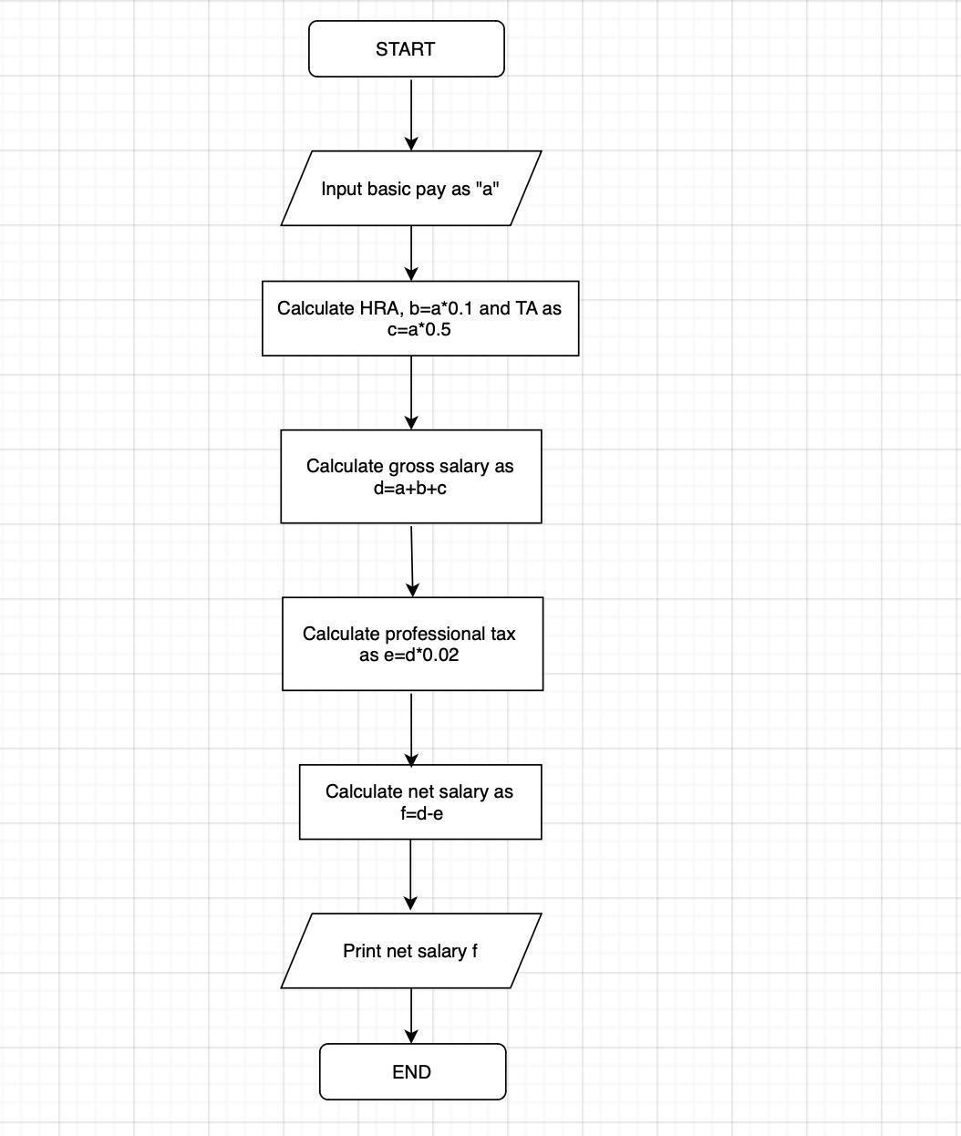

Code:
#include <stdio.h>

int main()
{
float basic_pay, HRA, TA, gross_salary, tax, net_salary;

printf("Enter Basic Pay: ");
scanf("%f", &basic_pay);

HRA = basic_pay * 0.1;

TA = basic_pay * 0.05;

gross_salary = basic_pay + HRA + TA;

tax = gross_salary * 0.02;

net_salary = gross_salary - tax;

printf("Net Salary = %.2f\n", net_salary);

return 0;
}

PLATFORM: Linux

INPUT:
Enter Basic Pay: 10000
OUTPUT:
Net Salary = 11270.00
CONCLUSION: Thus, we have learned to write algorithms and to draw its representation in terms of flowchart.

FAQs:
- Describe various symbols and their use in flowchart.
- Difference between Algorithm and Flowchart.

