

Foundations of Programming
Assignment No. : 10

PROBLEM STATEMENT:
Write a program in C to simulate a simple calculator that performs basic arithmetic operations such as addition, subtraction, multiplication, and division. The calculator should also perform special operations like computing xʸ (power) and x! (factorial).

OBJECTIVE:
• To understand the use of switch-case statements in C.
• To perform basic arithmetic and special mathematical operations.
• To enhance problem-solving skills using menu-driven programs.

THEORY:
A calculator is a basic computing device used to perform arithmetic operations. In C programming, a simple calculator can be implemented using conditional or switch-case statements. Arithmetic operations like addition, subtraction, multiplication, and division are fundamental operations. Special operations such as power (xʸ) and factorial (x!) require loops for repeated calculations.

PLATFORM:
Linux

ALGORITHM:
Step 1: Start
Step 2: Take a and b as an input from the user which are numbers.
Step 3: Take operator as an input from the user to perform particular task in variable op, which is a char.
Step 4: Declare variables result for power operation and fact for factorial operation.
Step 5: switch (op) {
case '+': printf("%f", a + b);
break;
case '-': printf("%f", a - b);
break;
case '*': printf("%f", a * b);
break;
case '/': printf("%f", a / b);
break;
case '^': while (b > 0) {
result *= a;
b--;
}
printf("%f", result);
break;
case '!': if (a < 0) {
printf("-ve no -> no factorial");
} else if (a == 0 || a == 1) {
printf("%f", 1);
}else {
for (float i = 2; i <= a; i++) {
fact *= i;
}
printf(“%f”, fact);
}
break;
default: printf(“wrong operator”);
}
Step 6: Stop.

FLOWCHART:
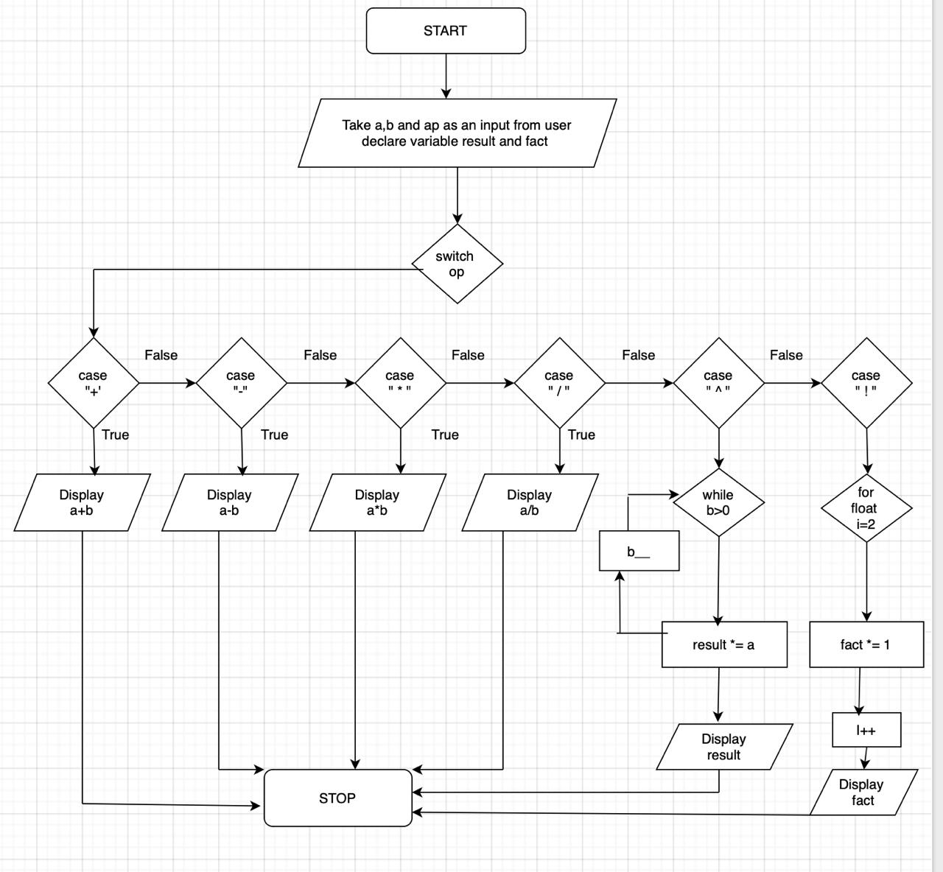

C PROGRAM:
#include <stdio.h>

int main() {

float a, b;
char op;
float result = 1;
float fact = 1;

printf("Enter two numbers (a and b): ");
scanf("%f %f", &a, &b);

printf("Enter operator (+, -, *, /, ^, !): ");
scanf(" %c", &op); // space before %c to avoid input issue

switch (op) {
case '+':
printf("%f\n", a + b);
break;

case '-':
printf("%f\n", a - b);
break;

case '*':
printf("%f\n", a * b);
break;

case '/':
if (b != 0)
printf("%f\n", a / b);
else
printf("Division by zero not allowed\n");
break;

case '^':
while (b > 0) {
result *= a;
b--;
}
printf("%f\n", result);
break;

case '!':
if (a < 0) {
printf("-ve no -> no factorial\n");
}
else if (a == 0 || a == 1) {
printf("%f\n", 1.0);
}
else {
for (float i = 2; i <= a; i++) {
fact *= i;
}
printf("%f\n", fact);
}
break;

default:
printf("wrong operator\n");
}

return 0;
}

INPUT:
User selects an operation from the menu and enters required values.
Example Input:
Choice: 1
Numbers: 10 20

OUTPUT:
Screen Shot of Output
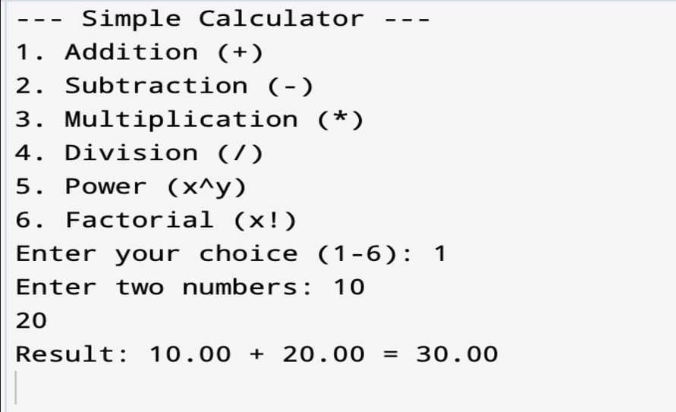

CONCLUSION:
Thus, a simple calculator program was successfully implemented using C programming. The program demonstrates the use of switch-case statements, loops, and arithmetic operations.

FAQs:
- What is a simple calculator program?
- Why is switch–case preferred in calculator programs?
- How does the program handle division by zero?
- How is the power operation (xʸ) implemented without using math library functions?
- What is factorial and how is it calculated using loops in C?

