

Foundations of Programming
Assignment No. : 11

PROBLEM STATEMENT:
Write a program in C to accept a number from the user and compute the following:
- Square root of the number
- Square of the number
- Cube of the number
- Check whether the number is prime
- Factorial of the number
- Prime factors of the number

OBJECTIVE:
• To understand the use of mathematical operations in C.
• To implement loops and conditional statements
. • To perform number-based computations.
• To enhance logical thinking using menu-driven programs.

THEORY:
Numbers and their mathematical properties play a vital role in programming. Operations such as square, cube, and square root are basic mathematical computations. Prime number checking involves verifying whether a number has exactly two divisors. Factorial is calculated by multiplying a sequence of integers. Prime factorization breaks a number into its prime components. In C programming, these operations can be efficiently implemented using loops, conditional statements, and mathematical functions.

PLATFORM:
Linux

ALGORITHM:
Step 1: Start
Step 2: Declare the variables num, i, isPrime as integers and fact as float.
Step 3: Ask the user to enter a number.
Step 4: Read the number and store it in variable num.
Step 5: Calculate and display square root of the number.
Step 6: Calculate and display square of the number.
Step 7: Calculate and display cube of the number.
Step 8: Check whether the number is prime:
- If number is less than or equal to 1, it is not prime.
- Otherwise, check divisibility from 2 to √num.
- Display whether the number is prime or not.
Step 9: Calculate the factorial of the number:
- If the number is negative, display that factorial is not defined.
- Otherwise, calculate factorial using a loop and display the result.
Step 10: Find and display the prime factors of num.
- Store the value of num in a temporary variable.
- Divide the number repeatedly by possible factors starting from 2.
- Print each factor when division is exact.
Step 11: Stop.

FLOWCHART:
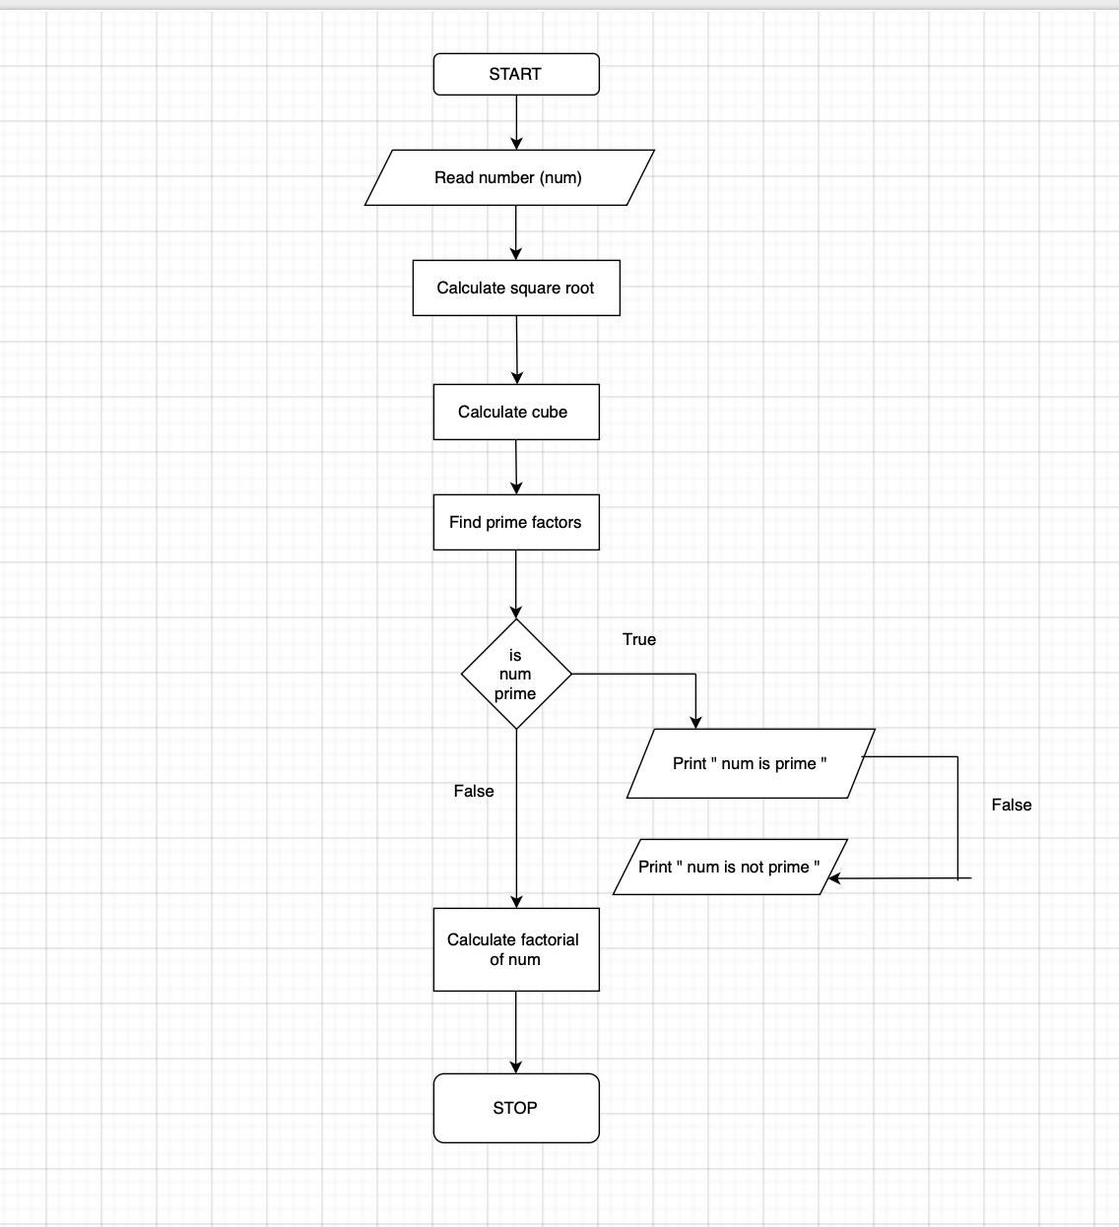

C PROGRAM:
#include <stdio.h>
#include <math.h>

int main() {

int num, i, isPrime;
float fact = 1;

// Step 3 & 4: Input
printf("Enter a number: ");
scanf("%d", &num);

// Step 5: Square root
printf("Square root: %.2f\n", sqrt(num));

// Step 6: Square
printf("Square: %d\n", num * num);

// Step 7: Cube
printf("Cube: %d\n", num * num * num);

// Step 8: Prime check
if (num <= 1) {
isPrime = 0;
} else {
isPrime = 1;
for (i = 2; i <= sqrt(num); i++) {
if (num % i == 0) {
isPrime = 0;
break;
}
}
}

if (isPrime)
printf("The number is Prime.\n");
else
printf("The number is Not Prime.\n");

// Step 9: Factorial
if (num < 0) {
printf("Factorial is not defined for negative numbers.\n");
} else {
fact = 1;
for (i = 1; i <= num; i++) {
fact = fact * i;
}
printf("Factorial: %.0f\n", fact);
}

// Step 10: Prime Factors
printf("Prime factors: ");
int temp = num;

for (i = 2; i <= temp; i++) {
while (temp % i == 0) {
printf("%d ", i);
temp = temp / i;
}
}

printf("\n");

// Step 11: Stop
return 0;
}

INPUT:
The user enters an integer number and selects an operation from the menu.
Example Input: Number: 5 Choice: 3

Paste Screen Shot of Input

OUTPUT:
Example Output:
The program displays the result based on the selected operation.
Example Output: Cube = 125

Paste Screen Shot of Output
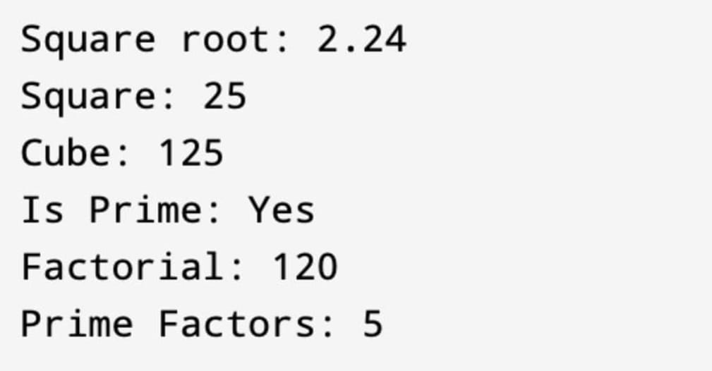

CONCLUSION:
Thus, the program to perform various mathematical operations on a number was successfully implemented using C programming. This program demonstrates the use of loops, conditional statements, switch-case, and mathematical functions.

FAQs:
- Why is checking divisibility only up to n/2 sufficient in prime number verification, and how can this be optimized further?
- What are the limitations of using int data type for factorial calculation, and how can overflow be handled in C?
- How does the time complexity of prime factorization change with increasing input size?
- Why is the math.h library required for square root calculation, and what happens if it is not included?
- How would the program behaviour change if a negative number is entered for factorial or square root operations?
- Explain the difference between checking a number for primality and generating prime factors of the same number.
- How can recursion be used to calculate factorial instead of loops, and what are its advantages and disadvantages?

