

Foundations of Programming
Assignment No. : 12

PROBLEM STATEMENT:
Write a program in C to accept two numbers from the user and compute:
- The smallest common divisor of the two numbers (other than 1, if any)
- The Greatest Common Divisor (GCD) of the two numbers

OBJECTIVE:
• To understand the use of mathematical operations in C.
• To implement loops and conditional statements
. • To perform number-based computations.
• To enhance logical thinking using menu-driven programs.

THEORY:
Divisors and the Greatest Common Divisor (GCD) are fundamental concepts in number theory. The smallest common divisor of two numbers is the smallest positive integer greater than 1 that divides both numbers. The GCD of two numbers is the largest positive integer that divides both numbers without leaving a remainder. In C programming, these operations can be efficiently implemented using loops and the Euclidean algorithm, which repeatedly applies the modulo operation until the remainder becomes zero.

PLATFORM:
Linux

ALGORITHM:
Step 1: Start
Step 2: Declare variables num1, num2, greatest, smallest.
Step 3: Accept 2 numbers from user.
Step 4: Find minimum number.
Step 5: For smallest common divisor:
for (i = 2; i ≤ min; i++)
if (smallestDivisor = i) then stop.
Step 6: For GCD:
while (num2 ≠ 0) → num2 = num1 % num2
the final value of num1 GCD.
Step 7: Display result.
Step 8: Stop.

FLOWCHART:
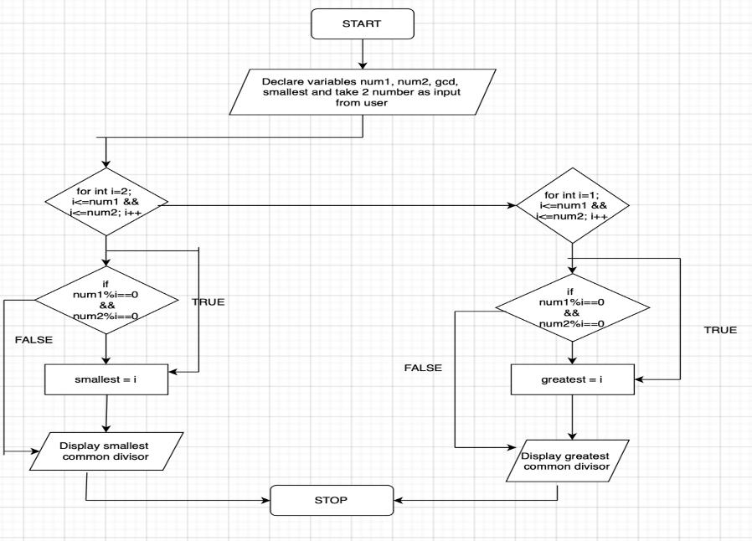

C PROGRAM:
#include <stdio.h>

int main() {
int num1;
printf("Enter first number:");
scanf("%d",&num1);
int num2;
printf("Enter second number:");
scanf("%d",&num2);
int smallest = 1;
int greatest = 1;
for(int i=2; i<=num1 && i<=num2; i++) {
if(num1%i==0 && num2%i==0) {
smallest = i;
break;
}
}
printf("Smallest Common Divisor: %d \n", smallest);

for(int i=1; i<=num1 && i<=num2; i++) {
if(num1%i==0 && num2%i==0) {
greatest = i;
}
}
printf("Greatest Common Divisor: %d \n", greatest);
return 0;
}

INPUT:



OUTPUT:


CONCLUSION:
Thus, the program to find the smallest common divisor and the Greatest Common Divisor of two numbers was successfully implemented using C programming. This program demonstrates the use of loops, conditional statements, and the Euclidean algorithm.

FAQs:
- What is meant by the Greatest Common Divisor (GCD)?
- Why does the Euclidean algorithm efficiently compute the GCD?
- How can this program be modified to handle negative numbers?
- What changes are required to compute the Least Common Multiple (LCM) using the GCD?
- How can this program be extended to find the LCM of two numbers?

