

Foundations of Programming
Assignment No. : 13

PROBLEM STATEMENT:
Write a program in C to accept a number from the user and print the digits of the number in reverse order.

OBJECTIVE:
• To understand number manipulation using loops
. • To learn the use of modulo (%) and division (/) operators.
• To implement logic for reversing digits of a number.
• To improve problem-solving skills using iterative structures.

THEORY:
• To understand number manipulation using loops. • To learn the use of modulo (%) and division (/) operators. • To implement logic for reversing digits of a number. • To improve problem-solving skills using iterative structures.

PLATFORM:
Linux

ALGORITHM:
Step1: Take a number input from the user and declare variables rev & ld.
Step2: use while loop: while (n > 0) {
int ld = n % 10;
rev = (rev * 10) + ld;
n /= 10;
}
Step3: Display the reversed number
Step4: Stop

FLOWCHART:
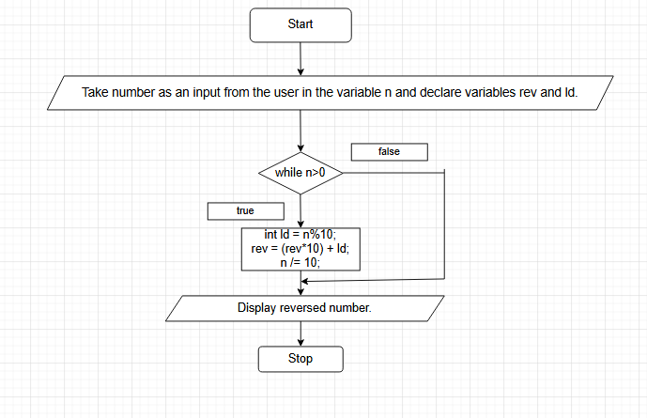

C PROGRAM:
#include <stdio.h>

int main() {

int n, rev = 0, ld;

printf("Enter a number: ");
scanf("%d", &n);

while (n > 0) {
ld = n % 10;
rev = (rev * 10) + ld;
n /= 10;
}
printf("Reversed number = %d\n", rev);

return 0;
}

INPUT:

OUTPUT:


CONCLUSION:
Thus, the program to print the digits of a number in reverse order was successfully implemented using C programming. The program demonstrates the effective use of loops, modulo operator, and division operator.

FAQs:
- Why is the modulo operator (%) used in this program?
- Why is division by 10 used after extracting each digit?
- What happens if the input number is zero?
- How will the program behave for negative numbers?
- Why is a while loop preferred for this operation?

