

Foundations of Programming

Lab Assignment No. : 02

PROBLEM STATEMENT:
Write a menu driven program in C to implement the basic arithmetic operations such as Addition, Subtraction, Multiplication, and Division.

OBJECTIVES:
• To understand the concept of menu driven programming in C.
• To apply conditional statements and switch–case control structures.
• To perform basic arithmetic operations using user-defined input.
• To enhance logical thinking and problem-solving skills.

THEORY:
1)if–else ladder statements syntax and sample program.
Solution- The if-else ladder is used in C to test a series of conditions sequentially and execute the block of code for the first condition that evaluates to true. If no condition is true, the optional else block is executed.
Syntax-
if (condition1) {
// code to be executed if condition1 is true
} else if (condition2) {
// code to be executed if condition1 is false and condition2 is true
} else if (condition3) {
// code to be executed if condition1 and condition2 are false and condition3 is true
}
...
else {
// code to be executed if all conditions are false
}

Example-
#include <stdio.h>

int main() {
int marks;

printf("Enter your marks: ");
scanf("%d", &marks);

if (marks >= 90) {
printf("Grade: A\n");
} else if (marks >= 80) {
printf("Grade: B\n");
} else if (marks >= 70) {
printf("Grade: C\n");
} else if (marks >= 60) {
printf("Grade: D\n");
} else {
printf("Grade: F\n");
}

return 0;
}
2)switch–case or if–else ladder statement syntax and sample program.
Solution- The switch-case statement is an alternative to the if-else ladder, specifically for cases where you are comparing a single expression against multiple constant integral or character values (not floating-point numbers or ranges). The program jumps directly to the matching case, which is often more efficient for many options.
Syntax-
switch (expression) {
case value1:
// code to be executed if expression == value1
break; // optional: exits the switch block
case value2:
// code to be executed if expression == value2
break;
...
default:
// code to be executed if none of the cases match
}

Example-
#include <stdio.h>

int main() {
char operator;
double n1, n2;

printf("Enter an operator (+, -, *, /): ");
scanf("%c", &operator);
printf("Enter two numbers: ");
scanf("%lf %lf", &n1, &n2);

switch (operator) {
case '+':
printf("%.1lf + %.1lf = %.1lf\n", n1, n2, n1 + n2);
break;
case '-':
printf("%.1lf - %.1lf = %.1lf\n", n1, n2, n1 - n2);
break;
case '*':
printf("%.1lf * %.1lf = %.1lf\n", n1, n2, n1 * n2);
break;
case '/':
if (n2 != 0.0) {
printf("%.1lf / %.1lf = %.1lf\n", n1, n2, n1 / n2);
} else {
printf("Error! Division by zero is not allowed.\n");
}
break;
default:
// operator doesn't match any case constant
printf("Error! operator is not correct\n");
}

return 0;
}
3)Basic arithmetic operations include Addition, Subtraction, Multiplication, and Division. Division by zero should be avoided.
Solution- In C programming, arithmetic operations are the primary way to perform mathematical calculations between variables and constants. These operations are represented by specific symbols called operators.
C provides four primary operators for basic math:
- Addition (+): This operator adds two values together.
  - Example: If a = 10 and b = 5, then a + b results in 15.
- Subtraction (-): This operator subtracts the second value from the first.
  - Example: If a = 10 and b = 5, then a - b results in 5.
- Multiplication (*): This operator multiplies two values.
  - Example: If a = 10 and b = 5, then a * b results in 50.
- Division (/): This operator divides the first value (numerator) by the second value (denominator).

Division by Zero
Division by zero is a critical issue in programming. In mathematics, dividing any number by zero is undefined. In C, if a program attempts to divide an integer by zero, it results in a Runtime Error. This usually causes the program to crash or stop working immediately without warning.

ALGORITHM: (using if-else)
Step 1: Start.
Step 2: Take a and b which are numbers, as an input from the user.
Step 3: Take operator as an input from the user to perform particular task in variable op, which is a char.
Step 4: if(op ==’+’) {
printf(“Addition = %f\n”, a+b);
} else if(op ==’-’) {
printf(“Subtraction = %f\n”, a-b);
} else if(op ==’*’) {
printf(“Multiplication = %f\n”, a*b);
} else if(op ==’/’) {
printf(“Division = %f\n”, a/b);
} else {
printf(“wrong operator”);
}
Step 5: Stop.

Algorithm: (using switch case)
Step 1: Start.
Step 2: Take a and b which are numbers, as an input from the user.
Step 3: Take operator as an input from the user to perform particular task in variable op, which is a char.
Step 4: switch(op) {
case ‘+’: printf(“%f”, a+b);
break;
case ‘-’: printf(“%f”, a-b);
break;
case ‘*’: printf(“%f”, a*b);
break;
case ‘/’: printf(“%f”, a/b);
break;
default: printf(“wrong operator”);
}

Flowchart:
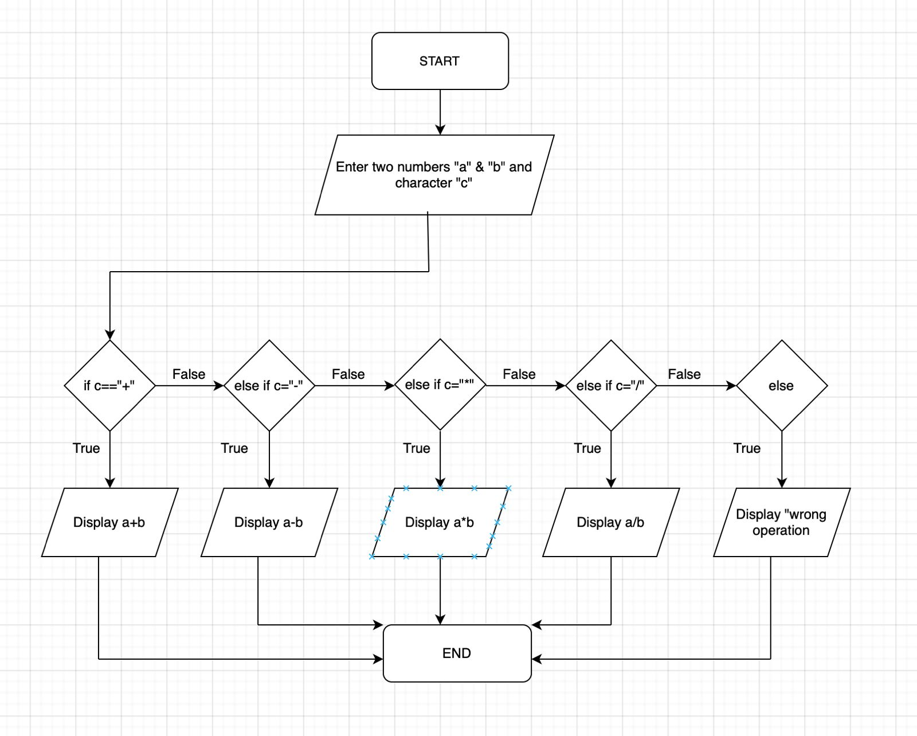
Type Program :
1)if-else
#include <stdio.h>
int main() {
printf(“Enter your first number: ”);
float a;
scanf(“%f”, &a);
printf(“Enter your second number: ”);
float b;
scanf(“%f”, &b);

printf(“Enter your operation: ”);
char op;
scanf(“%f”, &op);

if(op ==’+’) {
printf(“Addition = %f\n”, a+b);
} else if(op ==’-’) {
printf(“Subtraction = %f\n”, a-b);
} else if(op ==’*’) {
printf(“Multiplication = %f\n”, a*b);
} else if(op ==’/’) {
printf(“Division = %f\n”, a/b);
} else {
printf(“wrong operator”);
}
return 0;
}

2) Switch case:
#include <stdio.h>
int main() {
printf(“Enter your first number: ”);
float a;
scanf(“%f”, &a);
printf(“Enter your second number: ”);
float b;
scanf(“%f”, &b);

printf(“Enter your operation: ”);
char op;
scanf(“%f”, &op);

switch(op) {
case ‘+’: printf(“%f”, a+b);
break;
case ‘-’: printf(“%f”, a-b);
break;
case ‘*’: printf(“%f”, a*b);
break;
case ‘/’: printf(“%f”, a/b);
break;
default: printf(“wrong operator”);
}
return 0;
}

PLATFORM:
Linux

INPUT:
45
15

OUTPUT:
Addition=60
Subtraction=30
Multiplication=675
Division=3
SAMPLE INPUT:
10
5

SAMPLE OUTPUT:
Addition = 15

CONCLUSION:
Thus, the menu driven program in C successfully performs basic arithmetic operations using switch–case statements.

FAQs:
1. What is a menu driven program?
2. Why is switch–case preferred over if–else ladder in menu driven programs?
3. What is the purpose of the break statement in switch–case?
4. What is the purpose of the break statement in switch–case?
5. What are the limitations of switch–case compared to if–else?

