;l

Foundations of Programming

Assignment No. : 01
- PROBLEM STATEMENT:
Write a program in C to check whether a given year is a Leap Year

OBJECTIVE:

- To understand the use of conditional statements in C programming.
- To implement logical conditions for solving real-world problems.
- To develop problem-solving skills using decision control structures.

THEORY:
- Theory for conditional statements with syntax (if , if-else, if-else ladder) are used in C programming
Solution: Conditional statements are essential programming constructs used to execute different code blocks based on whether a specific condition evaluates to true or false. C programming provides several forms of conditional statements: if, if-else, and if-else ladder.
Syntax of if statement:
if (condition) {
// Code to be executed if the condition is true
}
Example: This program checks if a number entered by the user is positive.
#include <stdio.h>
int main() {
int number;

printf("Enter an integer: ");
scanf("%d", &number);

if (number > 0) {
printf("You entered a positive number: %d\n", number);
}
printf("This statement is always executed.\n");
return 0;
}

Syntax of if-else statement:
if (condition) {
// Code to be executed if the condition is true
} else {
// Code to be executed if the condition is false
}
Example:
#include <stdio.h>
int main() {
int number;

printf("Enter an integer: ");
scanf("%d", &number);

// Checks if the remainder is 0
if (number % 2 == 0) {
printf("%d is an even number.\n", number);
} else {
printf("%d is an odd number.\n", number);
}
return 0;
}
- Theory for a Leap Year - year that contains 366 days instead of the usual 365 days.
Rules:
• A year is a leap year if it is divisible by 400, OR
• A year is a leap year if it is divisible by 4 but not divisible by 100.
- Algorithm
Step 1: Start.
Step 2: Take year as an input from the user.
Step 3: if (year%4 == 0 && year%100 != 0 || year%400 == 0) {
printf(“It is a leap year”);
}
Step 4: else {
printf(“It is a leap year”);
}

Step 5: Stop.
- Flow Chart:
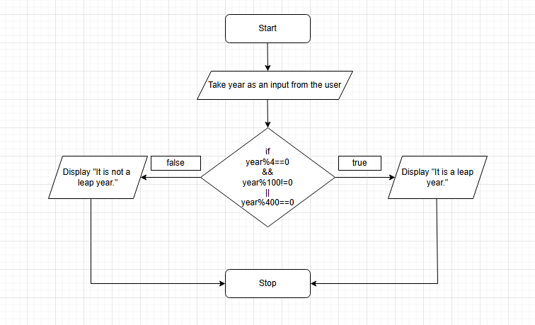

PLATFORM: Linux (Code)
#include <stdio.h>
int main() {
int year;
printf(“Enter the year: ”);
scanf(“%d”, &year);

if ((year%4 == 0 ) && (year%100 != 0) || (year%400 == 0)) {
printf(“It is a leap year.”);
} else {
printf(“It is not a leap year);
}

INPUT:

2000

OUTPUT:
It is a leap year.
Sample Input
2024
Sample Output
2024 is a Leap Year
CONCLUSION: Thus, the program successfully checks whether a given year is a Leap Year using conditional statements in C.

FAQs:
- What is a leap year?
- Why is the year 1900 not a leap year but 2000 is?
- Which operators are used in this program?
- Difference between if and if–else statements.

